

Sunday

11
th

January 2026

Baptism of Christ

“We believe in

inclusive church

–

a church which

celebrates and affirms every person

and does not discriminate.”

Services
Sunday 11
th

January

Holy Trinity Oakengates

Holy Trinity Wrockwardine Wood

9.30am Holy Communion 8.00am Holy Communion BCP
11.30am Baptism 11.00am Family Praise
St Peter’s Priorslee at Holy Trinity Academy St Matthew’s Donnington Wood
4.00pm Holy Communion Cancelled! 11.00am Holy Communion
St Georges Telford St Mary & St Leonard’s Wombridge
9.30am Morning Worship 11.00am Morning Worship
Please note: Dates and times are correct at time of going to print but are subject to change.

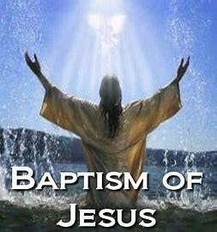

Readings

Baptism of Christ

Psalm

29

1
st

Reading

Isaiah 42.1
-
9

2
nd

Reading

Acts 10.34
-
43

Gospel

Matthew 3.13
-
end

Collect - Baptism of Christ
Eternal Father, who at the baptism of Jesus revealed him to be your Son, anointing him with the Holy Spirit: grant to us, who are born again by water and the Spirit, that we may be faithful to our calling as your adopted children; through Jesus Christ your Son our Lord, who is alive and reigns with you, in the unity of the Holy Spirit, one God, now and for ever. Amen.

Services Sunday 18th January

Holy Trinity Oakengates Holy Trinity Wrockwardine Wood
9.30am Morning Worship 11.00am Holy Communion
St Peter’s Priorslee at Holy Trinity Academy St Matthew’s Donnington Wood
11.00am Morning Worship 11.00am Morning Worship
St Georges Telford St Mary & St Leonard’s Wombridge
9.30am Holy Communion & Baptism 11.00am Holy Communion
Please note: Dates and times are correct at time of going to print but are subject to change.

WEEK OF PRAYER FOR CHRISTIAN UNITY
Deanery Service at All Saints Church Wellington Sunday 18th January 2026 at 6.30pm

Services Sunday 25th January

Holy Trinity Oakengates Holy Trinity Wrockwardine Wood
9.30am Holy Communion 11.00am Morning Worship
St Peter’s Priorslee at Holy Trinity Academy St Matthew’s Donnington Wood
4.00pm Holy Communion 11.00am Holy Communion
St Georges Telford St Mary & St Leonard’s Wombridge
9.30am Morning Worship 11.00am Morning Worship
Please note: Dates and times are correct at time of going to print but are subject to change.

Services Sunday 1st February

Holy Trinity Oakengates Holy Trinity Wrockwardine Wood
9.30am Morning Worship 11.00am Holy Communion
St Peter’s Priorslee at Holy Trinity Academy St Matthew’s Donnington Wood
No service 11.00am Morning Worship
St Georges Telford St Mary & St Leonard’s Wombridge
9.30am Holy Communion 4.00pm Holy Communion
11.00am Baptism
Please note: Dates and times are correct at time of going to print but are subject to change.

Those in need of our prayers

Please pray for the families of, Mike Gatford, Mike Bowley,

Robert Fielding and all who are grieving the loss of loved ones at this time.

Merciful God, be close to all who mourn. May they know the hope of your promises
and the comfort of your love, through Jesus Christ our Lord. Amen

In our prayers we remember the Church, its members and our community. We pray for those who are unwell, either at home or in hospital and those who are adjusting to changes in their lives. We also remember those who can no longer join us physically in our church buildings for worship or fellowship.

At this time please pray for:

- A fresh filling, & new awareness of Jesus ‘The Prince of Peace’
- Peace in our lives, our country and our world
- Pastoral care within the Benefice
- Our Church PCC’s as they plan for the future
- Eco Church and environmental issues
- All who find the need for Foodbanks
- All living on the streets during the winter
- Those affected by the weather through wind, rain or flood
You have committed to our care those who live in this Benefice, Lord Jesus Christ. Help us to hear your voice and to follow you that we, and all your disciples, may grow in faith and love. Inspire, equip and enable us to play our part in your mission that your kingdom may come here in this Diocese. We cannot know all the different people around us, but we ask that your Holy Spirit will guide us to those situations where we can minister something of your love and compassion. Help us to rejoice with those who rejoice, weep with those who weep, and bring practical solutions to problems we encounter, for Jesus Christ’s sake. Amen

Sunday Readings |  | 1st Reading | 2nd Reading | Gospel
18 Jan | Epiphany 2 | Isaiah 49.1-7 | 1 Corinthians 1.1-9 | John 1.29-42
25 Jan | Epiphany 3 | Isaiah 9.1-4 | 1 Corinthians 1.10-18 | Matthew 4.12-23
01 Feb | Presentation of Christ in the Temple (Candlemas) | Malachi 3.1-5 | Hebrews 2.14-end | Luke 2.22-40
Sad News
We were very saddened to hear of the passing of Mike Bowley. May he Rest in Peace and Rise in Glory. Mike has been a faithful servant of our Lord, supporting the churches in the Benefice for many years, especially Holy Trinity Wrockwardine Wood.
Our condolences and prayers go out to Ann and family at this difficult time. (Funeral :- Friday 21 January, 2.15pm at Holy Trinity Wrockwardine Wood).

Daily Readings Morning Evening
 | 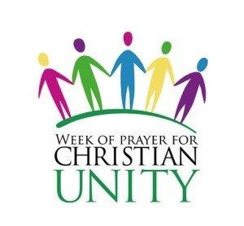
  Monday | 12/01 | Matthew 21.1-17 | 1 Corinthians 1.1-17
  Tuesday | 13/01 | Matthew 21.18-32 | 1 Corinthians 1.18-end
  Wednesday | 14/01 | Matthew 21.33-end | 1 Corinthians 2
  Thursday | 15/01 | Matthew 22.1-14 | 1 Corinthians 3
  Friday | 16/01 | Matthew 22.15-33 | 1 Corinthians 4
  Saturday | 17/01 | Matthew 22.34-end | 1 Corinthians 5
  Monday | 19/01 | Matthew 24.1-14 | 1 Corinthians 6.1-11
  Tuesday | 20/01 | Matthew 24.15-28 | 1 Corinthians 6.12-end
  Wednesday | 21/01 | Matthew 24.29-end | 1 Corinthians 7.1-24
  Thursday | 22/01 | Matthew 25.1-13 | 1 Corinthians 7.25-end
  Friday | 23/01 | Matthew 25.14-30 | 1 Corinthians 8
  Saturday | 24/01 | Matthew 25.31-end | 1 Corinthians 9.1-14
  Monday | 26/01 | Philippians 3.1-14 | Colossians 1.24—2.7
  Tuesday | 27/01 | Matthew 26.17-35 | 1 Corinthians 10.1-13
  Wednesday | 28/01 | Matthew 26.36-46 | 1 Corinthians 10.14—11.1
  Thursday | 29/01 | Matthew 26.47-56 | 1 Corinthians 11.2-16
  Friday | 30/01 | Matthew 26.57-end | 1 Corinthians 11.17-end
  Saturday | 31/01 | Matthew 27.1-10 | 1 Corinthians 12.1-11
 | 

Regular Dates for Diaries (For participation or prayer)
Mon 8.00pm Compline via Zoom
Tue 9.00-10.00am Prayer Group at Holy Trinity Wrockwardine Wood
7.00pm Whist in aid of Holy Trinity Oakengates (1st Tue of month) at Maddocks Club
Wed 8.45-10.30am Tea & Toast (Place of Welcome) at HT W/Wood (Term time only)
9.00-11.00am Food Bank & Clothes Bank at Holy Trinity Wrockwardine Wood
9.15am Morning Prayer at Wombridge Church
10.30am Midweek Service at St Matthew’s Donnington Wood
11.30am Bible Chat session at St Matthew’s Donnington Wood
11.00am Midweek Service at Holy Trinity Wrockwardine Wood
12.00-2.00pm Place of Welcome at Holy Trinity Oakengates
7.00-8.00pm Prayer Group meeting at St Georges (4th Wed each month)
Thu 1.00-3.00pm Pray Bake Read at Lantern Academy Ketley Bank (Only during School Term)
1.00-3.00pm Place of Welcome at Priorslee Scout HQ
Fri 12.30-2.00pm First Friday Free Lunch at Wombridge Parish Centre (1st Friday)
8.00pm Compline via Zoom
Sat 4.00-5.30pm Messy Church at HT Wrockwardine Wood (2nd Saturday of month)
11.00-1.00pm Welcome Saturday at St Matthews Donnington Wood (3rd Saturday of month)

Additional Dates for Diaries
Mon | 12/01 9.30am PCC Meeting at St Matthew’s Donnington Wood
Mon | 12/01 2.30pm Funeral of Mike Gatford at Holy Trinity Oakengates
Mon | 12/01 8.00pm Compline online (Zoom) re-starts
Wed | 14/01 10.00am PCC Meeting St Peter’s at 3 Church Road, Priorslee
Wed | 14/01 7.30pm PCC Meeting St Georges at Oak Cottage, Limekiln Bank
Mon | 19/01 2.00pm Funeral of Robin Dunseith at Aston House St Georges
Wed | 21/01 7.00pm PCC Meeting at Holy Trinity Oakengates
Fri 23/01 2.15pm Funeral Mike Bowley at Holy Trinity Church Wrockwardine Wood
Mon 26/01 11.00am Interment of Ashes of Jean Brown at Holy Trinity Wrockwardine Wood
Fri 30/01 1.30pm Funeral of Robert Fielding at St Georges Church
Fri 06/02 12.30pm First Friday Free Lunch at Wombridge Church in the Parish Centre
Please note: Dates and times are correct at time of going to print but are subject to change.

Those whose years mind we keep

Priorslee
^{11 Jan} Frank Feavyour, Eric Harper, Kathleen Feavyour, Gerald Elkes, Constance Whitehead, Kathleen Dean, Clasina Sheridan, Mary Leighton
^{18 Jan} Kenneth Breheny, Christine Harper, George Poole, Alan Phillips, Edna Lonorgan,
Doreen Yates, Michael Vickers, Margaret Howells, Martin Luter, Winifred Fox,
Constance Dodd, Alice Hickman, Edwin Richards, Harry Davies
^{25 Jan} George Lowe, Reginald Fieldhouse, Raymond Corbett, Florence Jones, Brenda Wall,
Sybil Perry, Kathleen Jones, John Smart, David Palfrey, Ernest Martin, George Ferriday, Justin Beddall

Oakengates
^{11 Jan} Sarah Bailey, Andrew Corbert, Margaret Smith, Elizabeth Jones, Elizabeth Corns,
Trevor Green, Graham Finch, Adah Pearce, Ivy Hicks, John Broughton
^{18 Jan} Emily Haywood, Thomas Branson, Olive Gregory, Harry Taylor, Elsie Attrill, Decima Philips, David Broadhurst, Graham Jones, Hilda Fitchett, Charles Havens, Thomas Hughes, Ernest Anslow, William Aplin
^{25 Jan} Margaret Smith, Laura Hesbrook, Jacqualine Fenwick, Nigel Warner, James Hope,
Sheila Phillips, Emily Taylor, Betty Mullard, Harry Onions, Samantha Bedford, Dot Watkins, Derek Richards

Wrockwardine Wood
^{11 Jan} Frances Margaret Cartwright, Kenneth Graham Edwards, Ellen Davies, Jennifer Lewis,
Harold Ball, David Humphreys, Emily Brown, Ruth Prescott, Phyllis Owen, Elizabeth Mansell,
Albert Gregory, Norman Oliver, Donald (Stan) Pritchard, Ingerborge Mears
^{18 Jan} Ronald Winch, Alfred Walters, Raymond Tonks, Gertrude Westcott, Frank Roberts,
Gladys Stevens, Edward Ernest Howells, Stanley Hillman, Alfred Hale, Phyllis Steadman, William Bailey, Bernard Morris, Margaret Powell
^{25 Jan} George Bancroft, Joseph Gavin, Jean Wilkinson, Lilian (Mary) Bray, Walter Leonard Edwards,
Florence Taylor, Gwyn Williams, Josephine (Jose`) Downing, Muriel Walters,
Jeanette Beddoes, Eileen Courtnell, Blanche Fryer, Keith Benting, Cyril “son” Bray

CHRISTMAS AROUND THE BENEFICE
Sharing our love and faith around the Benefice this Advent and Christmas has brought so many people together. Through the work with the local schools, Places of Welcome, Warm Spaces, Food Bank, Messy Church, Nativity & Carol Services to mention just some of the ways we are working together with the local community. Christmas celebrations in the Benefice were wonderful times of prayer, worship, fellowship and reaching out in the love of God. 2026 gives us yet more opportunities to reach out, reach deep within and grow both spiritually and numerically. We thank God now for the wonderful opportunities he will give us, and we pray that we will have the courage to reach out for them in faith and hope and love. May we all be blessed with a Happy and Peaceful New Year and may we in turn be a blessing to many others.

BAPTISMS WEDDINGS & FUNERALS IN CHURCH
We are always excited to be able to celebrate Baptisms, welcome you for your Wedding or help you through a difficult time arranging a Funeral within our Churches. Funerals are welcomed in Church or at the Graveside and Holy Trinity Wrockwardine Wood are able to livestream funerals. Please telephone Kerry, Benefice Administrator to discuss arrangements.
Our Ministers are also available for Services at the Crematorium, please speak with your Funeral Directors to make arrangements.

SAFEGUARDING
For all the churches in our benefice, the safeguarding, safety and security of each person is of the upmost importance. We have across all our churches committed to safeguarding and have adopted the national and diocesan safeguarding policies.

Please do not hesitate to contact one of the Coordinators, Churchwardens or the Benefice Admin office if you have any questions and concerns and understand that everyone has a role to play to ensure we achieve our aim of being a benefice who cares and protects all who visit.
For more information: https://www.churchofengland.org/safeguarding/national-safeguarding-standards https://www.lichfield.anglican.org/safeguarding/safeguarding.php

To report a Benefice concern please contact admin@easttelfordbenefice.co.uk and Kerry will direct you to the relevant safeguarding officer.


IMPORTANT…..BE AWARE!!!
Please be careful!
We have received reports that there have been scam phone calls and emails being sent to people seeking to extract money with a highly plausible and wellinformed story from clergy and others with positions of responsibility in parishes.
At this time of year, such scams are rife. It is likely that churches and their congregations will be targeted again. It bears repeating that the stories are highly plausible: please beware and make others aware.

PRAYING AT HOME
As we get older our involvement in local church life changes, and we find we have less time for physical activity but more time for prayer! We are a community of prayer – at home and in church. As a Benefice we are grateful to Nigel who hosts Compline (Evening Prayer) via Zoom (extremely easy to join on a mobile phone with internet access) at 8pm on Monday and Friday evenings. For more information please contact Nigel at Nigelcollins8561@gmail.com Come, pray with us!

BIBLE CHAT GROUP
The Bible Chat Group meet weekly at St Matthew’s Church Donnington Wood on Wednesdays at 11.30am. The group uses the themes from the Everyday Faith App as a basis of their weekly discussion. If you would like to join these discussions please do attend as new friends are always welcome.

EVERYDAY FAITH APP
Everyday Faith is a Church of England app offering daily readings, reflections, responses and prayers under various themes; recent themes have included: Journeying with others, Days of small things, Glimpses of Glory, and Generous Words, with each theme looking at where and how we meet God as we go about our lives. Faith is found in our joys and cares, in our challenges and conflicts as we lean into God’s presence and guidance. Faith informs our thinking and our actions as we discern how God might be using us in his work. Faith is an ongoing encounter with God - an Everyday Faith, an everyday existence with the God who holds all things together. You can download Everyday Faith from your app store.

Contact Details  Interim Minister: Revd Dr Tom Atfield  07449 770111 revdtom@yahoo.com  Licensed Reader: Christopher Harris  07941 961461  cjharrissinging@btinternet.com  Newsletter Editor: Christopher Harris  07941 961461  newsletter@easttelfordbenefice.co.uk | Licensed Reader: Kerry Debenham  01952 615367 (9.30am-12.00pm) admin@easttelfordbenefice.co.uk  Administrator: Kerry Debenham  01952 615367 (9.30am-12.00pm) admin@easttelfordbenefice.co.uk  Ecumenical Coordinator & Lay Funeral Minister:  Sue Rawlings  07715173634 Suerawlings12@gmail.com

WEBSITE UPDATE
The East Telford Benefice website has recently been updated and the weekly newsletter can now be found there. Each of our churches do use www.achurchnearyou.com where you can access individual church information.

EASY FUNDRAISING
For those who shop online it is possible to help fundraise for your

Benefice Church, by using the easy fundraising website to make your purchases from many of the well-known retailers. Why not use this website at no cost to yourself but a money earner for the church!
For more info: http://www.easyfundraising.org.uk/causes/stpeterspriorslee
https://www.easyfundraising.org.uk/causes/holytrinitywrockwardinewood https://www.easyfundraising.org.uk/causes/holytrinityoakengates

EMAIL NEWSLETTER
If you would like to receive this newsletter via email regularly please contact newsletter@easttelfordbenefice.co.uk requesting you would like to receive it weekly, or can be found on our Website at WWW.Easttelfordbenefice.co.uk


Messy Church needs your help!
Our Messy Church takes place for the benefice on the 2nd Saturday of the Month at
Holy Trinity Church Wrockwardine
Wood. Fiona and Kerry are looking to draw up a rota of helpers who would be able to help and oversee a craft table and talk about God/Jesus to those who attend.
January 2026 Cancelled!!

We have some wonderful parent helpers who are just at the beginning of their Christian journey and hope to have some of our wonderful congregation members come along and support them and help us out.
If you think you would like to be part of the team why not come along to the next one on the 10th January at 4pm and see what we do and maybe explore how you could fit in. Just speak to Kerry or Fiona to find out more.
Our aim is to build a team so we can continue to run this as a monthly service, rather than taking it to a quarterly event.


During the winter months the
Ecumenical Service has moved to daylight hours.
The next Service will be on
Monday 26th January at 1.00pm at Holy Trinity Church Wrockwardine Wood All are welcome to come along.

For more information about Ecumenical events please contact Sue Rawlings.

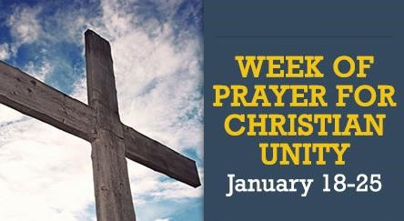
Deanery Service
All Saints Church Wellington
6.30pm
Sunday 18th January 2026 Everyone Welcome!
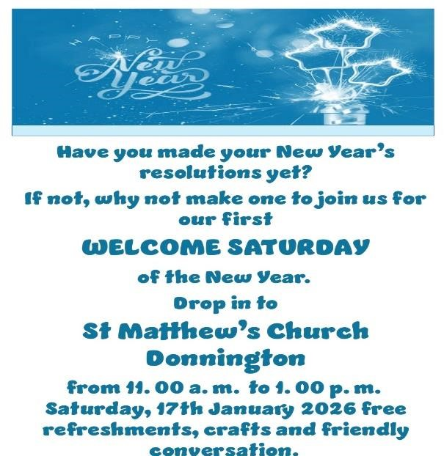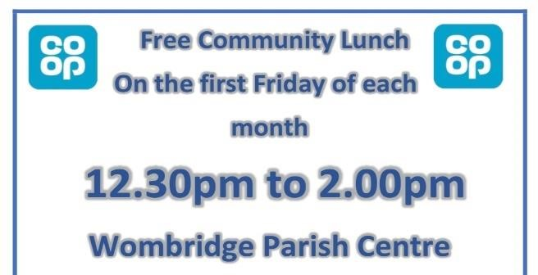

  Compline via Zoom
  As a Benefice we are grateful to Nigel who hosts Compline via Zoom at 8pm on Monday and Friday evenings.
  For more information please contact Nigel at
  Nigelcollins8561@gmail.com
  TOMBOLA STALLS
  
  Each of the churches in the Benefice are always in need of small quality items
  suitable for use on
  Tombola Stalls.
  If you can offer items for these stalls then please pass them to churchwardens who will forward them to the events coordinators for each of the churches.
  Thank You.

 | 
  ST GEORGE’S PRAYER GROUP
  
  The Prayer Group meets on the fourth Wednesday
  of each month between
  7pm & 8pm at St George’s Church.
  The next meeting is on Wednesday 28th
  January and is open for all to attend. During the time together there may be a brief discussion about issues of the day and/or individual concerns and then there is a time of prayer. Sometimes a bible passage is read and following a brief discussion may be used as a focus for additional prayers.

PRAY BAKE READ

PRAY….INTENTIONALLY FOR YOUR LOCAL SCHOOL
BAKE….A CAKE FOR STAFF EVERY HALF TERM
READ ….1:1 WITH A STUDENT ONCE A WEEK
Would you like to support children at The Lantern Academy, Ketley Bank by spending 1-2 hours a week with pupils listening to them read on a 1:1 (Thursday afternoons 1-3pm, Years 1 & 2 infants). Why do we want to do this?
As Christians, the Bible teaches us to love our neighbour. Our church and the many schools in our Benefice are close neighbours in our community and we want to show God’s love to them by serving them in a practical way. It really is that simple.
If you are interested please speak to Julia Ayers, or contact newsletter@easttelfordbenefice.co.uk and your details will be passed to the organiser.

PLACES of WELCOME at HTO, HTWW & St PETERS





This outreach is something which has helped bring our community together and we are always pleased when new people attend. The format is simple – a short service, a shared breakfast/lunch (toast, soup and roll or sandwiches), chat/board games/puzzles/craft etc.

Please do let your friends and neighbours know about these Places of Welcome especially those who live alone or those who are looking for a place to meet new people. You will find a warm welcome at each of these Places of Welcome. We look forward to meeting you!

Please note St Peters meets at: Priorslee Scout HQ, Snedshill Way, TF2 9QQ
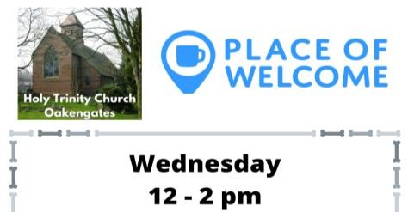

From the Deanery & Lichfield Diocese

Deanery Synod dates for 2026 are as follows: Thurs 23rd April, Wed 15th July & Tues 13th October More details to follow in the February Newsletter


From the Church of England A Prayer for the New Year
God and Father of our Lord Jesus Christ, whose years never fail and whose mercies are new each returning day: let the radiance of your Spirit renew our lives, warming our hearts and giving light to our minds; that we may pass the coming year in joyful obedience and firm faith; through him who is the beginning and the end, your Son, Christ our Lord,
who is alive and reigns with you, in the unity of the Holy Spirit, one God, now and for ever. Amen.

Taken from: www.churchofengland.org/prayer-and-worship/topical-prayers/prayer-new-year


We wish all who worship or live in our Benefice a very Happy, Peaceful & Safe New Year in 2026

