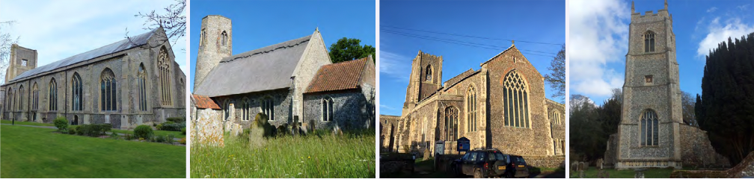

N.E.W.
North Walsham
Edingthorpe
Worstead and Westwick
NEWS
The Magazine for the North Walsham Benefice February 2026 40p
Transformed by Christ: Prayerful, Pastoral, Prophetic

Editor’s Bit

Contents in this issue:
- Vicar’s Page
- From the assistant curate
- Dates from the Diary
- February service Dates
- Upcoming Events
We hope to see you at our services; you are all welcome.

Please note the date for items to go in the March edition of NEWS needs to be at the Parish office by 20th February 2026 latest.

This magazine is published by the North Walsham Benefice. We reserve the right to edit or decline any material submitted for publication. While reasonable efforts are made to ensure that the contents of the magazine are accurate, no responsibility can be taken for errors and omissions or changes after publication. The material printed does not necessarily represent the views of the Benefice. In accepting advertisements for publication, no recommendation of products or services is implied and we cannot accept responsibility for any unsatisfactory transactions.

Financial Information

Please may we remind you, that if you are giving us a cheque for any of the Churches, they need to be made payable to the following:
St Nicholas’ Church – North Walsham PCC
All Saints’ – Edingthorpe PCC
St Mary’s – Worstead PCC
St Botolph’s – Diocesan Churches Trust
Please may we ask if you are sending any payments to us via an online service that you put a meaningful reference on the payment to ensure we know where the payment should go to.

Live-streamed services are available on YouTube - please search St Nicholas North Walsham. Do you participate in our live-streamed services - we would love to hear your feedback: contact David on 07506 723946 or davidnorthwalsham@gmail.com

If you are considering a change to your Committed Giving for St. Nicholas, please inform Chris Sherman (Committed Giving Officer)
Please support St. Nicholas Church, North Walsham on #easyfundraising, you can raise FREE donations when you shop online with over 5,000 retailers. It is simple and only takes 2 minutes to sign up! Plus, once you have raised your first £15, easy fundraising will match it!
Sign up now: https://www.easyfundraising.org.uk/causes/stnicholaschurchnw/

The Vicar’s page:
From David:
February begins with the Feast of Candlemas, as Jesus the Light of the World is presented to the Father for blessing and recognition. We had a good celebration of Christmas at all our churches, with large numbers attending and joining in our worship. In 2025 we were involved in considerably more funerals than the previous year - these figures, and new arrivals in our congregations are sources of hope and encouragement.

At Worstead the new kitchen has been fitted and other works are in progress thanks to the generosity of the Worstead Festival and its grants.

At Edingthorpe, thanks to a generous gift, the west wall will soon be replastered and we shall begin work to fundraise to renew the wiring, lighting and heating in the church - our continued thanks to all who arrange events and fundraising!

At North Walsham, we soon say thank you and farewell as Matthew ends his year as Administrator - not really farewell as he remains as Organist, but we thank him very sincerely for all he has given. We hope soon to be able to renew the speakers in church - these are vital, and the current speakers are hugely outdated and ineffective in large parts of the building. Watch this space!

We give thanks that Dan has returned fully to work and that his injuries were mercifully minor - we look forward to him joining in the full celebration of Lent, Holy Week and Easter as a Deacon.

The Church of England's theme for Lent is 'life-giving holy habits' and we hope that the courses and sessions on offer this Lent will help you to find, renew, or rebuild some of those in your worshipping life.

With my prayers and good wishes,

David

The Curate’s Page

As the first half of my first year with you has ended, I hope you are all used to my presence by now. Nowhere else is the presence of a deacon more visible than at the celebration of the Holy Eucharist. And there are a few special aspects to the ministry of a deacon that differentiate them from a priest. It is not to say that a priest cannot do these things (every priest is and always remains a deacon, not every deacon becomes a priest). So, I thought that for this magazine I will write a bit about these ‘special’ aspects of deacon’s ministry.
The most visible characteristic is the fact that a deacon wears a stole across hers/his shoulder. This is a sign that is there to remind a deacon of their duty to serve the needs of the Church and the world. This tradition goes back all the way to Jesus and His washing the disciples’ feet. He took a towel, which He put across his shoulder/around His waist to dry the washed feet. As we read in the Ordinal: ‘... as he washed the feet of his disciples, so they must wash the feet of others.’
The second aspect of a deacon’s ministry is the reading of the Gospel. This is one of the first charges those who are to be ordained deacon receive from the bishop: ‘They are to proclaim the gospel in word and deed, as agents of God’s purposes of love.’
The third most visible aspect of a deacon’s ministry, especially at the celebration of the Holy Eucharist, is the preparation of the altar. This goes back to the aspect and character of service. Deacon is there to help the priest in preparing the altar, to represent Christ’s servant ministry. As a deacon receives the gifts from people and sets up the altar, she/he embodies the role of a servant towards a priest and symbolise the connection between the altar and the needs of the world and her people.
This is why whenever I am present at the Eucharist, it will always be me who reads the Gospel and prepares the altar, as a sign of fulfilling my ministry as a deacon (even though currently my fractured knee stops me from jumping up and down the altar steps).
The same happens when, in some churches, there is a tradition of a liturgical deacon. In this instance, it is another priest who, for this particular celebration, changes the stole from wearing it on the neck to wearing it on the shoulder and ministers in the ways explained above. Because, as we are used to say, once a deacon, ALWAYS a deacon.

With every blessing and all my prayers,
Dan

Edingthorpe Village news for February
All Saints Church, Edingthorpe.
Services
14th February 9.15 a.m. Holy Communion
18th February, Ash Wednesday 12:30 p.m. Holy Communion
28th February. 9.15 a.m. Morning Prayer

Our thoughts and prayers are with the family of Audrey Rump who passed away in November. Her daughter has sent us memories of her life which is printed below.
Our Annual Christmas Fayre held in December made over £1400. towards Edingthorpe Church. We decided to hold it on a Thursday this year and many peopled supported us. Thanks once again to all who helped in any way to make it such a successful event.
We held our Carol Service on the 21st December. It was lovely to see the Church full in preparation for the celebration of Christmas. Having the Choir and organist from St. Nicholas made it even more special.
We would like to thank all who attended our Midnight Mass on Christmas Eve. The Church looked beautiful. Thank you to the organists playing at this service.
Chris and Karen will be holding a Coffee Morning on the 2nd Thursday of each month. We welcome your support.
Sunday 15th February we are having a SNOWDROP WALK. 11 a.m. to 2 p.m. Find out “Fun Facts” about Snowdrops and meet the Conservation team. Light refreshments and homemade soup available in the Church.
All events and information about the Church are available on the website:
https://www,achurchnearyou,com/church/10076/ or the village website: www.edingthorpe.village.org.uk
June Hannant 01692 402337

Audrey Rump
Audrey Rump, long-term resident of Edingthorpe, died on 23 November 2025 at the Manor House Residential Care Home, aged 93.
In 1952, Audrey married Bob Rump and began married life at Clay Lane Cottage, Edingthorpe, where they lived happily until Bob’s death in 2003. After Audrey suffered a stroke, she continued to live at Clay Lane Cottage, supported by her 3 daughters, until the house had to be vacated and demolished.
During her life at Clay Lane Cottage, Audrey took great pleasure in tending her flower garden, walking in the village and visiting friends. She played an active part in village life, delivering parish magazines, decorating the church with dahlias grown by Bob and attending church fund-raising events. She will be sadly missed by all who knew her.
A message from Audrey’s daughters, Rosemary, Susan and Jean:
Thank you to everyone who contributed to mum’s beautiful funeral service. We would especially like to thank Rev David Warner and the organist, Murrell Cork Funerals, Chris and his team of volunteers who provided delicious refreshments and to everyone who sent messages and cards of condolence, including generous donations for Edingthorpe PCC. Thank you everyone for braving the inclement weather and icy roads. Mum would have been so proud to see her “Church on the Hill” beautifully decorated with flowers and full of friends, neighbours and family, sharing fond memories of her long and happy life.

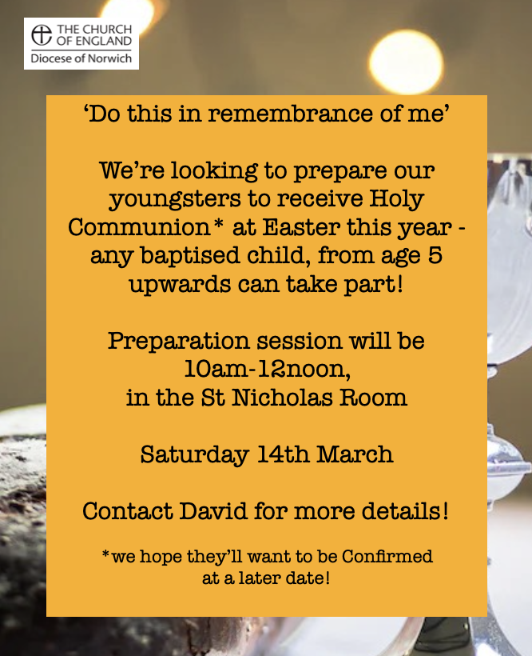
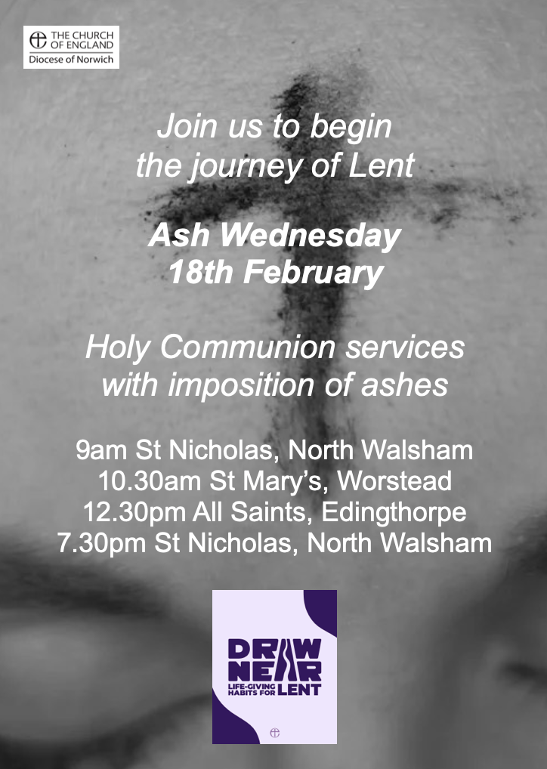

Life Giving Holy Habits, led by David & Dan
27th Feb - 'Forty days and forty nights ' - How does faith shape times and seasons?
5th Mar - 'Tis good Lord, to be here' - What does church design tell us about our faith?
12th Mar - 'Reclothe us in our rightful mind' - Does what we wear help us to do what we do?
19th Mar - 'Seven whole days not one in seven, I will praise thee...' How can we pray every day (not just Sundays!)?
26th Mar - 'Were you there when they crucified my Lord?' - Why are each of us part of the story of Holy Week and Easter?
Held in the St Nicholas Room, each session begins at 7pm with a welcome cuppa, then a talk and questions, ending with the short service of Compline, and our time together by 8.30pm. All welcome to any and all sessions!
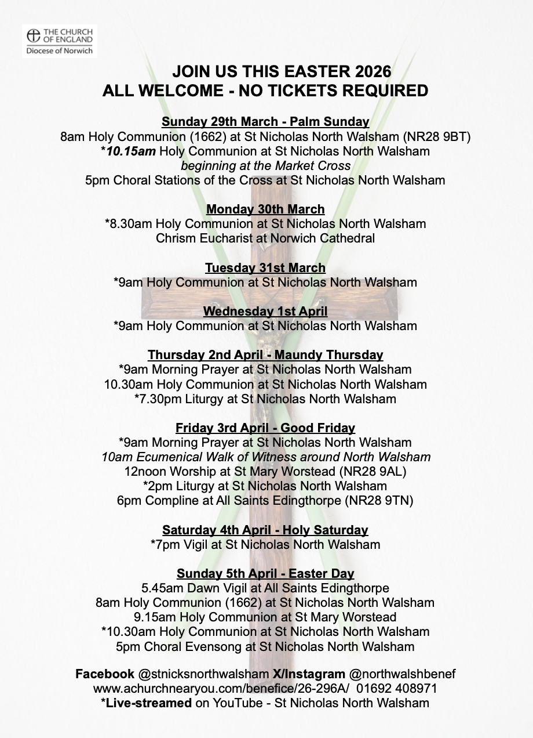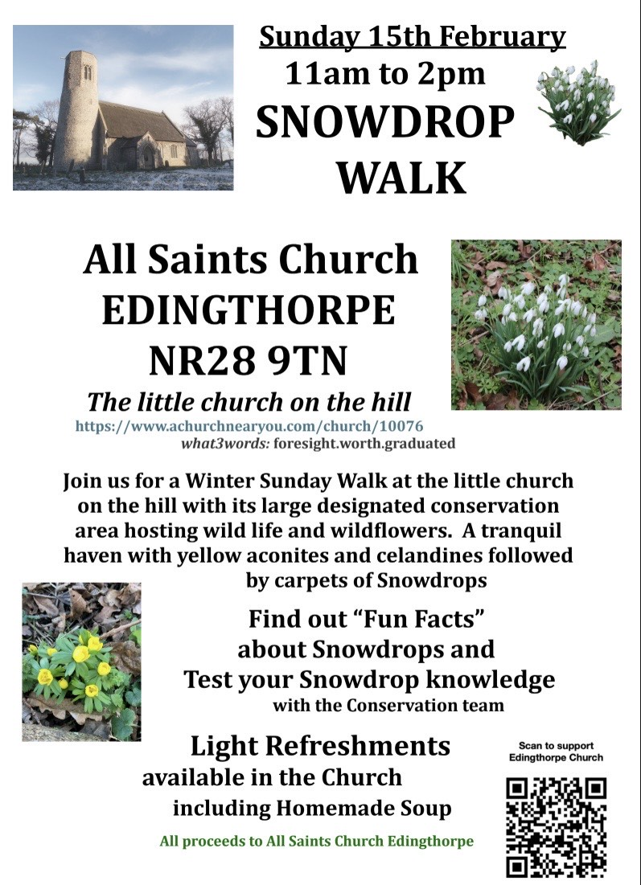

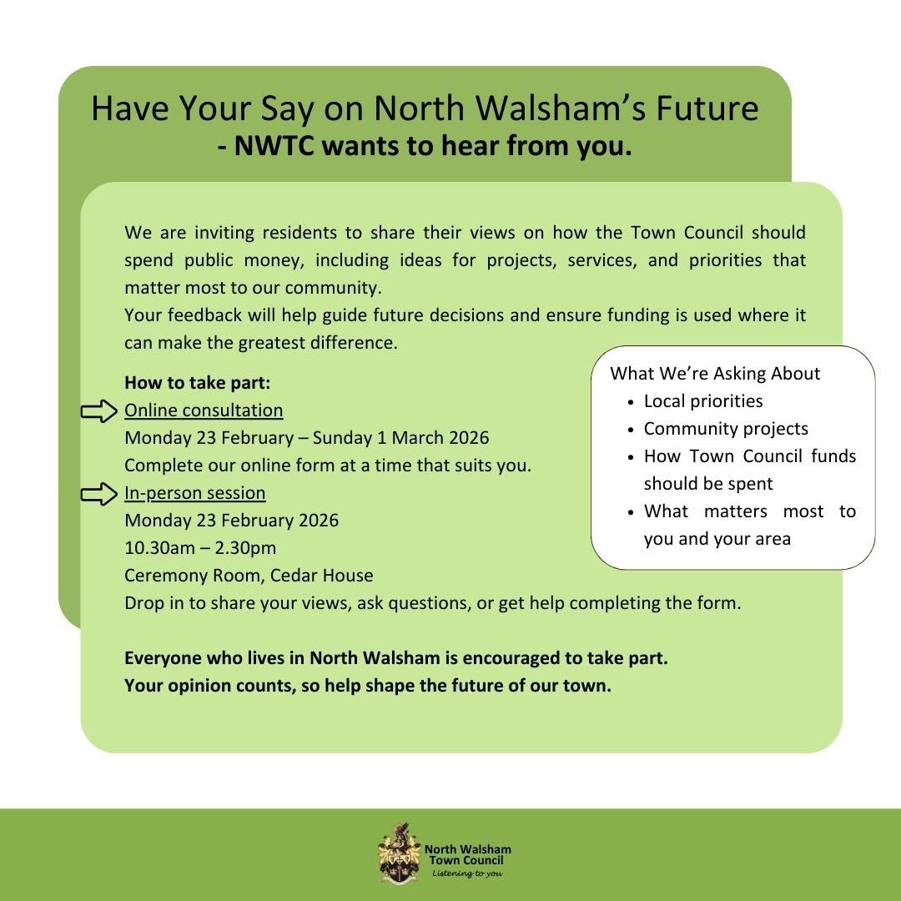
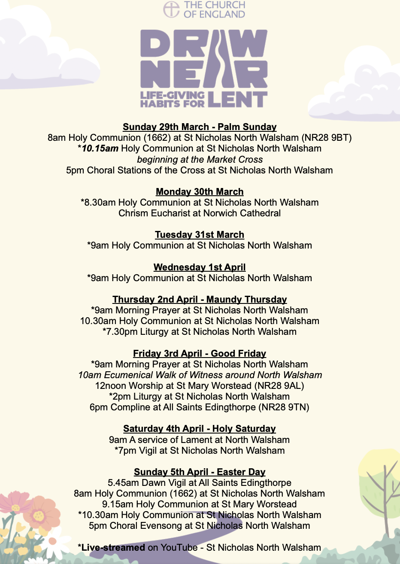

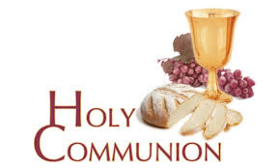
You may have read items in the press relating to the use of 'gluten free' wafers at Holy Communion - for those who require them, we use wafers which are approved and recommended for use by Coeliac UK - more information here. If you need a gluten free wafer, please advise the churchwardens/welcomers when you arrive for the service, and please indicate to the clergy distributing Holy Communion.
The Church teaches that receiving Holy Communion in both kinds (wafer and wine), or in one kind (the wafer or the wine) are acceptable and contain the fulness of the Sacrament. There are many reasons why this will be the case at different times in our lives, and there will be times when we cannot physically receive but join in an Act of Spiritual Communion (as those who watch online do - see below).

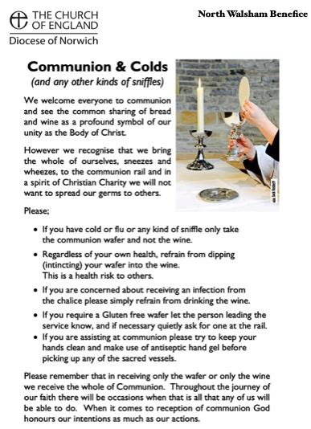
​Intinction (that is, dipping your wafer into the wine) is not permitted, both for hygiene reasons and because it might introduce gluten to the wine, which could be consumed by someone who is allergic to it.
If you wish to discuss any of this, please speak to David.

An Act of Spiritual Communion
In union, O Lord, with the faithful at every altar of your Church, where the Holy Eucharist is celebrated, I desire to offer you praise and thanksgiving. I present to you my soul and body with the earnest wish that I may always be united to you. And since I cannot now receive you sacramentally, I ask you to come spiritually into my heart.
I unite myself to you and embrace you with all the affections of my soul. Let nothing ever separate you from me. May I live and die in your love. Amen.



Why not come along to Sunday Kids and find out how to learn about what we do? We meet on the 1st and 3rd Sunday of the month at St Nicholas Church during the 10.30am service. You are most welcome.

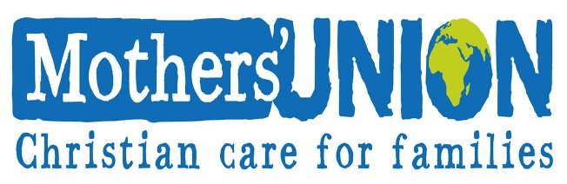

North Walsham Mothers’ Union. We meet in St Nicholas Room on the second Tuesday of the month at 2.00 p.m. Following a short act of worship and a few notices our speaker then takes the floor, after which, over tea and biscuits, there is an opportunity to ask questions and socialise. We usually finish about 3.30 pm.
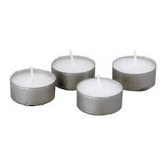
Thanks to all who’ve provided tealights for prayer stations at St Nicholas!
All donations of white, unscented tealights gratefully received!

Services for February 2026

Saturday 31st January
11am Baptism of James Warner at Worstead
Sunday 1st February - Candlemas
8am Holy Communion (1662) at North Walsham
9.15am Morning Prayer at Worstead
10.30am Holy Communion at North Walsham
4pm Choral Evensong at Westwick
Monday 2nd February
9am Morning Prayer at North Walsham
Tuesday 3rd February
9am Morning Prayer at North Walsham
Wednesday 4th February
9am Morning Prayer at North Walsham
Thursday 5th February
9am Morning Prayer at North Walsham
9.30am Market Day coffee morning in the St Nicholas Room
10.30am Holy Communion at North Walsham
Friday 6th February
9am Morning Prayer at North Walsham
9.30am Quiet Prayer at North Walsham
Sunday 8th February - 2nd before Lent
8am Holy Communion (1662) at North Walsham
9.15am Holy Communion at Edingthorpe
10.30am Holy Communion at North Walsham
2.30pm Air Cadets’ service at North Walsham
Monday 9th February
9am Morning Prayer at North Walsham
Tuesday 10th February
9am Morning Prayer at North Walsham
2pm Mothers’ Union, St Nicholas’ Rooms, North Walsham
Wednesday 11th February
9am Morning Prayer at North Walsham
Thursday 12th February
9am Morning Prayer at North Walsham
9.30am Market Day coffee morning in the St Nicholas Room
10.30am Holy Communion at North Walsham
Friday 13th February
9am Morning Prayer at North Walsham
9.30am Quiet Prayer at North Walsham

Sunday 15th February - Next before Lent
8am Holy Communion (1662) at North Walsham
9.15am Holy Communion at Worstead
10.30am Holy Communion at North Walsham
5pm Evening Prayer at North Walsham
Monday 16th February
9am Morning Prayer at North Walsham
Tuesday 17th February
9am Morning Prayer at North Walsham
Wednesday 18th February - Ash Wednesday
9am Holy Communion at North Walsham
10.30am Holy Communion at Worstead
12.30pm Holy Communion at Edingthorpe
7.30pm Holy Communion at North Walsham
all these services will include the imposition of ashes
Thursday 19th February
9am Morning Prayer at North Walsham
9.30am Market Day coffee morning in the St Nicholas Room
10.30am Holy Communion at North Walsham
Friday 20th February
9am Morning Prayer at North Walsham
9.30am Quiet Prayer at North Walsham
Sunday 22nd February - 1st of Lent
8am Holy Communion (1662) at North Walsham
9.15am Morning Prayer at Edingthorpe
10.30am Holy Communion at North Walsham
5pm Evening Prayer at North Walsham
Monday 23rd February
9am Morning Prayer at North Walsham
Tuesday 24th February
9am Morning Prayer at North Walsham
Wednesday 25th February
9am Morning Prayer at North Walsham
Thursday 26th February
9am Morning Prayer at North Walsham
9.30am Market Day coffee morning in the St Nicholas Room
10.30am Holy Communion at North Walsham
Friday 27th February
9am Morning Prayer at North Walsham
9.30am Quiet Prayer at North Walsham

Sunday 1st March - 2nd of Lent
8am Holy Communion (1662) at North Walsham
9.15am Morning Prayer at Worstead
10.30am Holy Communion at North Walsham
5pm Evening Prayer at North Walsham
Monday 2nd March
9am Morning Prayer at North Walsham
Tuesday 3rd March
9am Morning Prayer at North Walsham
Wednesday 4th March
9am Morning Prayer at North Walsham
Thursday 5th March
9am Morning Prayer at North Walsham
9.30am Market Day coffee morning in the St Nicholas Room
10.30am Holy Communion at North Walsham
Friday 6th March
9am Morning Prayer at North Walsham
9.30am Quiet Prayer at North Walsham

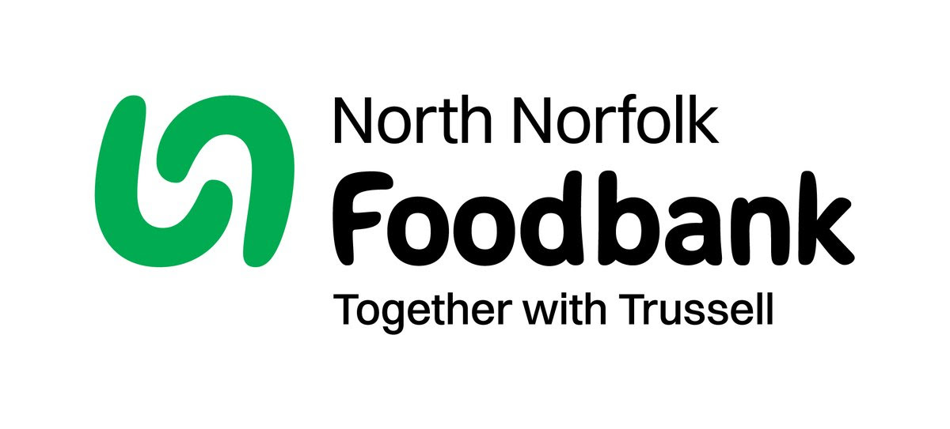Dear Harvest Festival Donors

Thank you for your generous Harvest Donations of 52.60 kg, we do appreciate it.
As we rely on food and financial donations to operate, we are extremely grateful when people choose to support us. So, thank you for thinking of us and enabling us to serve people facing hardship across North Norfolk.
In 2024/25 we fed 4520 people. Thanks to the generosity of our donors, we are able to provide clients with everything they need, with 50,349kg of stock coming in, which was down on the previous year.
Financial donations are always welcome. Please see our website for details https://northnorfolk.foodbank.org.uk/give-help/

Once again thank you so much for your generous donations.

Kind regards,

Julie Hunter Jennings
Foodbank Manager
North Norfolk Foodbank
07826 376343

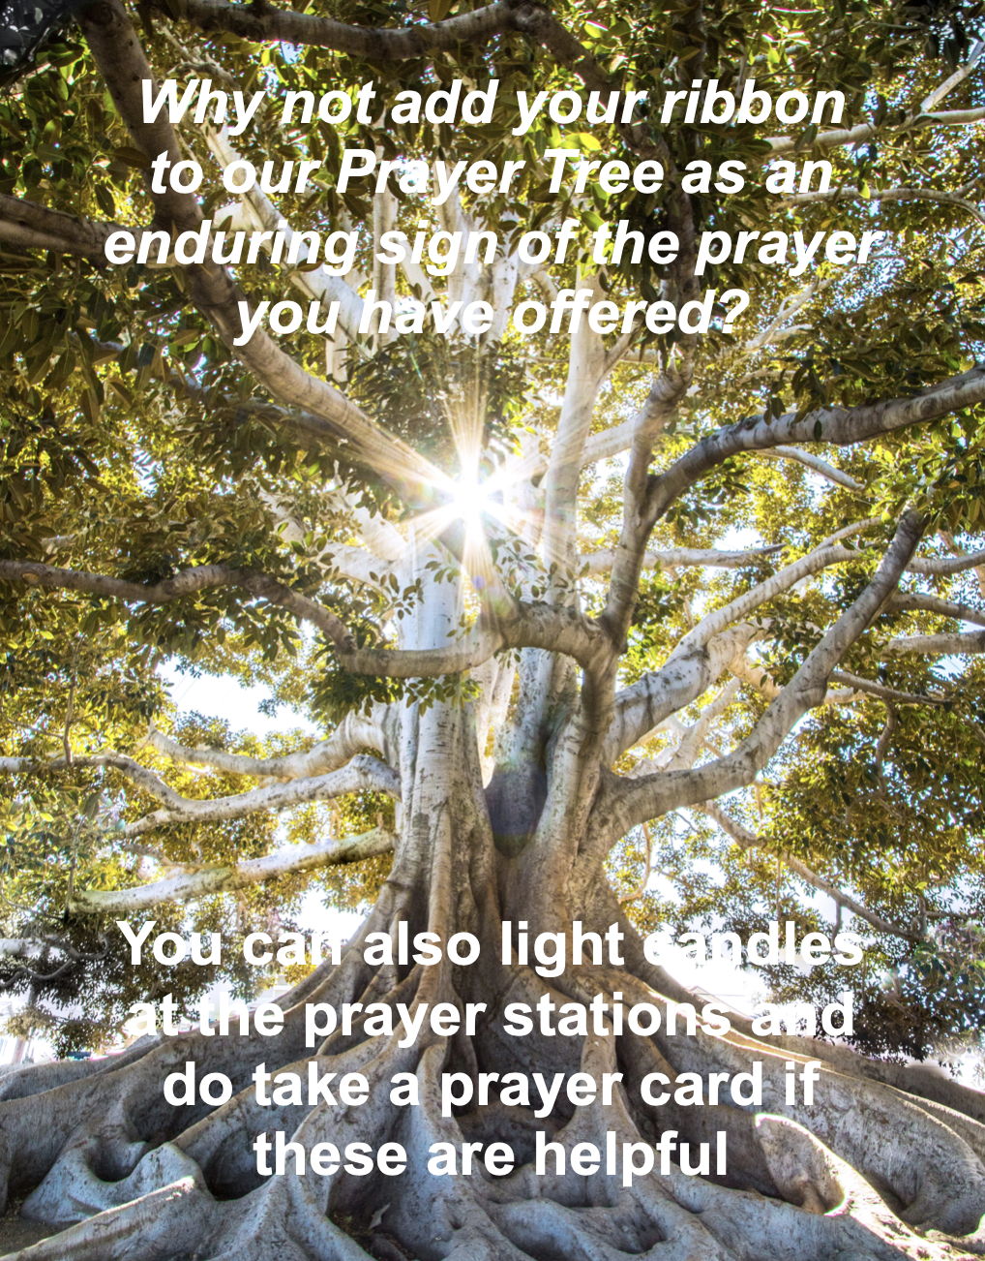

We are privileged to hold special
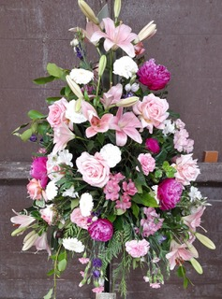
services at any of our churches
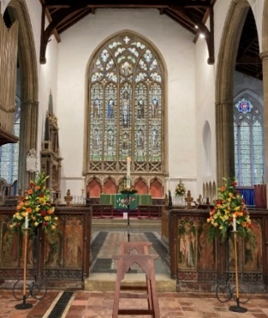
All who live in the benefice are entitled to a baptism, wedding or funeral service in church, and our clergy can officiate at the crematorium and cemeteries too. The church is here for you, through every moment of life.
************************************************************************************


Dates from the Diary

Baptisms

31st January James Benedict Rex Warner - St Mary's

Funerals
December 2nd Charles Sadler - St Nicholas
December 5th Dennis Leslie Lee - Cromer Crematorium
December 12th Thomas Edward Alan Strivens - St Nicholas
7th January Audrey May Rump - All Saints
13th January Joyce Olga Alley - St Nicholas

30th November Sienna Gabriel, Yasmin Gabriel and Daniel Gabriel - St Mary's

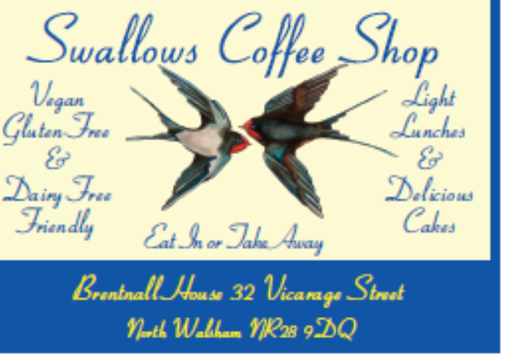




We're pleased that our weekly coffee mornings at North Walsham and Worstead are now registered with Warm Welcome Spaces
North Walsham Market Day Coffee Morning
Thursdays 9.30 – 12.00noon
The space is open to all (and their well-behaved dogs on leads), every Thursday! A warm welcome and refreshments available

Thank you to everyone for raising donations for St. Nicholas Church, North Walsham with #easyfundraising! If you have not signed up yet, it is easy and completely FREE. 8,100 brands will donate to us when you use easy fundraising to do your everyday online shopping - at no extra cost to you! Every donation you raise makes a difference to us so please sign up & share today. https://join.easyfundraising.org.uk/stnicholaschurchnw/XT7MPH/at/TSX8RX7z/RTND2/facebook/
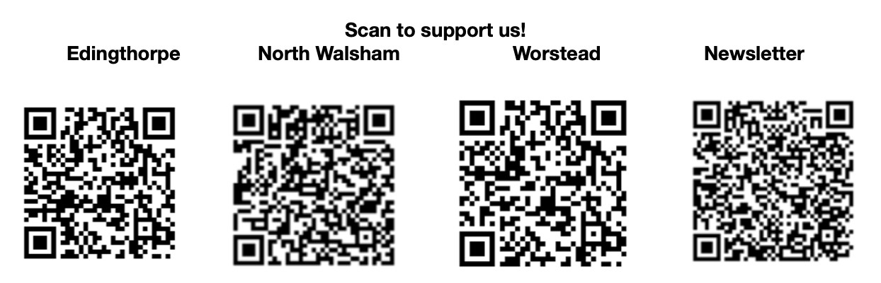


Please support the work of our Churches, by using the contactless giving point at St Nicholas or St Mary’s, leaving your gift on the offering plates or in the wall safes, or through these QR codes. Thank you.

Do you have a Business you would like to advertise in this magazine?
Whole, half or quarter page space is available.
Full Page £ 150.00
Half Page £ 75.00
Quarter Page £ 50.00
Please contact the Benefice office on 01692 408971
or email saintnicholasnw@gmail.com
for details and prices

Church Postcodes
Edingthorpe NR28 9TN, North Walsham NR28 9BT, Worstead NR28 9AL, Westwick NR10 5BW

Benefice dates

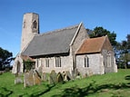
All Saints’ Edingthorpe
14th February 9.15 a.m. Holy Communion
18th February, Ash Wednesday 12:30 p.m. Holy
Communion
28th February. 9.15 a.m. Morning Prayer
Prayer

St. Mary’s, Worstead

1st February 9:15 a.m. Morning Prayer

18th February, Ash Wednesday 9:15 a.m. Holy Communion

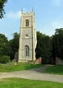
St Botolph’s Westwick

1st February 4 p.m. Choral Evensong

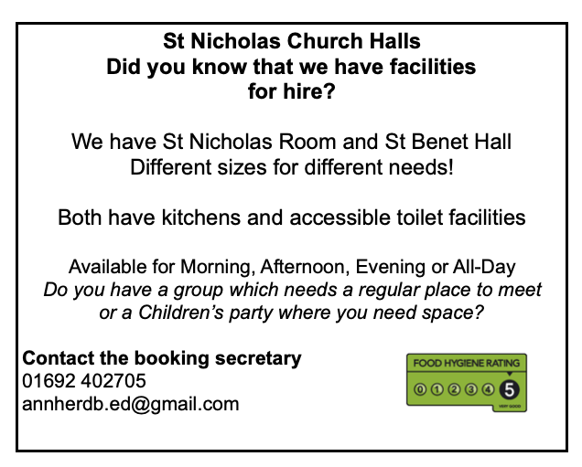
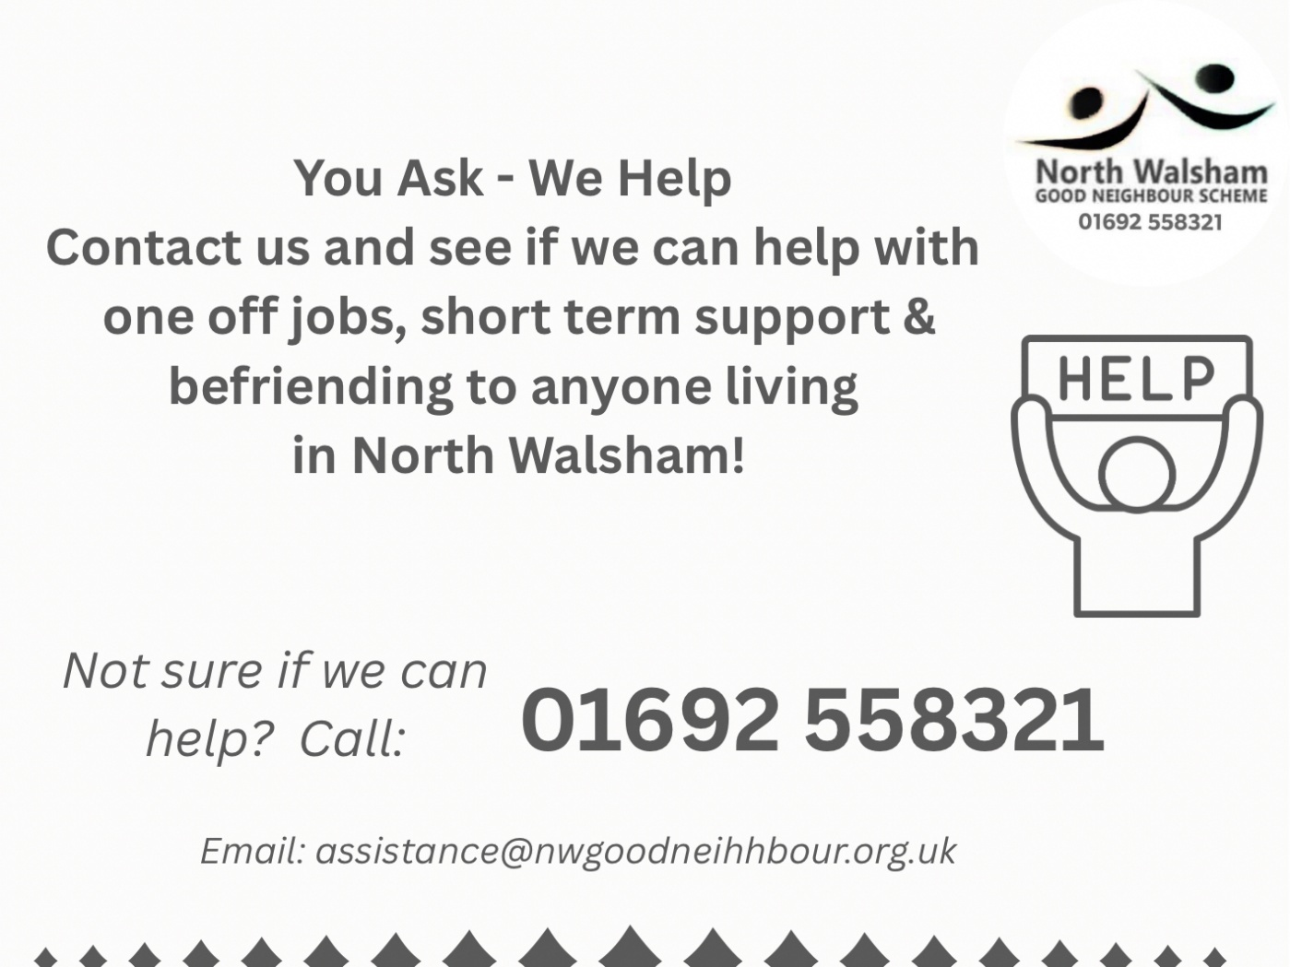

Ready to tick off your list – Will Made?

"The Church of England have teamed up with Farewills to provide a free will writing service: Online Will Writing Service | Legal Will In 15 Minutes . Anyone can use this service and it is not compulsory to leave something to your church, but it would be nice if you did. It is important for each one of us to leave our earthly matters in good order so why not take advantage of this opportunity now? It is good to remember a gift in your will to a charity is tax free. If you already have a will, you could consider leaving a legacy to the church by adding a codicil. https://farewill.com/norwich-diocese

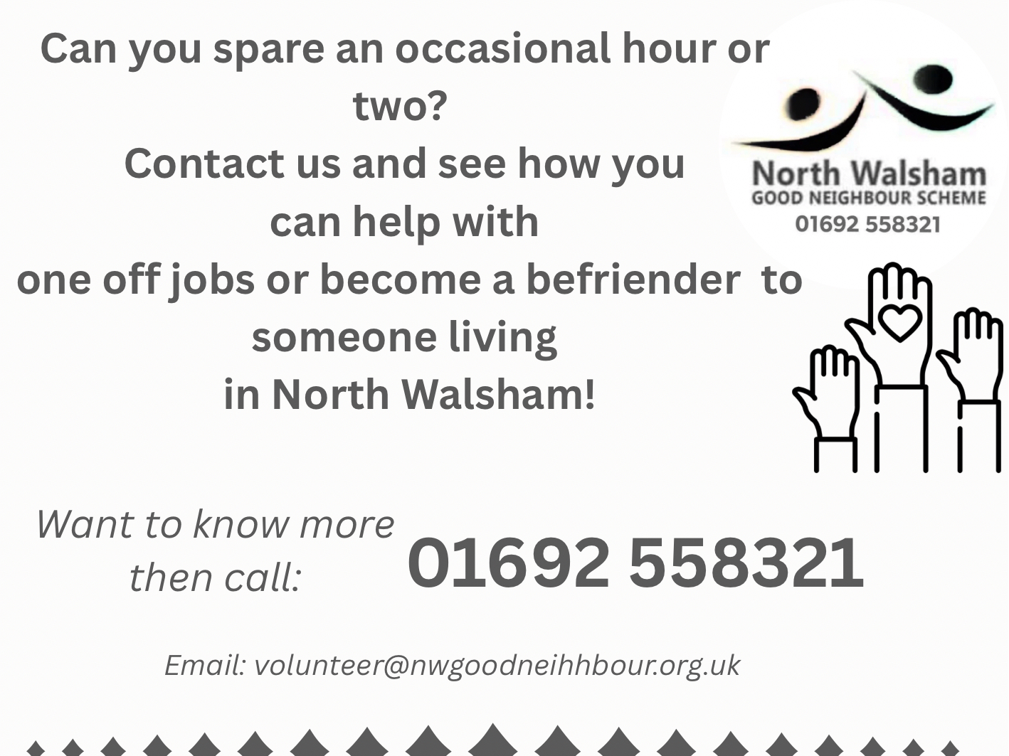

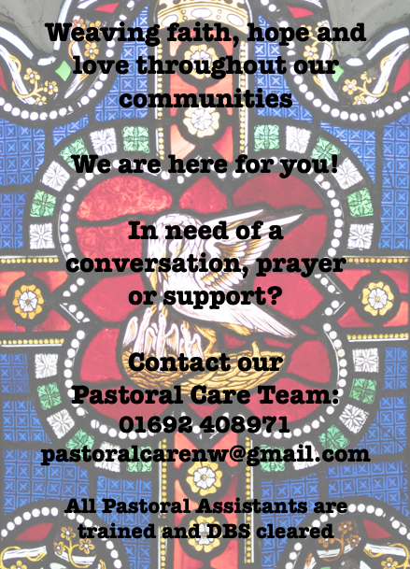

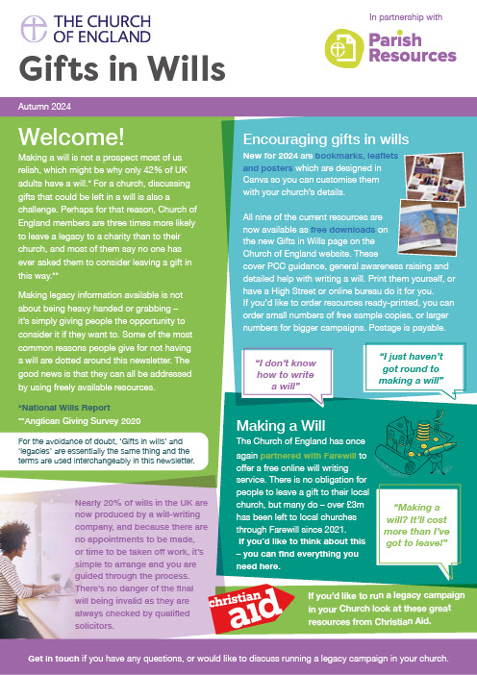
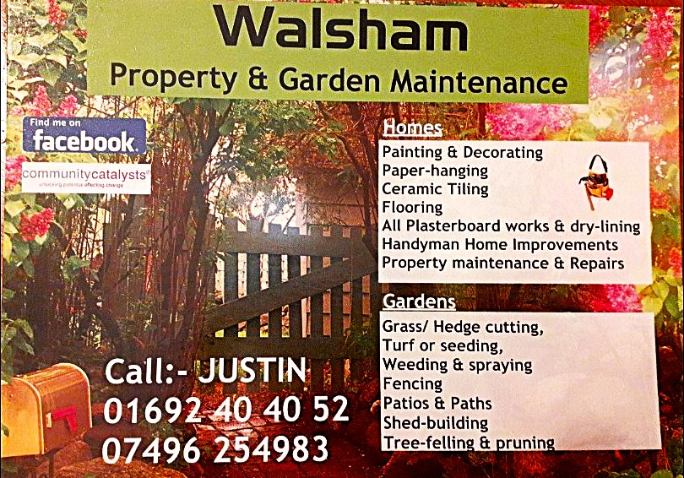

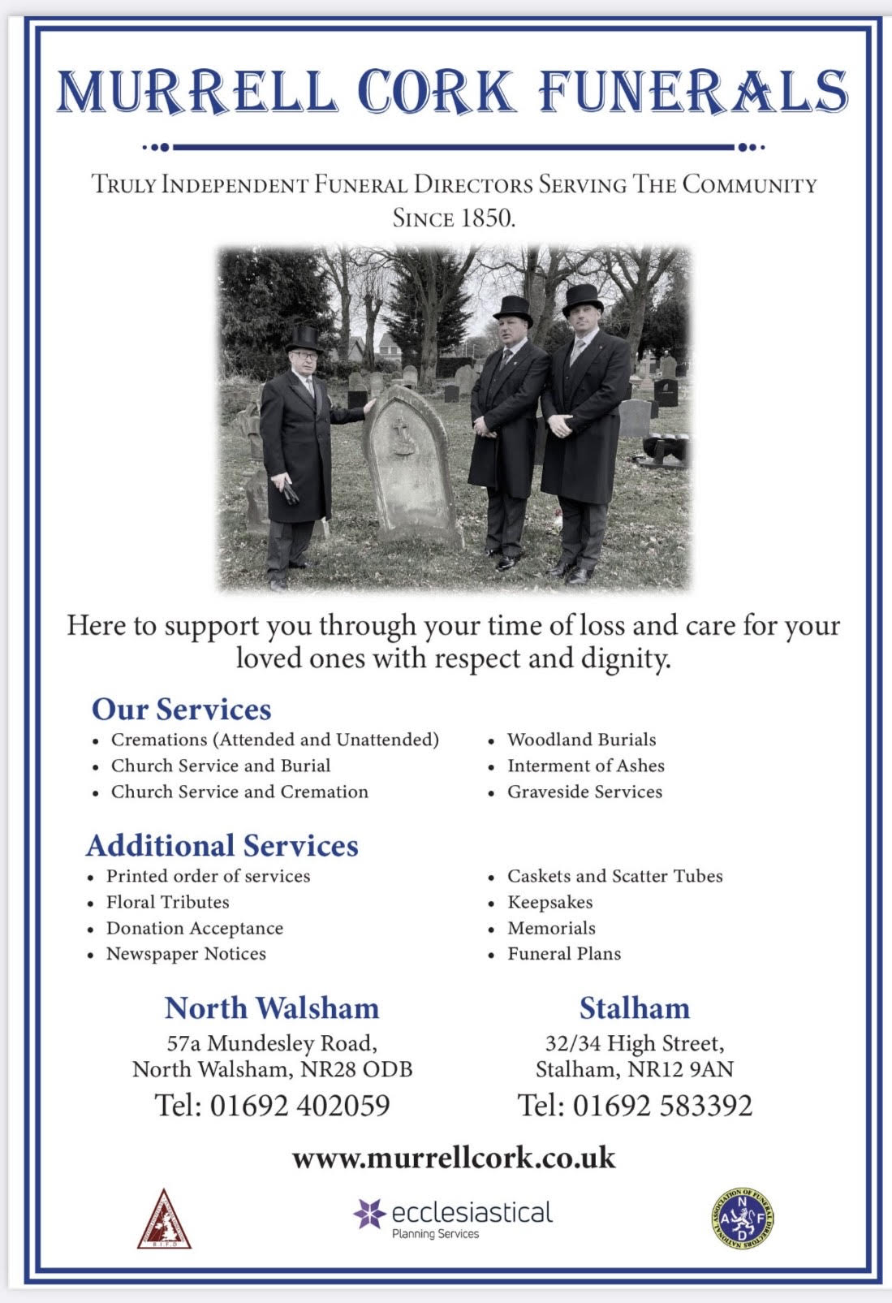
r Sale and Wants Page




Money Matters …
A regular report for our readers written by James Reginald Drake at ClearView Financial Consultants
Burgh Road, Aylsham - 01263 734859, Station Road, Hoveton - 01603 273590 and North Walsham 07773 626662

Lasting Powers of Attorney – Why are they so Important?
Lasting Powers of Attorney (LPA’s) are documents that give an individual you trust (your attorney) the legal authority to make decisions on your behalf should you either lose the mental capacity to make them, or you no longer wish to make these decisions yourself. Lasting Powers of Attorney come in 2 forms, these coming under the heading of ‘Property & Financial Affairs’ and ‘Health & Welfare’
So, how can they help?
The Property & Financial Affairs LPA covers things such as running your bank and savings accounts, making or selling investments, paying bills, buying or selling property and applying for benefits.
The Health & Welfare LPA covers things such as the type of health care and medical treatment you receive (including decisions on life sustaining treatment), where you live, as well as the type of care that you receive in areas such as diet and daily routine.
Given the wide range of areas that these documents cover, it becomes quite obvious as to why they are so important. However, according to ‘The Office of the Public Guardian’ via an article produced in 2022, less than 1% of the UK population have a Lasting Powers of Attorney in place.
So, why do so few people have them in place? One of the most commonly mentioned reasons is that people assume that their spouse will automatically have the right to make decisions for them should they ever reach the stage where they are unable to. This however is a common misconception and it is very often discovered far too late that they actually have no legal authority at all. Cost is another reason people put it off, I can assure you are costs for this type of work are minimal, in the hope this is not a reason to delay.
What should you do?
Well, the answer to this one is quite simple……. get on and set up both types of LPA as soon as you can. It is never too soon to set one up, but it certainly can be too late. By law, once your mental capacity has gone, so has your opportunity to appoint attorneys to act on your behalf. At this point your loved ones will be required to go down a different route and apply to the Court of Protection for a Deputyship order. This requires more forms, more cost and more time, which can all be easily avoided with a bit of forward planning.
So, if setting up Lasting Powers of Attorney(s) is something that you think would benefit you and your loved ones, please feel free to contact me and we can discuss how they can be put in place in a way that is best suited to your own personal requirements.
This short article in no way should be taken by readers as advice.
James can be contacted on either of the above landline numbers or via email at support@smithifa.co.uk
ClearView Financial Consultants is a trading name of Martin Smith Independent Financial Adviser Ltd, a company registered in England
under number 11439150 and authorised and regulated by the Financial Conduct Authority under number 944677.



