SUNDAY READING SHEET 25th January 3rd Sunday of Epiphany

A Reading from the Acts of the Apostles

Meanwhile Saul, still breathing threats and murder against the disciples of the Lord, went to the high priest and asked him for letters to the synagogues at Damascus, so that if he found any who belonged to the Way, men or women, he might bring them bound to Jerusalem. Now as he was going along and approaching Damascus, suddenly a light from heaven flashed around him. He fell to the ground and heard a voice saying to him, “Saul, Saul, why do you persecute me?” He asked, “Who are you, Lord?” The reply came, “I am Jesus, whom you are persecuting. But get up and enter the city, and you will be told what you are to do.” The men who were traveling with him stood speechless because they heard the voice but saw no one. Saul got up from the ground, and though his eyes were open, he could see nothing; so they led him by the hand and brought him into Damascus. For three days he was without sight and neither ate nor drank. Now there was a disciple in Damascus named Ananias. The Lord said to him in a vision, “Ananias.” He answered, “Here I am, Lord.” The Lord said to him, “Get up and go to the street called Straight, and at the house of Judas look for a man of Tarsus named Saul. At this moment he is praying, and he has seen in a vision a man named Ananias come in and lay his hands on him so that he might regain his sight.” But Ananias answered, “Lord, I have heard from many about this man, how much evil he has done to your saints in Jerusalem, and here he has authority from the chief priests to bind all who invoke your name.” But the Lord said to him, “Go, for he is an instrument whom I have chosen to bring my name before gentiles and kings and before the people of Israel; I myself will show him how much he must suffer for the sake of my name.” So Ananias went and entered the house. He laid his hands on Saul and said, “Brother Saul, the Lord Jesus, who appeared to you on your way here, has sent me so that you may regain your sight and be filled with the Holy Spirit.” And immediately something like scales fell from his eyes, and his sight was restored. Then he got up and was baptized, and after taking some food, he regained his strength. For several days he was with the disciples in Damascus, and immediately he began to proclaim Jesus in the synagogues, saying, “He is the Son of God.” All who heard him were amazed and said, “Is not this the man who made havoc in Jerusalem among those who invoked this name? And has he not come here for the purpose of bringing them bound before the chief priests?” Saul became increasingly more powerful and confounded the Jews who lived in Damascus by proving that Jesus was the Messiah. Acts 9:1-22

GOSPEL

Peter said in reply, “Look, we have left everything and followed you. What then will we have?” Jesus said to them, “Truly I tell you, at the renewal of all things, when the Son of Man is seated on the throne of his glory, you who have followed me will also sit on twelve thrones, judging the twelve tribes of Israel. And everyone who has left houses or brothers or sisters or father or mother or wife or children or fields for my name’s sake will receive a hundredfold and will inherit eternal life. But many who are first will be last, and the last will be first. Matthew 19:27-30

Royston Parish Church
Where all are welcome and God’s love is shared
Sunday 25th January 2026 - 3rd Sunday of Epiphany

If you would like regular copies of the Notice Sheet emailed to you please email the Parish Office at admin@roystonparishchurch.org.uk

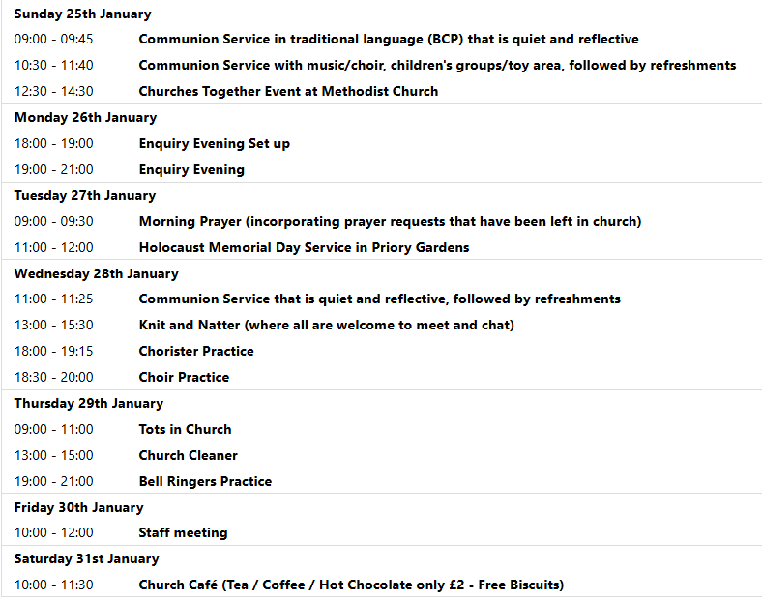
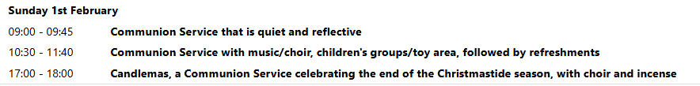

We pray for all Christians worldwide:
For all Christians in Cyprus, Greece, Türkiye
For all who are worship at Royston Parish Church and the Ministry Team
For the work of our mission partners: Royston Home Start
Pray for the community of Royston:
For our local health centres
For all who volunteer and make usr of The Barn
We pray for our world and ECO projects:
We pray for people participating in the Big Garden Birdwatch taking place this weekend. We pray for the habitats of our birdlife.

We pray for the sick and suffering:
4th January 11th January 18th Janury 25th December
Lee Cockerill Chris Christou Val Brown Peter Coates Pat Pritchard Paul & Pat Tidey Angie & Ken Rushall Emma & Phil Heath Jackson Herbert Mike Brown Paula Walker Peter Foster Marion Keith & Elaine Edwards Gwen Simmons
Laura O’nyamul (On-Ya-Mul) Maria Turi Katie
Margaret Green

We pray for those who have died in the faith of Christ:
Deceased | Bereaved
Harry McDonald | Ruth, Family and friends
Jamie Covington | Adam and Samantha Covington, family and friends

We pray for those whose anniversaries fall at this time:
Janet Heathfield

NOTICES

BASIC AWARENESS SAFEGUARDING COURSE Three years ago, after the church re-opened, we ran a Basic Awareness Safeguarding Course for anyone who was unable to access the training online and would find it easier to come along to the church to do the training as a group. For some people it is now time to renew their training after three years, for others it will be the first time. This is a relaxed, non threatening way for everyone to join together and learn how we can, as a church, keep everyone safe whether it is children or vulnerable adults. If you would like to take advantage of this opportunity we will be running the course on Monday 23rd February 2026 at 9.30 am in church. Please let me know if you would like to join us.
Alison Bailey, Parish Safeguarding Officer, 01763 250637, safeguarding@roystonparishchurch.org.uk

QUIZ RAFFLE: We are having a small raffle at the quiz on Saturday 14th February and are looking for contributions for this. At the back of the Church is a list of items that we need, if you feel able to contribute please cross off an item.
The hampers will be made up on the morning of the quiz so please bring items before then, thank you.
Looking forward, we will also be looking for donations of Easter eggs for the egg hunt on Easter Sunday, 5th April and chocolate items for a chocolate tombola at the Book Fayre, 2nd and 4th May. We are happy to take these at any time from now on so we can take advantage of any offers.
Please leave all items in the kitchen. As always we ask that all food items have good dates on them as we cannot include out of date items!
Thank you so much, the Events Committee.

LINK TO HOPE SHOEBOX APPEAL 2025 We want to say a heartfelt thank you to everyone who took part in the 2025 Shoebox Appeal. Thanks to your incredible support, 25,281 shoeboxes were sent to families and elderly people across Eastern Europe. Each box carried not only practical items, but also a powerful message of care, dignity and hope. For many recipients, these shoeboxes arrived at a time of great need, and were a reminder that they are not forgotten. We yet again were able to send a large amount of shoeboxes to Ukraine, where they have been safely distributed.

UPCOMING EVENTS :There are a number of events coming up over the next few months to look forward to.
Join us for an evening with GUY STAGG Monday, February 9th, 7.30pm, Royston Parish Church. Bow Books are delighted to welcome local author Guy Stagg to Royston Parish Church, where he will discuss his award-winning non-fiction books, The Crossway and The World Within, illustrated with slides. Tickets £5 per person (includes first drink free) available from Bow Books. Please see leaflet for more information.

18th April - Cheese and wine evening 2nd & 4th May - Book Fayre 19th June - Hymns and PIMM’ s
20th June - Concert

QUIZ NIGHT:Saturday 14th February, 7 for 7.30 pm, Venue: Royston Parish Church, teams of up to 8, £8 per person. If you wish to register a team or interest in joining a team, please contact Duncan Rodgers email: duncanrodgers66@gmail.com
Licensed bar, bring your own nibbles, opportunity to enter a raffle on the night. All proceeds in aid of church funds.


If you wish to make a donation to the church, then please hold your phone’s
camera over this image then touch the link that appears:

