Psalm 40: 1 to 12
Please stand, if able, and join in the verses in bold

I waited patiently for the Lord;
he inclined to me and heard my cry.
He drew me up from the desolate pit, out of the miry bog,
and set my feet upon a rock, making my steps secure.
He put a new song in my mouth, a song of praise to our God.
Many will see and fear, and put their trust in the Lord.

Happy are those who make the Lord their trust,
who do not turn to the proud, to those who go astray after false gods.
You have multiplied, O Lord my God, your wondrous deeds and your thoughts towards us; none can compare with you.
Were I to proclaim and tell of them, they would be more than can be counted.

Sacrifice and offering you do not desire,
but you have given me an open ear.
Burnt-offering and sin-offering you have not required.
Then I said, ‘Here I am;
in the scroll of the book it is written of me.
I delight to do your will, O my God;
your law is within my heart.’

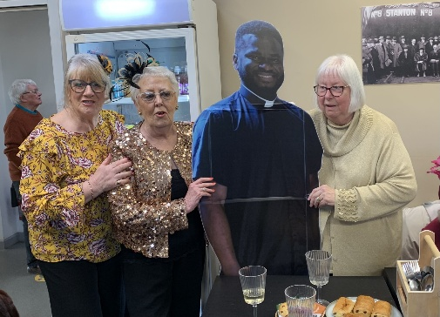
I have told the glad news of deliverance in the great congregation;
see, I have not restrained my lips, as you know, O Lord.
I have not hidden your saving help within my heart,
I have spoken of your faithfulness and your salvation;
I have not concealed your steadfast love and your faithfulness
from the great congregation.

Do not, O Lord, withhold your mercy from me;
let your steadfast love and your faithfulness keep me safe for ever.
For evils have encompassed me without number;
my iniquities have overtaken me, until I cannot see;
they are more than the hairs of my head, and my heart fails me.

Glory be to the Father and to the Son and to the Holy Spirit,
as it was in the beginning, is now and ever shall be,
world without end. Amen

Fr Julius and Mrs Esther Anozie
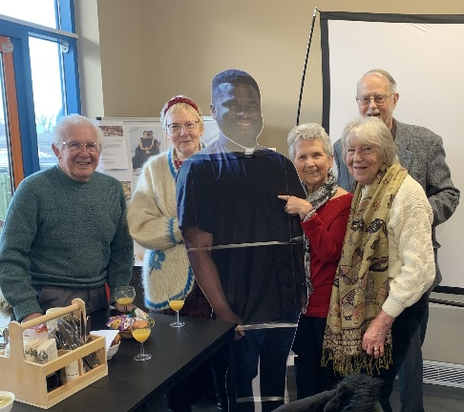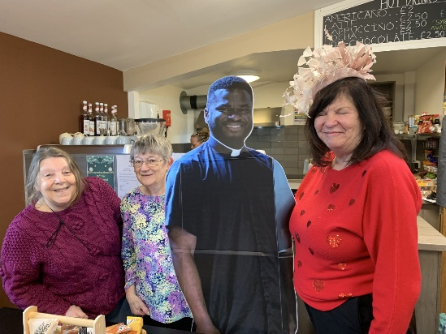

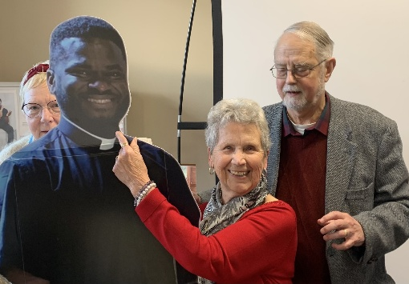
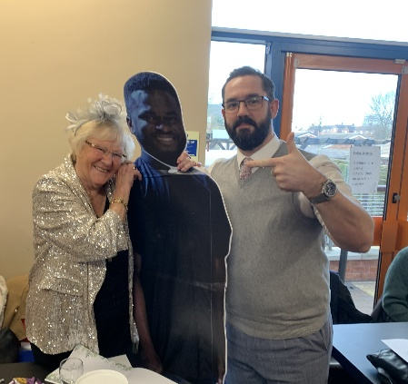
Thank you to everyone who came along for the Wedding Breakfast for Fr Julius and Esther, it was a lovely occasion – and that’s just for us in Kirk Hallam, let alone everyone with the couple too! Here are a few more photos

In our weekly prayers for our parish
This week we pray for God’s blessing on Dallimore Road, Deepdale Drive and Dumbles Close.
Distribution of Communion –currently the Priest will dip the communion wafer in the wine while we discern a safe way to bring the common cup back into worship, as we want everyone to feel included and safe. We also have gluten free wafers available.
Would you like to go to the Panto? Oh yes you would! Then please contact Julie Jones (the Reader) on 07528021021 as she has tickets at just £5 each for Mother Goose at Horsely Woodhouse by Stargazers at 3pm on Saturday 21st February. Lift might be possible too.
Refreshments After the Morning Service
Please stay seated after the service and a hot drink will be brought to you in the pews. Do not get up and head to the back of church, it is becoming a hazard, and a risk as trays of hot drinks could be knocked over.
Church contact information
Contact: Rev’d Christine - revchristine@outlook.com
The Rectory, The Village, West Hallam, DE7 6GR
Landline 0115 646 1497
Rev’d Ailsa -revailsahunt@gmail.com
Tel - 07356064856

Churchwardens – Mrs Janet Wheeldon, -Tel: 0115 8771593
Mrs Linda Gregory – linda.gregory3@icloud.com
https://www.achurchnearyou.com/church/13402/
https://www.facebook.com/allsaintskirkhallam

All Saints Church
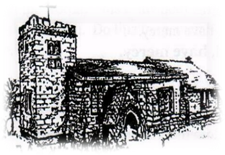
Kirk Hallam
Disabled Toilet in Friendship House.
Disabled Toilet in Friendship House.

Working with God to transform lives & communities.
Please can you ensure your mobile is on silence, or off during the service, it is affecting people with hearing aids and the loop system.

18th January – Second Sunday of Epiphany
10.00am CW Communion Service with Rev’d Christine
4.00pm BCP Communion Friendship House with Rev’d Christine

Forthcoming Events
Mon 19th 10.00am Funeral of Janet Ford in church,
Tues 20th 6.00pm Home Group in Friendship House
Weds 21st 9.30am Morning Prayer at UCAS
Fri 23rd 6.00pm Choir Practise in Friendship House
Sat 24th 10.00am Prayer Meeting in Friendship Huse
Mon 19th 10.00am Funeral in church for Janet Ford

25th January – Third Sunday of Epiphany
10.00am CW Communion Service with Rev’d Christine
4.00pm BCP Evening Prayer with Rev’d Christine
It’s Good to Talk! If you spot that someone is missing, please pop a news sheet through their door, & if you’ve time, call for a chat - just to check they’re OK & to let them know that they are not forgotten!
“You are the light of the world. A city on a hill cannot be hidden” Matthew 5:14
Our 4pm services are now in Friendship House until 15th February.

