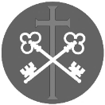
St Peter and the Holy Apostles, Plymouth- Sunday 4th January 2025
The Second Sunday of Christmas (Year A)
Welcome to the Parish Mass
Welcome to St Peters Church. This sheet provides all that you will need for today’s Mass. If you need any assistance before, during or after the service or need a large print copy of this order of service please speak to one of our welcome team. (identifiable by a lanyard)
Please respond to the words in non-italic Bold, The Hymns are sung by all. Please inform the people on the door when you enter if you require a Gluten Free Host
…………………………………………………………………………………
We Stand for The Entrance Hymn

1. Hark! the herald angels sing,
glory to the new-born King,
peace on earth and mercy mild,
God and sinners reconciled.
Joyful, all ye nations, rise,
join the triumph of the skies;
with the angelic host proclaim,
'Christ is born in Bethlehem.'
Hark, the herald angels sing
glory to the new-born King.
2. Christ, by highest heaven adored,
Christ, the everlasting Lord,
late in time behold him come,
offspring of a Virgin's womb!
Veiled in flesh the Godhead see:
Hail the incarnate Deity,
pleased as man with man to dwell,
Jesus, our Emmanuel.
Hark, the herald angels sing
glory to the new-born King.
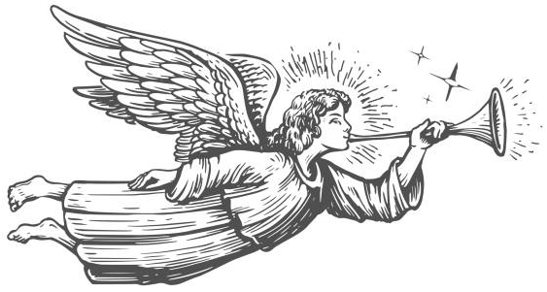
3. Hail, the heaven-born Prince of Peace!
Hail, the Sun of Righteousness!
Light and life to all he brings,
risen with healing in his wings.
Mild he lays his glory by,
born that man no more may die,
born to raise the sons of earth,
born to give them second birth.
Hark, the herald angels sing
glory to the new-born King.
The Introductory Rite
In the name of the Father and of the Son and of the Holy Spirit. Amen.
Following the greeting we respond. And with your spirit.
The Priest introduces the Mass
The Penitential Rite
Brothers and sisters, let us acknowledge our sins,
and so prepare ourselves to celebrate the sacred mysteries.

I confess to almighty God and to you, my brothers and sisters, that I have greatly sinned, in my thoughts and in my words, in what I have done and in what I have failed to do, through my fault, through my fault, through my most grievous fault; therefore I ask blessed Mary ever-Virgin, all the Angels and Saints, and you, my brothers and sisters, to pray for me to the Lord our God.

May almighty God have mercy on us, forgive us our sins, and bring us to everlasting life. Amen.

Either:
Lord, have mercy. Lord, have mercy.
Christ, have mercy. Christ, have mercy.
Lord, have mercy. Lord, have mercy.
Or:
Kyrie, eleison. Kyrie, eleison.
Christe, eleison. Christe, eleison.
Kyrie, eleison. Kyrie, eleison.

The Gloria
Glory to God in the highest, and on earth peace to people of good will.
We praise you, we bless you, we adore you, we glorify you, we give you thanks for your great glory, Lord God, heavenly King, O God, almighty Father.
Lord Jesus Christ, Only Begotten Son, Lord God, Lamb of God, Son of the Father, you take away the sins of the world, have mercy on us; you take away the sins of the world, receive our prayer; you are seated at the right hand of the Father, have mercy on us.
For you alone are the Holy One, you alone are the Lord, you alone are the Most High, Jesus Christ, with the Holy Spirit, in the glory of God the Father. Amen.

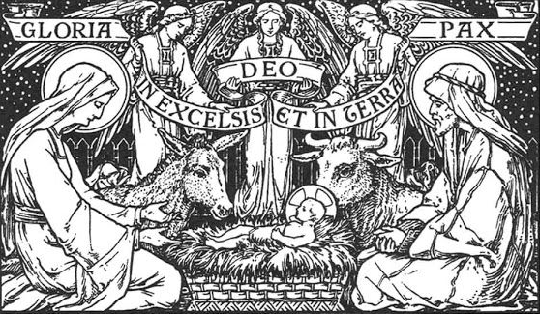

The Collect

Let us pray. Almighty ever-living God, splendour of faithful souls, graciously be pleased to fill the world with your glory, and show yourself to all peoples by the radiance of your light. Through our Lord Jesus Christ, your Son, who lives and reigns with you in the unity of the Holy Spirit, God, for ever and ever. Amen.

We sit for The First Reading- Sirach 24:1-2, 8-12

Wisdom will praise herself and will boast in the midst of her people. In the assembly of the Most High she will open her mouth, and in the presence of his forces she will boast: ‘Then the Creator of all things commanded me, and the one who created me gave my tent a resting place. And he said, “Make your dwelling in Jacob and in Israel receive your inheritance.” From eternity, in the beginning, he created me, and for eternity I shall not cease to exist. In the holy tabernacle I ministered before him, and so I was established in Sion. In the beloved city likewise he gave me a resting place, and in Jerusalem was my dominion. So I took root in an honoured people, in the portion of the Lord, his inheritance.’

The word of the Lord. Thanks be to God.

The Responsorial Psalm- Ps 147: 12-13. 14-15. 19-20. ℟12a

Response- The Word became flesh and dwelt among us.

O Jerusalem, glorify the Lord! O Sion, praise your God!
He has strengthened the bars of your gates; he has blessed your children within you. R

He established peace on your borders; he gives you your fill of finest wheat.
He sends out his word to the earth, and swiftly runs his command. R

He reveals his word to Jacob; to Israel, his decrees and judgements.
He has not dealt thus with other nations; he has not taught them his judgements. R

The second Reading- Ephesians 1:3-6, 15-18

Blessed be the God and Father of our Lord Jesus Christ, who has blessed us in Christ with every spiritual blessing in the heavenly places, even as he chose us in him before the foundation of the world, that we should be holy and blameless before him. In love he predestined us for adoption to himself as sons through Jesus Christ, according to the purpose of his will, to the praise of his glorious grace, with which he has blessed us in the Beloved.
For this reason, because I have heard of your faith in the Lord Jesus and your love towards all the saints, I do not cease to give thanks for you, remembering you in my prayers, that the God of our Lord Jesus Christ, the Father of glory, may give you the Spirit of wisdom and of revelation in the knowledge of him, having the eyes of your hearts enlightened, that you may know what is the hope to which he has called you, what are the riches of his glorious inheritance in the saints.

The word of the Lord. Thanks be to God

We stand for- The Gospel Procession and Acclamation- Cf. 1 Timothy 3:16

Alleluia, alleluia.
Glory to you, O Christ, proclaimed among the nations.
Glory to you, O Christ, believed in throughout the world.
Alleluia.
The Gospel- John 1:1-18

The Lord be with you. And with your spirit.
A reading from the holy Gospel according to N. Glory to you, O Lord.
In the beginning was the Word, and the Word was with God, and the Word was God. He was in the beginning with God. All things were made through him, and without him was not any thing made that was made. In him was life, and the life was the light of men. The light shines in the darkness, and the darkness has not overcome it.
There was a man sent from God, whose name was John. He came as a witness, to bear witness about the light, that all might believe through him. He was not the light, but came to bear witness about the light.
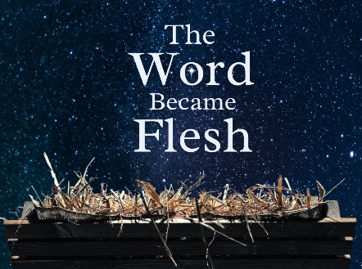
The true light, which gives light to everyone, was coming into the world. He was in the world, and the world was made through him, yet the world did not know him. He came to his own, and his own people did not receive him. But to all who did receive him, who believed in his name, he gave the right to become children of God, who were born, not of blood nor of the will of the flesh nor of the will of man, but of God. And the Word became flesh and dwelt among us, and we have seen his glory, glory as of the Only Begotten from the Father, full of grace and truth. John bore witness about him, and cried out, ‘This was he of whom I said, “He who comes after me ranks before me, because he was before me.” ’
For from his fullness we have all received, grace upon grace. For the law was given through Moses; grace and truth came through Jesus Christ. No one has ever seen God; the only begotten God, who is at the Father’s side, he has made him known.
The Gospel of the Lord. Praise to you, Lord Jesus Christ.
We sit for The Homily

We stand The Creed
I believe in one God, the Father almighty, maker of heaven and earth,
of all things visible and invisible.
I believe in one Lord Jesus Christ, the Only Begotten Son of God, born of the Father before all ages. God from God, Light from Light, true God from true God, begotten, not made, consubstantial with the Father; through him all things were made. For us men and for our salvation he came down from heaven,
At the words that follow, up to and including ‘and became man’, all bow.
and by the Holy Spirit was incarnate of the Virgin Mary, and became man.
For our sake he was crucified under Pontius Pilate, he suffered death and was buried, and rose again on the third day in accordance with the Scriptures.
He ascended into heaven and is seated at the right hand of the Father. He will come again in glory to judge the living and the dead and his kingdom will have no end.
I believe in the Holy Spirit, the Lord, the giver of life, who proceeds from the Father and the Son, who with the Father and the Son is adored and glorified, who has spoken through the prophets.
I believe in one, holy, catholic and apostolic Church. I confess one Baptism for the forgiveness of sins and I look forward to the resurrection of the dead and the life of the world to come. Amen.

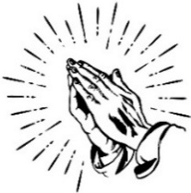
We remain standing for The Prayers of the Faithful

Each biding concludes with the following said or sung-

We pray to the Lord. Lord in your Mercy hear our prayer.

The Priest Concludes the Prayers of the Faithful
……………………………………………………………………………..
No collection is taken during the Mass, but there is a collection box at the back of church for you to give your financial contribution. All money collected helps towards the mission and ministry of our churches. If you would prefer, a card reading machine is available at the back of the church for your contribution.
The Offertory Hymn
1. Of the Father's love begotten, ere the worlds began to be,
he is Alpha and Omega, he the source, the ending he,
of all things that are and have been and that future years shall see:
Evermore and evermore
2. By his word was all created; He commanded, it was done:
heaven and earth and depth of ocean, universe of three in one,
all that grows beneath the shining of the light of moon and sun:
Evermore and evermore
3. Blessed was the day for ever when the virgin, full of grace,
by the Holy Ghost conceiving, bore the Saviour of our race,
and the child, the world's Redeemer, first revealed his sacred face:
Evermore and evermore
4. He, by prophets sung, is here now, promised since the world began,
now on earth in flesh descended to atone for sins of man.
All creation praise its Master, see fulfilment of his plan:
Evermore and evermore
5. Glory be to God the Father, glory be to God the Son,
glory to the Holy Spirit, persons three, yet Godhead one.
Glory be from all creation while eternal ages run:
Evermore and evermore
The Liturgy of the Eucharist
Pray, brethren (brothers and sisters), that my sacrifice and yours may be acceptable to God, the almighty Father. May the Lord accept the sacrifice at your hands for the praise and glory of his name, for our good and the good of all his holy Church.

The Lord be with you. And with your spirit.
Lift up your hearts. We lift them up to the Lord.
Let us give thanks to the Lord our God. It is right and just.
The Priest continues with the Preface. The Sanctus is the said or sung:
Holy, Holy, Holy Lord God of hosts.
Heaven and earth are full of your glory. Hosanna in the highest.
Blessed is he who comes in the name of the Lord. Hosanna in the highest.

The Priest continues the Eucharistic prayer. The following is said or sung
The mystery of faith…. We proclaim your Death, O Lord, and profess your Resurrection until you come again.

The Priest concludes the Eucharistic prayer.

Through him, and with him, and in him, O God, almighty Father, in the unity of the Holy Spirit, all glory and honour is yours, for ever and ever. Amen.

The Lord’s Prayer
At the Saviour’s command and formed by divine teaching, we dare to say:
Our Father, who art in heaven, hallowed be thy name; thy kingdom come, thy will be done on earth as it is in heaven. Give us this day our daily bread, and forgive us our trespasses, as we forgive those who trespass against us; and lead us not into temptation, but deliver us from evil.
Deliver us, Lord, we pray… and the coming of our Saviour, Jesus Christ.
For the kingdom, the power and the glory are yours now and for ever.

The Peace
Lord Jesus Christ, who said to your Apostles: Peace I leave you, my peace I give you,
look not on our sins, but on the faith of your Church, and graciously grant her peace and unity in accordance with your will. Who live and reign for ever and ever. Amen.
The peace of the Lord be with you always: And with your spirit.
Let us offer each other the sign of peace.
All are invited to make an acknowledgement to each other to mark the sign of the peace.
The Agnus Dei
All say or sing:
Lamb of God, you take away the sins of the world, have mercy on us.
Lamb of God, you take away the sins of the world, have mercy on us.
Lamb of God, you take away the sins of the world, grant us peace.

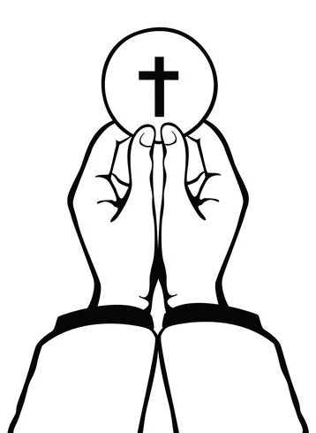
The Invitation to Communion
Behold the Lamb of God, behold him who takes away the sins of the world. Blessed are those called to the supper of the Lamb.
Lord, I am not worthy that you should enter under my roof, but only say the word and my soul shall be healed.

All who are regular communicants in their own tradition are welcome to receive the sacrament if you are not a communicant you are welcome to come forward at this point in the service to receive a blessing To indicate that it is just a blessing you require, please take this service sheet up with you. We have returned to offering the chalice at the time of communion but please do not feel any pressure to receive from the common cup as the church teaches that the sacrament is received fully in one kind. We request that you do not intinct (dip) your host in the Chalice but either take a sip from the cup or return directly to your seat. This is for reasons of good hygiene.

The Communion Hymn

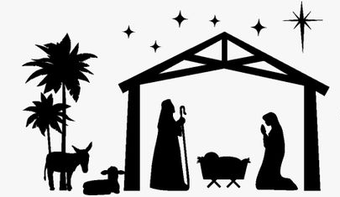
1. Child in the manger, infant of Mary;
outcast and stranger, Lord of all;
child who inherits all our transgressions,
all our demerits on him fall.
2. Once the most holy child of salvation
gently and lowly lived below;
now as our glorious mighty Redeemer,
see him victorious o'er each foe.
3. Prophets foretold him, infant of wonder;
angels behold Him on his throne;
worthy our Saviour of all their praises;
happy for ever are his own.
We stand for The Prayer After Communion

Lord our God, we humbly ask you, that, through the working of this mystery, our offences may be cleansed and our just desires fulfilled. Through Christ our Lord.
Amen

The priest may give some brief notices

The Concluding Rites
The Lord be with you. And with your spirit.
Bow your head and pray for Gods Blessing

May the God of infinite goodness, who by the Incarnation of his Son has driven darkness from the world and by that glorious Birth has illumined this most holy day,
drive far from you the darkness of vice and illumine your hearts with the light of virtue. Amen.

May God, who willed that the great joy of his Son’s saving Birth be announced to shepherds by the Angel, fill your minds with the gladness he gives and make you heralds of his Gospel. Amen.

And may God, who by the Incarnation brought together the earthly and heavenly realm, fill you with the gift of his peace and favour and make you sharers with the Church in heaven. Amen.

And may the blessing of almighty God, the Father, and the Son, ✠ and the Holy Spirit, come down on you and remain with you for ever. Amen.

The Dismissal
Go forth, the Mass is ended. Thanks be to God
The Final Hymn
1. The first Noel, the angel did say
Was to certain poor shepherds in fields as they lay;
In fields where they lay keeping their sheep,
On a cold winter’s night that was so deep.
Noel, Noel, Noel, Noel,
Born is the King of Israel.
2. They looked up and saw a star
Shining in the east, beyond them far,
And to the earth it gave great light,
And so it continued both day and night.
Noel, Noel, Noel, Noel,
Born is the King of Israel.
3. And by the light of that same star
Three Wise Men came from country far;
To seek for a King was their intent,
And to follow the star wherever it went.
Noel, Noel, Noel, Noel,
Born is the King of Israel.
4. Then let us all with one accord
Sing praises to our heav'nly Lord,
That hath made heav'n and earth of naught,
And with His blood mankind hath bought.
Noel, Noel, Noel, Noel,
Born is the King of Israel.
…………………………………………………………………
The Angelus
The Angel of the Lord declared unto Mary. And she conceived of the Holy Spirit.

Hail Mary, full of grace, The Lord is with Thee; Blessed art thou among women,
And blessed is the fruit of thy womb, Jesus.
Holy Mary, Mother of God, Pray for us sinners,
Now and at the hour of our death.

Behold the handmaid of the Lord.
Be it done to me according to thy word. Hail Mary. . .

And the Word was made flesh. And dwelt among us. Hail Mary…
Pray for us, O holy Mother of God.
That we may be made worthy of the promises of Christ.

Let us pray: Pour forth, we beseech Thee, O Lord, Thy grace into our hearts, that we to whom the Incarnation of Christ Thy Son was made known by the message of an angel, may by His Passion and Cross be brought to the glory of His Resurrection. Through the same Christ Our Lord. Amen.
……………………………………………………………………………..
The Notices

Important PCC Meeting- Wednesday 21st January at St Batholmew’s at 7.30pm.
This meeting is going to define how we are going to organise ourselves for the future.

Help Needed for our Winter night Shelter-
help is needed to support our winter night shelter between December and March on Wednesdays, overnight workers must be DBS checked. For further information please speak to Fr David or Ben

New Year De-clutter- On Mondays throughout January we will be tackling areas of clutter in St Peters- all help appreciated- we would appreciate cars being available to help take rubbish to Chelson meadows recycling centre. This will take place 11am- 2pm- please bring a packed lunch- hot drinks provided

Mary Wood RIP Mary’s funeral service will be on Tuesday 13th January at 2.30pm in St Peter’s

Fundraising is an important form of income for the Church. Over £2,800 was raised in 2025 by our 2 types of raffles. The Sunday raffle raised £2,119. Thank you to everybody who bought tickets each week and to those who supply the prizes. If you would like to help out by supplying prizes, please speak to Graham or Jenny. The Big Raffle raised £710. This is drawn twice a year, at Easter and at Christmas. Tickets are priced at 50p each and are on sale throughout the year. If you buy tickets before the Easter draw, you have 2 chances of winning, as these same numbers are included in the Christmas draw. Again, thank you to everybody who bought tickets throughout the year.

we operate a Christmas Savings scheme. As we all know, Christmas can be an expensive time of year, but by saving throughout the year, you can spread that cost, with saved money being paid out in early November. You can save as little or as much as you want to, when you want to. If you are interested in joining the scheme or would like more information, please speak to Graham or Jenny.

For Prayer

Those who have asked for our prayers…. Denise, Janice Allin, Leslie Porch,
Sheila Tucker, Tina Smart, Kathy Haydon, Bobby Lilicrap, June Brock,
Emma Addison, Georgie Maher, Ian Craggs, Brenda Alderson, Lois Tobin, Brenda Steed, Anne Lewis, Jenny Harvey, Jackie Morrison, Anna, Gwen Lamb, Anna Lynch, Jackie Fisher, Helen Lewis, Val Bradden, Cynthia Way, Pauleen Stewart, Amelia Coughlan, Roger Lewis, Shaun Carrie, Fr Jon Bielawski, Catherine Samuel, Julian Davies, Ron Morrison.

Recently Departed-

Anniversaries of Death-
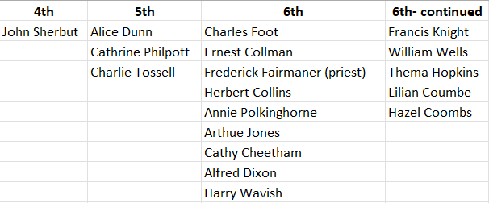
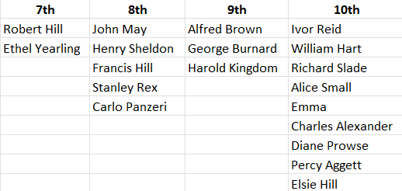

The Mission Community of St Peter and the Holy Apostles
St Peter, Wyndham Square + St Thomas, Royal Navy Avenue + St James-the-Less, Ham Drive
A Church of England Parish in the care of the Bishop of Oswestry
Parish Priest Fr. David Way SSC: 01752 240119 fr.davidway@gmail.com
.com
Mission Development Minister/ LLM/ Parish Ordinand: Ben Otley 07939800544 benotley.mission.plym@gmail.com

Parish Website: plymouthstpeter.co.uk ~ FOR MUCH MORE INFORMATION ON EVENTS, ETC.

This week’s services
Sunday 4th  The Second Sunday of Christmas | 8.30am St Thomas Fr DCW  10.00am St Peter Fr DCW  6.00pm St Peter | Mass with Hymns  Sung Mass  Evening Song and Benediction
Monday 5th- Weekday of Christmas | St Peter 10.00am Fr PL | Mass
Tuesday 6th-  The Epiphany of the Lord | St Peter 10.00am Fr KH | Mass with Hymns
Wednesday 7th- Weekday of Epiphany | St Peter 10.00am Fr KR | Mass
Thursday 8th- Weekday of Epiphany | St Peter 10.00am Fr KH | Mass
Friday 9th- Weekday of Epiphany | St Peter 10.00am Fr PL | Mass
Saturday 10th- Weekday of Epiphany | St Peter 10.00am Fr KH | Mass
Sunday 11th  The Baptism of the Lord | 8.30am St Thomas Fr DCW  10.00am St Peter Fr PL | Mass with Hymns  Sung Mass
St Peters is open daily 8.30am- 12noon- Place of Welcome, Place of Prayer, food larder etc.
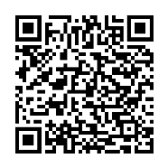
Safeguarding: If you have any concerns regarding the safety of children and others who are vulnerable, regardless of age, you must tell the Duty Priest or our parish Lay Safeguarding Representative- Jackie Morrison- email randj49@gmail.com Tel 07848859124.
For online donations please scan the QR code

