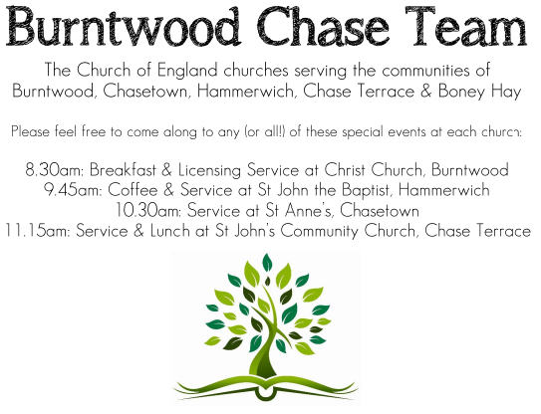
CHRIST CHURCH

SERVICE ON SUNDAY 1st FEBRUARY 2026 at 10am

Holy Communion

The Forth Sunday after The Epiphany

Readings:
Hebrews 2: 14-18

¹⁴ Since, therefore, the children share flesh and blood, he himself likewise shared the same things, so that through death he might destroy the one who has the power of death, that is, the devil, ¹⁵ and free those who all their lives were held in slavery by the fear of death. ¹⁶ For it is clear that he did not come to help angels, but the descendants of Abraham. ¹⁷ Therefore he had to become like his brothers and sisters in every respect, so that he might be a merciful and faithful high priest in the service of God, to make a sacrifice of atonement for the sins of the people. ¹⁸ Because he himself was tested by what he suffered, he is able to help those who are being tested.

Luke 2: 22-40
²² When the time came for their purification according to the law of Moses, they brought him up to Jerusalem to present him to the Lord ²³ (as it is written in the law of the Lord, ‘Every firstborn male shall be designated as holy to the Lord’), ²⁴ and they offered a sacrifice according to what is stated in the law of the Lord, ‘a pair of turtle-doves or two young pigeons.’
²⁵ Now there was a man in Jerusalem whose name was Simeon; this man was righteous and devout, looking forward to the consolation of Israel, and the Holy Spirit rested on him. ²⁶ It had been revealed to him by the Holy Spirit that he would not see death before he had seen the Lord’s Messiah. ²⁷ Guided by the Spirit, Simeon came into the temple; and when the parents brought in the child Jesus, to do for him what was customary under the law, ²⁸ Simeon took him in his arms and praised God, saying,
²⁹ ‘Master, now you are dismissing your servant in peace,
according to your word;
³⁰ for my eyes have seen your salvation,
³¹ which you have prepared in the presence of all peoples,
³² a light for revelation to the Gentiles
and for glory to your people Israel.’
³³ And the child’s father and mother were amazed at what was being said about him. ³⁴ Then Simeon blessed them and said to his mother Mary, ‘This child is destined for the falling and the rising of many in Israel, and to be a sign that will be opposed ³⁵ so that the inner thoughts of many will be revealed—and a sword will pierce your own soul too.’
³⁶ There was also a prophet, Anna the daughter of Phanuel, of the tribe of Asher. She was of a great age, having lived with her husband for seven years after her marriage, ³⁷ then as a widow to the age of eighty-four. She never left the temple but worshipped there with fasting and prayer night and day. ³⁸ At that moment she came, and began to praise God and to speak about the child to all who were looking for the redemption of Jerusalem.
³⁹ When they had finished everything required by the law of the Lord, they returned to Galilee, to their own town of Nazareth. ⁴⁰ The child grew and became strong, filled with wisdom; and the favour of God was upon him.

COLLECT FOR TODAY
God our creator,
who in the beginning
commanded the light to shine out of darkness:
we pray that the light of the glorious gospel of Christ
may dispel the darkness of ignorance and unbelief,
shine into the hearts of all your people,
and reveal the knowledge of your glory
in the face of Jesus Christ your Son our Lord,
who is alive and reigns with you,
in the unity of the Holy Spirit,
one God, now and for ever.

WHAT’S GOING ON
Upcoming Services

Monday 2nd February Cameo Cafe 10-12 noon
Wednesday 4th February Morning Prayer 9.30am
Saturday 7th February Art Cafe 3-5pm
Sunday 8th February Morning Worship 10am

Cameo Cafe
Our Cameo Cafe will be open on Monday 2nd February,
all welcome to join us for a cuppa and biscuit or two.

Art Cafe
Art Cafe will be open on Saturday 7th February from 3 till 5pm.
All welcome to join.

FLOODLIGHTING
If you think about commemorating a special occasion by floodlighting our Church. Please contact Chris Brown on 01543 683862 for details.

PRAYER CHAIN
Christ Church is blessed with a very active prayer chain. If you, or anyone you know, feel that they would like others to pray for them, please speak to Chris Brown on 01543 683862.

HOME COMMUNION
For anyone who is unable to attend church and would like a Home Visit and Communion, please contact the Vicar and he will be able to carry this out.

VICAR CONTACT DETAILS

Rev’d Stephen Morgan Tele: 07305 852152

CHURCH WARDENS CONTACT DETAILS
Judith Rogers Tele: 01543 324718
Mike Holmes Tele: 01543 672970
Church Office Tele: 01543 642187 [leave a message and we will respond]
Church Web Site:www.christchurchburntwood.org.uk
Church Email: christchurchburntwood15@gmail.com
Facebook: www.facebook.com/group/christchurchburntwood/

Other Contacts
Matt Wallace St. John’s, Chase Terrace— Tele: 01543 670078

NEXT SUNDAY SERVICE
Sunday 8th February at 10am
Morning Worship
Genesis 1: 1-2:3
Matthew 6: 25-34
2nd Sunday before Lent.

