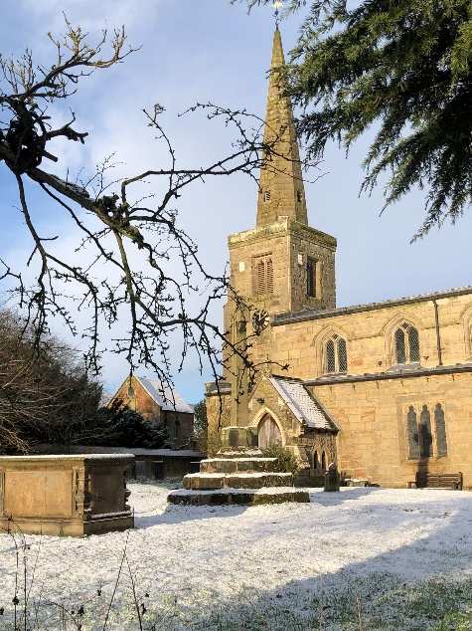
ST MICHAEL AND ALL ANGELS,
HAMSTALL RIDWARE

In the United Benefice of King’s Bromley, the Ridwares
and Yoxall

January 11th 2026
Baptism of Christ

PARISH NOTICES

UNITED BENEFICE SERVICE ROTA
 | Hamstall Ridware  St Michael and All Angels | Yoxall  St Peter | King’s Bromley  All Saints | Mavesyn Ridware  St Nicholas
January 11th  The Baptism of Christ | 4.00 pm  Holy Communion | 10.30 am  Parish Communion | 10.30 am  Parish Communion
January 18th  Epiphany 2 | 10.30 am  Parish Communion | 4.00 pm  Holy Communion | 9.00 am  Holy Communion | 10.30 am  Parish Communion
January 25th  Epiphany 3 | 10.30 am  Service of the Word | 9.00 am  Holy Communion | 10.30 am  Parish Communion
February 1st  Candlemas | 9.00 am  Holy Communion | 10.30 am  Parish Communion | 4.00 pm  Holy Communion | 10.30 am  Morning Prayer
February 8th  2 Before Lent | 4.00 pm  Holy Communion | 10.30 am  Parish Communion | 10.30 am  Parish Communion
Please note that services of Holy Communion at 9 am follow the Book of Common Prayer and are said. Services at 10.30 will include hymns and other singing.
There are services of Holy Communion at 10.00 every Wednesday at St Peter’s, Yoxall and on the first Thursday of each month at All Saints, King’s Bromley.
*******************
Rugeley Food Bank. Please do remember those who depend on Food Banks. They are needed now just as ever. If you wish to donate directly to Rugeley Foodbank at Rugeley Community Centre the Centre is open everyday to receive contributions. Alternatively, the Rugeley Food Bank welcomes financial contributions – see https://rugeley.foodbank.org.uk. Gifts can also be brought to St Michael’s and left in the box at the back of church near the font. If that is not convenient please contact Liz Carter on 07751 068181.
****************
Contact details: If you wish to contact the Rector, Jeremy Brading you can do so on revd@kbhmy.co.uk and Glenis Turner, the PCC Secretary and Benefice Administrator is on admin@kbhmy.co.uk. The churchwardens are Michael Elsom michael.elsom@btopenworld.com and John Ferguson clan.member1954@gmail.com Information about events at church can be found at our webpages at https://www.achurchnearyou.com/church/4451/ and https://kbhmy.co.uk/hamstall/
St Michael’s will continue to be open everyday (weather permitting) between 10.00 am until 4.00 pm. We will revert to shutting the church at 6.00 pm on March 29th 2026
Safeguarding of children and vulnerable adults. If you have any concerns please speak in complete confidence to the Parish Safeguarding Officer, Dr Paul Carter 01889 504347 or the Diocesan Safeguarding Officer Mr Neil Spiring 01543 306 030
St Michael’s encourages donations by means of this QR code and it will appear (all being well) on all our publications as an invitation to contribute to the important work of the church both
as a place of worship and a community asset where all can share in the wonderful place we have inherited and wish to pass down to those who come after.
PLEASE REMEMBER IN YOUR PRAYERS:
Those who are sick: Mary Mycock, Brenda, Angela Perkin, Doug, David and Barbara Rudge, May Windley, Pam Payne, Frank and Margaret Finch, Chris Poole, Les Wood, Pat Lomax, Alison Scott and any known personally to you.
Those who live and work in the Nursing, Care and Retirement homes in the villages both in and near the parishes of the United Benefice.
At this time when the world order looks more than a trifle uncertain we pray for the leaders of the nations that they may exercise wisdom and understanding when making decisions which will affect not only their own nations, but also their neighbours, friends and allies. May peace prevail and war be averted.
Using the Archbishops’ prayer for Ukraine at this time let us remember the people of that war-torn land:
God of peace and justice, we pray for the people of Ukraine today. We pray for peace and the laying down of weapons. We pray for all those who fear for tomorrow, that your Spirit of comfort would draw near to them. We pray for those with power over war or peace, for wisdom, discernment and compassion to guide their decisions. Above all, we pray for all your precious children, at risk and in fear, that you would hold and protect them. We pray in the name of Jesus, the Prince of Peace. Amen
The situation in the Middle East where hopes for a peaceful resolution sometimes appear irretrievably bleak:
O God of all justice and peace, we cry out to you in the midst of the pain and trauma of violence and fear which prevails in the Holy Land. Be with those who need you in these days of suffering; we pray for people of all faiths - Jews, Muslims and Christians and for all people of the land. While we pray to you, O Lord, for an end to violence and the establishment of peace, we also call to you to bring justice and equity to the peoples. Guide us into your kingdom where all people are treated with dignity and honour as your children - for to all of us you are our Heavenly Father. In Jesus' name we pray. Amen.
From the Diocesan Prayer Diary:
Tuesday 13th:
(Hilary, Bishop of Poitiers, Teacher of the Faith, 367. Kentigern (Mungo), Missionary Bishop in Strathclyde and Cumbria, 603.George Fox, Founder of the Society of Friends (the Quakers), 1691)
A prayer from George Fox; Praise, honour, and glory be to the Lord of heaven and earth! Lord of peace, Lord of joy! Thy countenance maketh my heart glad. Lord of glory, Lord of mercy, Lord of strength, Lord of life, and of power over death, and Lord of lords, and King of kings! In the world there are lords many, but to us there is but one God the Father, of whom are all things; and one Lord Jesus Christ, by whom are all things: to whom be all glory, who is worthy! In the world are many lords, and many gods, and the earth maketh lords, coveting after riches, and oppressing the creatures; and so, the covetous mind getting to itself, lords it above others. This nature of lordly pride is head, until subdued by the power of God: for everyone in that state, doth strive to be above another; few will strive to be the lowest. Oh! that everyone would strive to put down in themselves, mastery and honour, that the Lord of heaven and earth might be exalted!
Thursday 15th:
We pray for wisdom for the Shrewsbury Area Mission and Pastoral Committee as they meet today. Today we also start a series of prayers for Shrewsbury and Wrekin Deanery and especially remember the churches currently in vacancy, in the Haughmond and Wrekin Benefice, the Trinity Churches group, The Abbey, and Monkmoor St Peter. We pray particularly for the Abbey and St Peter's as they begin a new chapter as two separate parishes.
Friday 16th:
We pray for all those people who have been to services over Christmas, in Shrewsbury and beyond; that they would continue to 'ponder all these things' in their hearts.
COMMUNITY CAFÉ
All who come to these events obviously enjoy themselves tremendously – so why not come along with your family and friends. Who knows, you might meet some new folks and show them what a friendly place Hamstall – and St Michael’s - in particular is. See you there on January 22nd between 10.30 and 12.30!

