St John the Evangelist Church, Trent Vale
Newsletter Winter 2025/2026

January has arrived bringing snow and chilling winds but lengthening days and recollections of the final hectic days of 2025 bring us smiles and comforting memories.
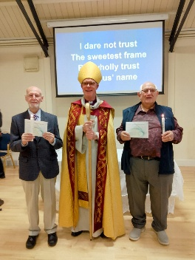
It was Sunday morning on 2nd November that Bishop Matthew came to confirm Denis Ankers and Ray Tizely. Den and Louise Turpin and it is hoped they will be confirmed in the near future.
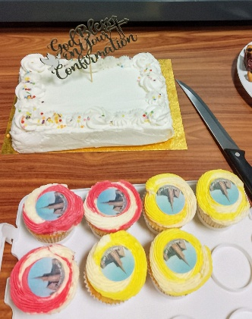
The service was led by Revd Liz with Bishop Matthew’s thoughtful words of “Hear, Believe and Receive. The renewal of Baptismal vows and him laying his hands on their heads for the Holy Spirit to be upon them brought a deep calmness into the room and a very special experience for Denis and Ray. It was followed by a reception with delicious cakes including small ones with edible pictures of the church on them and a large one with a standup Confirmation Topper.
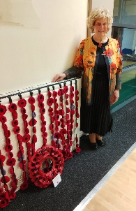
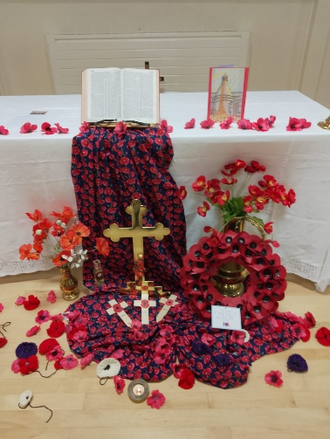
On the morning of Sunday 9th November, we held a Remembrance Day Service and as always, the altar was beautifully dressed with poppies drifting down to the floor and Lesley once again included the French WW1 perfume used on letters to tell soldiers they would be remembered. The fallen in both World Wars were read out as their names appeared on a screen, backed by falling poppies, a very sobering large number from this area.
A curtain of poppies made by Linda Allen was dedicated to Audrey and Derick Smith, passed staunch members of our church. In the foyer was an interesting display reflecting the Roll of Honour and items recalling both World Wars.
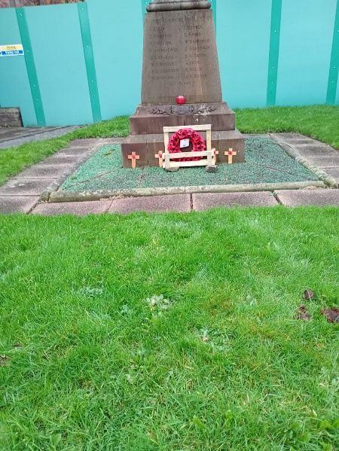
On Tuesday 11th November Steve led a short Armistice Day Service. A good number gathered around the WW1 War Memorial in the church grounds with readings and prayers. Matt Aplin (Penkhull Village Brass) played the Last Post as we stood in silent respect, our thoughts of the past and present as traffic rushed by on the busy A34. Reveille sounded and Harold Gregory moved forward to lay the Wreath of Poppies and others added wooden crosses for family members. We quietly dispersed, the dull grey sky shared our mood and memories.
Alex Wolvers spoke at our lay-led service on Sunday 14th November; a very interesting chat with a welcome fresh-face in our services.
Saturday 22nd November is a very important day in the year as our Christmas Fair is our main fundraising event with tables loaded with cakes, games, white elephant items and the enormous raffle which alone raised £600. A huge number of people attended spending generously and collecting tickets for the free Children’s Party. The total amount raised was £2495, an amazing amount reflecting weeks of preparation.
On Sunday 30th November we attended the Benefice Advent Service at Hartshill Church, led by Revd Liz with members of all three churches taking part. All of us singing the lovely Advent Hymns opening with “O come, o come Emmanuel”. Alan Smith went forward to light the first candle in the Advent Wreath. The readings continued as we listened and admired the beautiful tree and decorations.
An ensemble quietly sang as we received communion, the service ending with “Lo He comes with clouds descending”. We moved across to the Minton Centre for refreshments and fellowship. Joyful anticipation was in the air.
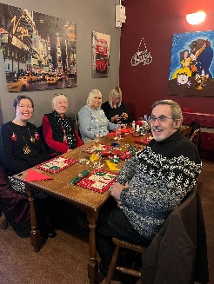
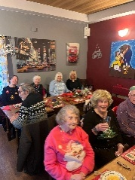
December is celebration time as Jackie Barnes again arranged the Christmas meals at the Black Lion. So many wishing to attend meant there were two dates; the first on Wednesday 3rd December. We pulled crackers, wore paper hats and laughed at jokes as the lovely meals arrived, all served by Jackie Elliot and cheerful staff as they happily sorted out the various meals and we admired the Portmeirion ware giving us a feeling of local pride.
It was a hectic day for those dining on Friday 12th December as we attended the evening performance of “Eric’s Christmas Turkey” at the Victoria Theatre. Thirty of us resplendent in Christmas sweaters found our front-row seats. As it is a theatre in the round, we waved to each other as we enjoyed the hilarious show. We laughed, sang and danced to old favourites, finishing as always with “Hi Ho Silver Lining”. Our thanks to Jackie for arranging it and to all who had provided transport.
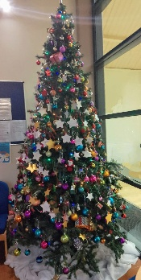
On Thursday 11th December a group of us visited Springfield Manor Care Home where we enjoyed carols with the residents and staff. Revd Liz played the flute as her greyhound Annie dozed throughout, with residents later enjoying stroking her before we left.
Although we enjoyed our services and social events there was also time to reflect and remember loved ones. On Sunday 7th December Revd Liz led the moving Star Sunday Service when names of our departed loved ones are written on stars and hung on the beautiful tall decorated tree in the foyer, their names appearing on the screen as soft music played.
On Sunday 14th December the other churches came to share a Carol Service. Accompaniment to the carols was provided by a trio of musicians.
Monday morning on 15th December came and rain did not deter people attending the “Places of Welcome” Christmas party. With people bringing food we chatted and sang along to the wonderful Strings and Sunshine Ukulele Band. Yet another community occasion with local councillor Waseem Akbar joining us. The raffle raised £53 for the Church Firefund.
On the afternoon of Saturday 20thDecember the centre was decorated and welcomed ninety children and families to the annual free Christmas party. We thank Waseem for the additional Ward Budget donation towards the expenses.
Councillor Waseem was accompanied by Deputy Lord Mayor Councillor Joan Bell and husband Consort Dennis and Councillor Finlay Gordon McCusker.
In the evening church members attended the Penkhull Village Brass (PVB) Christmas Concert at the Jubilee Club and thoroughly enjoyed the evening.
PVB Juniors, including Emaan, Isla, Cobi and other young members of St John’s, entertained us at St John’s Centre on Saturday 6th December with their annual Christmas Concert.
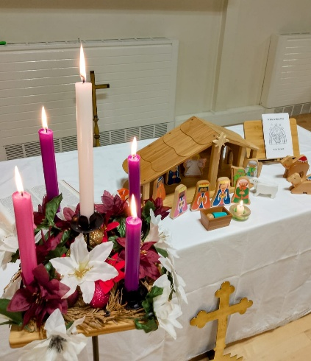
Christmas Eve
afternoon saw the small wooden stable awaiting the arrival of the simple figures, all carried forward by the congregation as Steve read the Christmas Story and people voiced the characters. Den Turpin excelled as a very grumpy innkeeper. Congregation members later attend Midnight Mass at Trentham Church and the Stoke Minster.
Sam led the last service of the year which we celebrated and the three kings were added to the nativity scene.
Songs were chosen by the congregation including “Refiners Fire”, “Amazing Grace” and “10,000 Reasons” (“Bless the Lord”). Others were sung and played before and after the service.
We have had a wonderful Advent and Christmas and thank everyone for their hard work.
Whilst we have celebrated in joy, we have also remembered those who have been unwell. We especially give thanks that Revd Fran is now at home. We continue to hold many on our Prayer List.
We have offered our support to those whose loved ones are no longer with us.
On 19th December many friends attended the funeral at Bradwell Crematorium of our dear friend ‘Ray’ Mountford, the service led by Pastor Marcus Chilaka where wife Josie and daughter spoke with such courage and faith, sharing that although having Alzheimer’s Ray said “I know I know nothing but I know Jesus is my Lord”.
In the last days we send love to our friends at Penkhull Church on the sudden passing of Ralph Richardson where he was such a valued member and a friend to all in the Benefice.
We look forward to the ongoing work in our church and to its final completion. The support and hard work by many in the church is greatly valued makes St John’s so much more than a church to worship and praise the Lord but also an extended family reaching out not only to us but to our Benefice and community.
We hope you continue to enjoy this originally ‘hand-written’ Newsletter and give thanks to those who edit and publish it.
All at St John’s send you their love and may 2026 be a year in which you will know the love of the Lord, good health and happiness.

Bobbie and all your friends at St John’s Trent Vale.

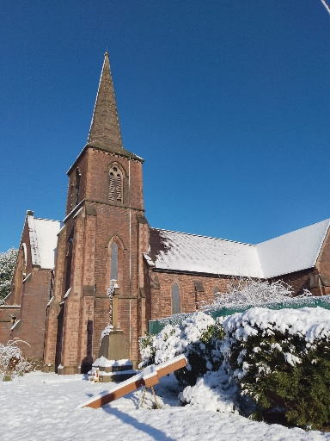

(Winter Newsletter at 14 January 2026)

