MASS & SERVICE TIMES THIS WEEK

SUNDAY 11TH JANUARY 2026
BAPTISM OF THE LORD

PARISH MASS
10 AM
Celebrant: Father Grantley Finlayson

MONDAY 12TH JANUARY Holy Hour 10 am

TUESDAY 13TH JANUARY Mass 11 am
Celebrant: Father Diego Galanzini

Afternoon Tea and Cakes 2-4 pm

SUNDAY 18TH JANUARY 2026
SECOND SUNDAY OF ORDINARY TIME
Parish Mass 10 am
Celebrant: Father Grantley Finlayson

Parish Priest
In Vacancy
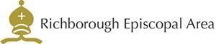



Please contact the churchwarden: Valerie Rice 07946 175105

Email: marshfarmholycross@gmail

