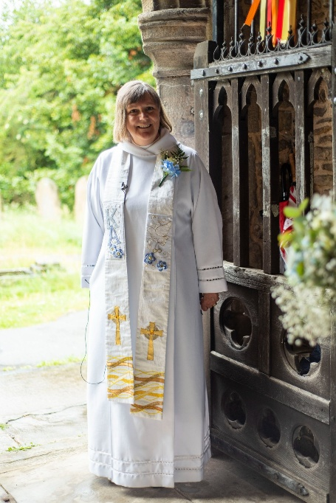
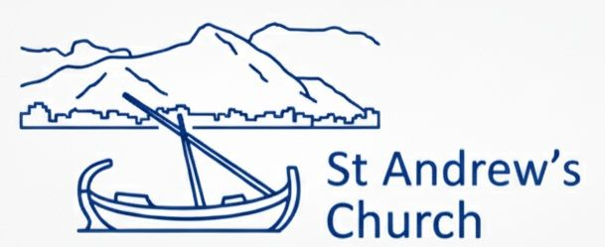

Welcome to St. Andrew’s
Church here in Puerto Pollensa (spelt so many ways!). My name is Reverend. Sara Davies and I became Chaplain here in November 2025. I am a Church of England Priest, and part of the Diocese of Europe which is very extensive. We are one of two English speaking Churches here in Mallorca, the other being St. Philip and St. James in Palma.
I am a Chaplain rather than Parish Priest as this is of course a Catholic country and we don’t have parishes. Everyone is very welcome, I am here for people of faith or no faith at all. The Church Council supports me and is responsible for the day to day running of the church. Our Church reader is Vicky Pacey.
Holy Communion takes place at the church every Sunday at 11am as well as other services depending on the Church liturgical season. I can also be asked to take wedding blessings, baptisms and funerals.
Contact me via:
chaplain@standrewspuertopollensa +34 622425094
A Church Near You.. English speaking Church Northern Mallorca
Facebook ; Anglican Chaplaincy of St. Andrew’s Church, Puerto Pollensa, Mallorca

