MASS & SERVICE TIMES THIS WEEK

SUNDAY 4TH JANUARY 2026
SECOND SUNDAY
AFTER THE NATIVITY

PARISH MASS
10 AM
Celebrant: Father Chris Burrows

MONDAY 5TH JANUARY Holy Hour 10 am

TUESDAY 6TH JANUARY Mass 11 am
Celebrant: Father Diego Galanzini

SUNDAY 11TH JANUARY 2026
THE BAPTISM OF THE LORD
Parish Mass 10 am
Celebrant: Father Grantley Finlayson

Parish Priest
In Vacancy
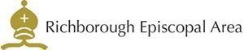



Please contact the churchwarden: Valerie Rice 07946 175105

Email: marshfarmholycross@gmail

