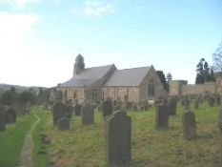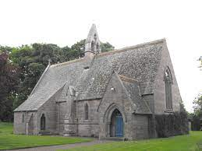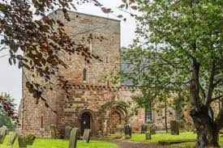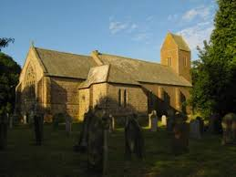
The Flake Parishes of
Ford, Lowick, Ancroft, Kyloe and Etal

A very warm welcome to you, especially if you are visiting.
Please take this sheet home with you and use it as a basis for prayer.
Children are welcome in all our services.

Sunday 4th January 2026
Epiphany
Lowick 9.15am Family Communion
Etal 11 am Holy Communion

Sunday 11th January 2026
Baptism of Christ, Plough Sunday
Lowick 9.15am Holy Communion
Etal 11am Service of the Word

Sunday 18th January 2026
Lowick 9.15am Holy Communion
Etal 11 am Holy Communion

Sunday 25th January 2026
Conversion of Paul
Lowick 9.15am Holy Communion
Etal 11am Holy Communion

We remember this month those whose funerals have been taken in the last 5 years, and those who mourn them: Andy Stockdale, David Clark, Alan Holmes, Nellie Stewart, Gregor Rutherford, Lesley Stoker, Tony Haigh, Edna Sim, Rita Oliver, Robin Reavley, Christopher Duncan, Janet Hogg.
Please pray for Andrew Watson, Heather Piper, Chloe French, George Hall, Gail Calder, Sam Quilty.

Licensed Clergy
Revd Charlotte Osborn (Vicar) 01289 388591 ceosborn@mail.com 07957 367457
Revd Alex Firman (Assistant Curate) 07935 732811
alex_firman@hotmail.co.uk

Parish Contacts
Ancroft Leigh Yorke 07716 116739
Etal Andrew Joicey 01890 820540
Ford Kathleen Holmes 07951 099668
Lowick Niall Cartlidge 07850 876246

Websites: www.achurchnearyou.com
Instagram: https://www.instagram.com/the_flake_churches/
Facebook: the_flake_churches

Other licensed clergy
Revd Margaret Sentamu 077871 204745, Canon Nick Sagovsky, Revd Marion Penfold 01289 305664
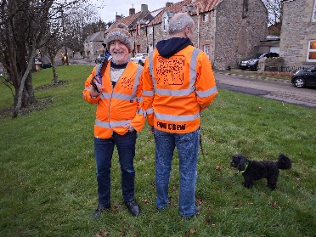
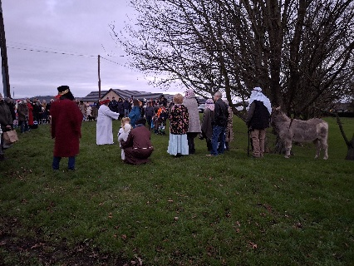
What a wonderful celebration Christmas has been. Numbers up at all 3 carol services, Midnight Communion and Christmas morning at Lowick and at Ford, despite the change from Etal. Good News for the Common People, i.e. the people on the common at Lowick, also saw a record crowd of around 200 as were enacted the nativity. Sheep and alpacas and Freddie the donkey were all in attendance, as were the ‘poo crew’.

Having welcomed the light of Christ into the world, which the darkness of this age cannot and will not overcome, we turn our thoughts in January to the Epiphany, the manifestation of the Saviour to the whole world. January also marks the Baptism of Christ, the week of prayer for Christian unity, the conversion of Paul and in rural parishes, Plough Sunday, which will be marked at Etal on Sunday 11th at 11am.

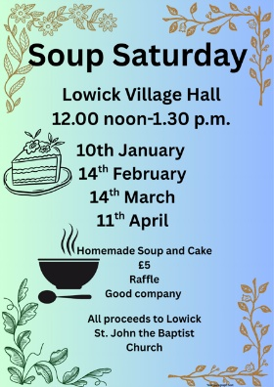
Soup Saturday returns to Lowick Village Hall on 10th January at 12 noon.

Men’s Breakfast is the first Saturday of every month in The White Swan, Lowick. Kevin is the contact should you wish to join this 07530 000941.

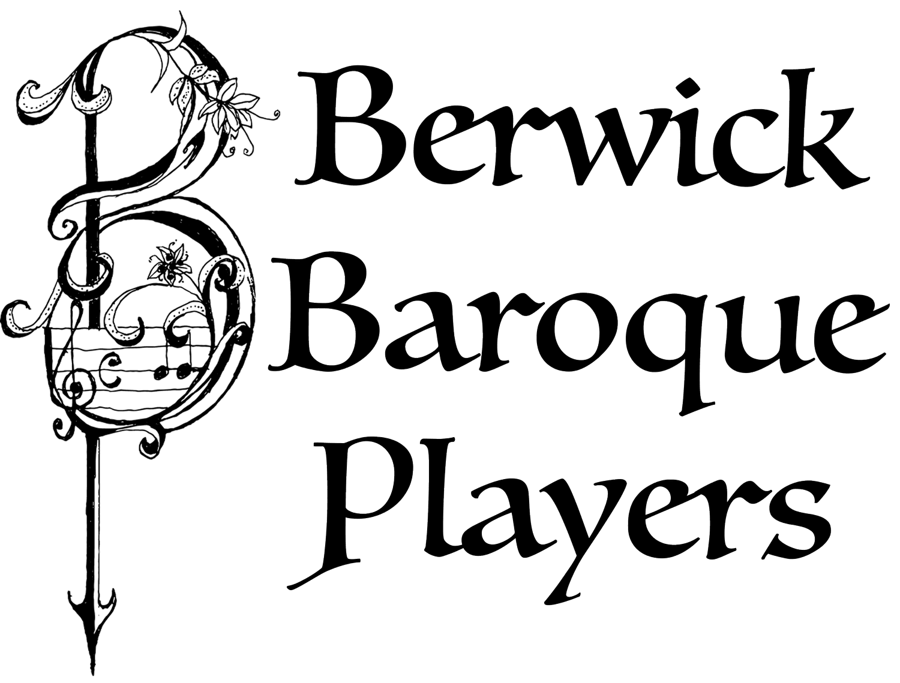
On Thursday 22nd January from 6-7.30pm
we are kindly invited by George and Jane Farr to Pallinsburn House for drinks and canapes and a New Year Concert given by the wonderful Berwick Baroque. Monies raised will go towards the installation of a much-needed loo and servery in Ford Church. Tickets booked with Rosanna on RMcCorkell@savills.com or from Charlotte.

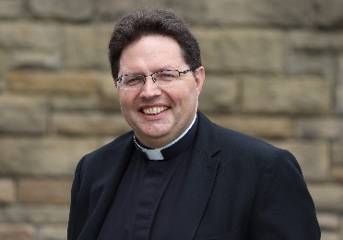
Finally, please mark the date of Saturday January 31st when the PCC’s from all our parishes will meet for a morning of prayer and vison casting with The Very Revd Lee Batson, Dean of Newcastle Cathedral, at The Hemmel on Fenham Farm. As we look out to Lindisfarne, so we hope to continue to build on the foundations laid by Aidan and Cuthbert for the churches in our parishes as we trust God for the future. 9am until 1pm, primarily for PCC members but open to others who would like to be part of this – please all register with dee.colam@gmail.com since there will be a breakfast roll and lunch provided!

