Sunday 7th December 2025 St Paul’s, Woodhouse Eaves
WE WELCOME YOU, for we are all one in Christ Jesus

MISSION  Our Mission Statement  Our Mission is to make known the Gospel and love of Jesus Christ. We hope that you experience us as a safe, sacramental, welcoming, loving and inclusive Kingdom people who seek to make Christ present in the hearts of all.  Safeguarding  The parishes of St Paul’s, Woodhouse Eaves & St Mary’s, Woodhouse, are committed to the safeguarding of children, young people and adults. We follow the House of Bishops’ guidance and policies, and have our own Parish Safeguarding Officers. If you are concerned that a child or adult has been harmed or may be at risk of harm please contact –  ST PAUL’S - Safeguarding  Co-ordinator: Tony Lane  07977 924 677  ST MARY’S - Safeguarding  Co-ordinator: Andrea Farnsworth 07958 376 963  As a Benefice, we affirm that it is about not just a set of policies and procedures, but about all of us as the body of Christ sharing the responsibility for making God’s Church as safe as we can  PRAYER  If you would like someone to listen or to pray with you, please contact your Parish Priest:  Rev’d Lisa Temperley-Barnes - 01509 890 972  If you would like us to pray for someone by name in our Sunday services and through the week, please email Rev’d Lisa or Stephen  Let us use our time  before the service  to talk to God,  during the service  may God talk to us, and  after the service  let us talk to one another |  | We pray for all who are ill  for Dennis, Amelia, Gill Kelly, Vincent Riley, June Taylor,  Tom Hobbs, Joyce Lane, Di Alsop,  Sue and John Thorne, Jean Sury,  June Shilton, Joseph Breed  We remember before God  the faithful departed,  and from St Mary’s  Book of Remembrance  Ida Emily Mee, Jean Mabel Gamble, Robert Andrew St George Martin  and from St Paul’s  Book of Remembrance  Alan Tapper, Irene Mary Corbett, Betty Evelyn Batchelder, Michael John Barker, Frederick Albert Wilson-Whitford, Margaret Hall, Olwyn Allen  Rest eternal grant unto them, O Lord, and let light perpetual shine upon them. May the souls of the faithful departed through the mercy of God, rest in peace and rise in glory. Amen  THANK YOU!  We raised £1008 for AfghanAid! A very big Thank You to everyone who supported the Art Exhibition and Cake Sale, and who supported Rev’d Lisa and her 200-mile run, donating so generously |  | SAVE THE DATES!    
  Advent Meditation
  - ‘Making Room for Jesus’
  Advent encourages us to reflect on the Virgin Mary, who gave space in her body for the Christ Child to grow. Advent challenges us also to make space… to make room in our hearts and lives for Jesus. Do join us at St Paul’s for Meditation followed by Compline on the following dates starting at 7.00pm:
  - Wednesday 3rd December
  - Wednesday 10th December
  All are very welcome. See
  you there … Rev’d Lisa
  CHRISTMAS SERVICES
  We look forward to welcoming you to our Christmas services!
  St Mary’s
  - Sunday 14th at 6pm: Service of 9 Lessons & Carols
  - Christmas Eve at 8pm -
  Midnight Mass
  St Paul’s
  - Sunday 21st at 6pm: Service of 9 Lessons & Carols
  - Christmas Eve at 2pm -
  Crib Service
  - Christmas Eve at 10pm - Midnight Mass
  - Christmas Day at 10am -
  Sung Eucharist
  £2.50 per adult, children free!
  Tea, coffee & biscuits - £1.50
  6th - 7th December
  12.00 - 5.00pm
Advent 2 Sung Eucharist
COLLECT  O Lord, raise up, we pray, your power and come among us, and with great might succour us; that whereas, through our sins and wickedness we are grievously hindered in running the race that is set before us, your bountiful grace and mercy may speedily help and deliver us; through Jesus Christ your Son our Lord, to whom with you and the Holy Spirit, be honour and glory, now and for ever. Amen  FIRST READING  A reading from the prophet Isaiah  The royal line of David is like a tree that has been cut down; but just as new branches sprout from a stump, so a new king will arise from among David's descendants.  The spirit of the Lord will give him wisdom and the knowledge and skill to rule his people. He will know the Lord's will and honor him, and find pleasure in obeying him. He will not judge by appearance or hearsay; he will judge the poor fairly and defend the rights of the helpless.  At his command the people will be punished, and evil persons will die. He will rule his people with justice and integrity. Wolves and sheep will live together in peace, and leopards will lie down with young goats. Calves and lion cubs will feed together, and little children will take care of them.  Cows and bears will eat together, and their calves and cubs will lie down in peace. Lions will eat straw as cattle do. Even a baby will not be harmed if it plays near a poisonous snake. On Zion, God's sacred hill, there will be nothing harmful or evil. The land will be as full of knowledge of the Lord as the seas are full of water. A day is coming when the new king from the royal line of David will be a symbol to the nations. They will gather in his royal city and give him honour.  Isaiah 11:1-10  This is the word of the Lord  Thanks be to God |  | PSALM 72  Refrain: The Lord is king; let the earth rejoice  - Give the king your judgements, O God, ♦  and your righteousness to the son of a king.  - Then shall he judge your people righteously ♦  and your poor with justice R  - May the mountains bring forth peace, ♦  and the little hills righteousness for the people.  - May he defend the poor among the people, ♦  deliver the children of the needy and crush the oppressor R  - May he live as long as the sun and moon endure, ♦  from one generation to another.  - May he come down like rain upon the mown grass, ♦  like the showers that water the earth.  - In his time shall righteousness flourish, ♦  and abundance of peace  till the moon shall be no more R  Glory be to the Father, and to the Son, and to the Holy Spirit: as it was in the beginning, is now, and ever shall be, world without end. Amen  GOSPEL  Alleluia, alleluia  “Speak, Lord, your servant is listening. You have the words to eternal life.”  Alleluia  Hear the holy Gospel of our Lord Jesus Christ according to St Matthew  -  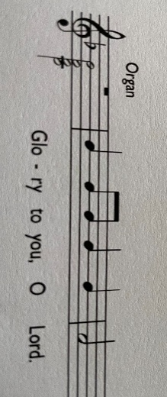  In those days John the Baptist appeared in the wilderness of Judea, proclaiming, ‘Repent, for the kingdom of heaven has come |  | near.’ This is the one of whom the prophet Isaiah spoke when he said, ‘The voice of one crying out in the wilderness: “Prepare the way of the Lord, make his paths straight.”’ Now John wore clothing of camel’s hair with a leather belt around his waist, and his food was locusts and wild honey. Then the people of Jerusalem and all Judea were going out to him, and all the region along the Jordan, and they were baptized by him in the river Jordan, confessing their sins. But when he saw many Pharisees and Sadducees coming for baptism, he said to them, ‘You brood of vipers! Who warned you to flee from the wrath to come? Bear fruit worthy of repentance. Do not presume to say to yourselves, “We have Abraham as our ancestor”; for I tell you, God is able from these stones to raise up children to Abraham. Even now the axe is lying at the root of the trees; every tree therefore that does not bear good fruit is cut down and thrown into the fire. ‘I baptize you with water for repentance, but one who is more powerful than I is coming after me; I am not worthy to carry his sandals. He will baptize you with the Holy Spirit and fire. His winnowing-fork is in his hand, and he will clear his threshing-floor and will gather his wheat into the granary; but the chaff he will burn with unquenchable fire.’  Matthew 3:1-12  This is the Gospel of the Lord  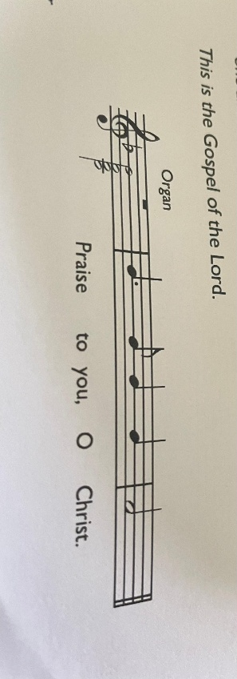  POST-COMMUNION PRAYER  Father in heaven, who sent your Son to redeem the world and will send him again to be our judge: give us grace so to imitate him in the humility and purity of his first coming that, when he comes again, we may be ready to greet him with joyful love and firm faith; through Jesus Christ our Lord. Amen

