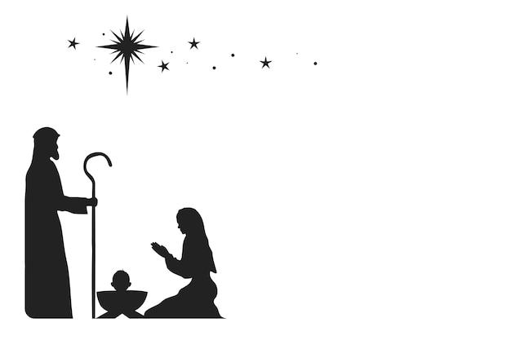
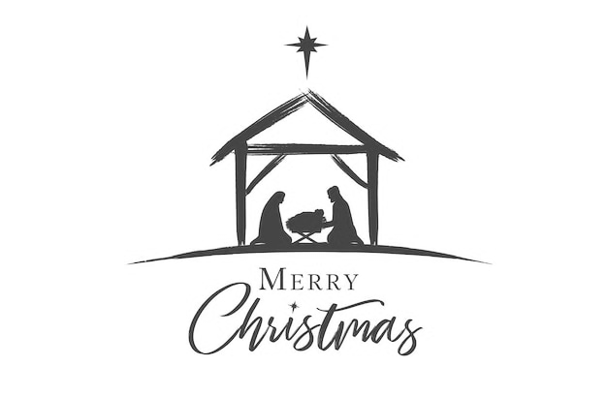
&
Blessings
from Fr Tony & Jules.
Christmas Services
for the
Society Parishes.
December 2025

Christmas Services for the Society Parishes, Christmas Services for the Society Parishes,
December 2025 December 2025

4th Thursday 6:30pm. Crematorium Lights of Love Service. 24th Wednesday 3pm Christmas Eve Service at St Albans

9th Tuesday 6pm Christingle & Carol Service at The Good Shepherd. 24th Wednesday 11.30pm Midnight Mass at
Followed by mince pies and Mulled wine The Good Shepherd.

21st Sunday 3pm Nine lessons & Carols at All Saints Godshill
With Nativity. 25th Thursday 9am Said Service at St Albans. (Fr Tony)

21st Sunday 6:30pm Nine Lessons & Carols at St Saviours, 25th Thursday 10:30am Sung Service All Saints Godshill. (Fr
Followed by minces Pies and sherry, Tony)

25th Thursday 11am Sung Service at St Saviours. (Barry Downer)

26th Friday 11am Said Service at All Saints, Godshill.

28th Sunday 9:30am Said Service at St Albans.

28th Sunday 11am Sung Service at All Saints Godhill.

28th Sunday 11am Service of the Word at St Saviours.

