GRATWICH NEWSLETTER  DECEMBER 2025  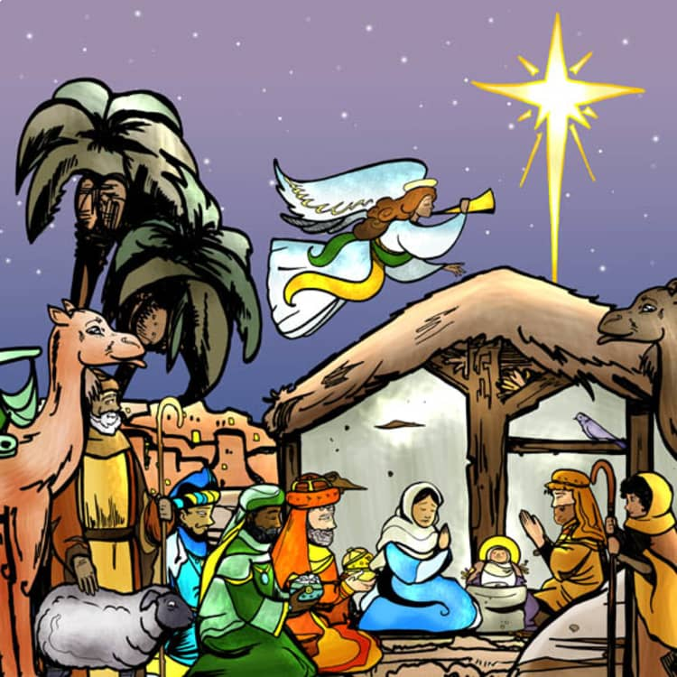  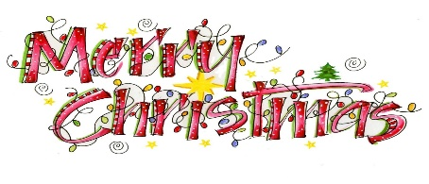  CLEANING ROTA  Carol Woolley & Jenny Talbot  EVENTS IN DECEMBER – OTHER PARISHES  WELLIES PROJECT COFFEE MORNING 3rd 11am – 1.30pm  In Uttoxeter Heath Community Centre, Holly Road, Uttoxeter ST14 7DP  Craft and other stalls, Raffle & Refreshments  CAROL CONCERT 4th 9.45am at Talbot 1st School Kingstone  Join the children for songs & a mince pie in the school hall to celebrate Christmas. Raffle tickets will be on sale too. Book a seat by telephoning the school 01889 500273  CHRISTMAS MUSIC 6th 7.00pm at Checkley Church  The Heath Chorus will be performing Christmas Music.  Entrance £5 on the night Light refreshments  CHRISTMAS FAIR 7th 10.00am – 3.00pm Uttoxeter Heath Community Centre  Stalls, Raffle and Refreshments Santa’s Grotto & Christmas Crafts(£7.50 per child)  To book a place at Santa’s grotto Email: manageruhcc@gmail.com  CHRISTINGLE SERVICE 10th 2.40pm St. John’s Church, Kingstone  Join the children of Talbot 1st School in Kingstone for a Christingle Service in church  Tea & Cake will be served beforehand at 2.15pm  CHRISTMAS TIDE 13th 7.30pm at St. Peter’s Church, Marchington ST14 8LJ  A Christmas concert by The Marchington Singers  Tickets: £10 (inc Refreshments) from Marchington Shop  CHILDRENS CHRISTMAS PARTY 14th 12noon – 2.00pm  Marchington Woodlands Village Hall  Games, tombola, music & storytelling, a buffet meal for children.  Santa arriving at 2.00pm. refreshments for adults  To book email: p.harrison251@btinternet.com   CHRISTMAS TREE FESTIVALS in DECEMBER  7th – 14th St. Lawrence Church, Bramshall 11.00am – 7.00pm daily  18th – 23rd St. Mary’s Church, Uttoxeter 10.00am – 2.00pm | DECEMBER SERVICES IN ST. MARY’S  SUNDAY 14th 11.15am HOLY COMMUNION  CHRISTMAS EVE CRIB SERVICE 7.00pm  With Mulled wine & Mince Pies  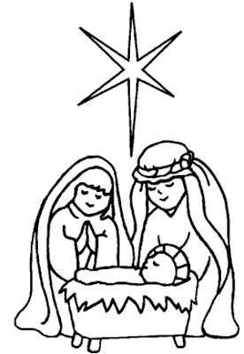  We had a brilliant evening last month at our Quiz – 11 teams! David did an amazing job  on the questions again and Margaret a sterling job adding up the scores.  Thank you so much to Carolyn and Kate for all their help, all who donated raffle prizes  and everyone who came along, making it so successful and raising £583 for church funds.  Now we are looking forward to all the Christmas Fairs, Carol Concerts and Christmas Tree exhibitions around the churches in the area. Gratwich are not having a Carol Singing Evening this year but will be holding the Crib Service at 7.00pm on Christmas Eve.  Put on your best Christmas jumpers, hats, nativity costumes and join us for the traditional readings, carols and dressing the crib – a lovely way to get ready for Christmas Day.  We will be having mulled wine and mince pies afterwards.  AREA SERVICE – 28th December 10.00am  This year the Christmas Area Service is at St. Mary’s Church in Uttoxeter Market Place.  A joyous occasion with lots of singing!  GRATWICH 100 CLUB – October & November  1st Ruth Adams (20) 2nd Lydia Downing (26) 3rd Molly Cotton (16)  1st James Chapman (90) 2nd Donna Morrin (62) 3rd Amber Threlfall (75)  December will be drawn at the Crib Service on Christmas Eve  AREA LETTER - Broken or Blessed?  I recently had the experience of spending two nights in Stranraer hospital after a fall, being knocked out and having an intra-cranial bleed and concussion. The care I received at every level was excellent, from the student paramedic who meant me feel I was in safe hands; the A&E doctor who sorted me out with a CT scan, ECG and chest X-ray, all within a few hours; the cleaning staff who spruced up the ward on both days; the nurses who woke me up throughout the night to take observations. The only slightly iffy part was the salt porridge but if that’s the extent of my grumbling, then I’m not grumbling.  However, politicians, commentators and journalists are regularly telling us that the country is ‘broken’. The NHS is ‘broken’, the welfare system is ‘broken’, the immigration system is ‘broken’ and now the prison service is ‘broken’. Such negativity is wearing and, I think, does a disservice to the people working in those institutions. Problems – yes; the need for more funding – yes; inefficiencies – yes; pressures – yes. But broken?  The UK has the fifth largest economy in the world, the 6th largest average Gross Domestic Product, protects its citizens through huge welfare and heath budgets, an independent judiciary and a free press, parliamentary democracy and – apart from aberrations such as at the Manchester synagogue – the right to worship (or not) without recrimination. Broken or Blessed?  It strikes me that politicians and commentators use that word to either dramatize a story, or to present a narrative from which they can then charge in like shining knights to fix, having blamed the previous government or the institution itself.  Church often talks in terms of ‘brokenness’. An ongoing theme in theology is that we are all broken, we are all sinners, we are all a bit rubbish in relation to God. I don’t buy it. In my view God did not create us to feel a bit rubbish, to feel broken. In John 10:10 Jesus says,  “The thief comes only to steal and kill and destroy; I have come that they may have life, and have it to the full.” (New International Version)  On the whole we are Blessed, not Broken. Problems – yes; pain – yes; hunger – for some at times; abuse – appallingly, yes, at times; joy – yes; friendship – yes; kindness – yes. We need to acknowledge what we are good at, what works well and deal with our difficulties better. Then maybe with a narrative of Blessings rather Brokenness, we can move away from a culture of blame and criticism.  Peace and prayers,  Rev. Joe Cant  Team Vicar, Uttoxeter Area of Parishes Tel.No. 07592 206706  For further information on Newsletter items please contact:  Jenny Talbot: 01889 502471 email: CHURCHGratwich7@outlook.com  Facebook: St. Mary’s Church Gratwic

