
SPIRE & LIGHT United Churches
United Benefice of St Keverne, St Ruan with St Grade & St.Wynwallow (The Lizard)

*If you do not wish to receive these notices, please let your Churchwarden know*

14th December 2025
ADVENT 3


Readings
Isaiah 35:1-10
Psalm 146:4-10
James 5:7-10
Matthew 11:2-11

9.30am – Morning Prayer – St.Peter’s, Coverack
11.15am – Café Church Carols – St.Wynwallow, The Lizard

3pm – Christingle – St.Grade
4pm – Carol Service – St.Keverne Church
6pm – Carol Service – St.Ruan, Ruan Minor

Next Sunday Dec 21st Advent 4
9.30am – Holy Communion – St.Wynwallow, The Lizard
11.15am – Family Service – St.Ruan, Ruan Minor
3pm – Nativity – St.Mary’s, Cadgwith
4pm – Carols by Candlelight – St.Peter’s, Coverack




The Prayer Spot
Lord Jesus Christ, as we pray today, please be with us and guide us in all we do and say in your wonderful name.
Help us to remember that you are a God who cares, who understands and who meets all our needs. We pray for the benefice and Deanery we belong to and we thank you for the faithful people you have brought together.
Remind us that we have been brought to faith by our saviour Jesus Christ to enjoy our time together. We thank you Lord Jesus for your presence in our lives and the love you have given us to share with others. Keep us strong in our faith and close to you. Help us to be always there for others in their time of need.
You have given us gifts to use, to reach out to give comfort to those around us who are in need.
Heavenly Father we live in a world that is slowly destroying itself, through greed, hatred and with no care or concern for others. Remind us that we can bring love, care and understanding into the world by reaching out into our communities and showing our love to all. We pray for those in our communities who need Gods help as they care for others, for those in need of hospital care but also those who look after them.
Loving God, be with us always. Remind us daily we are brothers and sisters in Christ, that God is ever present in our lives, through his wonderful Holy Spirit that he gives us freely. God Bless you all
O Lord our rock and Redeemer, guide our thoughts and our words in our discussions today. Let our hearts be filled with your praise. Let us never forget the good things you do for us. You have forgiven our sins. You have rescued us from death. You have crowned us with love and tender mercies. Renew our strength and refresh our souls. Through Jesus Christ our Lord, Amen Sam Buchanan
The Diocese of Truro’s Prayer Diary for this week
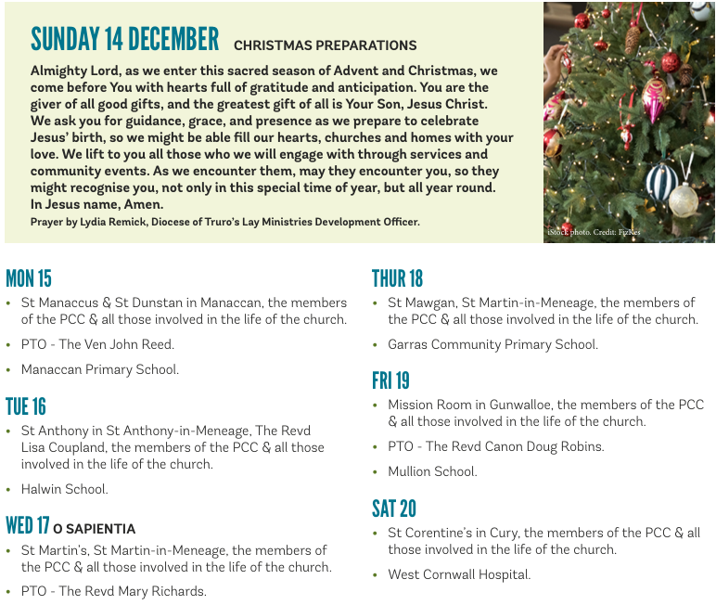

On the Way Prayers

God of hope, who brought love into this world, be the love that dwells between us.
God of hope, who brought peace into this world, be the peace that dwells between us.
God of hope, who brought joy into this world, be the joy that dwells between us.
God of hope, the rock we stand upon, be the centre, the focus of our lives always, and particularly this Advent time.

Now, halfway through Advent let us pause and breathe. Let us still our minds as we pray Lord for your help at this busy time. And may we all be filled with hope, not just for the coming season, but for the future of your church here in Kerrier.

We give thanks for the great words of comfort and joy that we hear in our church services, through our carols and even through our televisions and radios. Lord you have given us the great gift of music, and we give thanks for the Bible passages that have inspired so much of the choral music that we are hearing at the moment. We pray for all the carol services that will take place within our Deanery over the coming days, giving thanks for the An Lysard choir which brings singers together from all over our Deanery. And we pray for the service of Nine Lessons and Carols in Cury Church on Monday.

The challenging weather and Storm Bram have brought travel disruption and flooding in our Diocese as well as more widely in the West. Let us pray for all who have to travel at this time of the year and all whose lives are disrupted and distressed by this quite violent weather. Let us continue to pray for our planet; that we may all do what we can to use resources carefully and to consider our impact, however small, of our actions, on the environment.

As Australia has taken the bold step of banning social media for under 16s, let us pray for all our young people; that they can be kept safe from harm. We pray for our schools at this busy time, and give thanks for all the joint work that we are able to do with them during this Advent period.

Let us pray for all who mourn at this time, remembering Christmases with loved ones. We pray for all who feel lonely at Christmas, for all who are suffering with the aches and pains of old age and all who are anxious that this is may be theirs or a loved one’s last Christmas. God of hope, help us all to hope for peace at Christmas. Peace in this world, peace in our communities, our churches, our homes and most of all, within our hearts.

As our prayer time comes to a close, we give thanks. Thanks that you have been among us, listening to our prayers and that we can be confident that you will answer them, when the time is right. May heaven come close and angels surround us with Christ’s pure light. Amen

