NEWSLETTER NUMBER 300



+ =

Here we are at Newsletter Number 300 and it is a far cry from Newsletter Number 1. ITt was started to keep us all in contact as covid restrictions came into force and all churches were required to be locked.. It was particularly sad as the first Sunday of the restrictions was Mothering Sunday. Newsletter Number 1 was just one side of A4 paper

OUR SERVICE ON SUNDAY 14TH DECEMBER 2025 – 3rd SUNDAY OF ADVENT
Please note that there is no morning service at All Saints. Instead, we are going to hold a Carol Service amongst the trees at 3.00 p.m. today. This is a traditional service of well-known carols and readings. Mince pies and mulled apple juice will be served after the service so you will have the opportunity to chat and look at all the decorated trees.

LOOKING FORWARDS – REV ANDY
I hope you are enjoying the daily opening of doors on an Advent Calendar. As morning rituals go, the daily excitement of what will be behind today’s door is not a bad one. Perhaps you even have a calendar with the gift of chocolate inside, fabulous! Advent is a wonderful season of anticipation ahead of Christmas. The word Advent means “awaiting the coming of something or someone” and, throughout December, churches will be celebrating the anticipated arrival of the baby Jesus. We will be counting down the days until the familiar nativity story unfolds on Christmas Day.
Advent can also be understood as “the time when something new begins”. In the church we anticipate the day when all things are made new, when all tears are wiped away, when suffering and death will be no more. Now that really will be fabulous.
Each week as we count down towards the nativity story, we remind ourselves that the God who was revealed 2,000 years ago as a vulnerable baby, will one day return and fully reveal the heavenly life which we enjoy only in part at the present time. Rather like the presents that you will be gathering under your Christmas tree, which contain promising gifts that for now you can touch, but not see fully, life in the church allows us to get a feel of what heaven on earth will be like, whilst not fully comprehending it just yet.
Part of our vision as a family of seven village churches is to be a community where people encounter God. I hope that you can see touches of heaven in your church life. Whether it be the warmth of friendship, the blessing of lives that are flourishing or the healing of past hurts, I hope that life is full of promise for you.
If you would like to join us as we explore the Advent story and celebrate the joy of Christmas, then you are most welcome to come to any of our services this December. We are laying on a range of events for young and old, frequent church visitor or first timer. You will find details online at achurchnearyou.com and www.westtone.org.uk/services.
Each Sunday we will be lighting Advent candles to mark off the weeks until Christmas. Rather like the doors on Advent Calendars they mark the time passed throughout the month as we draw closer to the Christmas celebrations. The candles represent characters in the Bible story that leads to the birth of Jesus. Amidst the candlelight we will sing familiar Advent carols and let the excitement build. That too really will be fabulous.
ROTA FOR SUNDAY 14TH DECEMBER 2025
Sidesmen:- Jacquie Hockaday and Ann Fry
Reader:- Various readers at the Carol Service
Coffee:- Jacquie Hockaday and Ann Fry
Flowers:- None as it is Advent

READINGS FOR SUNDAY 14TH DECEMBER 2025
Collect:- O Lord Jesus Christ, who at your first coming sent your messenger to prepare your way before you: grant that the ministers and stewards of your mysteries may likewise so prepare and make ready your way by turning the hearts of the disobedient to the wisdom of the just, that at your second coming to judge the world we may be found an acceptable people in your sight; for you are alive and reign with the Father in the unity of the Holy Spirit, one God, now and for ever. Amen

Readings:-
Isaiah Chapter 35, vv 1 – 10
James Chapter 5, vv 7 – 10
Matthew Chapter 11, vv 2 – 11

PRAYER LIST
Chris Monckton
Elizabeth Miles
Eunice Durrance
Ian Sansom
John Wilkie
Mike Toogood
Pam Wilkie
Paul Tatnall
Stephen Daley
Susan Dobson

YEARS MIND FOR DECEMBER
18TH Patricia Eirene Rosemary (Pat) Rycroft
19TH Jeffrey Jones
19TH Edward (Ted) Frederick Hollick
BIRTHDAY LIST FOR DECEMBER
19TH Henry Yates
We hope you have a great birthday and have some time off to enjoy it.

OUTREACH GROUPS
Soup ‘n’ a Bite
The next meeting of this group will be on Saturday, 13th December 2025 at 12.00 noon. This will be the Christmas lunch and you must sign up for it. The list is on the Sidesman’s table in church. It will be back to the normal fare of soup, bread and various cheeses for the following meeting, which will be on Saturday, 10th January 2026 at 12.00 noon.

Recycled Teenagers
There will be no meeting in December as it is too close to Christmas. The next meeting will take place on Tuesday, 27th January 2026 at 2.30 p.m..

Knit, Sew and Natter
The next meeting will be on Thursday, 5th February 2026 at 2.00 p.m. It will be the usual meeting with lots of chat and refreshments.
OUR NEXT SERVICE
This will be a Sung Eucharist starting at 11.15 a.m. on Sunday, 21st December 2025. The celebrant will be Rev David Burton. There will be coffee and chat after the service.

FORTHCOMING EVENTS
All Saints – 13th and 14th December from 2 .00 to 5.00 p.m. – Christmas tree festival
This will be a two-day event with the trees staying up until the school has had its two mid-week Christmas services in the church.

All Saints – 24th December – Christingle/ Crib service 4.00 p.m. (3.00 p.m. make Christingles)
This annual event will take place as normal led by Rev Andy Barton.

Christmas Day – 25th December
There will be a Said Communion service with carols starting at 9.30 a.m. The celebrant will be Rev David Burton. There will be no refreshments afterwards on this occasion.
OTHER INFORMATION
Fund Raising Committee
The committee will soon be meeting to plan the social and fund-raising events for 2026. If you would like to join them, please let me know so you can be invited to the meeting. If you have any good ideas, please let me know so they can be discussed and programmed into the calendar.

From Rev Andrew Norris
The Home Service this week: We join the church of St Nicholas, Kittisford as it celebrated its Patronal Festival with a special service of Choral Evensong led by Revd. Andy Barton,
involving a specially formed community choir, the choir of Rockwell Green Primary school and the Bute Voices.

FUN CORNER
Last Sunday I went to Taunton for a concert and, following lunch, had a chance to look around. I spotted two items on display that gave me a chuckle and I hope they amuse you as well.

I think this one is a case of overkill and the place caters for men only!



Whoops, someone did not check the proof!

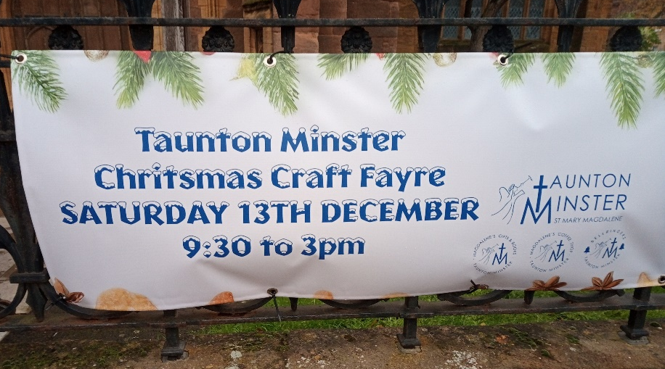

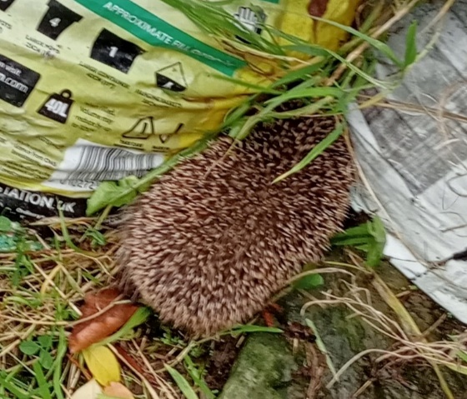
Ann Goodfield has sent me a photo of the recent intruder in the churchyard - a big Rockwell Green welcome to Mr or Mrs Tiggywinkle.

The American comedienne Anita Rudner said
“If you mix flour and water, you get glue;
if you then add eggs and sugar, you get cake
but” she asked “what happened to the glue?”

