MASS & SERVICE TIMES THIS WEEK

SUNDAY 28TH DECEMBER
THE HOLY FAMILY OF JESUS,
MARY AND JOSEPH

PARISH MASS
10 AM
Celebrant: Father Grantley Finlayson

MONDAY 29TH DECEMBER Holy Hour 10 am

TUESDAY 30TH DECEMBER Mass 11 am
Celebrant: Father Diego Galanzini

SUNDAY 4TH JANUARY 2026
SECOND SUNDAY AFTER THE NATIVITY
Parish Mass 10 am
Celebrant: Father Chris Burrows

Parish Priest
In Vacancy
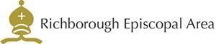



Please contact the churchwarden: Valerie Rice 07946 175105

Email: marshfarmholycross@gmail

