St Mary the Virgin & All Souls Church
Highbury Road, Bulwell, Nottingham
NG6 9AD

“THE CHURCH ON THE HILL”
PARISH MAGAZINE
January 2026 Vol. 156 No 1

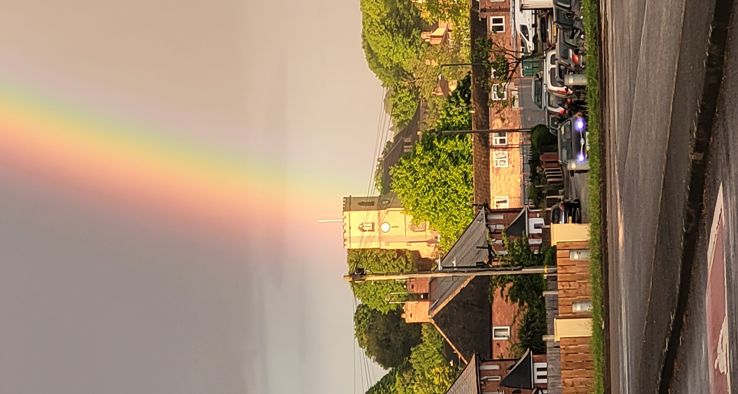
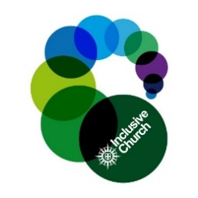

St Mary’s is a down-to-earth Christian Community seeking, serving and worshipping God by sharing the love of Jesus
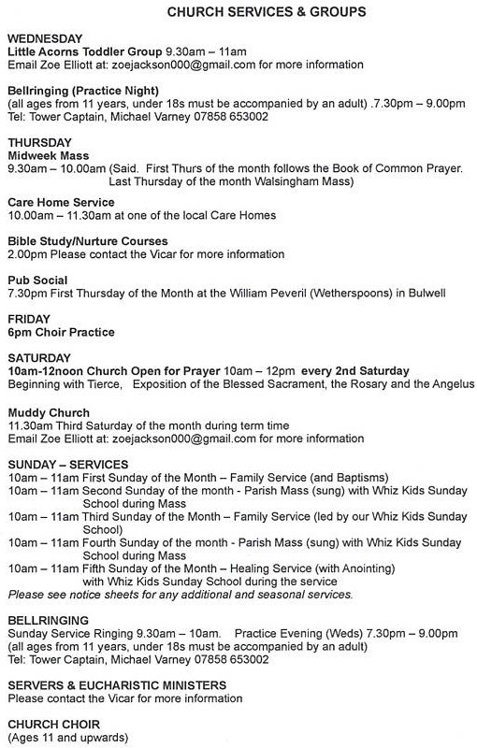
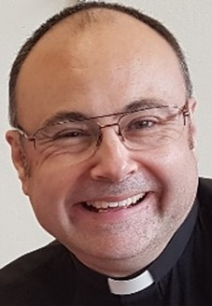
Your Vicar Writes

Happy New Year! I hope you had a wonderful Christmas. In January we celebrate Epiphany, the occasion on which we remember the Magi from the East following a star to find the baby Jesus: ‘Where is the One who has been born king of the Jews?’ (Matthew 2:1).

At the start of a New Year, in an uncertain world, we might be asking the same question. The gifts the Magi offered point us to how Jesus can answer our concerns and worries: ‘they bowed down and worshipped Him…and presented Him with gifts of gold, frankincense and myrrh.’ (2:11).

The gift of gold reflects that the Magi saw in the baby a king, destined to rule over us all. In this coming year we need to remember that Jesus is on the throne, the seat of power and authority in the whole universe. Will we crown Him king of our lives and dedicate all that we are and do to Him?

The gift of frankincense reflects that the visitors saw not just an earthly king, but God in human flesh. Incense symbolises the prayers of God’s people and so this gift reminds us that God is worthy of our worship and prayer. Will we offer our praise and prayer, as we seek God to guide us through the uncertainties of this coming year?

The gift of myrrh reflects that these astrologers saw beyond the baby’s birth and life, to His death which would secure life for all. Jesus was offered myrrh on the cross and was a spice used in His tomb. As we face challenges in the future, we can be confident that Jesus knows and understands our experience. Are we ready to trust Him in everything?

‘Glorious now behold Him arise, King and God and Sacrifice! Heav’n sings Hallelujah: Hallelujah the earth replies.’ (‘We Three Kings’).
God bless you this New Year and always, Fr Andrew.
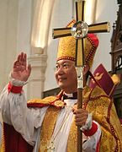
Anglicans in Hong Kong offer prayers and support in aftermath of deadly fire

“Pray with us,” the Archbishop of Hong Kong, the Most Revd Andrew Chan, has asked, following a horrific fire in seven residential tower blocks in Wang Fuk Court, in Tai Po. At least 146 people were killed. The complex was home to about 4600 people, and in addition to those killed, dozens have been critically injured, and others are still missing.

Community organisations – including the Hong Kong Anglican Church, known as the Hong Kong Sheng Kung Hui (HKSKH) – have rallied to support those displaced by the fire. The HKSKH’s Welfare Council has launched a disaster support fund, and an HKSKH church centre in Tai Po has been opened to provide a shelter for people now made homeless by the fire.

Archbishop Chan said: “As fellow children of God, even though we are separated by geographical distances, I ask of you to pray with us in Hong Kong for the mercy and love of our Lord,” he said.

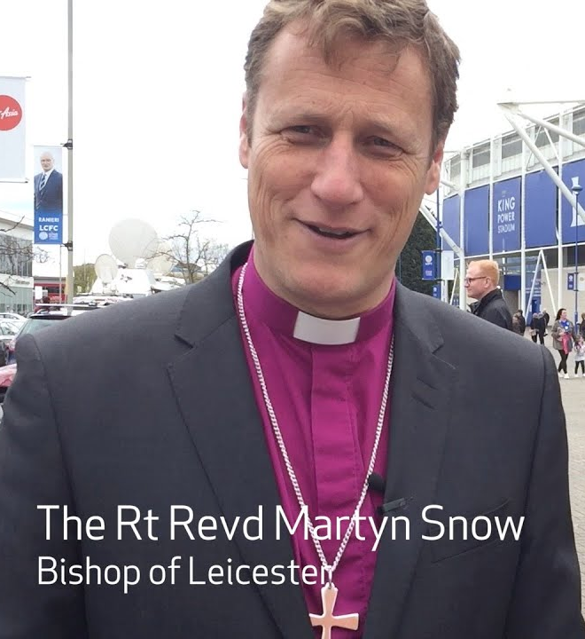
Bishop Martyn Welcomes End of Two-Child Limit
Following the recent announcement in the Budget, the Bishop of Leicester, Martyn Snow, the Church of England’s lead bishop for child poverty issues, has said:

“I warmly welcome the Government’s decision to remove the two-child limit from next April. This will make a profoundly positive difference to hundreds of thousands of children and their families. The Church of England has long called for this day as we believe in the equal and unsurpassable worth of every single child. As we celebrate the end of the two-child limit and commend the Government for taking action, we will continue to draw attention to the barriers – such as the household benefit cap – which still prevent many families from accessing vital support for their children.”

Archbishops’ Council Response to Charity Commission Case Review

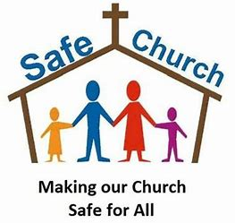
The Archbishops’ Council has welcomed the findings of the recently published Charity Commission case review on safeguarding improvements. A spokesperson said:

“It provides valuable clarity to support ongoing improvements in our work. We are reassured by the Commission’s finding of no evidence of mismanagement or misconduct, and that the Commission recognises the charity has made progress and delivered positive changes in safeguarding practice in recent years. Our priority in all our work remains to respond well to victims and survivors. This commitment continues to shape every aspect of our safeguarding work.”

The Archbishops’ Council is “immediately focused on building on the work undertaken over the past decade,” including the introduction of independent safeguarding audits, comprehensive safeguarding training for all who work in the Church (paid or voluntary), and ensuring Church bodies have safe and healthy cultures.”
The Archbishops’ Council is also committed to the implementation of further safeguarding reforms, particularly in governance, with detailed proposals to be brought to the next General Synod to ensure sustainable and long-lasting best practice.

The Bishop of Tewkesbury, Robert Springett, is to be the Church of England’s new Lead Safeguarding Bishop, taking over from Bishop Joanne Grenfell who leaves the role at the end of March 2026, when her three-year term ends. Bishop Robert will work closely with the National Director of Safeguarding and other members of the National Safeguarding Team. Bishop Robert said, “Safeguarding should not be seen as a burden, but embraced with joy for the opportunity it offers to serve others.”

Church of England Weddings at Historic Low

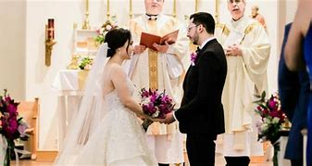
The Church of England conducted fewer weddings than ever in 2023, as the number of people in England and Wales getting married in religious ceremonies has slumped to a new low.

In 2023, 23,004 marriages were recorded by the Church of England and Church in Wales, according to recent data from the Office of National Statistics (ONS). It is the lowest number since the 1830s, except for 2020, when churches were closed during the pandemic. In total, 216,901 weddings of opposite-sex couples took place in 2023. The majority (184,428) were civil ceremonies. There were 32,473 religious weddings, of which 70 per cent were held in Anglican churches.

The Bishop of Manchester, Dr David Walker, told the Daily Telegraph: “We want to reassure couples that they don’t have to be churchgoers to have a church wedding, they don’t need to be christened, and we welcome couples who already have children.”

What’s the Big Idea?
An Introduction to a Book of the Old Testament:
Song of Songs

The title of this book, ‘Solomon’s Song of Song’ (1:1), claims to be written by Solomon, and while his name is mentioned seven times and several verses speak of the ‘king’, the book may be more about Solomon rather than written by him. However, it is reasonable to assume that Song of Songs was written in the tenth century BC, during Solomon’s reign (971-931 BC).

The focus of the Song is God’s choicest gifts of love and the voice of this love belongs to a woman, the beloved. It is her experience of love, both as the one who loves and as the one who is loved, that is most clearly expressed. The Song begins with her wish for her lover’s kiss and ends with an invitation for intimate love. It describes the intimacies of married love as God intends it to be. She speaks profoundly of love; of its beauty and delight; its exclusiveness (2:16); its spontaneity (2:7) and its overwhelming power: ‘Place me like a seal over your heart, like a seal on your arm; for love is as strong as death, its jealousy unyielding as the grave. It burns like blazing fire, like a mighty flame. Many waters cannot quench love; rivers cannot wash it away.’ (8:6,7).

God created man and woman, and established marriage as His purpose for society (Genesis 1:27; 2:20-24). This Song is part of the wisdom literature and shows us how to receive and live the gift of God’s love with thanksgiving and celebration. However, the Song also speaks symbolically of the experience of intimacy to be found in our relationship with Christ: ‘My lover is mine and I am his…and his banner over me is love.’ (2:16,4).

Dublin Given a Roman Catholic Cathedral
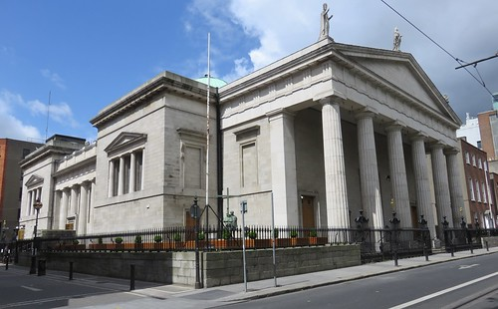
Dublin is to have a Roman Catholic cathedral – for the first time in 500 years. And it has the Pope to thank: Pope Leo XIV has designated St Mary’s Pro-Cathedral as the cathedral of the archdiocese of Dublin. Before the 16th century, the cathedral in Dublin was Christ Church, and St Patrick’s served as a second cathedral of the medieval diocese. At the Reformation, both buildings became Church of Ireland cathedrals. Today, St Patrick’s is the National Cathedral and Christ Church is that of the diocese. But this has left Roman Catholics in Dublin without a cathedral of their own.

It was not until St Mary’s opened in 1825, as a temporary solution, that the Roman Catholics had at least some big church in Dublin. Although long regarded as the de facto Catholic cathedral, its status was never formally recognised – until now.

St Mary’s Cathedral has even been welcomed by the Anglican Archbishop of Dublin, Dr Michael Jackson. He said it was “a happy day and noteworthy occasion” for Christians across the city, which now has three cathedrals.

New Year Reflection with Rev Bob
Now the Christmas festive has passed and we enter a New Year with hopes and uncertainties the church is still in the Christmas spirit until Epiphany and we still remember what Christmas is all about, we remember the family had to flee to Egypt because Herod wanted to kill Jesus as he was a threat to his power, sadly today in some parts of the world powerful people try to quell any dissent to protect there power although we see people with courage stand up to these kind of people. Jesus was a refugee fleeing persecution like so many today and it reminds us about our responsibility to those who have fled persecution that we might welcome the stranger.

Epiphany means a Christian holy day in January (traditionally 6 January in Western Christianity) that celebrates the visit of three wise men and revelation of the baby Jesus to the world, we are reminded of Anna and Simeon those Faithfull worshippers in the Temple seeing the baby Jesus and recognising who he was, not only for his own people but for all humankind.

The Nunc dimittis (The Song of Simeon) is normally sung at Evensong or compline and words give us a hope in 2026. Now, Lord, you let your servant go in peace: your word has been fulfilled. My own eyes have seen the salvation which you have prepared in the sight of every people; A light to reveal you to the nations and the glory of your people Israel. Glory to the Father and to the Son and to the Holy Spirit; as it was in the beginning is now and shall be for ever. Amen.

So let us take those words into 2026, the promised Saviour is here, and he welcomes anyone who comes to him, no restrictions or barriers just come as you are like the three wise men or the shepherds or ourselves. It remains for me to wish you all a peaceful New Year and a blessing for 2026.
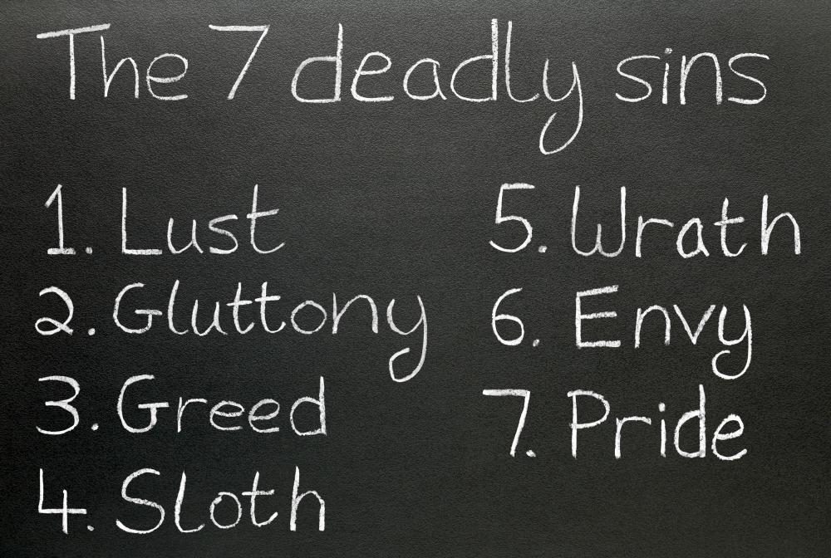
One of the Seven Deadly Sins: Pride

The Seven Deadly Sins, were compiled by Pope Gregory 1 in AD 590 to describe the nature of sin. This month we consider pride, ‘the beginning of all sin’ (St Augustine).

Pride is preoccupied with self and denies the need for others or God. We see it present in the first sin, when Adam and Eve wanted to become like God (Genesis 3:5).

What does pride look like? Jesus told the story of two men, a Pharisee and a tax collector, who went to pray in the Temple (Luke 18: 9-14). The Pharisee stood by himself and prayed: ‘God, I thank you that I am not like other people, robbers, evildoers, adulterers, or even like this tax collector. I fast twice a week and give a tenth of all I get.’ (11,12). He illustrates how pride is essentially putting ourselves in God’s place and believing we can run our own lives. It’s subtle and self-deceptive and eats away our lives: ‘Pride goes before destruction, a haughty spirit before a fall.’ (Proverbs 16:18).

So how do we deal with pride? The answer is humility. The tax collector stood at a distance ‘he would not even look up to heaven, but beat his breast and said, ‘God, have mercy on me, a sinner.” (13). This man was right with God, because he acknowledged his sin and his need for forgiveness. Humility is being realistic about ourselves, and acknowledging our total dependence on God. We develop it by giving ourselves wholeheartedly to God and repenting of our desire to do things our way: ‘Humble yourselves, therefore, under God’s mighty hand, that he may lift you up.’ (1 Peter 5:6).

‘Humility is not in thinking less of yourself, but in thinking of yourself less’ (Rick Warren).
High Days and Holy Days in January

1st January – The naming of Jesus
Matthew and Luke tell how the angel instructed that Mary’s baby was to be named Jesus – a common name meaning ‘saviour’. The Church recalls the naming of Jesus on 1st January – eight days after 25th December (by the Jewish way of reckoning days). In Jewish tradition, the male babies were circumcised and named on their eighth day of life. For early Christians, the name of Jesus held a special significance. In Jewish tradition, names expressed aspects of personality. Jesus’ name permeated His ministry, and it does so today: we are baptised in the name of Jesus (Acts 2:38), we are justified through the name of Jesus (1 Cor 6:11); and God the Father has given Jesus a name above all others (Phil 2:9). All Christian prayer is through ‘Jesus Christ our Lord’, and it is ‘at the name of Jesus’ that one day every knee shall bow.

6th January – Epiphany
On 6th January we celebrate Epiphany – the visit of the Wise Men to the baby Jesus. But who were these Wise Men? No one knows for sure. Matthew calls them ‘Magi’, and that was the name of an ancient caste of a priestly kind from Persia. It wasn’t until the third century that they were called kings – by a church father, Tertullian. Another church father, Origin, assumed there were three – to correspond with the gifts given. Later Christian interpretation came to understand gold as a symbol of wisdom and wealth, incense as a symbol of worship and sacrifice, and myrrh as a symbol of healing – and even embalming. Since the 8th century, the Magi have had the names Balthasar, Caspar and Melchior.

19th January – Wulfstan, Bishop of Worcester
Wulfstan, Bishop of Worcester from 1062 to 1095, occupies a unique place in British church history. He was the last surviving pre-Conquest bishop, the first bishop to pay homage to William the Conqueror after the battle of Hastings, and one of the few Saxons to keep high office to the end of William’s reign. On top of that, he seems to have been a truly good and holy man.

Wulfstan was born about 1008 at Long Itchington, Warwickshire. His uncle was Archbishop of York, and through his help, Wulfstan studied at the monasteries of Evesham and in Peterborough. Because of his Christian dedication, his superiors recommended him for the priesthood. Wulfstan was ordained in 1038 and joined a Benedictine monastery at Worcester. Wulfstan was appointed prior of the monastery and from 1034 also served as the parish priest of Hawkesbury, Gloucestershire. He was made bishop of Worcester in 1062.

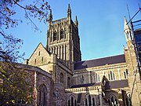
As a bishop, Wulfstan made some significant contributions to the English church. He had a passion for pastoral care and was the first English bishop to be known to have made a complete visitation of his diocese. He was a gifted administrator, increasing the effectiveness of his archdeacons. He was highly influential in monastic reform, overseeing laws and canons to reform the role of the clergy. He was a powerful preacher – with a great gift for explaining the teaching of Christianity. He encouraged a wider understanding of public penitence and taught against the many pagan customs throughout the land. He had a strong social conscience and soon became a bitter opponent of the slave trade. Wulfstan was responsible for ending the slave trade in Bristol, and also for abolishing the slave trade between Worcester diocese and Ireland. He had a passion for buildings, and founded Great Malvern Priory, as well as overseeing the large-scale rebuilding of Worcester Cathedral, Hereford Cathedral, and Tewkesbury Abbey. Wulfstan died in January 1095, apparently during his daily ritual of washing the feet of 12 of his parishioners.

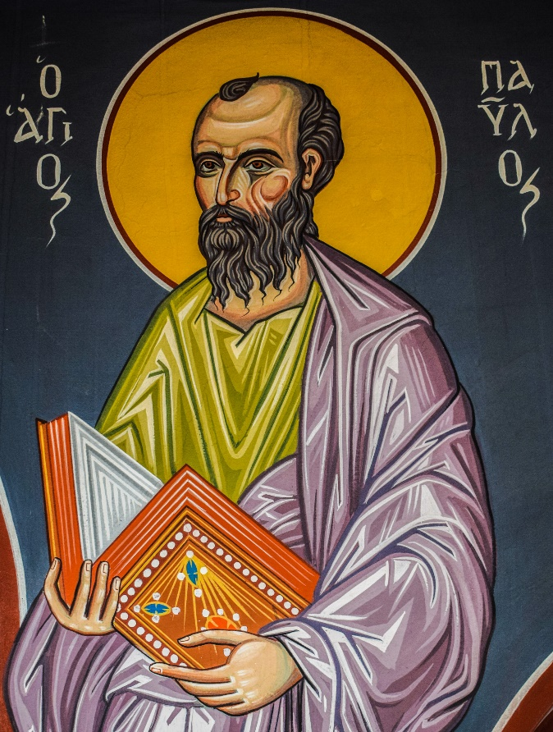
25th January – Conversion of St Paul
January is a month of the beginning of great things! As well as the naming of the Son of God, we celebrate the conversion of the greatest ever apostle of the Christian faith. Many books have been written on Paul, and here is the briefest of introductions. He was a Jew, born as ‘Saul’ at Tarsus, and brought up by the rabbi Gamaliel as a Pharisee. A devout, fanatical Jew, Saul persecuted the Christians, and watched with satisfaction the first Christian martyrdom, the stoning of Stephen. Then, on his way to Damascus, Saul had a vision of Christ that stopped him in his tracks. He realised that this Jesus whom he was persecuting was in fact the Messiah for whom he had longed.

Saul changed overnight. He was given a new name, Paul, and became an evangelist for the cause of Christ. He became a leader in the early Church, and his special calling was as an apostle to the non-Jews. He wrote epistles to the young churches that he founded – and thus, inadvertently, wrote a great part of the New Testament.

Life as the greatest apostle was hardly full of perks: Paul was stoned, beaten, mobbed, homeless, hated, imprisoned, and finally martyred. Tradition has it that he was beheaded in Rome during the persecution of Nero in 64AD. Paul’s mighty faith in Christ has kindled similar belief in many hundreds of millions of people down the centuries.

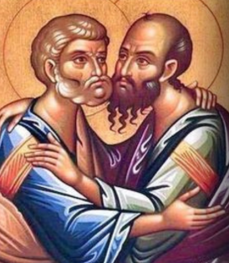
26th January – St Timothy and St Titus
Timothy and Titus are the saints for you if you’ve been a Christian for some time and now suspect that God wants you to move into some form of leadership. The books of First and Second Timothy and Titus are what are known as the three pastoral letters, where Paul writes to ministers in charge of important churches, instead of writing to the churches themselves. Paul gives both Timothy and Titus explicit instructions for how to shepherd the sheep in their care. Timothy had been given the responsibility of the church at Ephesus, and Titus the care of the church at Crete. Both Timothy and Titus were young men, and both felt quite daunted at the task ahead of them!

Timothy, half Jewish, had met Paul when he was still a child, living with his mother Eunice at Lystra. Paul had come to their city and preached, and they had both become Christians. Timothy had then accompanied Paul on his second missionary journey – a great training experience. But experience is given to us so that we might in turn become productive – and in due course Paul entrusted the vastly important church of Ephesus into Timothy’s care. This church was so vibrant in its faith that within 50 years so many Ephesians became Christians that the city’s pagan temples were almost forsaken. A huge responsibility!

Titus was a gentile, almost certainly converted through Paul. Paul had used Titus as a trouble-shooter with the Corinthians, and when Titus was successful in that, gave him a real bit of trouble: the church at Crete. Again, Titus served his Lord faithfully, even in this most difficult of situations.

Timothy became the first bishop of Ephesus and was finally martyred when he opposed pagan festivals (probably in honour of Dionysius). He was killed by stones and clubs, easily to hand during the pagan festival of Katagogia. His supposed relics were translated to Constantinople in 356.

Titus went on to become the first Bishop of Crete, and is believed to have died there, though history does not tell us how. His relics are supposed to be buried in Crete, except for his head, which was allegedly taken to Venice in 823. Both Timothy and Titus were good and faithful servants, and they could look back on lives well spent.

Holocaust Memorial Day (HMD)

Holocaust Memorial Day (HMD) is held each year on 27th January, marks the anniversary of the liberation of Auschwitz-Birkenau, the largest Nazi death camp. Under the Nazis, six million Jewish men, women and children were murdered, as well as millions of Gentiles. Holocaust Memorial Day also commemorates the more recent persecutions and slaughter in Cambodia, Rwanda, Bosnia and Darfur. A spokesman explains:

“HMD is for everyone. Each year across the UK, we bring people together to learn more about the past, empathise more with people today, and work to build a better future. Together we bear witness for communities who suffered attempted annihilation, and we honour the survivors and all those whose lives were changed beyond recognition. The responsibility of remembrance doesn’t end with the survivors – it lives on through their children, their grandchildren and through all of us.”


Some things to make you smile…

Two missionaries were comparing notes about their work in the arctic settlements of Siberia. “It was so cold where we were,” boasted one, “that the candle froze during our church service and we couldn’t blow it out.” “That’s nothing,” said the other. “Where we were it was so cold that my sermons came out in chunks of ice, and the congregation had to thaw them to see what I was talking about.”

A psychiatrist was training some young clergy who were interested in doing counselling. Deciding to test them, she asked: “How would you diagnose someone who visits your church, walks back and forth, screaming at the top of his lungs one minute, and then collapsing in a pew to weep uncontrollably the next?” A young man at the back of the room raised his hand and ventured: “A football coach?”

A churchwarden went to the Police Station wishing to see the burglar who had slipped in and out of the church during Mass. “You’ll get your chance in court,” said the Desk Sergeant. “I don’t want revenge,” said the man. “I want to know how he got out of the service early without the vicar noticing. I’ve been trying to do that for years!”

A clergyman was walking down the street when he came upon a group of about a dozen boys, surrounding a small puppy. Concerned lest the boys were hurting it, he went to investigate. One boy explained, “We just found this puppy, and we all want him. So, we’ve decided that whichever one of us can tell the biggest lie will get to take him home.” The minister was taken aback. “Don’t you boys know it’s a sin to lie? Why, when I was your age, I never told a lie.” There was dead silence for a moment. The minister thought he had got through to them. Then the smallest boy gave a deep sigh and said, “All right, give him the dog.”
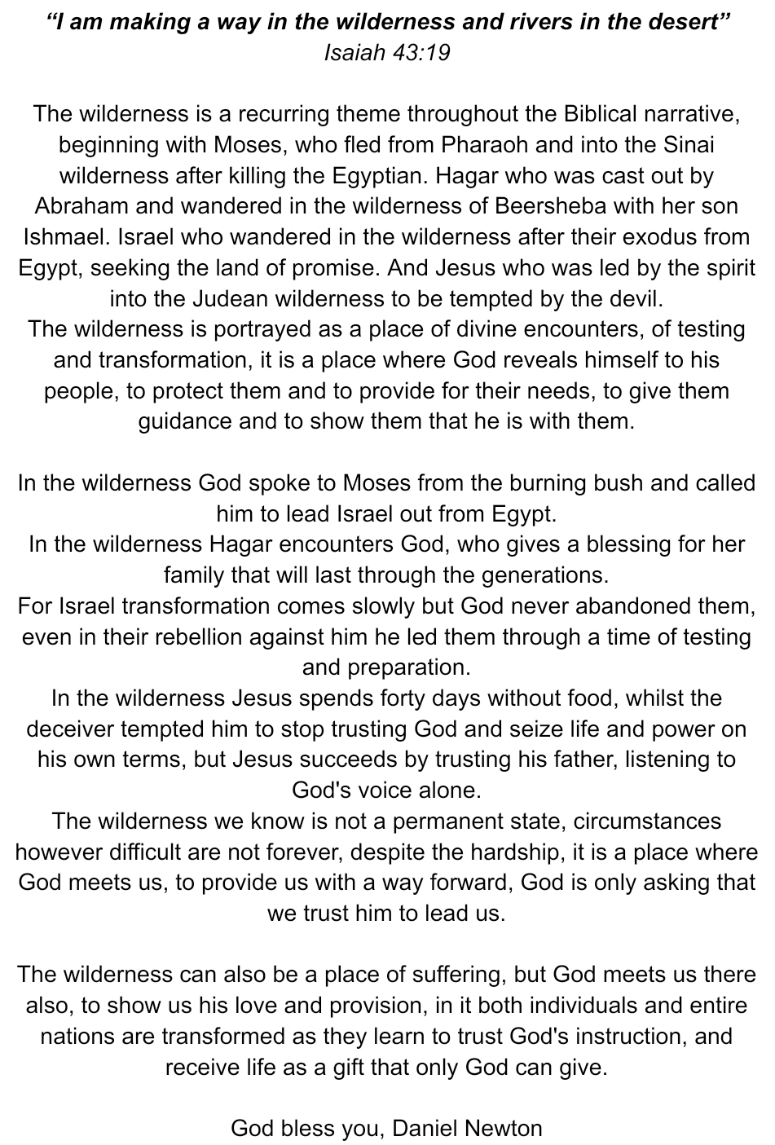
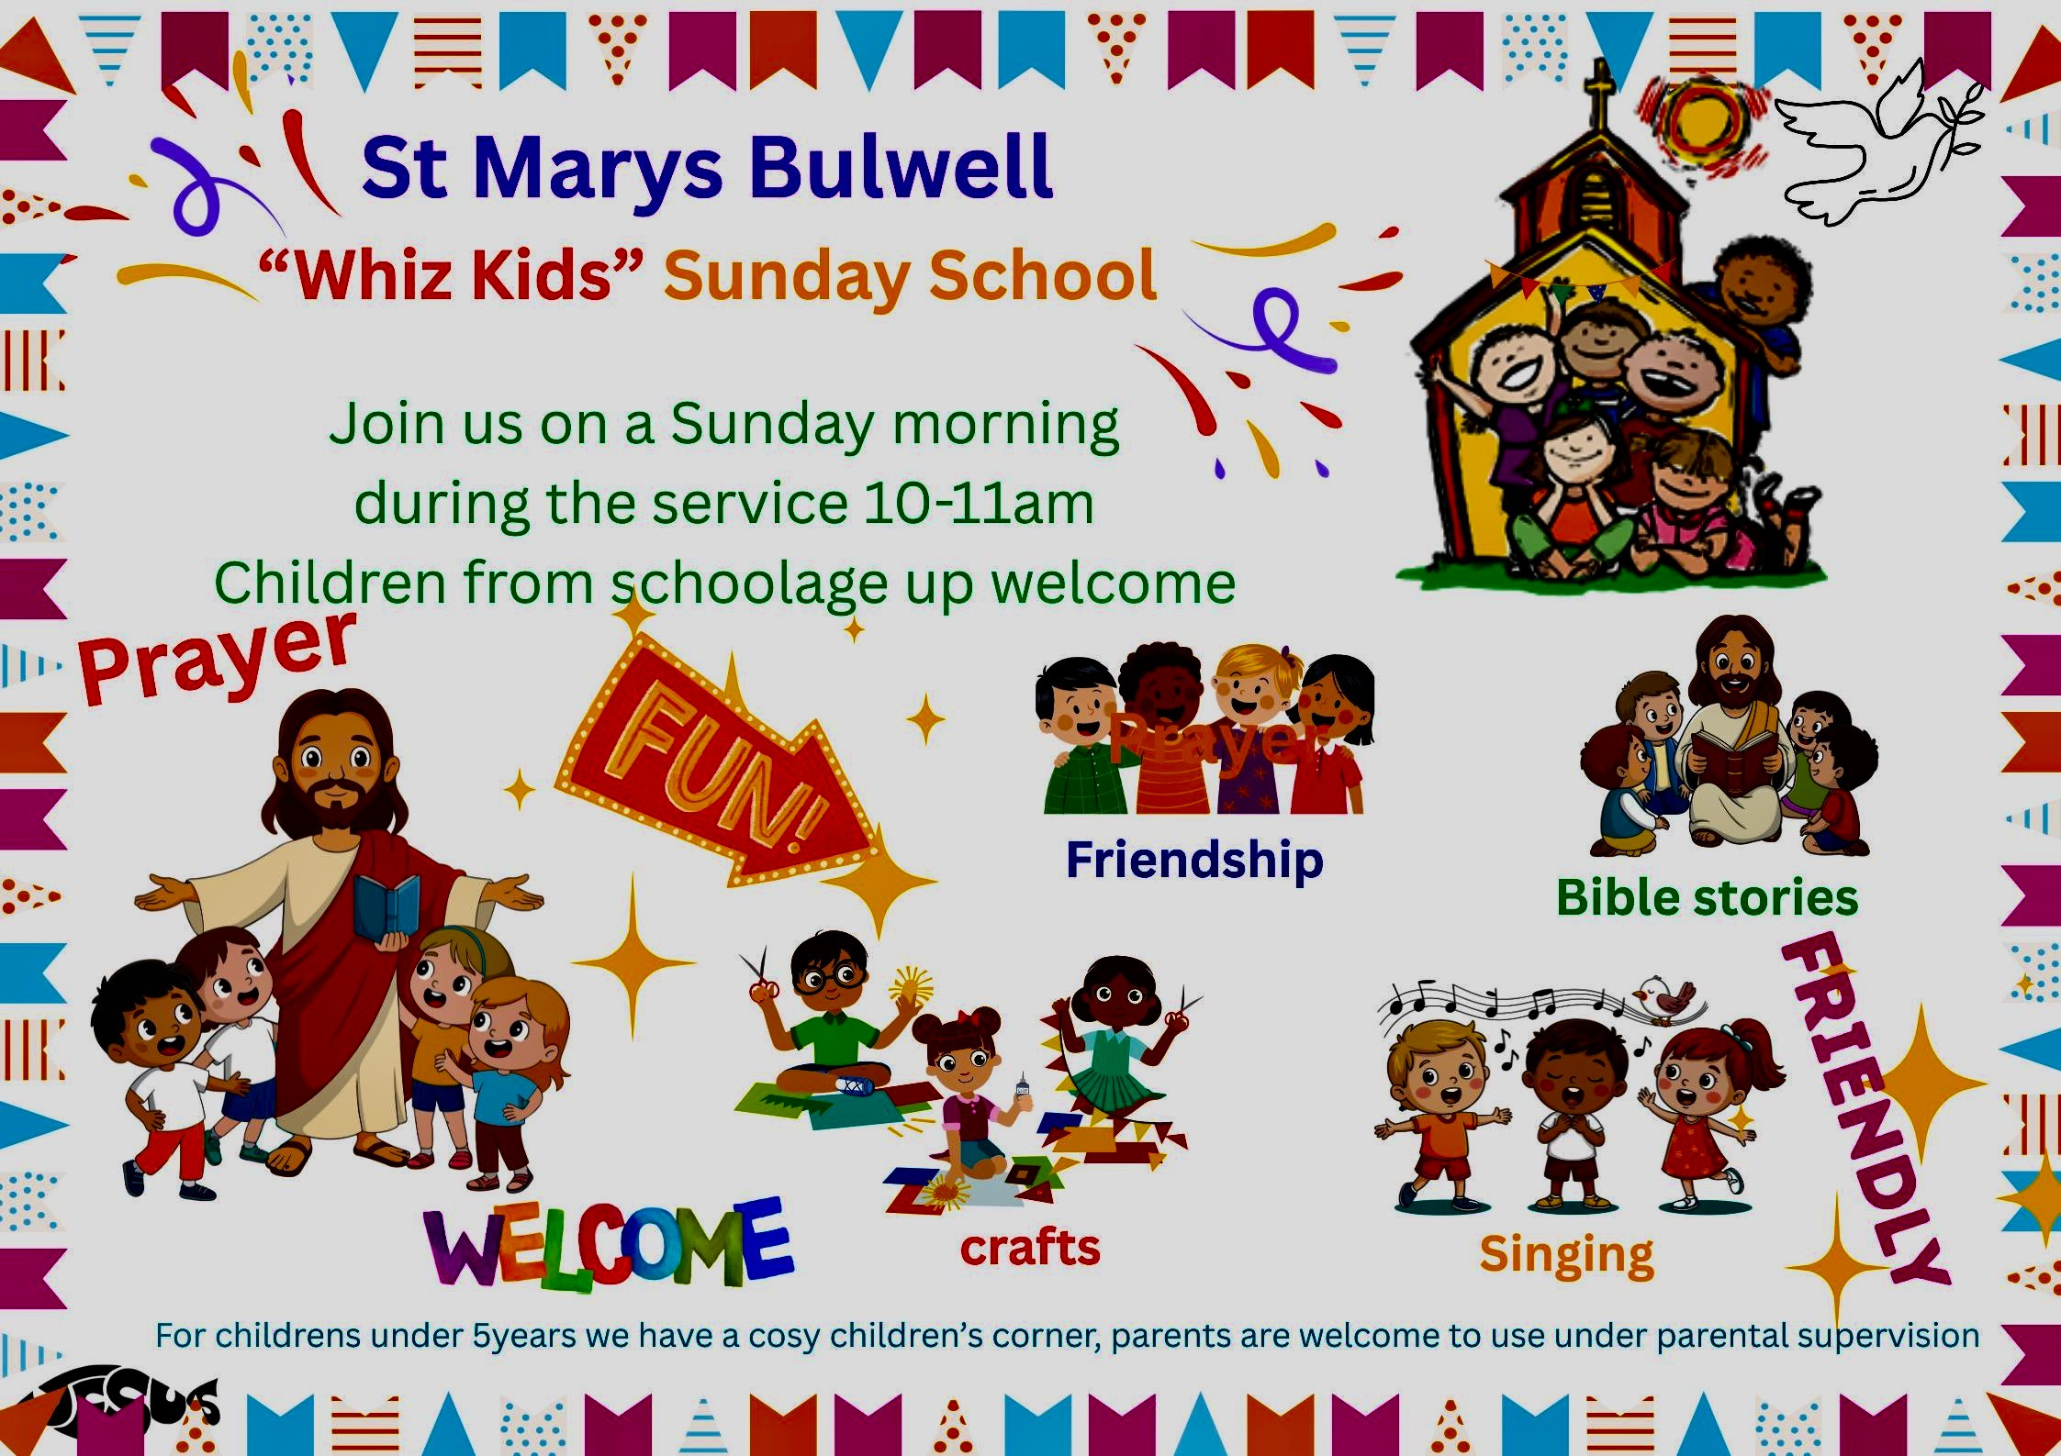
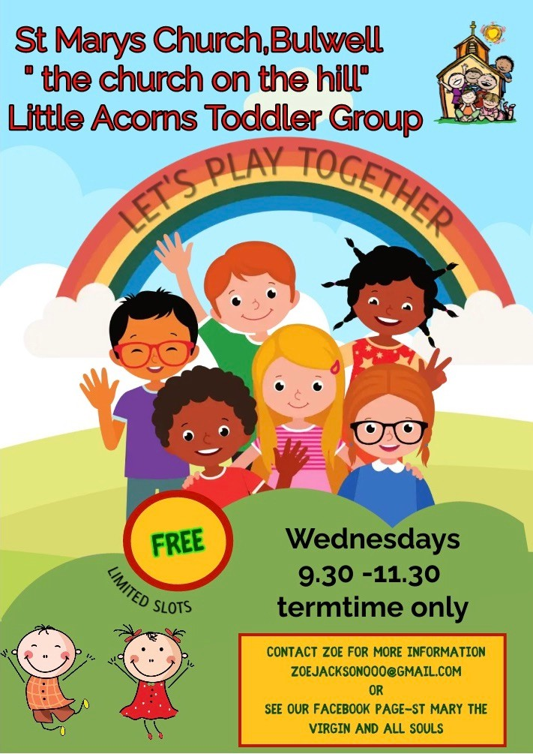
A Sermon by St Mary’s Licensed Lay Minister (Reader)
Juliet Twumasi

CHRIST THE KING (WHO DO MEN SAYS HE IS!)

Grace and peace to you in the name of our Lord and Savior Jesus Christ. This morning, we’re going to stand together at the foot of the cross. We’re going to look up—not at just a tragic scene—but at the most powerful moment in human history. The moment when heaven’s King took His throne… on a cross.

I want to tell you about a man named James who spent 15 years in prison. He was convicted of armed robbery when he was 22 years old. For most of those years, James was angry, bitter, hardened. But in his final year at custody, something changed. A chaplain visited him weekly, and slowly, James began to listen. Six months before his release, James gave his life to Christ. Today, he leads a prison ministry, going back to the very place where he found Jesus.

Why do I start with James? Because his story echoes what we find in Luke 23:33-43. Three men hanging on crosses. Three men dying. But only one conversation that changed eternity at the Place Called "The Skull" which means Golgotha. "The place of the skull." It wasn't some beautiful hillside chapel. It was a garbage dump outside Jerusalem where Rome executed the worst criminals. The smell of death hung in the air. Crowds gathered not to worship, but to mock.

When you read Colossians 1:15-16, “He is the image of the invisible God, the firstborn over all creation. For by Him all things were created that are in heaven and that are on earth, visible and invisible, whether thrones or dominions or principalities or powers. All things were created through Him and for Him.” Been on the cross. Brethren, please let Picture this: Jesus, the one who fed 5,000 people, now can't even lift a cup of water to His own lips. Jesus, who calmed storms, now can't stop the storm of insults raining down on Him. Jesus, who healed the sick, now bleeds from countless wounds. And the mockery was relentless: The religious leaders sneered: "He saved others, let him save himself!" The soldiers gambled for his clothes and laughed: "If you're really a king, come down from that cross!" Even the sign above His head—"THIS IS THE KING OF THE JEWS"—was meant as a cruel joke.
But here is the irony—in their mockery, they spoke the truth. He WAS the King. He WAS the Messiah. But His throne was a cross, and His crown was made of thorns.

Now, let's talk about these two criminals hanging beside Jesus. Matthew tells us that at first, BOTH mocked Jesus. But somewhere between the first hour and the sixth hour, something incredible happened to one of them.

The first criminal kept his heart hard. "Aren't you the Messiah? Save yourself and us!" Notice what he wanted—escape from pain, not forgiveness of sin. He wanted Jesus to be his "get out of jail free" But the second criminal, something broke open in his heart. Maybe he watched how Jesus prayed: "Father, forgive them." Maybe he realized, "This man is dying for something—or someone—else." Whatever it was, this criminal did something remarkable. He turned to his fellow thief and said, "Don't you fear God? We're getting what we deserve. But this man has done nothing wrong." Then this dying thief prays the simplest, most beautiful prayer: "Jesus, remember me when you come into your kingdom." Think about the faith in those words. Jesus is covered in blood—the thief sees a King. Jesus appears defeated—the thief sees victory coming. Jesus looks powerless—the thief trusts Him with eternity. This criminal had nothing to offer: He did not have time to do good works • No opportunity to get baptized • No chance to go to church or join a Bible study • No ability to make things right with the people he has hurt, He came to Jesus with absolutely nothing but faith. Empty hands. Desperate heart. But he prayed simple prayer. LORD REMEMBER ME WHEN YOU COME INTO YOUR KINGDOM.
When I was back home, Ghana, we use to visit people in the hospital (ICU) who has few days to live. We met 98 years Muslim man without Christ. He has been successful, wealthy, respected in business. But now, with machines breathing for him and hours left to live, all that success meant nothing. His daughter who was Christian called us to pray for him. When we arrived, he could barely whisper. But he said: I wish I knew Jesus in my youthful days. We prayed with him. "Jesus, I'm sorry. Please forgive me. Remember me." When we went back a week after he passed on. That's all it takes. Not perfection. Not a cleaned-up life. Just honest faith.

The sinner on the cross gained that salvation by believing in him as Christ the King. And listen to Jesus' response: "Truly I tell you, today you will be with me in paradise." Not "maybe." Not "we'll see." Not "if you're good enough." Jesus said "TODAY." Salvation happened instantly. One moment, a condemned criminal. The next moment, a citizen of heaven. From the depths of sin to the heights of paradise in one conversation. And Jesus didn't just promise him paradise—He promised him "you will be with ME in paradise." The thief asked to be remembered. Jesus gave him companionship. Heaven isn't just streets of gold—it's being with Jesus forever.

I love what Jesus called it: "paradise." The word means "garden." Eden restored. What humanity lost when Adam sinned, this thief gained through faith in Christ. Brother and sister what does this ancient story mean for us today?

1# It's never too late while you're still breathing. *This man was saved in his final hours. Maybe you're here today and you think, "I've wasted my whole life. I'm too old. I've sinned too much." Listen—if you have breath, you have hope. God's grace reaches to the eleventh hour. I think of John Newton, who wrote "Amazing Grace." He was a slave trader—one of the evillest professions imaginable. But God saved him, and he spent his remaining years fighting against the very evil he once participated in. It's never too late.

2# Salvation is a gift, not an achievement. * This thief couldn't have earn his way to heaven. He just believed. You don't have to clean up your life before coming to Jesus. You come to Jesus AS YOU ARE, and He does the cleaning.

3#Jesus saves completely. * From criminal to forgiven. From condemned to free. From hell-bound to heaven-bound. Completely. Totally. Finally.

But fourth, don't wait. Yes, one thief was saved in his last moment. But notice—the OTHER thief died lost. Of the two criminals, only one repented. Don't gamble with your soul. Don't presume you'll have a deathbed moment. Today is the day of salvation. Three crosses. Three men. Three destinies. One thief died hardened in sin. One thief died forgiven, entering paradise. And Jesus died to make that forgiveness possible for all of us. The question isn't whether you're a good person or a bad person. The question is simple: Which criminal are you? Are you still mocking? Still rejecting? Still trying to do it on your own? Or are you ready to pray that simple prayer: "Jesus, remember me"? Maybe today you feel like that criminal—broken, guilty, empty-handed. Good. That's exactly where grace meets us. Just pray: "Jesus, I'm a sinner. I can't save myself. Please remember me. Forgive me. Save me." And I promise you, based on the authority of God's Word, Jesus will respond to you just like He did to that thief: "Today, you will be with me in paradise."

Let's pray together. Father, we thank you that salvation is not about our goodness, but about Your grace. We thank you for the cross, where Jesus paid for our sins. And we thank you that it's never too late to come to you. If anyone here today needs to pray that prayer—"Jesus, remember me"—give them the courage to do it right now. In Jesus' name, Amen.

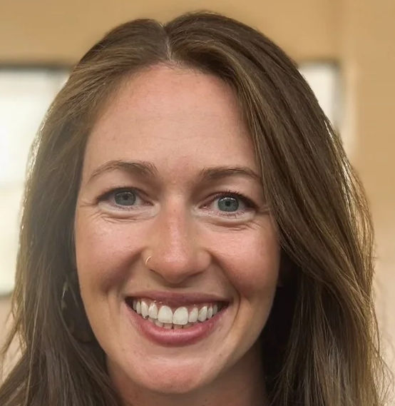
As part of my training for ordained ministry in the Church of England, I recently had the opportunity to spend some time at St Mary’s in Bulwell. I chose St Mary’s because its tradition differs from that of the church where I usually worship, and I believe there is always more of God to discover when we remain open. Before arriving, I found myself thinking about the emphasis high-church traditions place on the Eucharist and the expectation that God will meet us in that sacrament. My hope for my placement at St Mary’s was to encounter something of God in a fresh way, particularly through the Eucharist.

I met a truly wonderful community and especially appreciated getting to know people at the mid-week Bible study. I am so grateful for the warmth of your welcome and the way you helped me feel at home from the very beginning.

I did indeed encounter God deeply in the final service I attended—though not quite in the way I had anticipated. During the service, I had the opportunity to help someone, and in that moment I felt so close to Jesus through his Spirit. Afterwards, we shared communion together. I was filled both with compassion for this person I had only just met and with a strong awareness of God’s presence. As I reflect on the experience, what stays with me is how beautiful it was to witness Christ’s love moving through such a simple act of service. My hope as I continue in training is that I will keep witnessing the power of God’s love transforming those around me - and that, in partnering with him, my own life will be transformed as well. My prayer for St Mary’s this Advent is that you, too, would encounter Emmanuel—God with us—as you say yes to the simple, everyday opportunities to help and serve the people God places in your path.

Christine Proctor, Ordinand, Trinity Church, Nottingham
CHURCH MEMORIAL BOOK

During the last few weeks, the official Coronation Roll has hit the news headlines. The first roll was produced (as far as is known) in 1308. The latest roll has all the details written on it from King Charles III and Queen Camilla’s Coronation. The previous rolls likewise. It was written by Stephanie von Werther-Gill and took 56 days to complete, without any breaks, so she didn’t lose the rhythm of the writing. The heraldic work was done by Tim Wood. It is 21 metres long and contains 11,600 words. This is first time vegan paper has been used, previously vellum, (calf skin) has been used.

Entries in the Church Memorial book are written by Jillian Naylor (Calligrapher). The paper in the memorial book is Goatskin Parchment (watermarked). This paper is used for writing laws and other important documents of the land and has a 500year lifespan.
The book was started by the then Churchwarden, Eric Rydeheard, who had an interest in calligraphy. Names written in the book then were those whose ashes were interred in St Mary’s Churchyard.

Nowadays the entries are by request and can include loved ones buried in the churchyard or buried elsewhere. The font used is Foundation Hand. The pages are turned over regularly, and names are remembered in prayer.

If you would like a person’s name adding to the Church Memorial Book please contact Jillian Naylor, with the following information. Loved one’s name, date of death (date - month – year), and age at death. If you are not the next of kin, please obtain the next of kin’s permission.

Entries in the Memorial Book are by donation (minimum £5 please) to the Parochial Church Council - cash, cheque (made payable to ‘Bulwell PCC’) or the card machine at the back of church.

Jillian Naylor, 0115 916 1787 jillian.naylor@ntlworld.com

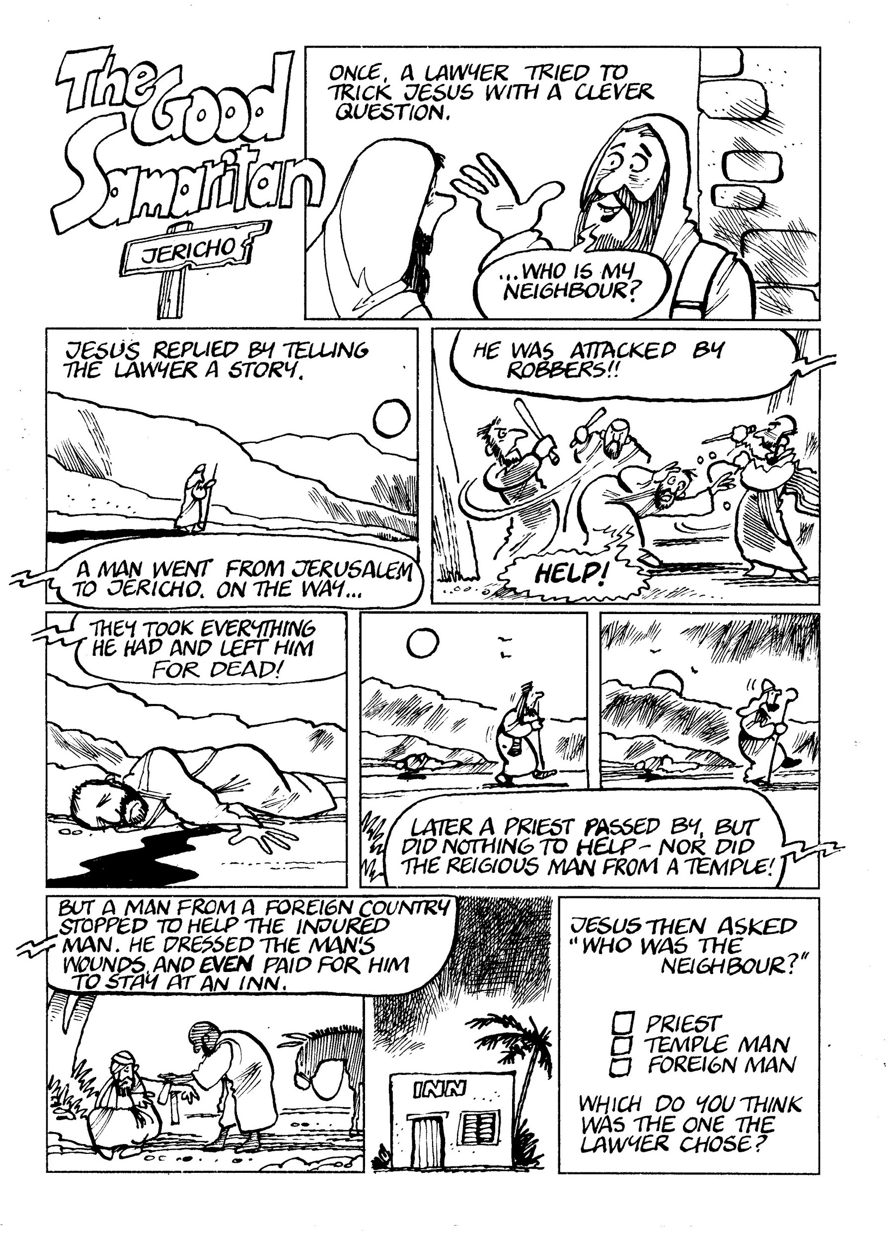

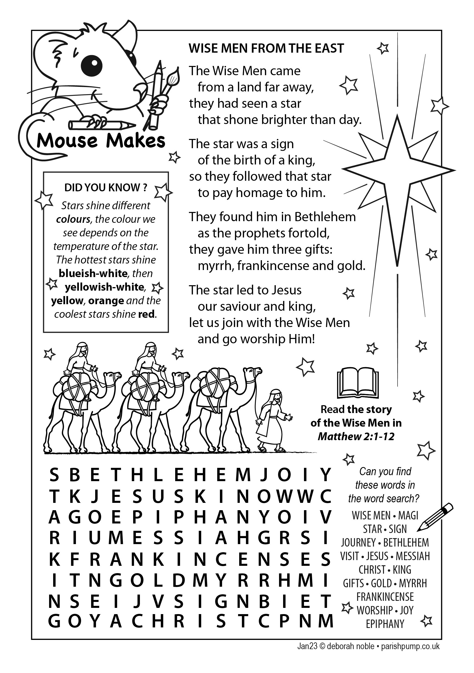

From the Parish Registers

Baptisms

19th October 2025
Harrison Willis, Layla-Mae Willis, Leilah-Willow Murphy
Arlo Loosemore, Carl Loosemore, Andrew Loosemore
Nicole Knowles, Evie Curwood

16th November 2025
Caleb Waddilove, Rowan Waddilove

Further Confirmations in 2025
Congratulations Adaeze, Scarlett, Lexi, Cassie, Charlene, Eagle and David who were confirmed by Bishop Paul at St. Peter’s Church, Ruddington on Sunday 5th October 2025. Thanks to Zoe and Rev Bob for preparing our Whiz Kids children, and to folk who were able to attend the service and support our candidates. St Mary’s has presented 12 candidates for Confirmation this year.

Funerals & Burials of Ashes

7th October
Helen Costello RIP at Northern Cemetery Chapel

19th October
Burial of Ashes of the late Joanna Zolynski RIP in the churchyard

4th November
Funeral of the late Violet Irwin RIP in church

12th November
Funeral of the late Barry Spinks RIP at Mansfield Crematorium


Confirmation Services 2026
Confirmation is a special service in which folk confirm the promises that been made when they were baptized. During the service the bishop lay’s his hands on the candidates’ heads and ask God’s Holy Spirit to give them the strength and commitment to live God’s way for the rest of his life. See:
https://www.churchofengland.org/life-events/confirmation
The Diocesan Confirmation Services for 2026 will be 10th May 6pm at St. Margaret’s, Aspley and/or 23rd May 7pm at Southwell Minster. If you would like to be Confirmed please speak with Fr Andrew or Rev Bob.

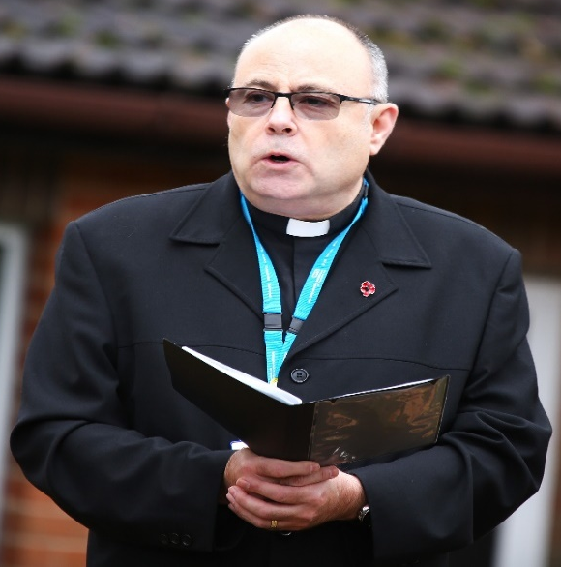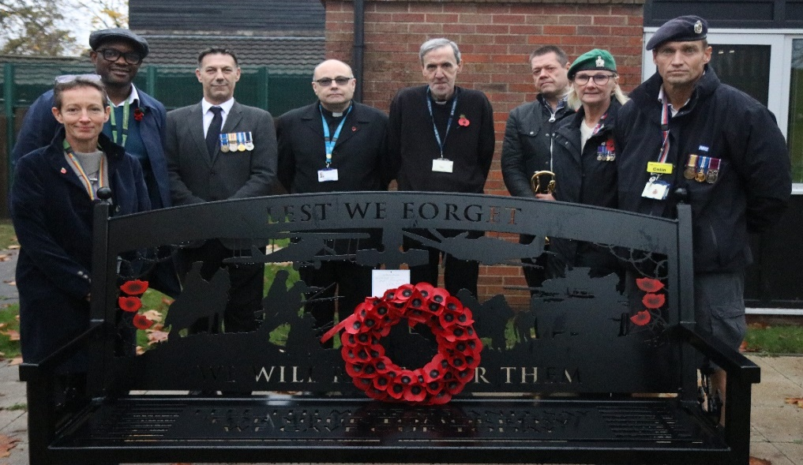

Photos from the Armistice Day Act of Remembrance and Dedication of the Memorial Bench at Highbury Hospital
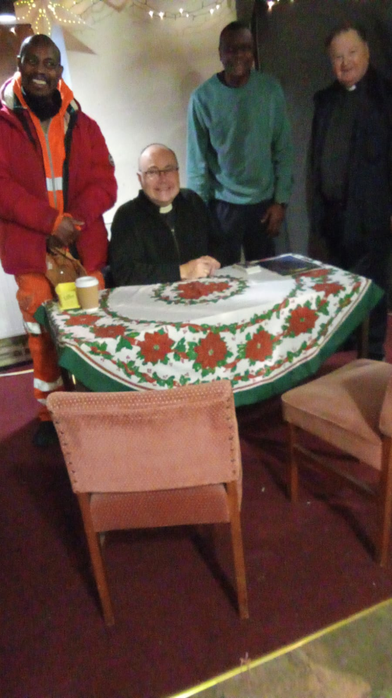

Photo from the Christmas Fayre at St Mary’s Church
(in the Jesus Deck Tent!)

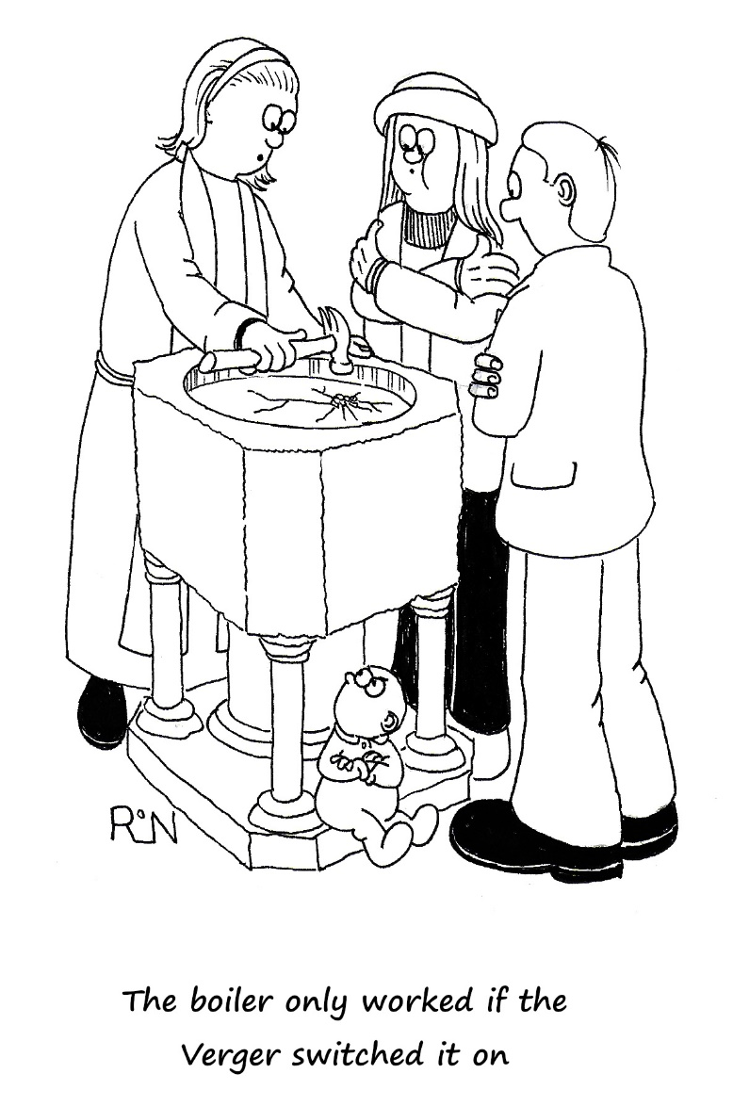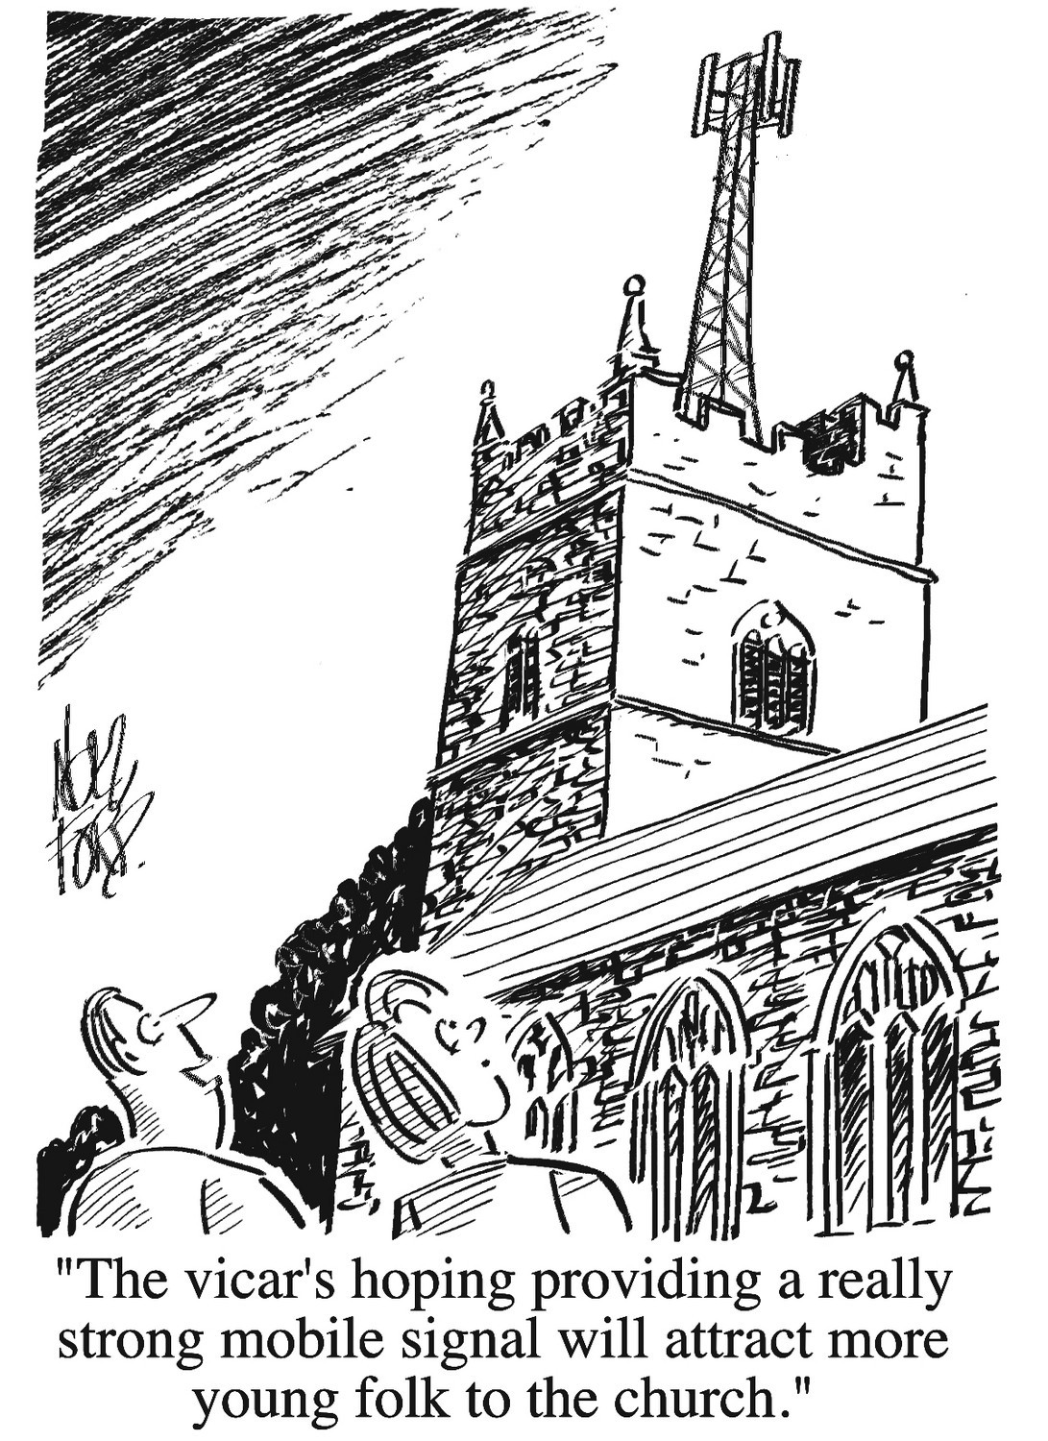
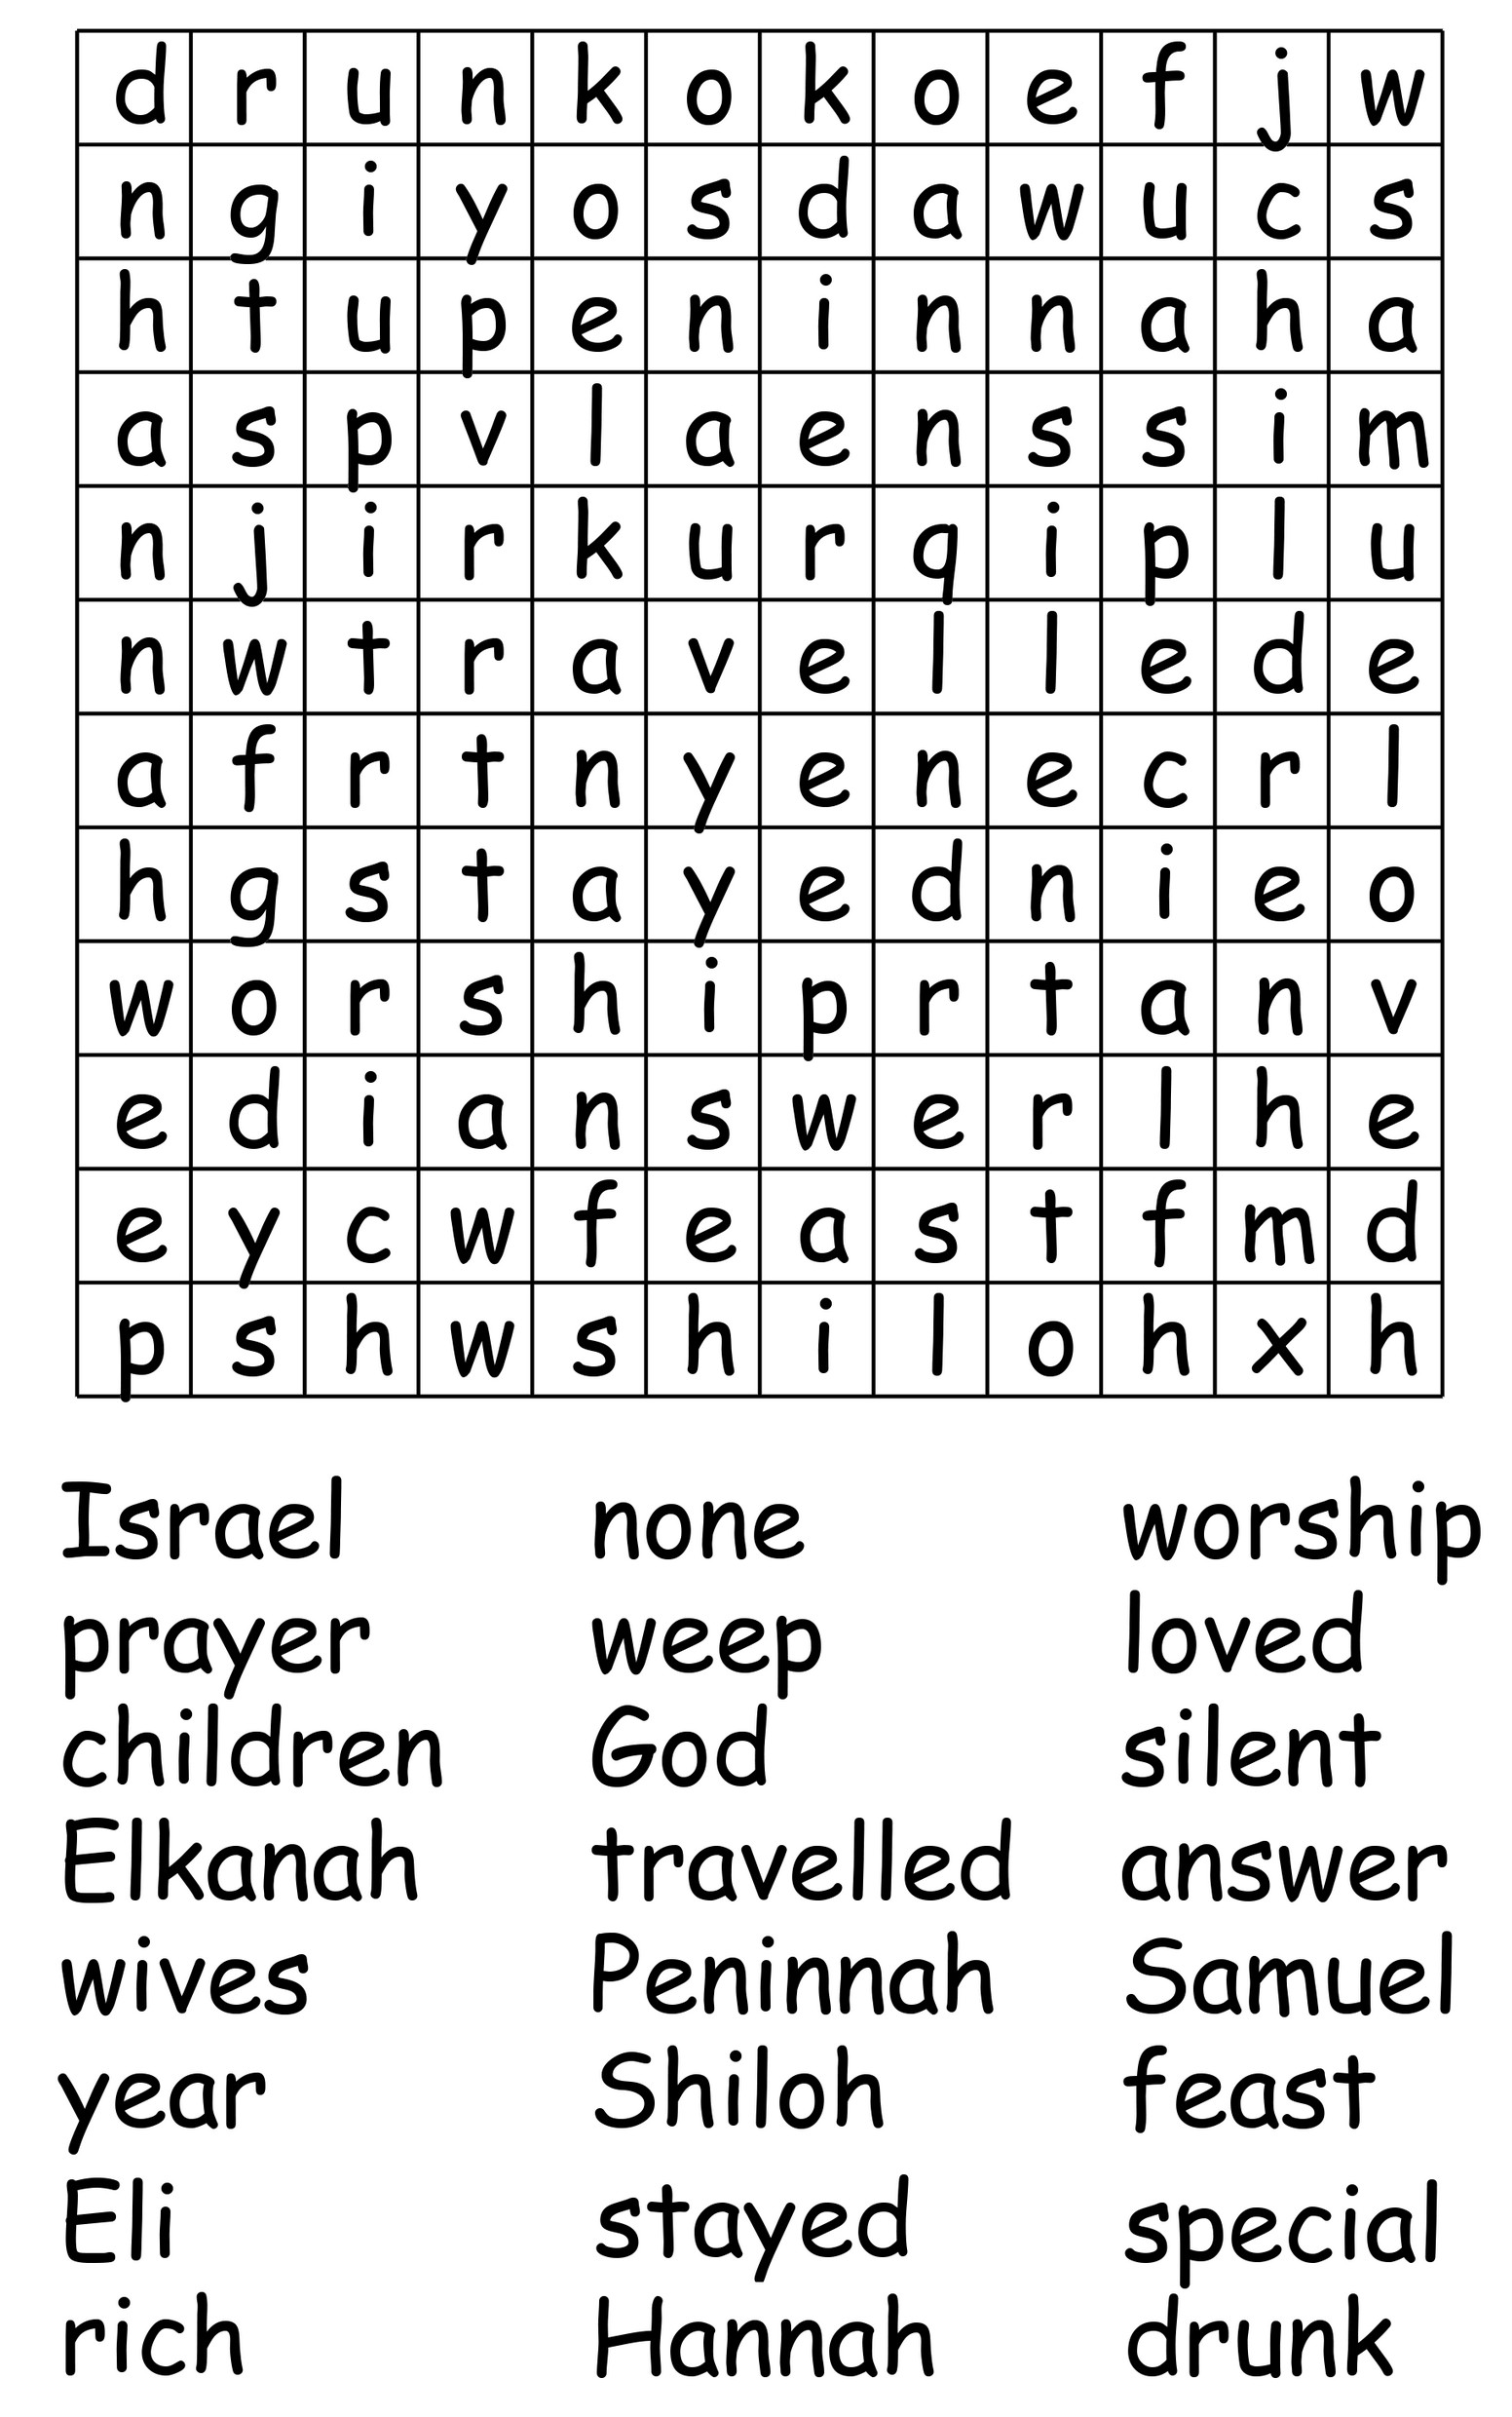
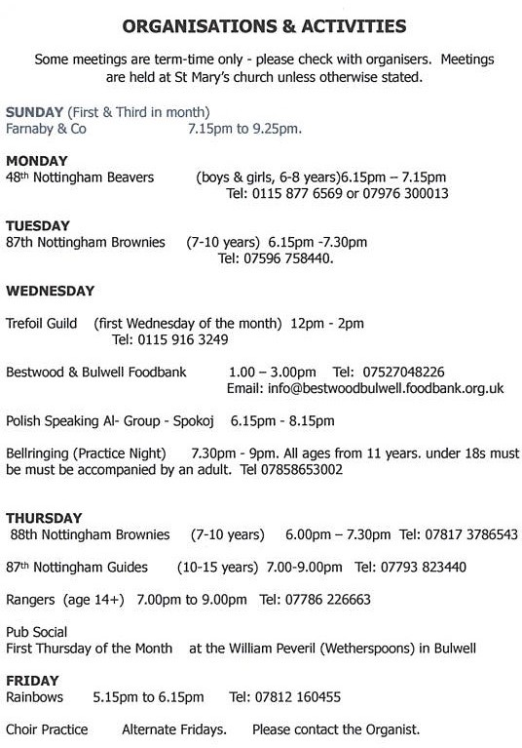
CONTACT DETAILS
Vicar | Fr Andrew Fisher | 0115 975 5358  a.j.fisher@outlook.com
Honorary Associate Priest | The Revd. Bob Stephens | 07757422260  revbob63@sky.com
Reader/Licensed Lay Minister (LLM) | Juliet Twumasi | jto2025@hotmail.com
Churchwardens | Eleanor Lang | 0115 9277212  ellielang@btinternet.com
Churchwardens | Martin Walton | 07746 535552  martinwalton57@outlook.com
Churchwarden  Emeritus | Robert Naylor | 0115 916 1787  jillian.naylor@ntlworld.com
Parish Safeguarding Officer (PSO) | Maureen Pates | 0115 976 4612  maureeni.pates@googlemail.com
Prayer Chain Ministry | Jackie Bramford  (Pastoral Care Visitor)  Daniel Newton | jackiebramford@hotmail.co.uk  newtondaniel826@gmail.com
Children & Young  Peoples’ Ministry | Zoe Elliott | zoejackson000@gmail.com
Tower Captain | Michael Varney | 07858 653002  MichaelVarney2015@outlook.com
Organist | Situation Vacant | Situation Vacant
Magazine Editor | Situation Vacant | Situation Vacant
Foodbank | Nigel Webster | 07527 048226  info@bestwoodbulwell.foodbank.org.uk

