CHESHUNT TEAM MINISTRY
ST MARY THE VIRGIN CHESHUNT

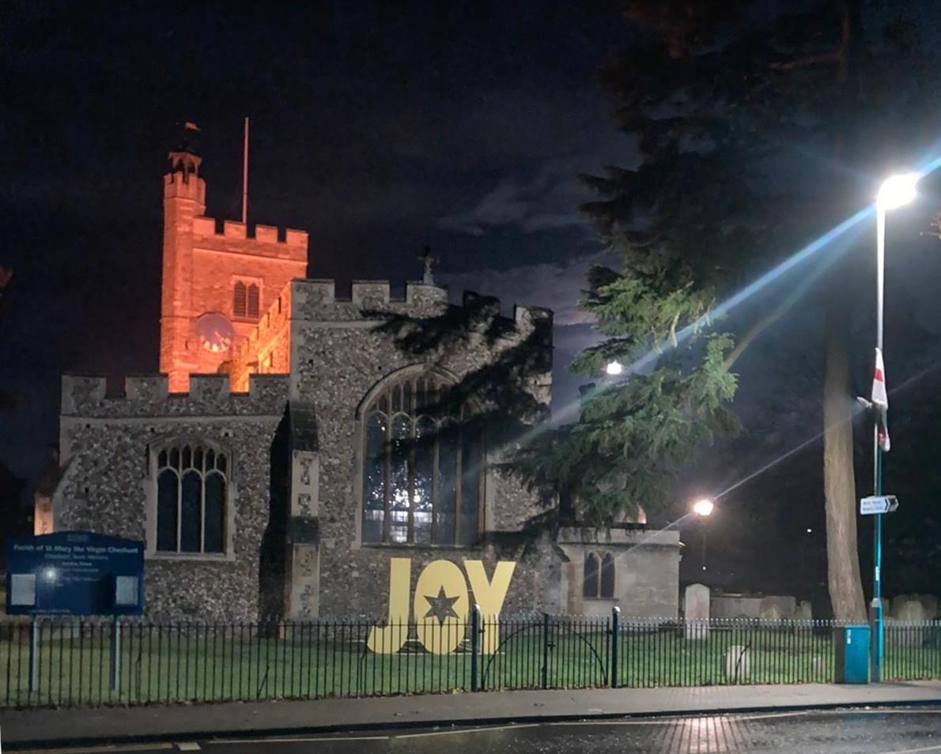

CHURCH NEWSLETTER
January 2026

Foreword from Revd Elizabeth Fellows
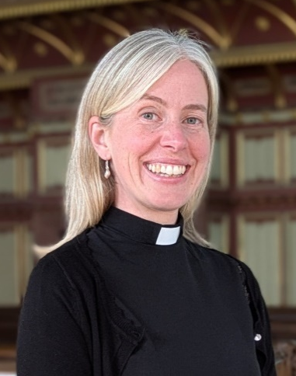
Dear St Mary’s Church Community
Happy New Year! I hope that you have had a peaceful and JOY-filled Christmas, and I pray that 2026 will be a year of blessings for you.
I recently shared that hearing from God in our lives can be like birdwatching. When birdwatching, we intentionally go to places where birds are likely to be found and give our full attention to noticing them. We put aside distractions, stay alert to movement or sound, and pause when something catches our attention, remaining there until there is nothing more to see before moving on. We don’t worry if we don’t see a bird on a particular outing; we simply return another time and try again. Over time, the more we practise birdwatching, the more confident we become at knowing what movements and sounds are birds, and which are just the weather.
In a similar way, when listening to God, we place ourselves in situations where we are likely to hear from Him, such as going to church, reading the Bible, praying or listening to Christian music. We set aside distractions and give God our attention, staying with whatever draws us; perhaps a Bible verse, a line from a song or a thought that resonates. As we ponder it, we may notice or realise other things. When it seems that there is nothing else there, we can move on and listen to, or read something else. We don’t need to worry if we don’t feel a special encounter every time; we are still doing the right things. As we continue to give time and attention to God, we notice more and more ways that God is present in our lives, even in small and everyday moments.
Why not try it and see where you find God in 2026? Let’s make 2026 a year that is significant in our spiritual journey. Later in the newsletter, there are some recommended resources to use in personal times with God each day. There is also information about a Team Confirmation Service in 2026. Why not consider being baptised (if you haven’t been before), or confirmed or affirming your baptismal faith (this is intended for people who have been baptised and confirmed and who want a formal way of marking either that they have returned to the practice of the Christian faith, or that their faith has become meaningful to them in a new way)?
May the God of hope fill you with all joy and peace as you trust in him, so that you may overflow with hope by the power of the Holy Spirit. (The Bible, Romans 15:13)
With every blessing for 2026
Revd Elizabeth

News from December 2025
Advent and Christmas Thank You
Revd Elizabeth wants to say a huge “thank you” to all those who helped with Advent and Christmas events, and to all those who attended them. We welcomed over 2,000 people into the church for our special Christmas services, Tea With Santa, school events, Advent Lunch, etc. Thank you to our welcome teams, those who unlocked and locked up the church, those who decorated the church, those involved in catering for events, those who helped with lights, sound system, readings, intercessions, managing rotas, those who sang, to our musicians, serving teams, JOY letter creators, those who shared JOY postcards, put up posters, the bell ringing team, and many more people and roles besides. It really does take a team, and this season saw St Mary’s at its collaborative best.

Tea with Santa
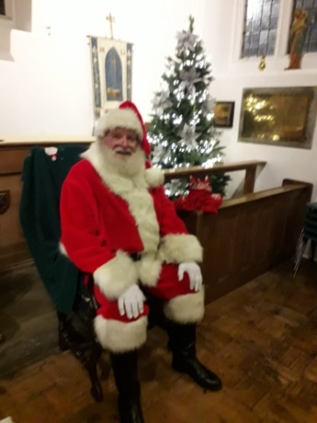 | Great fun was had by all when Santa came to St Mary’s for tea!  Children enjoyed throwing snowballs at cheeky elves to knock them off their stands and aiming other snowballs down four chimneys. | 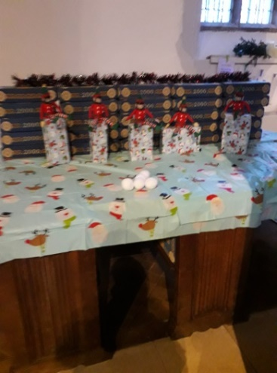  Snowballing the Elves
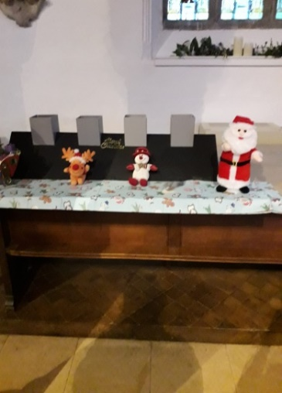  Chimney challenge | Santa spent time talking to each child and a fantastic festive feast completed the afternoon.  Well done to everyone who played a part in making the event a St Mary’s Christmas special! | 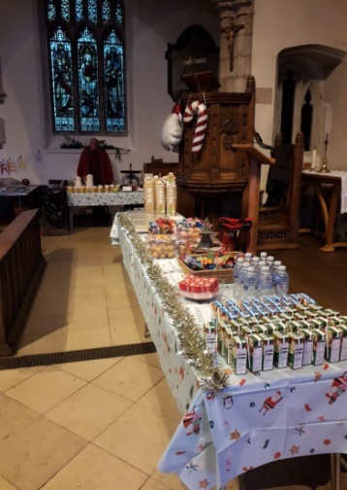

Advent Lunch
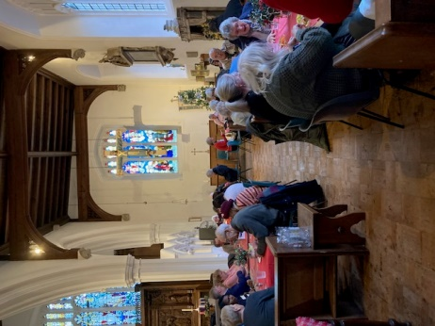 | A lunchtime treat was enjoyed by all who attended the Advent Lunch in December. No-one left church hungry as jacket potatoes with a variety of fillings were served, followed by a delicious choice of home-made desserts (with seconds) and tea and coffee afterwards. | 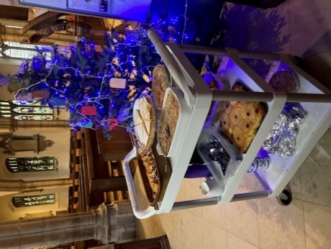  The dessert trolley
A huge “thank you” to the organisers, dessert-makers, servers and everyone who attended the lunch which made nearly £300 towards the Crisis appeal helping people facing homelessness.

Chaps, Chips and Chat Christmas Meal
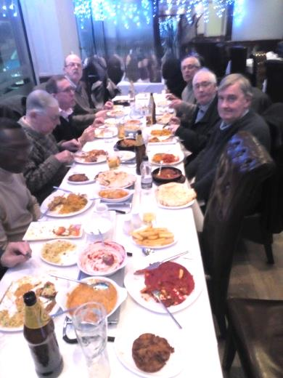
Once again, as has become the tradition, members of the Chaps, Chips and Chaps fraternity relocated from the church to the Mahek Indian Restaurant for their annual Christmas meal. The restaurant has hosted the meal for the past four years and has an extensive selection of Indian delicacies on the menu. Not a piece of battered fish was devoured during the whole evening although chips were still in demand by some and enjoyed. The good company, conversation and anecdotes were appreciated, and by the end, the world had been put to rights. The evening was rounded off with a complimentary digestif, which was most welcome and everyone went home feeling very content.
Thanks to all the chaps for continuing to support the group.
Geoff Parks

The Mothers’ Union

Members of St Mary’s MU and friends met on 4 December for festive fun, with carol singing, quizzes and craft. Members donated generously towards the cost of the children’s gift bags for the Crib Service.
Nationally, the MU took part in “The Big Give”, a week when donations to charity are doubled. MU’s target was £32,000 for projects in Uganda. This total was reached in TWO DAYS, so this can be doubled and sent to Uganda. What a wonderful achievement!
The next meeting is on 8 January at 1.30 in church. This will be a post-Christmas social, with some games available to anyone who fancies one.
There will also be a Bring and Buy table, anything suitable welcome, but if not sold, donators are asked to take their goods home again.
Subs for 2026 are £39.50, all of which goes to central funds and the diocese. If you are interested in joining, please come along to the meeting to find out more.
Vicky Clarke

A Mice Ending to a Woolly Tale

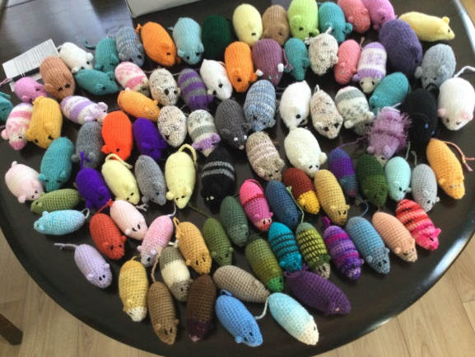
During the year, readers of Women’s Weekly were invited to knit or crochet mice for rescued cats in shelters, hoping to set a new Guinness record for the largest number of handmade pet toys to be donated.
St Mary’s Church contributed 87 towards the challenge and in September, it was confirmed that a total of 46,506 toys were made and a new record set. The mice have already been distributed to many rescue centres around the UK for rescued cats and kittens.

Resources for personal times with God
For adults: Information about the Twelve Joys of Christmas: https://www.churchofengland.org/faith-life/what-we-believe/advent-and-christmas/advent-and-christmas-theme-joy-christmas

The Everyday Faith app from the Church of England: (https://www.churchofengland.org/faith-life/exploring-faith/everyday-faith).
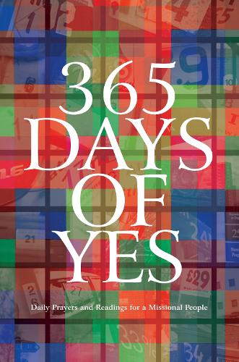
365 Days of Yes: Daily Prayers and Readings for a Missional People
(https://www.eden.co.uk/christian-books/christian-devotional-books/365-day-devotionals/365-days-of-yes/)

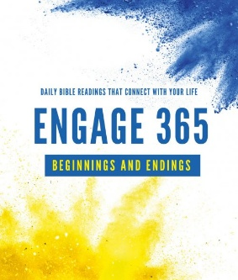
For teens: Engage 365
(https://www.eden.co.uk/christian-books/books-for-teens/youth-and-teen-bible-study/engage-365-beginnings-and-endings/)

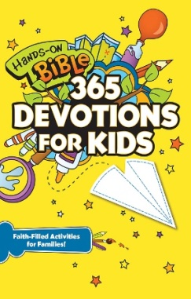
For children: Hands-On Bible 365 Devotions for Kids (https://www.eden.co.uk/christian-books/christian-books-for-children/childrens-devotional-books/age-8-12-devotionals/hands-on-bible-365-devotions-for-kids/)

Bibles
At the church’s special Christmas services, we offered Bibles as gifts for anyone that wanted one. More than 60 were taken. We also shared a postcard which with a blessing for 2026 and encouraged everyone to make 2026 a year when they invested in their spiritual lives. Let’s be praying that God really speaks to people through those Bibles and that he draws people to himself and to St Mary’s.

January Events

Services
- Thursday 1 January: there will be no Communion Service

- Sunday 4 January (Epiphany) at 10am: Parish Eucharist

- Thursday 8 January at 11am: Service of the Word

- Sunday 11 January at 10am: All Age Eucharist

- Thursday 15 January at 11am: Midweek Eucharist

- Sunday 18 January at 10am: Parish Eucharist

- Thursday 22 January at 11am: Midweek Eucharist

- Sunday 25 January at 10am: Family Service with sausages
- Thursday 29 January at 11am: Midweek Eucharist

Regular Events in Church
- Church Cleaning and Gardening from 10am on Saturday 3 January,
all welcome.

- Coffee Mornings every Wednesday from 8.45 to 10.30am (in term time), all welcome and no charge.

- Chaps, Chips and Chat at 6pm on Thursday 15 January

- Handbells at 7pm on Thursdays 8 and 22 January

- Ladies’ Puddings and Prosecco at 7 pm on Friday 16 January


Looking Forward
Confirmations in 2026
We have a Team Confirmation Service on Saturday 6 June 2026. Confirmation is a special church service in which a person confirms the promises that were made when they were baptised, and they are prayed for by a bishop. There is more information on the Church of England website: https://www.churchofengland.org/life-events/confirmation. Speak with Revd Elizabeth to register your interest. Let’s make 2026 a year that is significant in our spiritual journey.

Friends of St Mary’s Film Night

Save the date! On Friday 13 February, a Film Night in church featuring the Lion King is being planned. Details to be finalised and communicated.

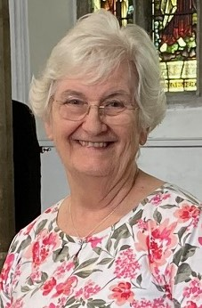
Angela’s January Gardening Tips
- Tidy up fallen leaves, twigs and debris, but leave some uncleared area for hibernating wildlife.
- Top up bird feeders and have a supply of water for wildlife in the garden.
- Perform garden maintenance on tools and structures.
- Plant trees, fruit bushes and hedging.
- Have horticultural fleece to hand to throw over tender plants if frost is expected.
- Move deciduous shrubs before the worst winter weather sets in.
- Cut pack perennial plants and mulch to protect crowns from winter frost.
- Plan for the spring sowing of seeds.
- Buy potato tubers and chit indoors for planting out in March.

PCC of St Mary Cheshunt
Church Income/Expenditure
November 2025

Total Income for November | £6,931
Total Expenditure for November | £7,477
Budget Surplus/Deficit for November | -£546
Total Income Year to Date | £92,756
Total Expenditure Year to Date | £92,930
Budget Surplus/Deficit Year to Date | -£175
Total Parish Share Initial Request 2025  3 monthly payments of £4,393 initially | £57,703
Then adjustment following appointment  of Team Vicar  8 monthly payments of £4,965 + 1 of £4,963 | £57,862
Parish Share Payment November | £4,965
Parish Share Bill Year to Date | £52,899
Total Contribution Year to Date | £52,899

Contact Information
Clergy:
The Revd Elizabeth Fellows: 07352 324584, elizabeth@cheshunt.church
(usual day off is Friday)
Church Wardens:
Mrs Vicky Clarke and Mrs Angela Dronyi
Parish Safeguarding Officer:
Vicky Clarke: 07803 203 438, vickyclareclarke@aol.com
Diocesan Safeguarding Advisor:
Jez Hurst: 01727 818107, safeguarding@stalbans.anglican.org
Parish Office: 01992 635190 (messages picked up regularly)
Email: cheshunt.church@stmary1418.onmicrosoft.com (emails checked regularly)
Newsletter: marian.coombs@cheshunt.church

Find out more about St Mary’s:
St Mary’s Calendar with all forthcoming events: https://calendar.google.com/calendar/embed?src=c_26f51d0230dfcdec3d21f5e3033b098afd032e5b31874208c2c2ab1e6e6f1e81%40group.calendar.google.com&amp;ctz=Europe%2FLondon
St Mary’s Facebook page: https://www.facebook.com/StMaryCheshunt
Please follow it and interact with posts.
Information about St Mary’s is available on a page on “A Church Near You”: https://www.achurchnearyou.com/church/7854/

Did you know that the Church of England is now on WhatsApp?
WhatsApp channels are a way for you to get updates about organisations or topics you're interested in, straight to your phone. You can find channels you follow through the 'Updates' tab on WhatsApp. We're sharing prayers, reflections, uplifting stories, news and more, so to keep in the loop, follow the link below to subscribe to our channel.
You can follow here: https://ow.ly/Lp8T50XGjGz

