21st December Psalm 80:1 to 8, 18 to 20
Please stand, if able, and join in the verses in bold

Give ear, O Shepherd of Israel,
you who lead Joseph like a flock!
You who are enthroned upon the cherubim, shine forth
before Ephraim and Benjamin and Manasseh.
Stir up your might, and come to save us!

Restore us, O God;
let your face shine, that we may be saved.

O Lord God of hosts,
how long will you be angry with your people’s prayers?
You have fed them with the bread of tears,
and given them tears to drink in full measure.
You make us the scorn of our neighbours;
our enemies laugh among themselves.

Restore us, O God of hosts;
let your face shine, that we may be saved.

But let your hand be upon the one at your right hand,
the one whom you made strong for yourself.
Then we will never turn back from you;
give us life, and we will call on your name.

Restore us, O Lord God of hosts;
let your face shine, that we may be saved.

Glory be to the Father and to the Son and to the Holy Spirit,
as it was in the beginning, is now and ever shall be,
world without end. Amen
Our 4pm services are now in Friendship House (except on 21st December for the Carol Service) until Sunday 15th February.

24th December – Midnight Mass – Psalm 98
Please stand, if able, and join in the verses in bold

O sing to the Lord a new song, for he has done marvellous things.
His right hand and his holy arm have gained him victory.
The Lord has made known his victory;
he has revealed his vindication in the sight of the nations.
He has remembered his steadfast love and faithfulness to the
house of Israel.
All the ends of the earth have seen the victory of our God.

Make a joyful noise to the Lord, all the earth;
break forth into joyous song and sing praises.
Sing praises to the Lord with the lyre,
with the lyre and the sound of melody.
With trumpets and the sound of the horn
make a joyful noise before the King, the Lord.

Let the sea roar, and all that fills it;
the world and those who live in it.

Let the floods clap their hands;
let the hills sing together for joy
at the presence of the Lord, for he is coming to judge the earth.
He will judge the world with righteousness, and the peoples with equity.

Glory be to the Father and to the Son and to the Holy Spirit,
as it was in the beginning, is now and ever shall be,
world without end. Amen
Distribution of Communion –currently the Priest will dip the communion wafer in the wine while we discern a safe way to bring the common cup back into worship, as we want everyone to feel included and safe. We also have gluten free wafers available.
In our weekly prayers for our parish
This week we pray for God’s blessing on Avondale Road, Balmoral Road & Bankfield Drive.
It’s Good to Talk! If you spot that someone is missing, please pop a news sheet through their door, & if you’ve time, call for a chat - just to check they’re OK & to let them know that they are not forgotten!
Church contact information
Contact: Rev’d Christine - revchristine@outlook.com
The Rectory, The Village, West Hallam, DE7 6GR
Landline 0115 646 1497
Rev’d Ailsa -revailsahunt@gmail.com
Tel - 07356064856

Churchwardens – Mrs Janet Wheeldon, -Tel: 0115 8771593
Mrs Linda Gregory – linda.gregory3@icloud.com
https://www.achurchnearyou.com/church/13402/
https://www.facebook.com/allsaintskirkhallam
‘Thank You’
A huge thank you to everyone who has helped at the recent fund raising events, together we raised…
Tree of Lights = £560
Christmas Fayre = £1,202
Christmas Carol Play = £126
And for the Children Society the Christingle raised £85.43!

All Saints Church
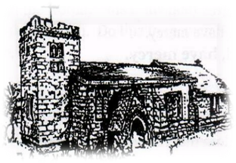
Kirk Hallam
Disabled Toilet in Friendship House.
Disabled Toilet in Friendship House.

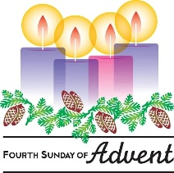
Working with God to transform lives & communities.
Please can you ensure your mobile is on silence, or off during the service, it is affecting people with hearing aids and the loop system.

21st December – Fourth Sunday of Advent
10.00am CW Communion Service with Rev’d Ailsa
4.00pm Carol Service with Rev’d Christine

Forthcoming Events
Mon 22nd 10am Internment of Joyce Kirk
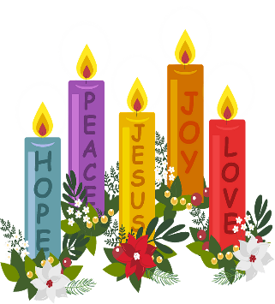
Mon 22nd 3.00pm Building Faith, Lego Church in Church
Tues 23rd 6.00pm Home Group in Friendship House

Wednesday 24th – Christmas Eve
11.30pm Midnight Mass with Rev’d Jan
& Rev’d Christine

Thursday 25th – Christmas Day
10am Iona Communion with Rev’d Ailsa

28th December – First Sunday After Christmas
10.00am CW Communion Service with Rev’d Alan
No evening service.
‘For to us a child is born, to us a son is given; and the government shall be upon his shoulder, and his name shall be called Wonderful Counsellor, Mighty God, Everlasting Father, Prince of Peace.’ Isaiah 9:6

