
SPIRE & LIGHT United Churches
United Benefice of St Keverne, St Ruan with St Grade & St.Wynwallow (The Lizard)

*If you do not wish to receive these notices, please let your Churchwarden know*

21st December 2025
ADVENT 4


Readings
Isaiah 7:10-16
Psalm 89:1-8, 18-20
Romans 1:1-7
Matthew 1:18-end

9.30am – Holy Communion – St.Wynwallow, The Lizard
11.15am – Family Service – St.Ruan, Ruan Minor
3pm – Nativity – St.Mary’s, Cadgwith
4pm – Carols by Candlelight – St.Peter’s, Coverack


CHRISTMAS EVE
3pm Christingle - St.Keverne

4pm Christingle – St.Wynwallow

6pm Carols around the tree – St.Keverne

11.30pm Midnight Holy Communion – St.Peter’s, Coverack


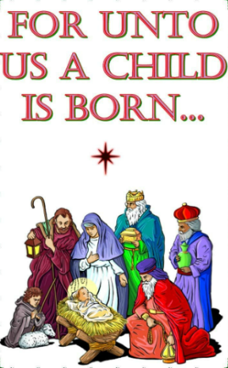

CHRISTMAS DAY
10am – Holy Communion – St.Wynwallow, The Lizard
10am – Morning Worship – St.Peter’s, Coverack
10am – Holy Communion – St.Keverne

Next Sunday Dec 28th Christmas 1
No services in the Spire and Light Benefice
Services across the Deanery
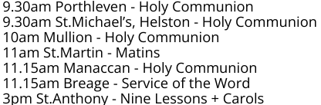


The Prayer Spot

Lord Jesus Christ, as we pray today, please be with us and guide us in all we do and say in your wonderful name.
Help us to remember that you are a God who cares, who understands and who meets all our needs. We pray for the benefice and Deanery we belong to and we thank you for the faithful people you have brought together.
Remind us that we have been brought to faith by our saviour Jesus Christ to enjoy our time together. We thank you Lord Jesus for your presence in our lives and the love you have given us to share with others. Keep us strong in our faith and close to you. Help us to be always there for others in their time of need.
You have given us gifts to use, to reach out to give comfort to those around us who are in need.
Heavenly Father we live in a world that is slowly destroying itself, through greed, hatred and with no care or concern for others. Remind us that we can bring love, care and understanding into the world by reaching out into our communities and showing our love to all. We pray for those in our communities who need Gods help as they care for others, for those in need of hospital care but also those who look after them.
Loving God, be with us always. Remind us daily we are brothers and sisters in Christ, that God is ever present in our lives, through his wonderful Holy Spirit that he gives us freely. God Bless you all
O Lord our rock and Redeemer, guide our thoughts and our words in our discussions today. Let our hearts be filled with your praise. Let us never forget the good things you do for us. You have forgiven our sins. You have rescued us from death. You have crowned us with love and tender mercies. Renew our strength and refresh our souls. Through Jesus Christ our Lord, Amen
Sam Buchanan
The Diocese of Truro’s Prayer Diary for this week and next

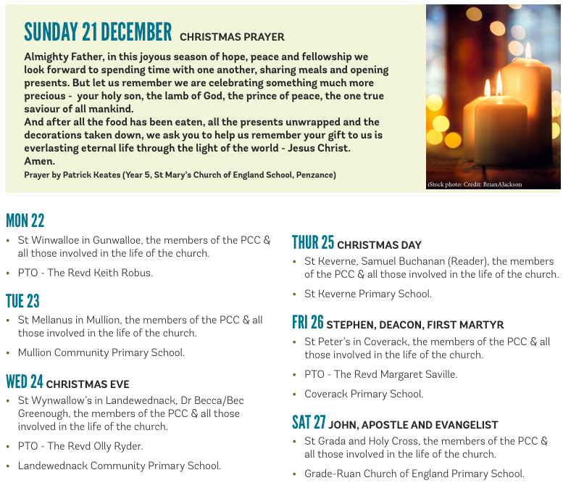

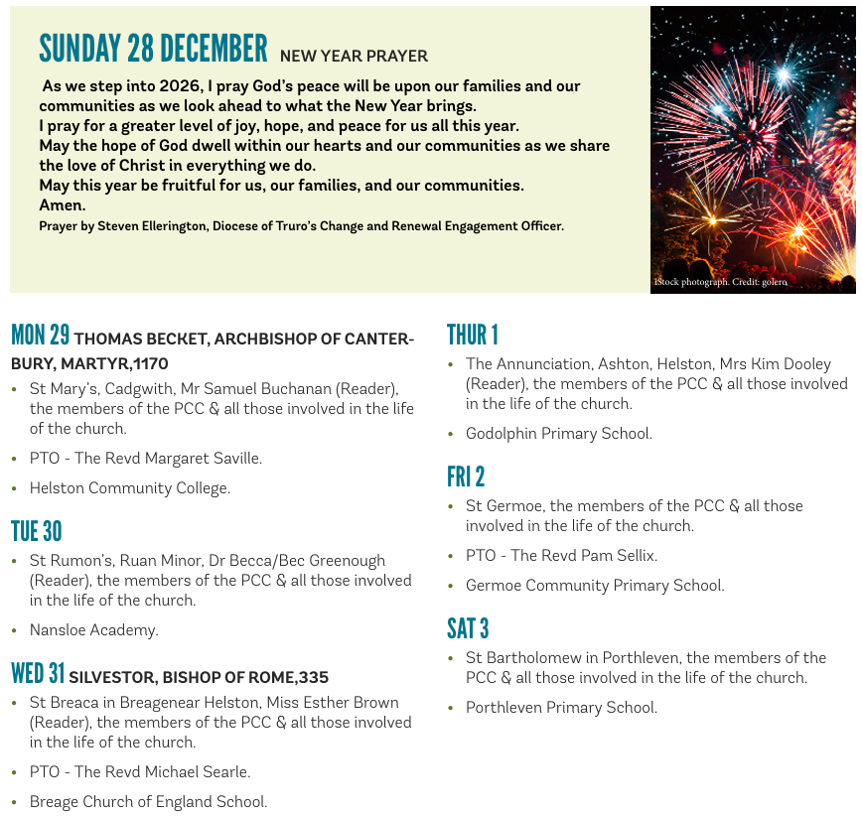

On the Way Prayers
My soul doth magnify the Lord and my spirit hath rejoiced in God my Saviour! Lord in these last few days of Advent let us just pause and ponder on those words. We pray that what we are doing in our churches over this Christmas period magnifies our congregations’ and communities’ souls and that more and more people come to rejoice in the fact that God is our Saviour.

We give thanks for all the festivities and celebrations that we are holding, for the carols that we sing, for the nativity plays that get staged and for the prayers that we offer for our world and for ourselves. Let us bring before you now the various events that we have planned over the next few days.

Christmas really is a time for children. We pray now for all those in our schools and for the special things that they have happening that they will treasure throughout their lives. We pray for all the teachers and other school staff in what can be quite a stressful time, that they will also find some joy and that they will be able to relax and enjoy a couple of weeks well earned rest. Lord we give thanks for the dedication of all those who educate our children.

We pray for the Church of England for Sarah as she prepares to take up her role as the next Archbishop of Canterbury. For David our Bishop and Hugh as he spends his last few days in the Diocese. We pray for those who lead us locally – particularly for Heidi and Susie. Lord give all leaders wisdom, patience and perseverance and may they all find time in this Christmas Season to really experience the joy of the nativity.

And now let us pray for all those who provide music in our churches this Christmas, the choirs, the organists, the bell ringers and all other musicians who enhance our worship and our celebrations. We give thanks for all those who through the ages have penned the words of our carols and composed the tunes and harmonies that we so love.

Many of us support particular charities at this time of the year – we pray for all who work in charitable organisations internationally and locally. Close to home we pray for the work of the Helston and Lizard Foodbank and for St Petrocs, that their Christmas Appeals may once again be successful.

This prayer group is now going to have a short break over the Christmas period so now we pray for one another, for what we are doing, for our families and friends and that we will all have a bit of time to just relax and enjoy the season. And may we all have a very Happy and Blessed Christmas. Amen


