Westfield Church Notices Sunday 21st December

Valerie writes:
Come Now with Joy

A beautiful carol written by Timothy Dudley-Smith to welcome the birth of Jesus this Christmas Day.

Come now with joy
To worship and adore Him.
Hushed in the stillness,
Wonder and behold -
Christ in the stable
Where His mother bore Him,
Christ whom the prophets,
Faithfully foretold.
High King of ages,
Low we kneel before Him,
Starlight for silver,
Lantern light for gold.

W8ishing everyone a very Happy Christmas.

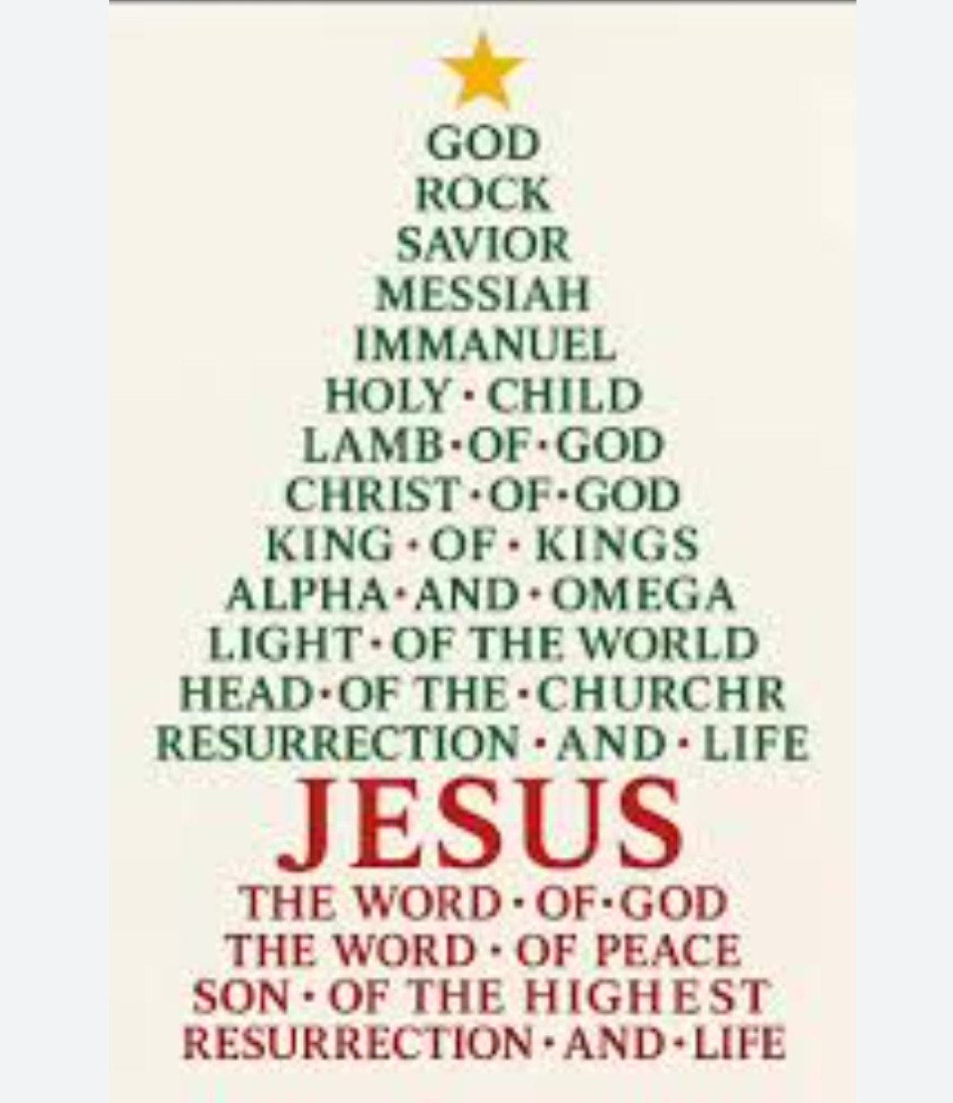

What’s on:

Sunday 21st December
8.00am: Prayer Book Communion
9.30am: Holy Communion
Christmas Eve 24th December
(9.30am: No service.)
(10.30am: No Hub)
4.00pm Christingle Service
6.00pm Christingle Service
10.00pm Christmas Eve Holy Communion
Christmas Day 25th December
8.00am Prayer Book Communion
9.30am Christmas Family Communion

Messages:

FSW

Please note there will not be a collection for FSW this month.

Kathy

Guestling and Fairlight

The Benefice Office will be closed from 2pm on Wednesday 17th December until Monday 5th January 2026.

Please note that all church services in Fairlight during January will take place at St. Peter's (corner of the Broadway) because it is easier to heat.

Merry Christmas and a Happy New Year!

Sarah – Parish Administrator

Prayer:

If you would like a situation prayed about urgently, please contact the church Prayer Share. Contact Dawn 01424 255423 / 0750 7745 159

If you know anyone who would like to be added to the notices, please send me an email with their details. If you don’t want to receive this email each week, or would rather receive it in a different format, please let me know.
Please give information for notices to me by Thursday morning (contact details below).
Have a good week everyone,
Tony Demarco tonydemarcohastings@gmail.com

