SUNDAY 14 DECEMBER
9.30AM
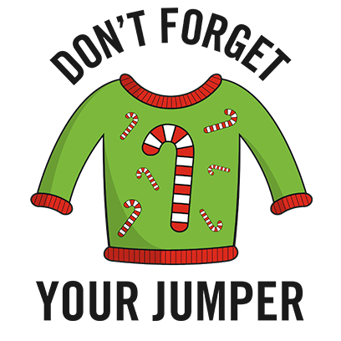
WEAR YOUR CHRISTMAS JUMPER
TO RAISE FUNDS FOR ST PETER’S
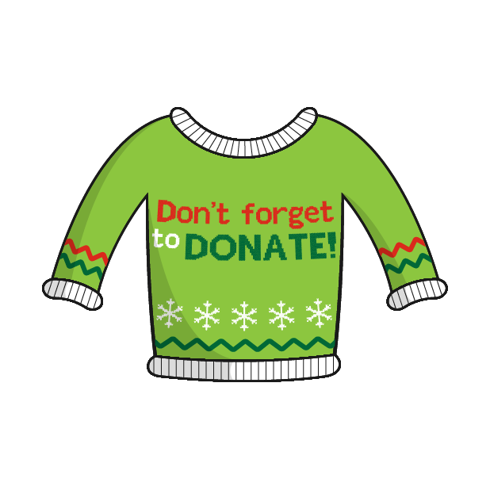
&
THE CHILDRENS SOCIETY
