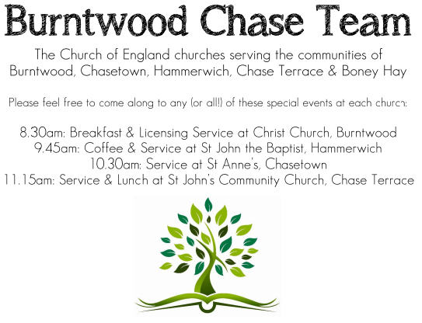 CHRIST CHURCH
SUNDAY 7th December 2025 at 4pm

SERVICES:
Sunday 7th December 2025
In Loving Memory
2nd Sunday of Advent

Readings:
Isaiah 11: 1-10
A shoot shall come out from the stock of Jesse,
and a branch shall grow out of his roots.
² The spirit of the Lord shall rest on him,
the spirit of wisdom and understanding,
the spirit of counsel and might,
the spirit of knowledge and the fear of the Lord.
³ His delight shall be in the fear of the Lord.
He shall not judge by what his eyes see,
or decide by what his ears hear;
⁴ but with righteousness he shall judge the poor,
and decide with equity for the meek of the earth;
he shall strike the earth with the rod of his mouth,
and with the breath of his lips he shall kill the wicked.
⁵ Righteousness shall be the belt around his waist,
and faithfulness the belt around his loins.
⁶ The wolf shall live with the lamb,
the leopard shall lie down with the kid,
the calf and the lion and the fatling together,
and a little child shall lead them.
⁷ The cow and the bear shall graze,
their young shall lie down together;
and the lion shall eat straw like the ox.
⁸ The nursing child shall play over the hole of the asp,
and the weaned child shall put its hand on the adder’s den.
⁹ They will not hurt or destroy
on all my holy mountain;
for the earth will be full of the knowledge of the Lord
as the waters cover the sea.
¹⁰ On that day the root of Jesse shall stand as a signal to the peoples; the nations shall inquire of him, and his dwelling shall be glorious.
Matthew 3: 1-12
In those days John the Baptist appeared in the wilderness of Judea, proclaiming, ² ‘Repent, for the kingdom of heaven has come near.’ ³ This is the one of whom the prophet Isaiah spoke when he said,
‘The voice of one crying out in the wilderness:
“Prepare the way of the Lord,
make his paths straight.”’
⁴ Now John wore clothing of camel’s hair with a leather belt around his waist, and his food was locusts and wild honey. ⁵ Then the people of Jerusalem and all Judea were going out to him, and all the region along the Jordan, ⁶ and they were baptized by him in the river Jordan, confessing their sins.
⁷ But when he saw many Pharisees and Sadducees coming for baptism, he said to them, ‘You brood of vipers! Who warned you to flee from the wrath to come? ⁸ Bear fruit worthy of repentance. ⁹ Do not presume to say to yourselves, “We have Abraham as our ancestor”; for I tell you, God is able from these stones to raise up children to Abraham. ¹⁰ Even now the axe is lying at the root of the trees; every tree therefore that does not bear good fruit is cut down and thrown into the fire.
¹¹ ‘I baptize you with water for repentance, but one who is more powerful than I is coming after me; I am not worthy to carry his sandals. He will baptize you with the Holy Spirit and fire. ¹² His winnowing-fork is in his hand, and he will clear his threshing-floor and will gather his wheat into the granary; but the chaff he will burn with unquenchable fire.’

COLLECT FOR TODAY
O Lord, raise up, we pray, your power
and come among us,
and with great might succour us;
that whereas, through our sins and wickedness
we are grievously hindered
in running the race that is set before us,
your bountiful grace and mercy
may speedily help and deliver us;
through Jesus Christ your Son our Lord,
to whom with you and the Holy Spirit,
be honour and glory, now and for ever.

WHAT’S GOING ON
Upcoming Services

Wednesday 10th December Morning Prayer 9.30am
Sunday 14th December Carol Service 4pm
Wednesday 17th December Morning Prayer 9.30am
Sunday 21st December Morning Worship 10am

An Evening of Christmas Music and Readings – Thursday, 11th December, 7.00pm
Time to dig out those Christmas jumpers! Come along to an informal evening of Christmas readings, carols and Christmas songs including the ever popular “White Christmas”. Bring your own drinks, if you wish, and a small amount of Christmas food to share.

FLOODLIGHTING
If you think about commemorating a special occasion by floodlighting our Church. Please contact Chris Brown on 01543 683862 for details.

PRAYER CHAIN
Christ Church is blessed with a very active prayer chain. If you, or anyone you know, feel that they would like others to pray for them, please speak to Chris Brown on 01543 683862.

HOME COMMUNION
For anyone who is unable to attend church and would like Home Communion,
Steve Morgan is able to carry this out.

VICAR CONTACT DETAILS
Stephen Morgan Tele: 07305 852152
CHURCH WARDENS CONTACT DETAILS
Judith Rogers Tele: 01543 324718
Mike Holmes Tele: 01543 672970
Church Office Tele: 01543 642187 [leave a message and we will respond]
Church Web Site:www.christchurchburntwood.org.uk
Church Email: christchurchburntwood15@gmail.com
Facebook: www.facebook.com/group/christchurchburntwood/

Other Contacts
Matt Wallace St. John’s, Chase Terrace— Tele: 01543 670078
Richard Westwood St. Anne’s, Chasetown—Tele: 01543 686111

NEXT SUNDAY SERVICE
Sunday 14th December at 4pm
Carol Service
Isaiah 35: 1-10
Matthew 11: 2-11
3rd Sunday of Advent

