Westfield Church Notices Sunday 7th December

Valerie writes:
Emmanuel: God With Us
Emmanuel, is a Hebrew name signifying God's presence: it is a powerful reminder of God's closeness. The name Emmanuel emphasises that God is present with humanity and with individuals.
God came to earth in human form to live among us and build personal relationships with us culminating in Jesus' promise to his disciples to be with them to the end of time.

'In the beginning was the Word,
and the Word was with God
and the Word was God
and the Word became flesh
and dwelt among us
full of grace and truth.'



What’s on:

Sunday 7th December
8.00am: Prayer Book Communion
10.30am: Holy Communion
6.00pm: Christmas Tree Festival begins
Wednesday 10th December
9.30am: Holy Communion
10.30am: Warm Space Community Hub
7.30pm: Home Groups at Dawn and Jess’ and Cathy and Howard’s
Tuesday 16th December
7.30pm: Prayer Group at Brenda’s
Church Christmas Dinner

7.00pm Tuesday 16th December at Fairlight Lodge Hotel
Don’t forget to reserve your place, and provide menu choices, I would like to get the final list of names to Fairlight Lodge by the 10th December please.

Sarah, Parrish Administrator

Messages:

The Bishop’s Christmas Message 2025

Bishop Martin writes:

Knowing that we are loved:

A new generation attending Chichester cathedral have shifted the atmosphere. Buggies now take their place alongside the Zimmer frames, to the delight of everyone.
We are being reminded what it’s like to be a baby. The needs are basic: warmth and security, food, sleep, and clean clothes.
In early childhood we need people to notice us, and we need one or two people who always do this. That’s how we know that we are loved. We need things to play with, capturing our imagination and teaching us communication and how to work with what we see.
We never really grow out our earliest needs which guarantee our human dignity.
I was reminded of this at the joyful celebrations of baptism and confirmation just before Christmas. Candidates spoke of their need of being loved, feeling safe, finding kindness and knowing that you can be forgiven.
Some of the most moving testimonies came from our asylum seeker and refugee brothers and sisters. They spoke of how the local church has shown them the kindness of God our loving Father, which we see in the face of his Son, Jesus Christ.
This kindness has done much to restore their sense of dignity as the children of God. And because words can sometimes be a barrier, the symbolic gestures of worship become more important as a form of communication.
The washing with water in baptism, like the laying-on of hands and anointing in confirmation speaks powerfully. It says that the love of God is as tender and reassuring as the gentle touch of a parent is to a new-born child.
So, with Christians young and old we rejoice this Christmas that what God the Father sees and loves in the new-born Christ, he sees and loves in you and me.
The Virgin Mother looks on with love. Joseph is a friend and guardian. Angels enchant us with music promising peace on earth. And all for your sake.

Church Card Reader

The new Church card reader has arrived and is set up. All donations made via the card reader will go towards the Church Hall ceiling.

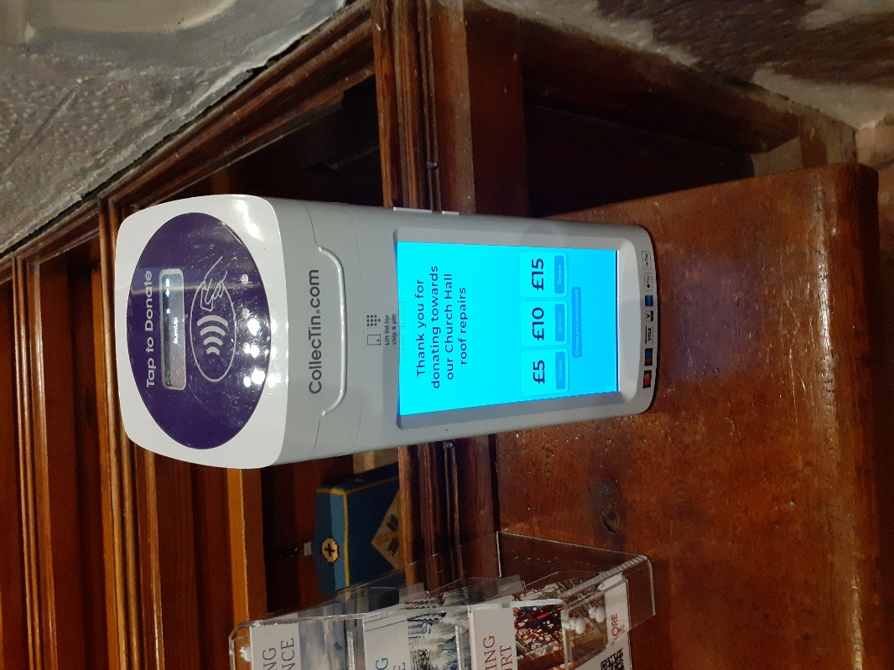

The Friends of Westfield Church

The Friends held their Christmas Fair in the Community Hall last Saturday, raising £520 for repairs to the Church Hall ceiling. We were very grateful to everyone who baked, cooked, gave contributions as raffle prizes, ran stalls, helped in the kitchen and all who supported the event. Jim.

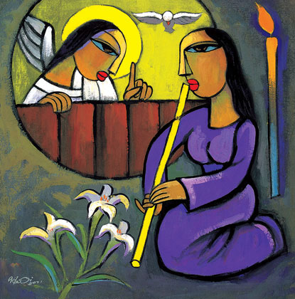
Pregnant with Hope
(Reflections for Advent)

Join us for an evening of reflections for Advent, along with poetry and music. The evening will be led by Professor Tina Beattie.

Tina is Professor Emerita of Catholic Studies at the University of Roehampton in London and a well-known Roman Catholic theologian. She has published extensively on sacramentality, desire, embodiment and gender, engaging with psychoanalytical theory and art history as well as theology. She has a particular interest in Marian theology, art and devotion. She now works as an independent researcher and writer. In addition to her academic publications, Tina is also a published novelist and a regular contributor to the media, including BBC Radio 4’s “Thought for the Day”.

Please join us for what will undoubtedly be an interesting, thought-provoking and stimulating evening.

Date: Wednesday December 10th, 2025

Time: 7.00 pm

Venue: St Thomas the Apostle Church, Camber, New Lydd Rd, TN31 7RJ

Wine and cheese will be served after the talk.

There’s plenty of parking in both the church grounds and the neighbouring street.
For more details, please contact The Revd. Jacques Desrosiers, on 07931 217458 (including WhatsApp) or email jtmdesrosiers@gmail.com.

Carols by Candlelight 14th December 6pm

Sandi would like to have a robed choir for this lovely service, so we need the help of singers from the congregation. We hope to sing two anthems (not too difficult) as well as two or three descants. There will be two or three practices, probably on Thursdays (TBC) from 27th November. Please let Janice know if you can help.

Guestling School

Guestling School is looking for two new Governors, please see attached poster for details.

Prayer:

If you would like a situation prayed about urgently, please contact the church Prayer Share. Contact Dawn 01424 255423 / 0750 7745 159

If you know anyone who would like to be added to the notices, please send me an email with their details. If you don’t want to receive this email each week, or would rather receive it in a different format, please let me know.
Please give information for notices to me by Thursday morning (contact details below).
Have a good week everyone,
Tony Demarco tonydemarcohastings@gmail.com

