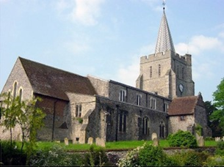
Please visit our website for information about our churches, services & events www.elhamvalleygroupofchurches.co.uk

This was amended post receipt of January rota so incorrect info on printed newsletter. Copy of joint Dec/Jan issue sent to CB on 4/11 -no reply with corrections, so forwarded to Renee 10/12. Subsequently did a separate copy for Jan 26 using same (incorrect) info.

Every Tuesday at St. Mary’s…

Traditional Morning Prayer at 8.30am in the Jesus Chapel. Download the free Church of England app or use the red book. A good way to begin the day. https://play.google.
com/store/apps/details?id=com.aimermedia.dailyprayer&pli=1


Every Monday at the Methodist Hall …
Coffee and cake, a warm welcome and friendship, 10.30am –
12pm

Churches Together in Elham Valley January
There are no meetings in January. They will resume in February. Please note the times may change.
Contact : Ruth Collie (01303 840773)

4th January – Epiphany
08:00 Said Eucharist 09.30 Service of the Word

Lectionary readings:
Isaiah 60:1-6; Psalm 72 :[1-9],10-15; Ephesians 3:1-12; Matthew 2:1-12

11th January – Baptism of Christ
09.30 Service of the Word

Lectionary readings:
Isaiah 42.1-9 ; Psalm 29 ; Acts 10.34-43; Matthew 3.13-17

18th January – 2nd Sunday of Epiphany. Week of Prayer for Christian Unity
09:30 Churches Together at Methodist Church

Lectionary readings:
Isaiah 49.1-7; Psalm 40.1-12; 1 Corinthians 1.1-9; John 1.29-42

25th January – 3rd Sunday of Epiphany
09:30 Service of the Word

Lectionary readings:
Isaiah 9.1-4; Psalm 27.1,4-11; 1 Corinthians 1.10-18; Matthew 4.12-23

Events for the February Notice sheet Please send to Margaret Keeble by 5th of each preceding month. m.keeble@outlook.com

Elham Methodist Church
(all at 9.30am unless otherwise stated)
Services for JANUARY
4th Circuit Covenant Service at St Andrew’s
11th Valley United Service at Lyminge 10.15am
18th Revd Gill Songer United Service with St Mary’s at Methodist Church
25th Local Arrangement

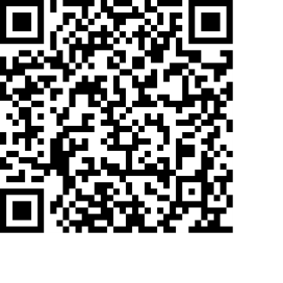
Donations
We would greatly appreciate your help to continue our work for God in the village of Elham and surrounding areas. If you can, please consider making a donation. This is our QR code for St Mary’s Elham. To donate using this code, open up the camera on a mobile phone - point the camera at the QR code – follow the instructions.
The offertory plate will go round in the service, during one of the hymns. There is also the opportunity to donate by card using the PAYAZ machine by the North door.

Safeguarding / ‘A Safe Church’:
If you ever have any concerns, contact our Parish Safeguarding Officer:
Susannah Pallot : susannahpallot@gmail.com

Paper Copies of Notices
Some copies are available on back table in church. Please take a copy to give to those unable to access the internet.

