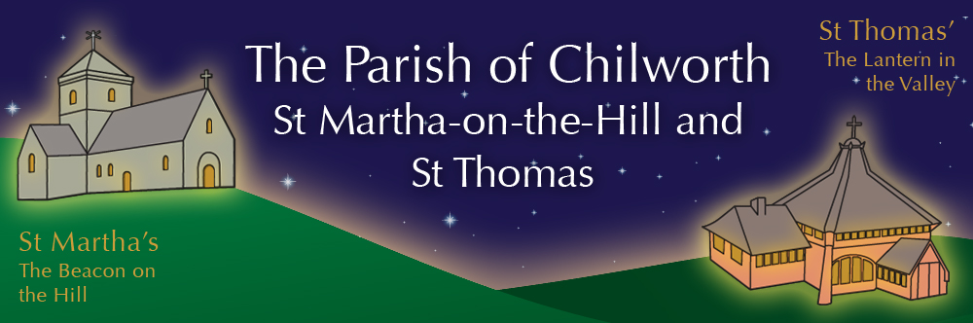

NOTICES: - 7th DECEMBER 2025
Priest David Oakden – Revdavid@parishofchilworth.org.uk - 01483 534293 (day off Friday)
Do let me know of anybody or anything that you would like to be prayed for.
www.parishofchilworth.org.uk and find us on https://www.achurchnearyou.com

**********Isaiah 40:31 (NLT)***********
But those who trust in the Lord will find new strength. They will soar high on wings like eagles. They will run and not grow weary. They will walk and not faint.
***********************************

Opportunities to pray together: -
Ecumenical Prayer Breakfast 1st Saturday of the month at the Vicarage, from 9am, prayer, coffee and croissant. Next is the 6th December – Thursday evening at St Thomas at 7:30 pm for an hour every other week. **18th December & 1st January 2026.

This Sunday Services: – 2nd of Advent
9:30 St. Thomas. Holy Communion
11:15 St. Martha’s – BCP Morning Prayer inc. Baptism

Next Sunday Services: - 14th December
9:30 St. Peter & St Paul Morning Prayer
11:15 St. Martha’s – BCP Communion
4:30 St Thomas – Candlelit Carols

Looking further ahead: -
Chilworth Tinies and Toddler Group: St T’s Monday 9:15 – 10:30am
Christmas Carol Jukebox: 6th Dec St M’s 12:00
Advent Art +Lunch: 8th Dec Midday St T’s
Candlelit Carols: 14th Dec St T’s 4:30
Advent Art +Lunch: 15th Dec St T’s Midday
Coromarta Carols: 20th Dec St M’s 1:30 & 3:00
9 Lessons & Carols: 21st Dec St M’s 11:15
Midnight Communion: 24th Dec St M’s 11:00pm
Christmas Day Communion: 25th Dec St T’s 9:30
Christmas Day Communion: 25th Dec St M’s 11:15

Food & Hygiene Bank: -
The Foodbank Larder box is located in the porch of St Thomas Church. Suggested items: - Long life milk /tins tuna/ tins meat/ sachets microwaveable rice /pasta sauces/curry sauces/cereal/spreads/ tea/ coffee/ hot chocolate/ tins soup/ baked beans. Please assist, especially as the autumn is now upon us.

Chilworth Tinies and Toddler Group: -
Mondays from 9:15 -10:30 meet in St Thomas, play chat, pray and support.
Benefice News - David Oakden: -
He will be licenced to this additional role by Archdeacon Catherine on December 9th at 2.30pm at Albury Parish Church – St Peter & St Paul, Church Lane, Albury. Come and support, and enjoy the refreshments after a very short service.

Advent Art + Lunch 8th & 15th of Dec: -
Simple lunch of cup a soup, and a look at paintings with an Advent theme in St T’s from midday.

Hark, the Glad Sound: -
Annie, BBC Young Chorister of the Year 2025 finalist, singing a selection of Christmas carols and songs in ST Martha’s 14th Dec 12:45 – 1:15

UOSSB Brass Ensemble: -
The popular Jukebox Brass Carol Concert from Noon at St M’s on 6th Dec.

Christmas Highlights: -
6th Dec Midday Carol Jukebox St M’s
6th Dec 5:00pm Gathering Carols – St James, Shere
14th Dec 4pm Christingle – St Mark’s Peaslake
14th Dec 4:30pm Candlelit Carols – St T’s
17th Dec 2:30pm Songs of Praise – St James, Shere
20th Dec 1:30pm & 3pm Coromarta Carols – St M’s
21st Dec 11:15am 9lessons & Carols – St M’s
21st Dec 6:30pm 9 Lessons & Carols – St James, Shere
21st Dec 5:00pm Candlelit Carols – Old Saxon Church
22nd Dec 7pm Carols at the Bar – Gomshall Club
23rd Dec 6:30pm Carols at Drummond Arms
24th Dec 4:00pm Crib/ Christingle – St P & St P’s
24th Dec 6:30pm Carols in the Square, Shere
24th Dec 11:00pm Midnight Communion – St M’s
25th Dec 9:30 Christmas Day Communion – St T’s
25th Dec 11:15 Christmas Day Communion – St M’s

