Those who are sick, grieving, or in any kind of need, remembering especially:
Garsington: Anne,
Cuddesdon: Julie Grindod,
Horspath: Anne & Bob Adams, John Llewellyn, Susan Gee,
For those who have died, and those who grieve for them including Ian Caldwell of Chippinghurst, Cnythia ‘Tut’ Jennings of Garsington, and
Bishop David Wilcox (Former Vicar or Cuddesdon and former Principal of Ripon College Cuddesdon)

NOTICES:

CONTEMPLATIVE PRAYER GROUP – ALL SAINTS, CUDDESDON – 5pm on Wednesdays
ALL WELCOME – 30 minutes of silent prayer FOLLOWED BY: Midweek Eucharist 6pm in All Saints Cuddesdon, this is a new benefice service, everybody is welcome.

CHRISTMAS WEEK SERVICES IN THE BENEFICE
Below is a list of the Benefice services during Christmas week; there are several different services at different times. We look forward to sharing Christmas worship with you all.

Christmas season continues until Candlemas on 2nd February. You are especially welcome to join us for a Benefice Communion on Sunday 28th December at 10.00am in St Giles Horspath.

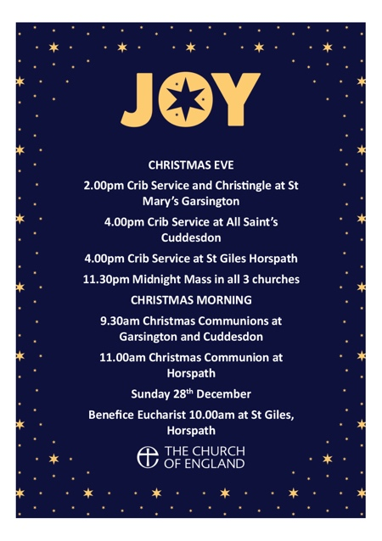

Next week’s services: (All Welcome – why not invite a friend?)
Sunday 21st December The Fourth Sunday of Advent
Cuddesdon, All Saints: 9.30am. Parish Eucharist
Garsington, St Mary’s: 9.30am – Parish Eucharist
Horspath, St Giles: 11.00am-11.15am Family Time and Christingle
3.00pm – Village Carol Service followed by Blessing the Village Treeon the Green

Administrator and Contact details for booking baptisms, weddings, pastoral visits, etc
07540051798 Email gchbenefice@gmail.com

The weekly pew sheet for St Mary’s, Garsington,
All Saints’, Cuddesdon and St Giles’, Horspath

Sunday 14th December 2025 The Second Sunday of Advent
Cuddesdon, All Saint’s. 9.30am. Parish Eucharist
3.00pm Benefice Storytime Church
Garsington, St Mary’s: 6.00pm Carols by Candlelight
Horspath, St Giles: 11.00am Parish Eucharist
Benefice Sunday Funtime at the Hub

Collect
O Lord Jesus Christ,
who at your first coming sent your messenger
to prepare your way before you:
grant that the ministers and stewards of your mysteries
may likewise so prepare and make ready your way
by turning the hearts of the disobedient to the wisdom of the just,
that at your second coming to judge the world
we may be found an acceptable people in your sight;
for you are alive and reign with the Father
in the unity of the Holy Spirit,
one God, now and for ever.

Post Communion
We give you thanks, O Lord, for these heavenly gifts;
kindle in us the fire of your Spirit
that when your Christ comes again
we may shine as lights before his face;
who is alive and reigns now and for ever.

Isaiah 35.1-10
35The wilderness and the dry land shall be glad,
the desert shall rejoice and blossom;
like the crocus ²it shall blossom abundantly,
and rejoice with joy and singing.
The glory of Lebanon shall be given to it,
the majesty of Carmel and Sharon.
They shall see the glory of the Lord,
the majesty of our God.
³ Strengthen the weak hands,
and make firm the feeble knees.
⁴ Say to those who are of a fearful heart,
‘Be strong, do not fear!
Here is your God.
He will come with vengeance,
with terrible recompense.
He will come and save you.’
⁵ Then the eyes of the blind shall be opened,
and the ears of the deaf unstopped;
⁶ then the lame shall leap like a deer,
and the tongue of the speechless sing for joy.
For waters shall break forth in the wilderness,
and streams in the desert;
⁷ the burning sand shall become a pool,
and the thirsty ground springs of water;
the haunt of jackals shall become a swamp,
the grass shall become reeds and rushes.
⁸ A highway shall be there,
and it shall be called the Holy Way;
the unclean shall not travel on it,
but it shall be for God’s people;
no traveller, not even fools, shall go astray.
⁹ No lion shall be there,
nor shall any ravenous beast come up on it;
they shall not be found there,
but the redeemed shall walk there.
¹⁰ And the ransomed of the Lord shall return,
and come to Zion with singing;
everlasting joy shall be upon their heads;
they shall obtain joy and gladness,
and sorrow and sighing shall flee away.

Matthew 11.2-11
2 When John heard in prison what the Messiah was doing, he sent word by his disciples ³and said to him, ‘Are you the one who is to come, or are we to wait for another?’ ⁴Jesus answered them, ‘Go and tell John what you hear and see: ⁵the blind receive their sight, the lame walk, the lepers are cleansed, the deaf hear, the dead are raised, and the poor have good news brought to them. ⁶And blessed is anyone who takes no offence at me.’
7 As they went away, Jesus began to speak to the crowds about John: ‘What did you go out into the wilderness to look at? A reed shaken by the wind? ⁸What then did you go out to see? Someone dressed in soft robes? Look, those who wear soft robes are in royal palaces. ⁹What then did you go out to see? A prophet? Yes, I tell you, and more than a prophet. ¹⁰This is the one about whom it is written,
“See, I am sending my messenger ahead of you,
who will prepare your way before you.”
¹¹Truly I tell you, among those born of women no one has arisen greater than John the Baptist; yet the least in the kingdom of heaven is greater than he.

Tom will be praying the offices in church this week:
Tuesday 16th December: EP 6pm All Saints’
Wednesday 17th December: MP 9:15 St Mary’s
Thursday 18th December: EP 6pm St Giles
Friday 19th December: EP 5pm St Mary’s

Please pray for Tom's priorities this week, which include:
Presiding at Cuddesdon followed by interment of ashes, Benefice Storytime Church, Garsington Village Carol Service, school services in church and school, funeral of Ian Caldwell in All Saints Church, counselling, prayer, Julian Group, Benefice midweek Communion, Home Communion, meeting, Garsington monthly coffee (drop in), sermon prep, service prep, desk work, admin, emails

Please pray for growth in the churches in our Benefice God of mission, who alone brings growth to your Church, send your Holy Spirit to give vision to our planning, wisdom and love to our actions, joy to our worship, and power to our witness. Help our churches (St Mary’s, Garsington; All Saints’, Cuddesdon and St Giles’, Horspath) to grow in numbers, in spiritual commitment to you, in generous giving, and in loving service to each other and to our local communities. Amen

PLEASE JOIN WITH US FOR OUR CAROL SERVICES
Sunday 14th December 6pm St Mary’s Garsington
Candlelit Carol Service
Saturday 20th December All Saints Cuddesdon
5.00pm Intermezzo Carol Service
Sunday 21 December 3pm St Giles’ Horspath
Candlelit Carol Service

Please pray for:
- The people of Gaza, Palestine, Iran, Israel, Lebanon, Syria; Ukraine, Yemen, Sudan and all conflict zones – for a lasting ceasefire, peace with justice, reconciliation, mercy and compassion
- This Advent, we pray for all in the busy run up to Christmas, that through the business and the preparations they may catch a glimpse of the joy of the Incarnation.
- As the winter approaches, we pray for the homeless and everyone affected by food and fuel poverty.
- All refugees, asylum seekers, and those who support refugees
- Our parishes of Garsington, Cuddesdon and Horspath, our Churchwardens, Clergy, Treasurers, Secretaries and PCCs
- Our Benefice Safeguarding Officer, (Kathryn) and all that we do to keep children and vulnerable adults safe
- Story-time Church, Sunday Fun Time, Chatter and Clatter, Family Time, our all-age Eucharists, and all our work with children, young people and families
- Our Church Primary schools in Garsington and Horspath – for the Headteachers, staff and pupils and governors
- for Ripon College Cuddesdon – Bp Humphrey, Emma, in thanksgiving for all he has given and wishing them a happy and fulfilled retirement. For all members of staff and all the community – For The Revd Dr Harriet Harris as she prepares to take on the role of Principal in January.

