Those who are sick, grieving, or in any kind of need, remembering especially:
Garsington: Anne,
Cuddesdon: Julie Grindod,
Horspath: Anne & Bob Adams, John Llewellyn, Susan Gee,
For those who have died, and those who grieve for them including Ian Caldwell of Chippinghurst, and Cynthia ‘Tut’ Jennings of Garsington

NOTICES:

CONTEMPLATIVE PRAYER GROUP – ALL SAINTS, CUDDESDON – 5pm on Wednesdays
ALL WELCOME – 30 minutes of silent prayer FOLLOWED BY: Midweek Eucharist 6pm in All Saints Cuddesdon, this is a new benefice service, everybody is welcome. The Prayer Group and the Benefice Communion will NOT take place on Wednesday 24th and Wednesday 31st December. Both will reconvene on 7th January.

Administrators Christmas Quiz – I have left copies of a Christmas Dingbat Quiz, please enjoy, there is a small prize for the first winning entry to be announced and if you are able to be there presented at the Benefice Communion on Sunday 28th December

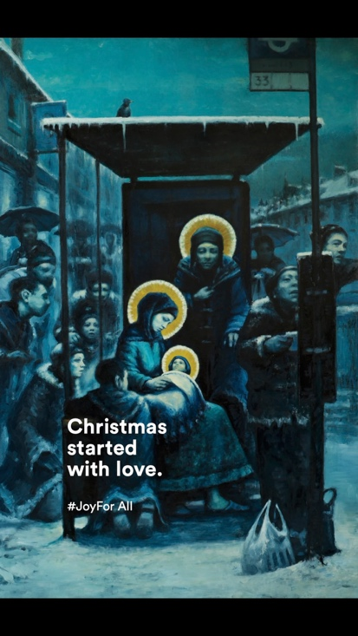

Next week’s service: (All Welcome – why not invite a friend?)
Sunday 28th December The Sunday after Christmas

Horspath, St Giles: 10.00am-Benefice Eucharist

Administrator and Contact details for booking baptisms, weddings, pastoral visits, etc
07540051798 Email gchbenefice@gmail.com


The weekly pew sheet for St Mary’s, Garsington,
All Saints’, Cuddesdon and St Giles’, Horspath

Sunday 21st December 2025 The Second Sunday of Advent
Cuddesdon, All Saint’s. 8.00am Holy Communion (BCP)
9.30am Parish Eucharist
Garsington, St Mary’s: 9.30am Pariah Eucharist
Horspath, St Giles: 11.00am for 11.15 Family Service with Christingle
3.00pm Village Carol Service followed by The Blessing of the Village Christmas Tree.

Collect
God our redeemer,
who prepared the Blessed Virgin Mary
to be the mother of your Son:
grant that, as she looked for his coming as our saviour,
so we may be ready to greet him
when he comes again as our judge;
who is alive and reigns with you,
in the unity of the Holy Spirit,
one God, now and for ever.

Post Communion
Heavenly Father,
who chose the Blessed Virgin Mary
to be the mother of the promised saviour:
fill us your servants with your grace,
that in all things we may embrace your holy will
and with her rejoice in your salvation;
through Jesus Christ our Lord.

Isaiah 7.10-16
10 Again the Lord spoke to Ahaz, saying, ¹¹Ask a sign of the Lord your God; let it be deep as Sheol or high as heaven. ¹²But Ahaz said, I will not ask, and I will not put the Lord to the test. ¹³Then Isaiah said: ‘Hear then, O house of David! Is it too little for you to weary mortals, that you weary my God also? ¹⁴Therefore the Lord himself will give you a sign. Look, the young woman is with child and shall bear a son, and shall name him Immanuel.¹⁵He shall eat curds and honey by the time he knows how to refuse the evil and choose the good. ¹⁶For before the child knows how to refuse the evil and choose the good, the land before whose two kings you are in dread will be deserted.

Romans 1.1-7
Paul, a servant of Jesus Christ, called to be an apostle, set apart for the gospel of God, ²which he promised beforehand through his prophets in the holy scriptures, ³the gospel concerning his Son, who was descended from David according to the flesh ⁴and was declared to be Son of God with power according to the spirit of holiness by resurrection from the dead, Jesus Christ our Lord, ⁵through whom we have received grace and apostleship to bring about the obedience of faith among all the Gentiles for the sake of his name, ⁶including yourselves who are called to belong to Jesus Christ,
7 To all God’s beloved in Rome, who are called to be saints:
Grace to you and peace from God our Father and the Lord Jesus Christ.

Matthew 1.18-21
18 Now the birth of Jesus the Messiah took place in this way. When his mother Mary had been engaged to Joseph, but before they lived together, she was found to be with child from the Holy Spirit. ¹⁹Her husband Joseph, being a righteous man and unwilling to expose her to public disgrace, planned to dismiss her quietly. ²⁰But just when he had resolved to do this, an angel of the Lord appeared to him in a dream and said, ‘Joseph, son of David, do not be afraid to take Mary as your wife, for the child conceived in her is from the Holy Spirit. ²¹She will bear a son, and you are to name him Jesus, for he will save his people from their sins.’ ²²All this took place to fulfil what had been spoken by the Lord through the prophet:
²³ ‘Look, the virgin shall conceive and bear a son,
and they shall name him Emmanuel’,
which means, ‘God is with us.’ ²⁴When Joseph awoke from sleep, he did as the angel of the Lord commanded him; he took her as his wife, ²⁵but had no marital relations with her until she had borne a son; and he named him Jesus.

Tom will be praying the offices in church this week:
Tuesday 23rd December: MP 9:15 St Mary’s, EP 6pm All Saints’
Wednesday 24th December: MP 9:15 St Mary’s

Please pray for Tom's priorities this week, which include:
Presiding at Garsington, Horspath Village Carol Service, Cuddesdon village carols around the Christmas tree, prayer, Christingle preparation, Christingle Service, Crib Service, Midnight Mass, Christmas services, sermon prep, service prep, desk work, admin, emails

Tom will be taking his post-Christmas break from 26 December – 3 January and will not be checking emails or telephone messages during this period

Please pray for growth in the churches in our Benefice God of mission, who alone brings growth to your Church, send your Holy Spirit to give vision to our planning, wisdom and love to our actions, joy to our worship, and power to our witness. Help our churches (St Mary’s, Garsington; All Saints’, Cuddesdon and St Giles’, Horspath) to grow in numbers, in spiritual commitment to you, in generous giving, and in loving service to each other and to our local communities. Amen
CHRISTMAS EVE AND CHRISTMAS DAY SERVICES
2.00pm Crib Service and Christingle at St Mary’s Garsington
4.00pm Crib Service at All Saint’s Cuddesdon
4.00pm Crib Service at St Giles Horspath
11.30pm Midnight Mass in all 3 churches
CHRISTMAS MORNING
9.30am Christmas Communions at Garsington and Cuddesdon
11.00am Christmas Communion at Horspath
We wish you all a very Happy Christmas

A PRAYER FOR THE WORK OF THE CHILDREN’S SOCIETY: A CHARITY OUR PARISHES SUPPORT AT CHRISTMAS ESPECIALLY AT CHRISTINGLE SERVICES
Loving Lord,
we thank you for the Children’s Society as it reaches out
to young people experiencing pain and injustice.
Guide and strengthen its work alongside children and young people
who are homeless and on the streets,
in prison or facing problems in the community.
Grant us the wisdom to listen to the voices of the young
and to recognize their gifts and insights.
Help us to work with them to create a fair and just society
where all may know the fullness of your love,
through Jesus Christ our Lord. Amen.

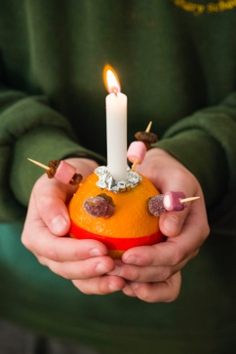

Please pray for:
- The people of Gaza, Palestine, Iran, Israel, Lebanon, Syria; Ukraine, Yemen, Sudan and all conflict zones – for a lasting ceasefire, peace with justice, reconciliation, mercy and compassion
- For all the victims and families affected by the shooting on Bondi beach, for all victims of terrorism and violence.
- As the winter approaches, we pray for the homeless and everyone affected by food and fuel poverty.
- All refugees, asylum seekers, and those who support refugees
- Our parishes of Garsington, Cuddesdon and Horspath, our Churchwardens, Clergy, Treasurers, Secretaries and PCCs
- Our Benefice Safeguarding Officer, (Kathryn) and all that we do to keep children and vulnerable adults safe
- Story-time Church, Sunday Fun Time, Chatter and Clatter, Family Time, our all-age Eucharists, and all our work with children, young people and families
- Our Church Primary schools in Garsington and Horspath – for the Headteachers, staff and pupils and governors
- for Ripon College Cuddesdon – Bp Humphrey, Emma, in thanksgiving for all he has given and wishing them a happy and fulfilled retirement. For all members of staff and all the community – For the Revd Dr Harriet Harris as she prepares to take on the role of Principal in January.

