SUNDAY 21st
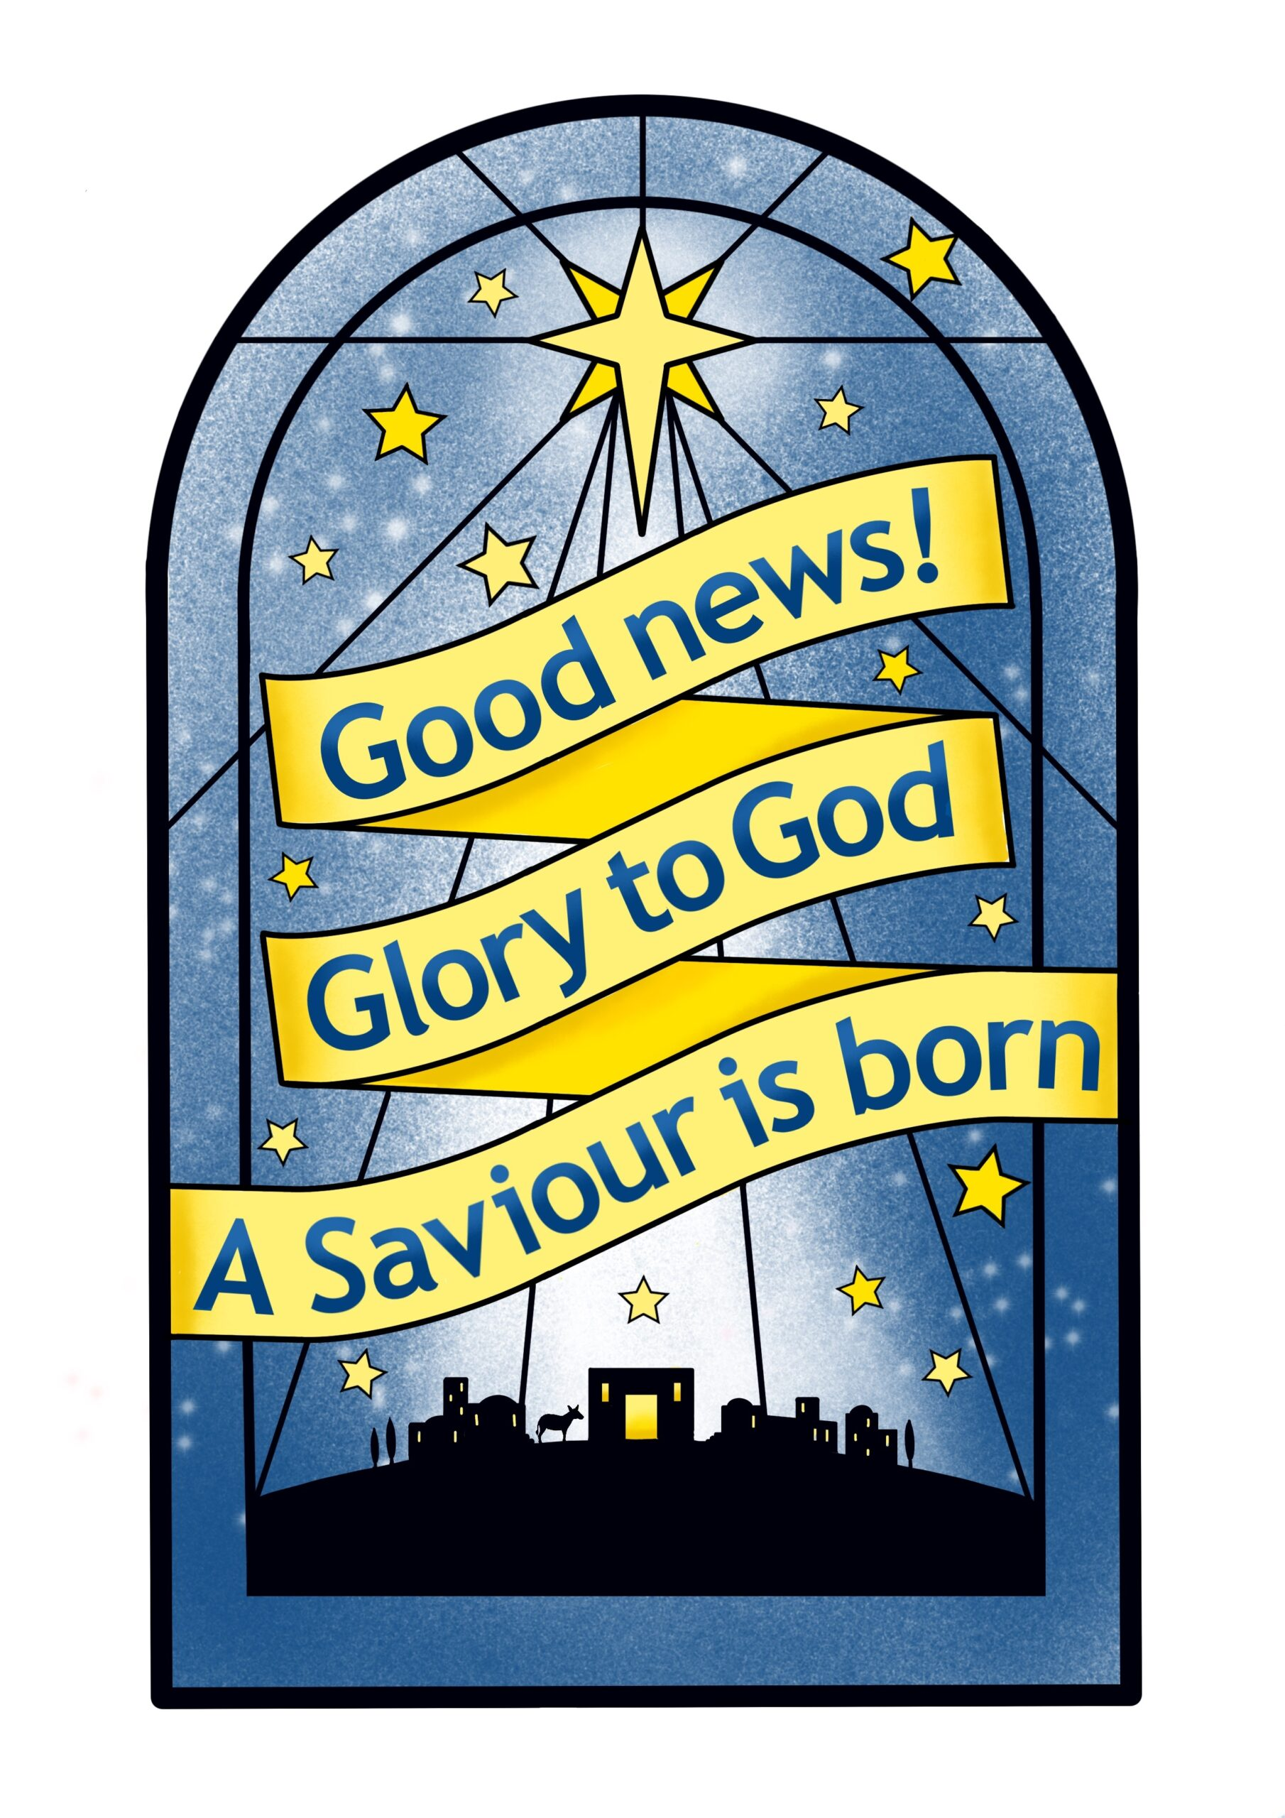

11am Holy Communion
Rev Mark & Rev Jan
Readings Isaiah 7¹⁰⁻¹⁶; Matt 1¹⁸⁻²⁵

3pm Nine Lessons and Carols
I heard the Bells on Christmas Day
I heard the bells on Christmas day
Their old familiar carols play,
And wild and sweet the words repeat
Of peace on earth, good will to men.
And in despair I bowed my head:
‘There is no peace on earth, ‘ I said
‘For hate is strong, and mocks the song
Of peace on earth, good will to men.’
Then pealed the bells more loud and deep:
‘God is not dead, nor doth He sleep;
The wrong shall fail, the right prevail,
With peace on earth, good will to men.’
Till, ringing, singing on its way,
The world revolved from night to day
A voice, a chime, a chant sublime,
Of peace on earth, good will to men.
by Henry Wadsworth Longfellow

,

ALPHA
Starting on Weds 21st Jan 7.30 - 9pm
we are running an Alpha course for 8 weeks. It will be a welcoming space to explore faith and life’s big questions in a relaxed, supportive environment. Each session offers an opportunity to connect over a shared meal, followed by an engaging talk and open discussions where you can explore topics.
This will be good for friends and families keen to learn more about Christianity. Please do take a flyer and give them out.

WEDS 24th

10:30am NO SERVICE
2:00pm Christingle & Crib
Service
11:30pm Midnight Mass
Readings Isaiah 29¹³⁻¹⁸, 1 John 4⁷⁻¹⁶

CHRISTMAS DAY
9:30am Holy Communion at St. B

Upcoming Services
Sun 28th Dec 11:00am Holy Communion
Weds 31st Dec 10:30am NO SERVICE

Sun 4th Jan 8:00am Holy Communion
11:00am Morning Worship
4:00pm Epiphany Service
at St. B
Weds 7th Jan 10:30am Holy Communion

Thanks be to God for
His indescribable gift!
2 Corinthians 9:15
Heavenly Father, thank You for freely giving the most precious gift of all, Your only begotten Son, Jesus, to all who will receive Him. Help us to share this indescribable gift with the world.
AMEN

Smile Lines
Weird Christmas
Christmas is weird – at what other time of the year do you sit in front of a dead tree and eat sweets out of your socks?

