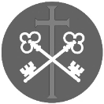
St Peter and the Holy Apostles, Plymouth- Sunday 21st December 2025
The Fourth Sunday of Advent/ (Year C)
Welcome to the Parish Mass
Welcome to St Peters Church. This sheet provides all that you will need for today’s Mass. If you need any assistance before, during or after the service or need a large print copy of this order of service please speak to one of our welcome team. (identifiable by a lanyard)
Please respond to the words in non-italic Bold, The Hymns are sung by all. Please inform the people on the door when you enter if you require a Gluten Free Host
…………………………………………………………………………………
We Stand for The Entrance Hymn

1. Come, thou long-expected Jesus,
born to set thy people free;
from our fears and sins release us;
let us find our rest in thee.
2. Israel's strength and consolation,
hope of all the earth thou art;
dear desire of every nation,
joy of every longing heart.
3. Born thy people to deliver;
born a child and yet a king;
born to reign in us for ever;
now thy gracious kingdom bring.
4. By thy own eternal Spirit,
rule in all our hearts alone:
by thy all-sufficient merit,
raise us to thy glorious throne.

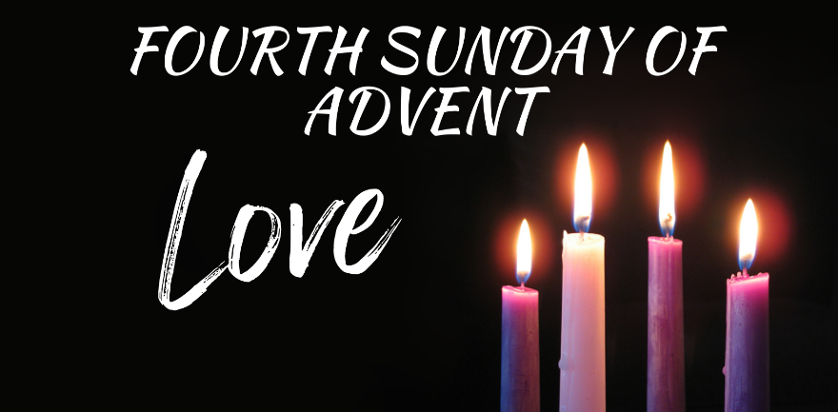
The Introductory Rite
In the name of the Father and of the Son and of the Holy Spirit. Amen.
Following the greeting we respond. And with your spirit.
The Priest introduces the Mass
The Lighting of Advent Candle 4- Mary
Jesus said, ‘Anyone who does what my Father in heaven wants is my brother or sister or mother.’
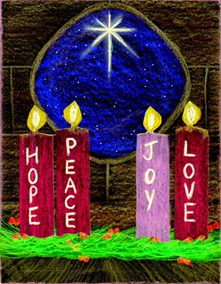
I am the servant of the Lord. Let it be to me according to his word.
The second candle is lit and this response is used
Jesus is the light of the world.
A light no darkness can ever put out.
We sing:
Mary’s gift, beyond all telling,
was to give Christ room.
She gave God a human dwelling
in a mother’s womb.
Who could guess the final story?
cross and glory; empty tomb!
The Penitential Rite
Cantor- Show mercy to us, loving Father.
We have sinned against you, please make us anew.
In your love and your grace You forgive us.
(Lord have mercy…)
All- Lord have mercy, Lord have mercy.
Cantor- Look not on our failings, Lord, Jesus.
We have sinned against you, please make us anew.
By your life and your death, You redeem us.
(Christ have mercy…)
All- Christ have mercy, Christ have mercy.
Cantor- Come fill our hearts Holy Spirit.
We have sinned against you, please make us anew.
Forgive us and heal us and save us.
(Lord have mercy…)
All- Lord have mercy, Lord have mercy.
Priest- May almighty God have mercy on us, forgive us our sins, and bring us to everlasting life. Amen.

The Collect

Let us pray. Pour forth, we beseech you, O Lord, your grace into our hearts, that we, to whom the Incarnation of Christ your Son was made known by the message of an Angel, may by his Passion and Cross be brought to the glory of his Resurrection. Who lives and reigns with you in the unity of the Holy Spirit, God, for ever and ever. Amen.

We sit for The First Reading-

In those days: The Lord spoke to Ahaz: ‘Ask a sign of the Lord your God; let it be deep as Sheol or high as heaven.’ But Ahaz said, ‘I will not ask, and I will not put the Lord to the test.’ And Isaiah said, ‘Hear then, O house of David! Is it too little for you to weary men, that you weary my God also? Therefore the Lord himself will give you a sign. Behold, the virgin shall conceive and bear a son, and shall call his name Emmanuel.’

The word of the Lord. Thanks be to God.

The Responsorial Psalm- Ps 24(23):1-2. 3-4b. 5-6. ℟ cf. 6

Response- Let the Lord enter; he is the king of glory.

The Lord’s is the earth and its fullness, the world, and those who dwell in it.
It is he who set it on the seas; on the rivers he made it firm. R

Who shall climb the mountain of the Lord? Who shall stand in his holy place?
The clean of hands and pure of heart, whose soul is not set on vain things. R

Blessings from the Lord shall he receive, and right reward from the God who saves him.
Such are the people who seek him, who seek the face of the God of Jacob. R

The second Reading- Romans 1:1-7

Paul, a servant of Christ Jesus, called to be an Apostle, set apart for the gospel of God, which he promised beforehand through his prophets in the holy Scriptures, concerning his Son, who was descended from David according to the flesh and was declared to be the Son of God in power according to the Spirit of holiness by his resurrection from the dead: Jesus Christ our Lord, through whom we have received grace and apostleship to bring about the obedience of faith for the sake of his name among all the nations, including you who are called to belong to Jesus Christ. To all those in Rome who are loved by God and called to be saints: Grace to you and peace from God our Father and the Lord Jesus Christ.

The word of the Lord. Thanks be to God

We stand for- The Gospel Procession and Acclamation- Matthew 1:23

Alleluia, alleluia.
Behold, the virgin shall conceive and bear a son,
and they shall call his name Emmanuel — which means, God with us.
Alleluia.

The Gospel- Matthew 1:18-24

The Lord be with you. And with your spirit.
A reading from the holy Gospel according to N. Glory to you, O Lord.
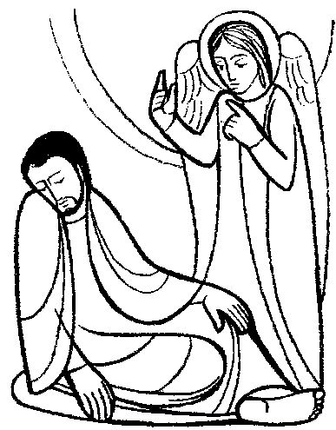
Now the birth of Jesus Christ took place in this way. When his mother Mary had been betrothed to Joseph, before they came together she was found to be with child from the Holy Spirit. And her husband Joseph, being a just man and unwilling to put her to shame, resolved to send her away quietly. But as he considered these things, behold, an angel of the Lord appeared to him in a dream, saying, ‘Joseph, son of David, do not fear to take Mary as your wife, for that which is conceived in her is from the Holy Spirit. She will bear a son, and you shall call his name Jesus, for he will save his people from their sins.’
All this took place to fulfil what the Lord had spoken by the prophet:
‘Behold, the virgin shall conceive and bear a son,
and they shall call his name Emmanuel’ —
which means, God with us.
When Joseph woke from sleep, he did as the angel of the Lord commanded him: he took his wife.

The Gospel of the Lord. Praise to you, Lord Jesus Christ.

We sit for The Homily

We stand The Creed
I believe in one God, the Father almighty, maker of heaven and earth,
of all things visible and invisible.
I believe in one Lord Jesus Christ, the Only Begotten Son of God, born of the Father before all ages. God from God, Light from Light, true God from true God, begotten, not made, consubstantial with the Father; through him all things were made. For us men and for our salvation he came down from heaven,
At the words that follow, up to and including ‘and became man’, all bow.
and by the Holy Spirit was incarnate of the Virgin Mary, and became man.
For our sake he was crucified under Pontius Pilate, he suffered death and was buried, and rose again on the third day in accordance with the Scriptures.
He ascended into heaven and is seated at the right hand of the Father. He will come again in glory to judge the living and the dead and his kingdom will have no end.
I believe in the Holy Spirit, the Lord, the giver of life, who proceeds from the Father and the Son, who with the Father and the Son is adored and glorified, who has spoken through the prophets.
I believe in one, holy, catholic and apostolic Church. I confess one Baptism for the forgiveness of sins and I look forward to the resurrection of the dead and the life of the world to come. Amen.

We remain standing for The Prayers of the Faithful

Cantor- There is a longing in our hearts, O Lord, for you to reveal yourself to us.
There is a longing in our hearts for love we only find in you, our God.

All- There is a longing in our hearts, O Lord, for you to reveal yourself to us.
There is a longing in our hearts for love we only find in you, our God.
Cantor- For justice, for freedom, for mercy, hear our prayer.
In sorrow, in grief, be near, hear our prayer, O God.
All- There is a longing in our hearts…
Cantor- For wisdom, for courage, for comfort, hear our prayer.
In weakness, in fear, be near, hear our prayer, O God.
All- There is a longing in our hearts…
Cantor- For healing, for wholeness, for new life, hear our prayer.
In sickness, in death, be near, hear our prayer, O God.
All- There is a longing in our hearts…
Cantor- Lord save us, take pity, light in our darkness.
We call you, we wait, be near, hear our prayer, O God.
All- There is a longing in our hearts…

The Priest Concludes the Prayers of the Faithful
No collection is taken during the Mass, but there is a collection box at the back of church for you to give your financial contribution. All money collected helps towards the mission and ministry of our churches. If you would prefer, a card reading machine is available at the back of the church for your contribution.
The Offertory Hymn

1. Ye who own the faith of Jesus
sing the wonders that were done,
when the love of God the Father
o'er our sin the victory won,
when he made the Virgin Mary
Mother of his only Son.
Hail Mary, full of grace.
2. Blessèd were the chosen people
out of whom the Lord did come,
blessèd was the land of promise
fashioned for his earthly home;
but more blessèd far the Mother
she who bare him in her womb.
Hail Mary, full of grace.
3. Wherefore let all faithful people
tell the honour of her name,
let the church in her foreshadowed
part in her thanksgiving claim;
what Christ's Mother sang in gladness
let Christ's people sing the same.
Hail Mary, full of grace.
4. Let us weave our supplications,
she with us and we with her,
for the advancement of the faithful,
for each faithful worshipper,
for the doubting, for the sinful,
for each heedless wanderer.
Hail Mary, full of grace.


5. Praise, O Mary, praise the Father,
praise thy Saviour and thy Son,
praise the everlasting Spirit,
who hath made thee ark and throne;
o'er all creatures high exalted,
lowly praise the Three in One.
Hail Mary, full of grace.
The Liturgy of the Eucharist
Pray, brethren (brothers and sisters), that my sacrifice and yours may be acceptable to God, the almighty Father. May the Lord accept the sacrifice at your hands for the praise and glory of his name, for our good and the good of all his holy Church.

The Lord be with you. And with your spirit.
Lift up your hearts. We lift them up to the Lord.
Let us give thanks to the Lord our God. It is right and just.
The Priest continues with the Preface. The Sanctus is the said or sung:
Holy, Holy, Holy Lord God of hosts.
Heaven and earth are full of your glory. Hosanna in the highest.
Blessed is he who comes in the name of the Lord. Hosanna in the highest.
The Priest continues the Eucharistic prayer. The following is said or sung
The mystery of faith…. We proclaim your Death, O Lord, and profess your Resurrection until you come again.

The Priest concludes the Eucharistic prayer.

Through him, and with him, and in him, O God, almighty Father, in the unity of the Holy Spirit, all glory and honour is yours, for ever and ever. Amen.

The Lord’s Prayer
At the Saviour’s command and formed by divine teaching, we dare to say:
Our Father, who art in heaven, hallowed be thy name; thy kingdom come, thy will be done on earth as it is in heaven. Give us this day our daily bread, and forgive us our trespasses, as we forgive those who trespass against us; and lead us not into temptation, but deliver us from evil.
Deliver us, Lord, we pray… and the coming of our Saviour, Jesus Christ.
For the kingdom, the power and the glory are yours now and for ever.

The Peace
Lord Jesus Christ, who said to your Apostles: Peace I leave you, my peace I give you,
look not on our sins, but on the faith of your Church, and graciously grant her peace and unity in accordance with your will. Who live and reign for ever and ever. Amen.
The peace of the Lord be with you always: And with your spirit.

Let us offer each other the sign of peace.
All are invited to make an acknowledgement to each other to mark the sign of the peace.
The Agnus Dei
All say or sing:
Lamb of God, you take away the sins of the world, have mercy on us.
Lamb of God, you take away the sins of the world, have mercy on us.
Lamb of God, you take away the sins of the world, grant us peace.

The Invitation to Communion
Behold the Lamb of God, behold him who takes away the sins of the world. Blessed are those called to the supper of the Lamb.
Lord, I am not worthy that you should enter under my roof, but only say the word and my soul shall be healed.
All who are regular communicants in their own tradition are welcome to receive the sacrament if you are not a communicant you are welcome to come forward at this point in the service to receive a blessing To indicate that it is just a blessing you require, please take this service sheet up with you. We have returned to offering the chalice at the time of communion but please do not feel any pressure to receive from the common cup as the church teaches that the sacrament is received fully in one kind. We request that you do not intinct (dip) your host in the Chalice but either take a sip from the cup or return directly to your seat. This is for reasons of good hygiene.

The Communion Hymn

1. The advent of our King
our prayers must now employ,
and we must hymns of welcome sing
in strains of holy joy.
2. The everlasting Son
incarnate deigns to be;
himself a servant's form puts on,
to set his servants free.
3. Daughter of Sion, rise
to meet thy lowly King;
nor let thy faithless heart despise
the peace he comes to bring.
4. As judge, on clouds of light,
he soon will come again,
and his true members all unite
with him in heaven to reign.
5. All glory to the Son
who comes to set us free,
with Father, Spirit, ever One,
through all eternity.

We stand for The Prayer After Communion

Having received this pledge of eternal redemption, we pray, almighty God, that, as the feast day of our salvation draws ever nearer, so we may press forward all the more eagerly to the worthy celebration of the mystery of your Son’s Nativity. Who lives and reigns for ever and ever. Amen

The priest may give some brief notices

The Concluding Rites
The Lord be with you. And with your spirit.

May almighty God bless you, the Father, and the Son, ✠ and the Holy Spirit. Amen.

The Dismissal
Go forth, the Mass is ended. Thanks be to God

The Final Hymn
1. Joy to the world, the Lord is come!
let earth receive her King;
let every heart prepare him room,
and heaven and nature sing,
and heaven and nature sing,
and heaven, and heaven and nature sing.
2. Joy to the world, the Saviour reigns!
let all their songs employ;
while fields and floods, rocks, hills and plains
repeat the sounding joy,
repeat the sounding joy,
repeat, repeat the sounding joy.
3. He rules the world with truth and grace,
and makes the nations prove
the glories of his righteousness
and wonders of his love,
and wonders of his love,
and wonders, wonders of his love.
…………………………………………………………………
The Angelus
The Angel of the Lord declared unto Mary. And she conceived of the Holy Spirit.

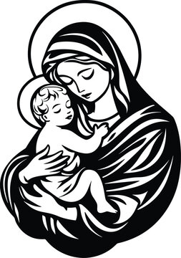
Hail Mary, full of grace, The Lord is with Thee;
Blessed art thou among women,
And blessed is the fruit of thy womb, Jesus.
Holy Mary, Mother of God, Pray for us sinners,
Now and at the hour of our death.

Behold the handmaid of the Lord.
Be it done to me according to thy word.
Hail Mary. . .

And the Word was made flesh.
And dwelt among us.
Hail Mary…

Pray for us, O holy Mother of God.
That we may be made worthy of the promises of Christ.
Let us pray:

Pour forth, we beseech Thee, O Lord, Thy grace into our hearts, that we to whom the Incarnation of Christ Thy Son was made known by the message of an angel, may by His Passion and Cross be brought to the glory of His Resurrection. Through the same Christ Our Lord. Amen.
……………………………………………………………………………..
The Notices
Advent across the Society Parishes in Plymouth
Through Advent at St Peter’s the Blessed Sacrament will be exposed from 8.00am – 9.00am (except Monday & Sundays)

Sunday 21st December- Christmas Carol Service- at St Gabriels, 5.30pm TODAY
………………………………………………………………………..

Help Needed for our Winter night Shelter-
help is needed to support our winter night shelter between December and March on Wednesdays… splitting the shifts and duties will make this more manageable for volunteers! Therefore, Help is needed with…
- preparing beds and welcoming night shelter users with a hot drink 8pm- 11pm on Wednesdays.
- Overnight cover 11pm Wednesdays to 7.00am Thursday (you need to be able to stay awake to cover this shift!)
- Making hot drinks and toast and clearing beds- 7am- 9.30am on Thursday.
For further information please speak to Fr David or Ben

Through the winter months we will be supplying toast for those in need and on Wednesday lunchtimes we will also be supplying soup.

Christmas food hampers- once again we have the privilege of being to supply food hampers to families in our local community, families will collect these from church on Tuesday 23rd from 11am- help will be needed to welcome families into church and provide friendly hospitality. Please speak to Fr David or Ben if you are able to help

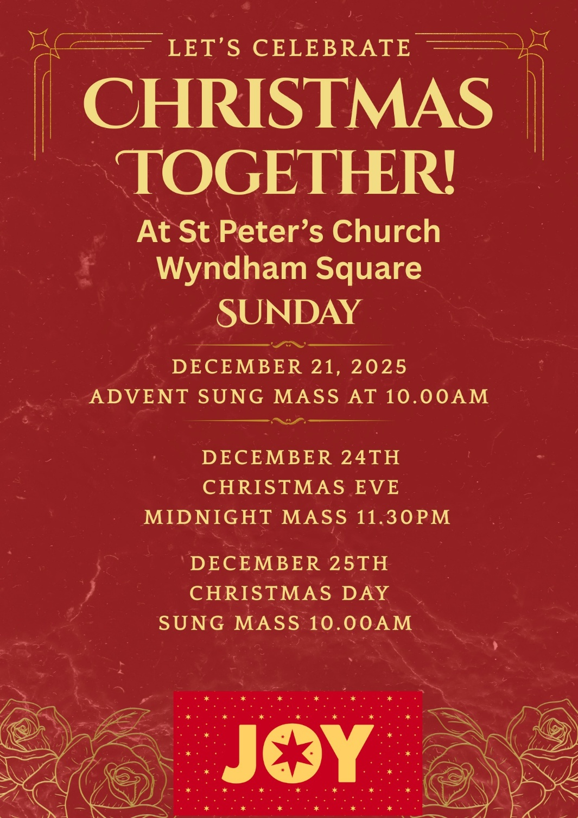

For Prayer

Those who have asked for our prayers…. Denise, Janice Allin, Leslie Porch,
Sheila Tucker, Tina Smart, Kathy Haydon, Bobby Lilicrap, June Brock,
Emma Addison, Georgie Maher, Ian Craggs, Brenda Alderson, Lois Tobin, Brenda Steed, Anne Lewis, Jenny Harvey, Jackie Morrison, Anna, Gwen Lamb, Anna Lynch, Jackie Fisher, Helen Lewis, Val Bradden, Cynthia Way, Pauleen Stewart, Amelia Coughlan, Roger Lewis, Shaun Carrie, Fr Jon Bielawski, Catherine Samuel, Julian Davies, Ron Morrison.

Recently Departed-

Anniversaries of Death-

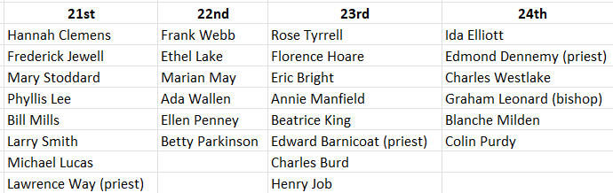
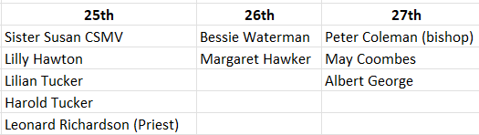

The Mission Community of St Peter and the Holy Apostles
St Peter, Wyndham Square + St Thomas, Royal Navy Avenue + St James-the-Less, Ham Drive
A Church of England Parish in the care of the Bishop of Oswestry
Parish Priest Fr. David Way SSC: 01752 240119 fr.davidway@gmail.com
.com
Mission Development Minister/ LLM/ Parish Ordinand: Ben Otley 07939800544 benotley.mission.plym@gmail.com

Parish Website: plymouthstpeter.co.uk ~ FOR MUCH MORE INFORMATION ON EVENTS, ETC.

This week’s services
Sunday 21st-  The Fourth Sunday of Advent  O Oriens  (Liturgical Year A, Weekday Cycle 2)  (Psalter Week 4) | 8.30am St Thomas Fr DCW  10.00am St Peter Fr DCW  4.00pm St Gabriels- Peverell | Mass with Hymns  Sung Mass  Christmas Carol Service
Monday 22nd- O Rex Gentium | St Peter 10.00am Fr PL | Mass
Tuesday 23rd- O Emmanuel | St Peter 10.00am Fr DCW | Mass
Wednesday 24th | St Peter 10.00am Fr DCW  St peter 11.30pm Fr DCW | Mass  Midnight Mass
Thursday 25th- Christmas Day/  The Nativity of the Lord | St Peter 10.00am Fr DCW | Mass
Friday 26th- St Stephen,  The first Martyr | St Peter 10.00am Fr DCW | Sung Mass
Saturday 27th- St John,  Apostle and Evangelist | St Peter 10.00am Fr DCW | Mass
Sunday 28th-  The Holy Family | 10.00am St Peter Fr DCW  Preacher Pete Simmons | Sung Mass
St Peters is open daily 8.30am- 12noon- Place of Welcome, Place of Prayer, food larder etc.

Safeguarding: If you have any concerns regarding the safety of children and others who are vulnerable, regardless of age, you must tell the Duty Priest or our parish Lay Safeguarding Representative- Jackie Morrison- email randj49@gmail.com Tel 07848859124.
For online donations please scan the QR code

