
SPIRE & LIGHT United Churches
United Benefice of St Keverne, St Ruan with St Grade & St.Wynwallow (The Lizard)

*If you do not wish to receive these notices, please let your Churchwarden know*

7th December 2025
ADVENT 2

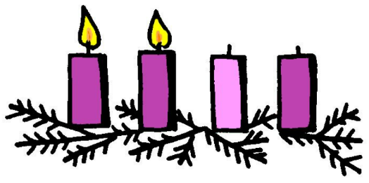
Readings
Isaiah 11:1-10
Psalm 72:1-7, 18-19
Romans 15:4-13
Matthew 3:1-12

9.30am – Holy Communion – St.Peter’s, Coverack
9.30am – Holy Communion (BCP) – St.Wynwallow, The Lizard
11am – Morning Prayer (BCP) - St.Keverne Church
11.15am – Morning Prayer – St.Ruan, Ruan Minor

Next Sunday Dec 14th Advent 3
9.30am – Morning Prayer – St.Peter’s, Coverack
11.15am – Café Church Carols – St.Wynwallow, The Lizard

3pm – Christingle – St.Grade
6pm – Carol Service – St.Ruan, Ruan Minor
6pm – Carol Service – St.Keverne Church


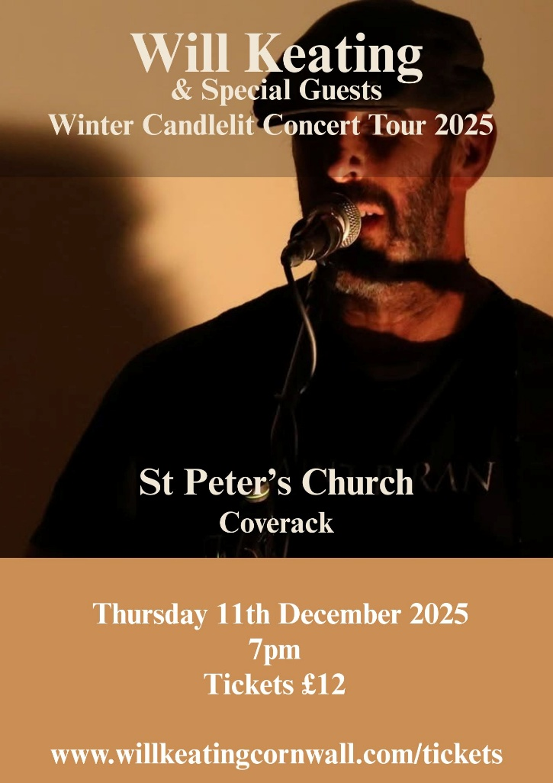

With special guests John Dowling on banjo
+ Ben Sutcliffe on fiddle


The Prayer Spot
Lord Jesus Christ, as we pray today, please be with us and guide us in all we do and say in your wonderful name.
Help us to remember that you are a God who cares, who understands and who meets all our needs. We pray for the benefice and Deanery we belong to and we thank you for the faithful people you have brought together.
Remind us that we have been brought to faith by our saviour Jesus Christ to enjoy our time together. We thank you Lord Jesus for your presence in our lives and the love you have given us to share with others. Keep us strong in our faith and close to you. Help us to be always there for others in their time of need.
You have given us gifts to use, to reach out to give comfort to those around us who are in need.
Heavenly Father we live in a world that is slowly destroying itself, through greed, hatred and with no care or concern for others. Remind us that we can bring love, care and understanding into the world by reaching out into our communities and showing our love to all. We pray for those in our communities who need Gods help as they care for others, for those in need of hospital care but also those who look after them.
Loving God, be with us always. Remind us daily we are brothers and sisters in Christ, that God is ever present in our lives, through his wonderful Holy Spirit that he gives us freely. God Bless you all
O Lord our rock and Redeemer, guide our thoughts and our words in our discussions today. Let our hearts be filled with your praise. Let us never forget the good things you do for us. You have forgiven our sins. You have rescued us from death. You have crowned us with love and tender mercies. Renew our strength and refresh our souls. Through Jesus Christ our Lord, Amen Sam Buchanan
The Diocese of Truro’s Prayer Diary for this week
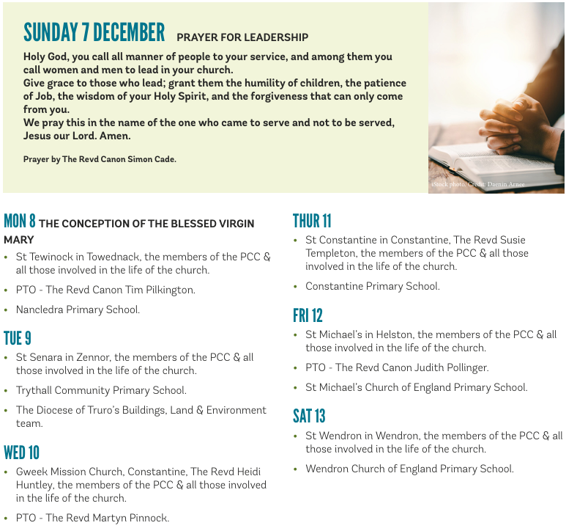

On the Way Prayers

A Celtic Advent Prayer
Days of heavy clouds stifling the sunlight; the world burdened by greyness and gloom.
Open our eyes, Lord, to the coming of your light, lifting the burden of darkness from our lives.
Chillness that seeps deep into bones; hearts and spirits rigid with frost-hardness;
souls wrapped up against coldness and loneliness.
Open our souls, Lord, to the warmth of your coming, melting the hardness that keeps us from you and from each other.
Trees, branches bare against the steel skies; Stems crumpled under weight of frost, weight of snow; Last year’s leaves, blackened and slippery underfoot; Nature oppressed by wintriness, yet resting, awaiting rebirth.
Cherish our hearts, Lord, oppressed by wintriness - assure us of your coming, of your call to new life.

O Lord our God, make us watchful and keep us faithful as we await the coming of your Son our Lord; that, when he shall appear, he may not find us sleeping in sin but active in his service and joyful in his praise. Dear Lord, most of us are probably pretty active at the moment, help us always during this Advent to remember why! Help us always to be active in his service and joyful in his praise.

We pray for Bishop Hugh who is now officially the Bishop of Worchester, wishing him well as he embarks on a new Advent-ure. And we continue to pray that priests are being called to come and serve in our Diocese and in Kerrier Deanery. We pray for all our small congregations, that we can all grow and develop to serve our communities.

As the winter weather starts to bite we pray for all those in our congregations suffering with the aches and pains of old age, and with the loneliness that so often accompanies our later years. May our congregations be caring and respectful towards our most senior members and, in the process of thinking about the future, we pray Lord that you don’t allow us to forget to look after them and their needs. Now let’s take a few moments to pray for anyone who needs to feel the power of our collective prayers at this time. Heavenly Father, be with these and all who are in distress at this time – keep them warm in body, mind and spirit and may they feel the comfort of your healing hands now and in the days to come.

During this Advent we continue to pray for the day to day work in our churches – for the special activities and services we are planning, for the cleaning, decorating and other mundane chores that are being done by fewer and fewer of us. Help us to make our churches places of welcome, and warmth – even if the warmth is in the welcome! Help us to provide occasions that will touch the hearts of the young and the old this Christmas time.

Lord, we thank you for coming close to us, for being with us in our homes and for listening to our prayers. Watch over each one of us and give us all rest, calm and peace. Amen.

