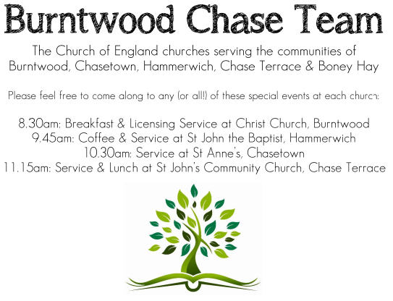 CHRIST CHURCH
SUNDAY 4th JANUARY 2026 at 10am

SERVICES:
Sunday 4th January 2026
Epiphany Carol Service

Readings:
Isaiah 60: 1-6
Arise, shine; for your light has come,
and the glory of the Lord has risen upon you.
² For darkness shall cover the earth,
and thick darkness the peoples;
but the Lord will arise upon you,
and his glory will appear over you.
³ Nations shall come to your light,
and kings to the brightness of your dawn.
⁴ Lift up your eyes and look around;
they all gather together, they come to you;
your sons shall come from far away,
and your daughters shall be carried on their nurses’ arms.
⁵ Then you shall see and be radiant;
your heart shall thrill and rejoice,^{[a]}
because the abundance of the sea shall be brought to you,
the wealth of the nations shall come to you.
⁶ A multitude of camels shall cover you,
the young camels of Midian and Ephah;
all those from Sheba shall come.
They shall bring gold and frankincense,
and shall proclaim the praise of the Lord.

Matthew 2: 1-12

In the time of King Herod, after Jesus was born in Bethlehem of Judea, wise men from the East came to Jerusalem, ² asking, ‘Where is the child who has been born king of the Jews? For we observed his star at its rising, and have come to pay him homage.’ ³ When King Herod heard this, he was frightened, and all Jerusalem with him; ⁴ and calling together all the chief priests and scribes of the people, he inquired of them where the Messiah was to be born. ⁵ They told him, ‘In Bethlehem of Judea; for so it has been written by the prophet:
⁶ “And you, Bethlehem, in the land of Judah,
are by no means least among the rulers of Judah;
for from you shall come a ruler
who is to shepherd my people Israel.”’
⁷ Then Herod secretly called for the wise men and learned from them the exact time when the star had appeared. ⁸ Then he sent them to Bethlehem, saying, ‘Go and search diligently for the child; and when you have found him, bring me word so that I may also go and pay him homage.’ ⁹ When they had heard the king, they set out; and there, ahead of them, went the star that they had seen at its rising, until it stopped over the place where the child was. ¹⁰ When they saw that the star had stopped, they were overwhelmed with joy. ¹¹ On entering the house, they saw the child with Mary his mother; and they knelt down and paid him homage. Then, opening their treasure-chests, they offered him gifts of gold, frankincense, and myrrh. ¹² And having been warned in a dream not to return to Herod, they left for their own country by another road.

COLLECT FOR TODAY
Almighty God,
in the birth of your Son
you have poured on us the new light of your
incarnate Word,
and shown us the fullness of your love:
help us to walk in his light and dwell in his love
that we may know the fullness of his joy;
who is alive and reigns with you,
in the unity of the Holy Spirit,
one God, now and for ever.

WHAT’S GOING ON
Upcoming Services

Monday 5th January Cameo Cafe 10-12noon
Wednesday 7th January Morning Prayer 9.30am
Sunday 11th January Morning Worship 10am
Wednesday 14th January Morning Prayer 9.30am
Sunday 18th January Holy Communion 10am

FLOODLIGHTING
If you think about commemorating a special occasion by floodlighting our Church. Please contact Chris Brown on 01543 683862 for details.

PRAYER CHAIN
Christ Church is blessed with a very active prayer chain. If you, or anyone you know, feel that they would like others to pray for them, please speak to Chris Brown on 01543 683862.

HOME COMMUNION
For anyone who is unable to attend church and would like Home Communion,
Steve Morgan is able to carry this out.

VICAR CONTACT DETAILS
Stephen Morgan Tele: 07305 852152
CHURCH WARDENS CONTACT DETAILS
Judith Rogers Tele: 01543 324718
Mike Holmes Tele: 01543 672970
Church Office Tele: 01543 642187 [leave a message and we will respond]
Church Web Site:www.christchurchburntwood.org.uk
Church Email: christchurchburntwood15@gmail.com
Facebook: www.facebook.com/group/christchurchburntwood/

Other Contacts
Matt Wallace St. John’s, Chase Terrace— Tele: 01543 670078
Richard Westwood St. Anne’s, Chasetown—Tele: 01543 686111

NEXT SUNDAY SERVICE
Sunday 11th January at 10am
Morning Worship
Isaiah 42: 1-9
Matthew 3: 13-17
1st Sunday of Epiphany

