
SAINT PAUL’S CHURCH
Coven, Staffordshire
A parish of the Diocese of Lichfield under the pastoral and sacramental care of the Bishop of Oswestry
https://www.achurchnearyou.com/st-paul-coven
The Rev’d Paul Farthing SSC, Vicar
Email: father_paul@fastmail.com
Interim telephone: 07927 965 116
FIRST SUNDAY OF ADVENT
30 November 2025
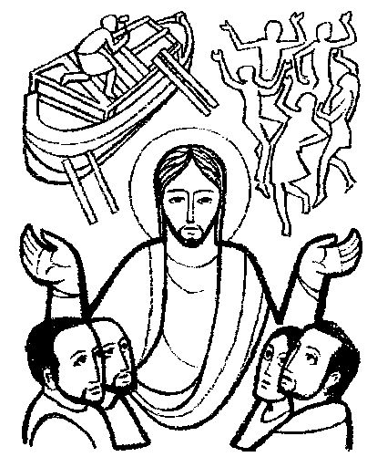
The Son of Man is coming at an unexpected hour, warns Jesus; so we must be ready at all times, living honourable lives in his image and casting off all that does not bear the scrutiny of the day, for our salvation is close at hand.
38 Hark, a thrilling voice is sounding
784 Stand up, stand up for Jesus
-- O Jesus Christ, remember
41 Lo, he comes with clouds descending
The Angelus follows the blessing:
The Angel of the Lord brought tidings to Mary,
And she conceived by the Holy Spirit.
Hail Mary, full of grace; the Lord is with thee:
blessed art thou amongst women,
and blessed is the Fruit of thy womb, Jesus.
Holy Mary, Mother of God, pray for us sinners,
now and at the hour of our death. Amen.
Behold the handmaid of the Lord.
Be it unto me according to thy word.
Hail Mary, full of grace …
And the Word was made flesh.
And dwelt among us.
Hail Mary, full of grace …
Pray for us, O Holy Mother of God.
That we may be made worthy
of the promises of Christ.
A prayer follows and all respond, Amen.
NOTICES
Welcome to Saint Paul’s. This morning’s service can be followed in the green booklets you were given as you came in, with hymns from the red hymn book.
This week at Saint Paul’s:
WI Carol Service, Tuesday, 7.00pm.
(Christmas Choir at the Memorial Hall)
Said Mass, Wednesday, 10.30am.
Coffee Pop-in, Saturday, 10.30am.
Saint Paul’s School Christmas Fair will take place Friday 5 December from 3.30pm. Parishioners are also invited to a short carol concert by the children in school the following Wednesday, 10 December, at 9.30am.
We pray for the sick, especially Pauline Appleby, Alan Badger, Peter Rouwenhorst, Ethan, Megan and Nikki; for the recently departed; and for those whose anniversaries occur at this time: Mary Cole, Margaret Guest, Jessie Ellick, George Barrett, Hilda Forbes.
POST-COMMUNION HYMN
O Jesus Christ, remember, when thou shalt come again,
Upon the clouds of heaven, with all thy shining train;
When ev’ry eye shall see thee, in Deity revealed,
Who now upon this altar in silence art concealed.
Remember then, O Saviour, I supplicate of thee,
That here I bowed before thee upon my bended knee; That here I owned thy presence, and did not thee deny;
And glorified thy greatness, tho’ hid from human eye.
Accept, divine Redeemer, the homage of my praise;
Be thou the light and honour, and glory of my days.
Be thou my consolation when death is drawing nigh:
Be thou my only treasure, through all eternity.
Edward Caswall, 1814-48
DAILY BIBLE READINGS
First Week of Advent
Monday Isaiah 4.2-5
Advent feria Matthew 8.5-11
Tuesday Isaiah 11.1-10
Advent feria Luke 10.21-24
Wednesday Isaiah 25.6-10
Saint Francis Xavier Matthew 15.29-37
Thursday Isaiah 26.1-6
Saint John Damascene Matthew 7.21-27
Friday Isaiah 29.17-end
Feria Matthew 9.27-31
Saturday Isaiah 30.19-26
Saint Nicholas Matthew 9.35-10.1 & 6-8
Next Sunday Isaiah 11.1-10, Romans 15.4-9
Second Sunday of Advent Matthew 3.1-12

