
WELCOME!
ST STEPHEN’S CHURCH IS OPEN
10am-3pm daily
for Private Prayer and Reflection

BULLETIN
7th December 2025
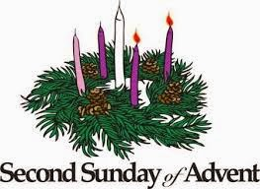

9am Holy Communion
10.30am All Age Worship
with The Music Group

Notices for inclusion in the bulletin please email to me by Tuesday of each week

officeststephenfradley@gmail.com
Please take Bulletin away with you

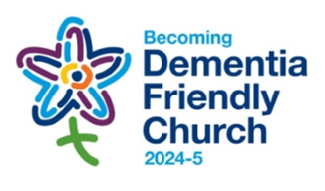

Diary Dates

December 2025

Sunday 7th 9am Holy Communion
10.30am All Age Worship for Advent

Refreshments are served after every service

Tuesday 9th 11.30am Funeral of Gregory John Jones followed by Private Committal at Fradley crematorium

Wednesday 10th2-4pm Wednesday Welcome

Friday 12th 1.45pm Fradley Park School Carol Service

Saturday 13th 7.30pm Community Choir Carol Concert

Sunday 14th 10.30am Family Communion

See separate note for our Christmas Services

Welcome to our Worship today
If you are visiting for the first time, please introduce yourself
so that we may welcome you personally.

7th December 2025

Collect
Almighty God,
purify our hearts and minds,
that when your Son Jesus Christ comes again as
judge and saviour
we may be ready to receive him,
who is our Lord and our God.

Readings
Isaiah 11. 1-10 Romans 15. 4-13
Matthew 3. 1-12

Post Communion Prayer
Father in heaven,
who sent your Son to redeem the world
and will send him again to be our judge:
give us grace so to imitate him
in the humility and purity of his first coming
that, when he comes again,
we may be ready to greet him
with joyful love and firm faith;
through Jesus Christ our Lord.

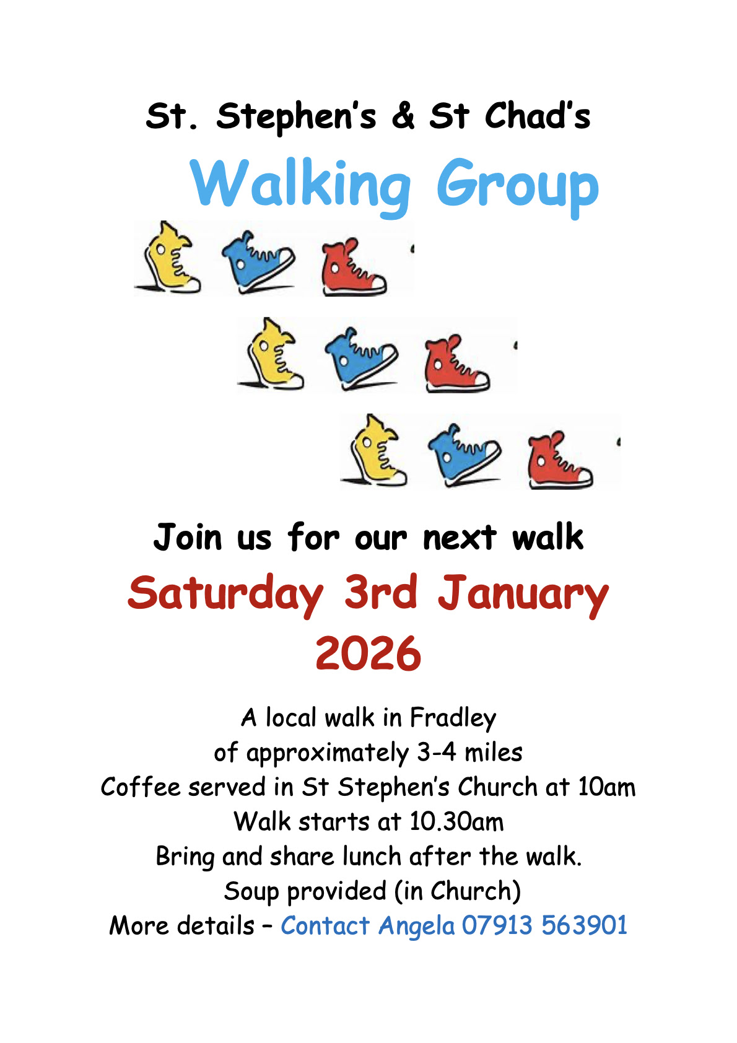

St Stephen’s Church Fradley Advent & Christmas Events 2025
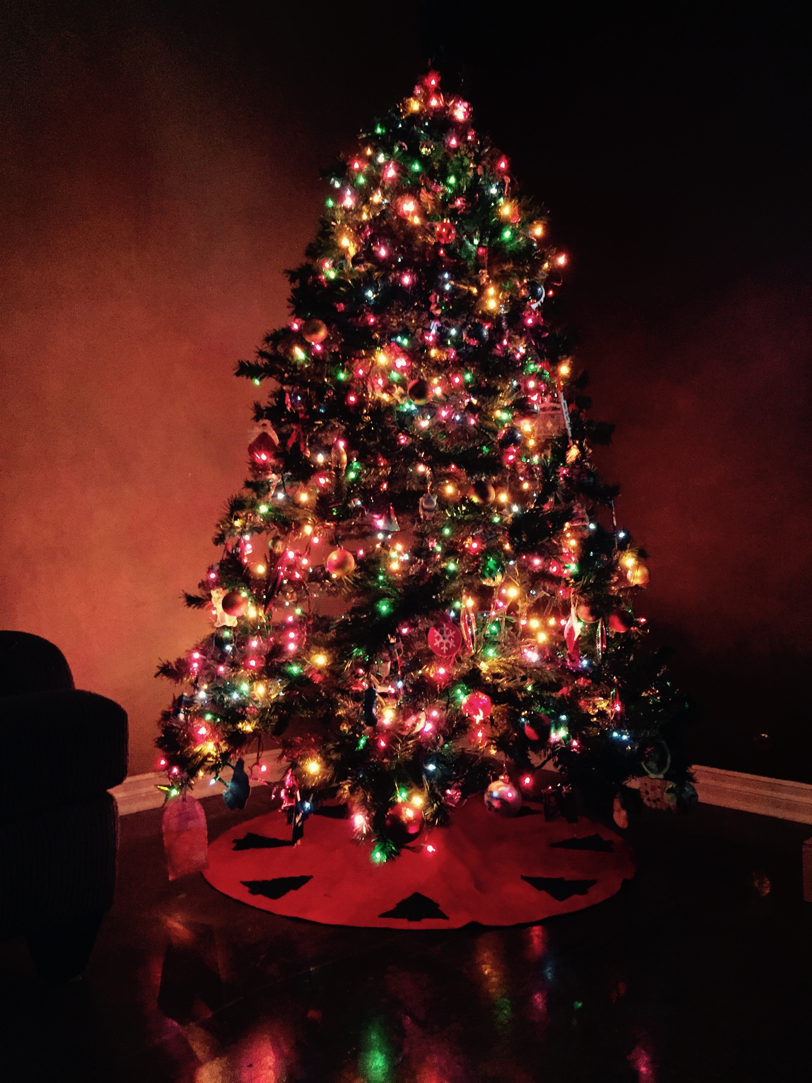

Wednesday 17th December
2pm Places of Welcome Carol Service followed by the usual places of welcome hospitality

Saturday 20th December
10am 12noon CHRISTMAS TREE FESTIVAL begins
Come and admire the wonderful Christmas Trees. Coffee and Cake served.
12noon Hamper Raffle Draw
The Festival continues until 29th December

Sunday 21st December
4pm LESSONS & CAROLS by CANDLELIGHT
Mulled Cider and Mince Pies will be served

Wednesday 24th December
4pm Birthday Service Children are invited to come dressed as a character from the Nativity Scene as we retell the age old story of The Birth of Christ.
11.30pm Midnight Service by Candlelight
The first Communion of Christmas with traditional carols and music led by our Music Group

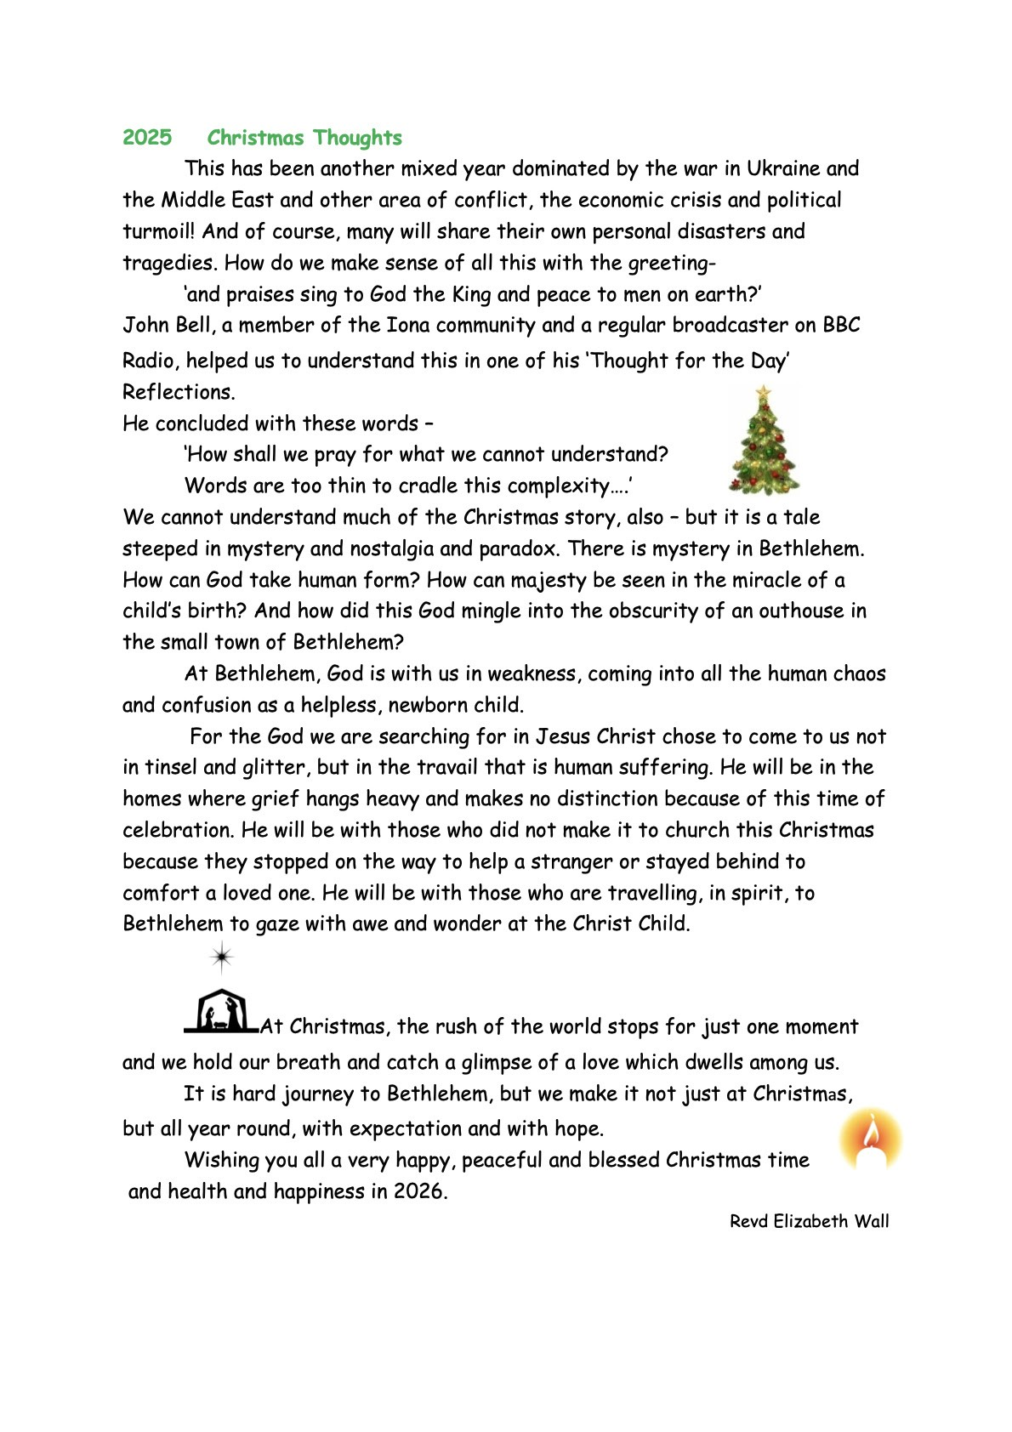

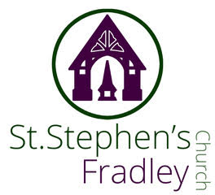



Christmas Tree Festival
20th-29th December
Free Entry
Refreshments available on
Saturday 20th December
10am-12 noon
Grand Hamper Raffle Draw at 12noon
Coffee, Cakes, Mince Pies
and Chocolate treats

Can you help to support St Stephens Church?
St Stephen’s Church is heavily dependent on voluntary donations and income from events in order to fulfil its ministry to the local and wider communities.
If you would like to support us at this time,
donations can be made via our Just Giving page.
We are grateful for any donation, large or small.

https://www.justgiving.com/fundraising/ststephensfradley

Contact us
Revd. Elizabeth Wall
01543 254891
Email: ayton265@gmail.com

Churchwarden
Marian Derry
01283 791573

St Stephen’s Administrator: Di Cooper
07930162991
officeststephenfradley@gmail.com

Find us on
ACNY https://www.achurchnearyou.com/church/4123/
Face bookwww.facebook.comststephensfradley

DC 03/12/25

