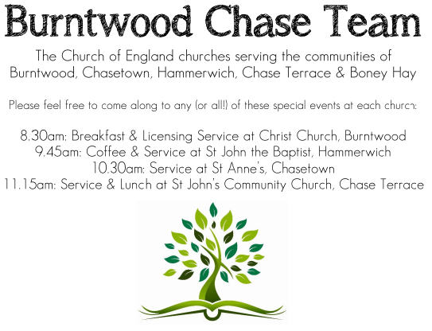 CHRIST CHURCH
SUNDAY 14th December 2025 at 4pm

SERVICES:
Sunday 14th December 2025
Carol Service
3rd Sunday of Advent

Readings:
Isaiah 35: 1-10
The wilderness and the dry land shall be glad,
the desert shall rejoice and blossom;
like the crocus ² it shall blossom abundantly,
and rejoice with joy and singing.
The glory of Lebanon shall be given to it,
the majesty of Carmel and Sharon.
They shall see the glory of the Lord,
the majesty of our God.
³ Strengthen the weak hands,
and make firm the feeble knees.
⁴ Say to those who are of a fearful heart,
‘Be strong, do not fear!
Here is your God.
He will come with vengeance,
with terrible recompense.
He will come and save you.’
⁵ Then the eyes of the blind shall be opened,
and the ears of the deaf unstopped;
⁶ then the lame shall leap like a deer,
and the tongue of the speechless sing for joy.
For waters shall break forth in the wilderness,
and streams in the desert;
⁷ the burning sand shall become a pool,
and the thirsty ground springs of water;
the haunt of jackals shall become a swamp,
the grass shall become reeds and rushes.
⁸ A highway shall be there,
and it shall be called the Holy Way;
the unclean shall not travel on it,
but it shall be for God’s people;
no traveller, not even fools, shall go astray.
⁹ No lion shall be there,
nor shall any ravenous beast come up on it;
they shall not be found there,
but the redeemed shall walk there.
¹⁰ And the ransomed of the Lord shall return,
and come to Zion with singing;
everlasting joy shall be upon their heads;
they shall obtain joy and gladness,
and sorrow and sighing shall flee away.

Matthew 11: 2-11
² When John heard in prison what the Messiah was doing, he sent word by his disciples ³ and said to him, ‘Are you the one who is to come, or are we to wait for another?’ ⁴ Jesus answered them, ‘Go and tell John what you hear and see: ⁵ the blind receive their sight, the lame walk, the lepers are cleansed, the deaf hear, the dead are raised, and the poor have good news brought to them. ⁶ And blessed is anyone who takes no offence at me.’
⁷ As they went away, Jesus began to speak to the crowds about John: ‘What did you go out into the wilderness to look at? A reed shaken by the wind? ⁸ What then did you go out to see? Someone dressed in soft robes? Look, those who wear soft robes are in royal palaces. ⁹ What then did you go out to see? A prophet? Yes, I tell you, and more than a prophet. ¹⁰ This is the one about whom it is written,“See, I am sending my messenger ahead of you,
who will prepare your way before you.”
¹¹ Truly I tell you, among those born of women no one has arisen greater than John the Baptist; yet the least in the kingdom of heaven is greater than he.

COLLECT FOR TODAY
O Lord Jesus Christ,
who at your first coming sent your messenger
to prepare your way before you:
grant that the ministers and stewards of
your mysteries
may likewise so prepare and make ready your way
by turning the hearts of the disobedient to the
wisdom of the just,
that at your second coming to judge the world
we may be found an acceptable people in your sight;
for you are alive and reign with the Father
in the unity of the Holy Spirit,
one God, now and for ever.

WHAT’S GOING ON
Upcoming Services

Wednesday 17th December Morning Prayer 9.30am
Sunday 21st December Morning Worship 10am
Wednesday 24th December Midnight Communion 11pm
Sunday 28th December Benefice Service at St Anne’s at 10.15am

FLOODLIGHTING
If you think about commemorating a special occasion by floodlighting our Church. Please contact Chris Brown on 01543 683862 for details.

PRAYER CHAIN
Christ Church is blessed with a very active prayer chain. If you, or anyone you know, feel that they would like others to pray for them, please speak to Chris Brown on 01543 683862.

HOME COMMUNION
For anyone who is unable to attend church and would like Home Communion,
Steve Morgan is able to carry this out.

VICAR CONTACT DETAILS
Stephen Morgan Tele: 07305 852152
CHURCH WARDENS CONTACT DETAILS
Judith Rogers Tele: 01543 324718
Mike Holmes Tele: 01543 672970
Church Office Tele: 01543 642187 [leave a message and we will respond]
Church Web Site:www.christchurchburntwood.org.uk
Church Email: christchurchburntwood15@gmail.com
Facebook: www.facebook.com/group/christchurchburntwood/

Other Contacts
Matt Wallace St. John’s, Chase Terrace— Tele: 01543 670078
Richard Westwood St. Anne’s, Chasetown—Tele: 01543 686111

NEXT SUNDAY SERVICE
Sunday 21st December at 4pm
Morning Worship
Isaiah 7: 10-16
Matthew 1: 18-25
4th Sunday of Advent

