Psalm 146: 4 to 10
Our 4pm services are now in Friendship House (except on 21st December for the Carol Service) until Sunday 15th February.
Please stand, if able, and join in the verses in bold

When their breath departs, they return to the earth;
on that very day their plans perish.

Happy are those whose help is the God of Jacob,
whose hope is in the Lord their God,
who made heaven and earth, the sea, and all that is in them;
who keeps faith for ever;
who executes justice for the oppressed;
who gives food to the hungry.
The Lord sets the prisoners free;
the Lord opens the eyes of the blind.
The Lord lifts up those who are bowed down;
the Lord loves the righteous.
The Lord watches over the strangers;
he upholds the orphan and the widow,
but the way of the wicked he brings to ruin.

The Lord will reign for ever,
your God, O Zion, for all generations.
Praise the Lord!
Refreshments After the Morning Service
Please stay seated after the service and a hot drink will be brought to you in the pews. Do not get up and head to the back of church, it is becoming a hazard, and a risk as trays of hot drinks could be knocked over.

We are blessed to have energetic young people and less mobile more mature folk, using walking sticks, so please lets show care for each other and let drinks and biscuits etc be brought to you.

Glory be to the Father and to the Son and to the Holy Spirit,
as it was in the beginning, is now and ever shall be,
world without end. Amen
Distribution of Communion –currently the Priest will dip the communion wafer in the wine while we discern a safe way to bring the common cup back into worship, as we want everyone to feel included and safe. We also have gluten free wafers available.

In our weekly prayers for our parish
This week we pray for God’s blessing on Wyndale Drive, Abbot Road && Ascot Place.

Gospel Readings from the Lectionary

Monday 15th Matthew 16: 13 to end
Tuesday 16th Matthew 17: 1 to 13
Wednesday 17th Matthew 17: 14 to 21
Thursday 18th Matthew 17: 22 to end
Friday 19th Matthew 18: 1 to 20
Saturday 20th Matthew 18: 21 to end

Readings from the Church of England’s Lectionary
All Saints Church
Christmas Fayre
Thank you to everyone who helped organise, set up and volunteer at the Christmas Fayre, the total raised for the new build, is £1,202.40!
Church contact information
Contact: Rev’d Christine - revchristine@outlook.com
The Rectory, The Village, West Hallam, DE7 6GR
Landline 0115 646 1497
Rev’d Ailsa -revailsahunt@gmail.com
Tel - 07356064856

Churchwardens – Mrs Janet Wheeldon, -Tel: 0115 8771593
Mrs Linda Gregory – linda.gregory3@icloud.com
https://www.achurchnearyou.com/church/13402/
https://www.facebook.com/allsaintskirkhallam
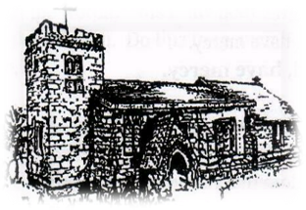
Kirk Hallam
Disabled Toilet in Friendship House.
Disabled Toilet in Friendship House.

Working with God to transform lives & communities.
Please can you ensure your mobile is on silence, or off during the service, it is affecting people with hearing aids and the loop system.

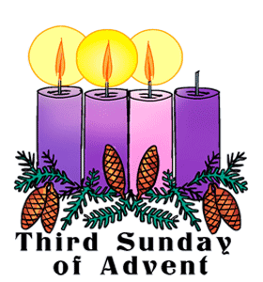
14th December – Third Sunday of Advent
10.00am Iona Communion Service
with Rev’d Christine
11.30am Christingle with Uniformed Groups
4.00pm Iona Evening Prayer in Friendship House with Rev’d Alan

Forthcoming Events
Tues 16th 6.00pm Home Group in Friendship House
Weds 17th 9.30am Morning Prayer at UCAS, Stanley Common
Fri 19th 6.00pm Choir Practice in Friendship House
Sat 20th 10.00am Prayer Meeting in Friendship House
Mon 22nd 3.00pm Building Faith in Church
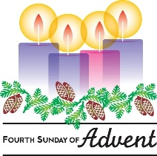
21st December – Fourth Sunday of Advent
10.00am CW Communion Service with Rev’d Ailsa
4.00pm Carol Service with Rev’d Christine
It’s Good to Talk! If you spot that someone is missing, please pop a news sheet through their door, & if you’ve time, call for a chat - just to check they’re OK & to let them know that they are not forgotten!
‘Beloved, let us love one another, for love is of God; and everyone who loves is born of God and God knows’ 1 John 4:7

