Prayers
Please pray for the sick, particularly George Hall, Chloe French, Gail Calder, Andrew Watson, Revd Sam Quilty, Heather Piper. We pray for the family and friends of those who have recently died, particularly Jessie Grey, whose funeral will be at Ford on January 5th at 1pm, and we remember all whose anniversaries of death fall at this time of year, including Joan Burns, David Clark, Leslie Clark.

This week and beyond

- Men’s Breakfast Saturday 3rd January, 8.30am – 10am in Lowick White Swan. Book with Kevin on 07530 000941
- Save the Date: Saturday January 31st 9am-1pm PCC’s Vision Morning at The Hemmel. Details and booking to follow.

Parish Contacts
Ancroft Leigh Yorke 07716116739
Etal Andrew Joicey 01890 820540
Ford Kathleen Holmes 07951099668
Lowick Niall Cartlidge 07850876246

Websites: www.achurchnearyou.com
Instagram: https://www.instagram.com/the_flake_churches/
Facebook: the_flake_churches

Other licensed clergy
Revd Margaret Sentamu 077871 204745 m.sentamu@gmail.com
Canon Nick Sagovsky, Revd Marion Penfold 01289 305664

The Parishes of Ford and Etal, Ancroft, Lowick with Kyloe

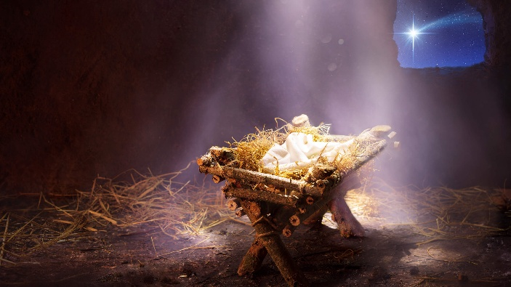

A very warm welcome to you, especially if you are visiting. We’d love to meet you.
Please take this sheet home with you and use it as a basis for prayer.
Children are welcome in all our services. No coffee today as lunch beckons!
Have a very Happy and Holy Christmas Day
Christmas Day
Lowick 9am Holy Communion
Revd Charlotte Osborn
Ford 10.30am Family Worship with Carols
Revd Charlotte Osborn/Revd Alex Firman

Sunday 28th December 2025
Christmas 1
Ancroft Memorial Hall 10am Flake Service Holy Communion
Revd Margaret Sentamu

Sunday 4th January 2026
Christmas 2
Lowick 9.15am Family Communion
Etal 11 am Holy Communion

Licensed Clergy
Revd Charlotte Osborn (Vicar) 01289 388591
ceosborn@mail.com 07957 367457
Revd Alex Firman (Assistant Curate) 07935 732811 alex_firman@hotmail.co.uk

