Westfield Church Notices Sunday 14th December

Valerie writes:
Jesus is the Light of the World

As you walk into Westfield Church you will be welcomed by the brightness and beauty of the decorated Christmas trees lighting up the church.
How glad we are to have light. The power cut on Sunday evening demonstrated the power of a single candle in the darkness of my kitchen, it was so dark, yet that one light illuminated the room with a warming glow.
How glad I was when the power was restored overnight.
Jesus is the Light of the World, and his love shines out for us all to accept and pass on.
As we enjoy our Christmas Tree Festival let's thank God for sending his son Jesus, the Light of the World.

Lord, the light of your love is shining
In the midst of the darkness shining.
Jesus, light of the world shine upon us,
Set us free by the truth you now bring us,
Shine on me.
Shine on me.

Shine Jesus shine,
Fill this land with the Father's glory.
Blaze spirit blaze,
Set out hearts on fire.
Flow river flow,
Flood the nations with grace and mercy,
Send forth your word Lord and
Let there be light.

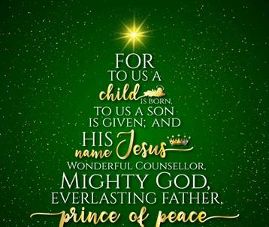
What’s on:
Saturday 13th December
3.00pm: Messy Church

Sunday 14th December
8.00am: Prayer Book Communion
9.30am: Café Church
6.00pm Carols by Candlelight

Tuesday 16th December

7.00pm Church Christmas Dinner at Fairligh Lodge Hotel

Wednesday 17th December
9.30am: Holy Communion
10.30am: Warm Space Community Hub
7.30pm: Home Groups at Dawn and Jess’ and Cathy and Howard’s

Messages:

Alpha Course is Back

We are excited to begin the new year with Alpha and everyone is invited. Alpha will begin with a soup lunch, then there’s a video to watch and discuss over a cuppa and cake.

What: 11 week course exploring Christianity and some of the big questions of life

When: Weekly on Thursdays from 15th January to 26th March 12.30pm - 2.30pm plus Saturday 28th February

Where: St Peter’s Fairlight on the corner of Waites Lane and Broadway

Got any questions? Want to register your interest? Please phone or email Kizzy (07356 077755 or email revkpenfold@outlook.com). See you in 2026!

Guestling School

Guestling School is looking for two new Governors, please see attached poster for details.

Prayer:

If you would like a situation prayed about urgently, please contact the church Prayer Share. Contact Dawn 01424 255423 / 0750 7745 159

If you know anyone who would like to be added to the notices, please send me an email with their details. If you don’t want to receive this email each week, or would rather receive it in a different format, please let me know.
Please give information for notices to me by Thursday morning (contact details below).
Have a good week everyone,
Tony Demarco tonydemarcohastings@gmail.com

