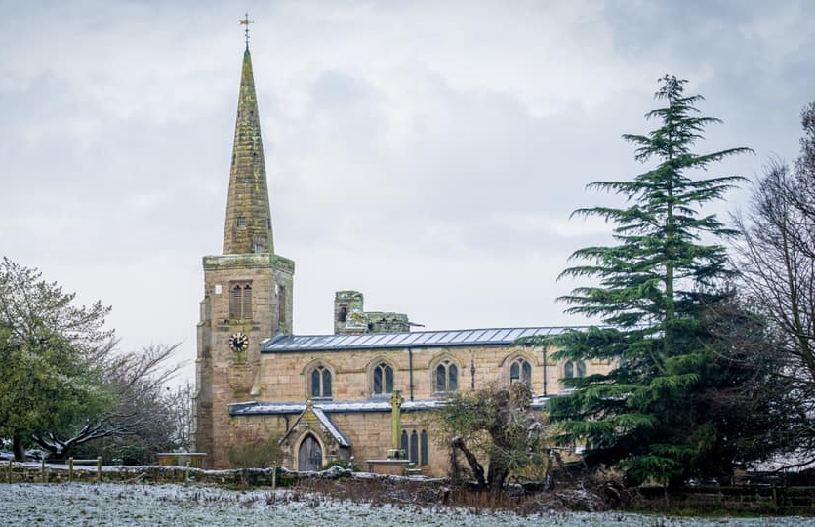
ST MICHAEL AND ALL ANGELS,
HAMSTALL RIDWARE

In the United Benefice of King’s Bromley, the Ridwares
and Yoxall

November 30th 2025
Advent Sunday
PARISH NOTICES

UNITED BENEFICE SERVICE ROTA
 | Hamstall Ridware  St Michael and All Angels | Yoxall  St Peter | King’s Bromley  All Saints | Mavesyn Ridware  St Nicholas
November 30th  Advent Sunday | 10.30 am  United Benefice Holy Communion Service at St Peter’s, Yoxall
December 7th  Advent 2 | 10.30 am  United Benefice Holy Communion Service at St Nicholas, Mavesyn Ridware
December 14th  Advent 3 | 9.00 am  Holy Communion | 10.30 am  Holy Communion | 10.30 am  Holy Communion | 4.00 pm  Christingle
December 21st  Advent 4 | 5.00 pm  Carol Service | 7.30 pm  Carol Service | 3.00 pm  Carol Service | 4.00 pm  Carol Service
December 24th  Christmas Eve |  | 3.00 pm  Crib Service  11.00 pm  Midnight Mass | 10.30 am  Crib Service | 8.00 pm  “Midnight Mass”
Please note that services of Holy Communion at 9 am follow the Book of Common Prayer and are said. Services at 10.30 will include hymns and other singing.
There are services of Holy Communion at 10.00 every Wednesday at St Peter’s, Yoxall and on the first Thursday of each month at All Saints, King’s Bromley.
*******************
Rugeley Food Bank. Please do remember those who depend on Food Banks. They are needed now just as ever. If you wish to donate directly to Rugeley Foodbank at Rugeley Community Centre the Centre is open everyday to receive contributions. Alternatively, the Rugeley Food Bank welcomes financial contributions – see https://rugeley.foodbank.org.uk. Gifts can also be brought to St Michael’s and left in the box at the back of church near the font. If that is not convenient please contact Liz Carter on 07751 068181.
****************
Contact details: If you wish to contact the Rector, Jeremy Brading you can do so on revd@kbhmy.co.uk and Glenis Turner, the PCC Secretary and Benefice Administrator is on admin@kbhmy.co.uk. The churchwardens are Michael Elsom michael.elsom@btopenworld.com and John Ferguson clan.member1954@gmail.com Information about events at church can be found at our webpages at https://www.achurchnearyou.com/church/4451/ and https://kbhmy.co.uk/hamstall/
St Michael’s will continue to be open everyday (weather permitting) between 10.00 am until 4.00 pm. We will revert to shutting the church at 6.00 pm on March 29th 2026

St Michael’s encourages donations by means of this QR code and it will appear (all being well) on all our publications as an invitation to contribute to the important work of the church both
as a place of worship and a community asset where all can share in the wonderful place we have inherited and wish to pass down to those who come after.
PLEASE REMEMBER IN YOUR PRAYERS:
Those who are sick: Mary Mycock, Brenda, Angela Perkin, Doug, David and Barbara Rudge, May Windley, Pam Payne, Frank and Margaret Finch, Chris Poole, Les Woods, Pat Lomax, Alison Scott and any known personally to you.
Those who live and work in the Nursing, Care and Retirement homes in the villages both in and near the parishes of the United Benefice.
Using the Archbishops’ prayer for Ukraine at this time let us remember the people of that war-torn land:
God of peace and justice, we pray for the people of Ukraine today. We pray for peace and the laying down of weapons. We pray for all those who fear for tomorrow, that your Spirit of comfort would draw near to them. We pray for those with power over war or peace, for wisdom, discernment and compassion to guide their decisions. Above all, we pray for all your precious children, at risk and in fear, that you would hold and protect them. We pray in the name of Jesus, the Prince of Peace. Amen
The situation in the Middle East where hopes for a peaceful resolution sometimes appear irretrievably bleak:
O God of all justice and peace, we cry out to you in the midst of the pain and trauma of violence and fear which prevails in the Holy Land. Be with those who need you in these days of suffering; we pray for people of all faiths - Jews, Muslims and Christians and for all people of the land. While we pray to you, O Lord, for an end to violence and the establishment of peace, we also call to you to bring justice and equity to the peoples. Guide us into your kingdom where all people are treated with dignity and honour as your children - for to all of us you are our Heavenly Father. In Jesus' name we pray. Amen.
From the Diocesan Prayer Diary:
Sunday 30th November: (Advent Sunday. Andrew the Apostle.)
On St Andrew's day we pray for all the churches in the diocese dedicated to him; in Birchills, Carters Green, Church Aston, Clifton Campville, Doxey, Great Ness, Kemberton, Kettlebrook, Landywood, Porthill, Ryton, Shifnal, Sneyd Green, Stanton upon Hine Heath, The Westlands, Welsh Frankton. Whitmore Reans, Weston Coyney, Weston on Trent, and Weston under Redcastle. We pray for your hand of blessing to rest on all of these churches and the communities they serve.
Lord, as today we remember 'the first called' in the Apostle Andrew, so too we remember today as Advent Sunday, and we start to look towards when you came to earth to live amongst us, and we can only thank you again that you came here to give each of us the opportunity to follow you, just like Andrew.
Saturday 6th: (Nicholas, Bishop of Myra, c.326)
On St Nicholas' day we pray for all the churches in the diocese dedicated to him; in Abbots Bromley, Codsall, Fulford, Mavesyn Ridware, and Newport. We pray for your hand of blessing to rest on all of these churches and the communities they serve.
As we remember two saints connected with the sea and seafarers - St Andrew (Patron Saint of fishermen) and St Nicholas (Patron Saint of seafarers) - it is a good time to remember the words of Psalm 107:
They that go down to the sea in ships, that do business in great waters;
These see the works of the Lord, and his wonders in the deep.
For he commandeth, and raiseth the stormy wind, which lifteth up the waves thereof.
They mount up to the heaven, they go down again to the depths: their soul is melted because of trouble.
They reel to and fro, and stagger like a drunken man, and are at their wit's end.
Then they cry unto the Lord in their trouble, and he bringeth them out of their distresses.
He maketh the storm a calm, so that the waves thereof are still.
COMMUNITY CAFÉ
All who come to these events obviously enjoy themselves tremendously – so why not come along to the next ones with your family and friends. Who knows, you might meet some new folks and show them what a friendly place Hamstall – and St Michael’s - in particular is. Once again Jo and her team look forward to welcoming you. The next event will be on Tuesday December 16th in the afternoon – the significance of that date will not be lost on the Jane Austen fraternity! Not only will the time be different but we are expecting a spectacular display in the church – see this space for details!
.
Safeguarding of children and vulnerable adults. If you have any concerns please speak in complete confidence to the Parish Safeguarding Officer, Dr Paul Carter 01889 504347 or the Diocesan Safeguarding Officer Mr Neil Spiring 01543 306 030.

