
WELCOME!
ST STEPHEN’S CHURCH IS OPEN
10am-3pm daily
for Private Prayer and Reflection

BULLETIN
14th December 2025
The Third Sunday of Advent

10.30am Family Communion

Notices for inclusion in the bulletin please email to me by Tuesday of each week
officeststephenfradley@gmail.com

Please take Bulletin away with you

Diary Dates

This week….
Wednesday 17th 2pm Wednesday Welcome Carol Service
2-4pm Wednesday Welcome hospitality

Friday 19th 2-4pm Set up Christmas Tree Festival

Saturday 20th Launch of Christmas Tree Festival
10am-12noon Coffee and Cake morning.
Grand Draw for the Hamper raffle
at 12 noon
Sunday 21st
NO MORNING SERVICE
4pm Lessons & Carols by Candlelight
with Fradley Community Choir
Mulled Cider and Mince Pies will be served

Help needed!
We are very graceful for all the extra help as we work together to progress the vacancy. We can’t do any of it without you! And we do want to maintain our current pattern of services in Church.
There are a number of ‘Specials’ coming up as we approach Christmas and we do need help to steward all of these. All arrangements for the services will be made beforehand and if you are able to help in any way please have a word with our Warden.

Welcome to our Worship today
If you are visiting for the first time, please introduce yourself
so that we may welcome you personally.

14^{h} December 2025

Collect

God for whom we watch and wait,
you sent John the Baptist to prepare the way of your Son:
give us courage to speak the truth,
to hunger for justice,
and to suffer for the cause of right,
with Jesus Christ our Lord.

Readings

Isaiah 35.1-10 James 5.7-10
Matthew 11. 2-11

Post Communion

We give you thanks, O Lord, for these heavenly gifts;
kindle in us the fire of your Spirit
that when your Christ comes again
we may shine as lights before his face;
who is alive and reigns now and for ever.

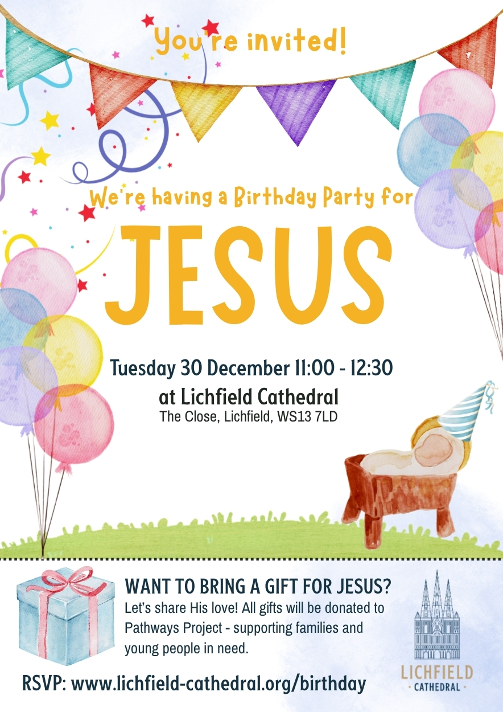

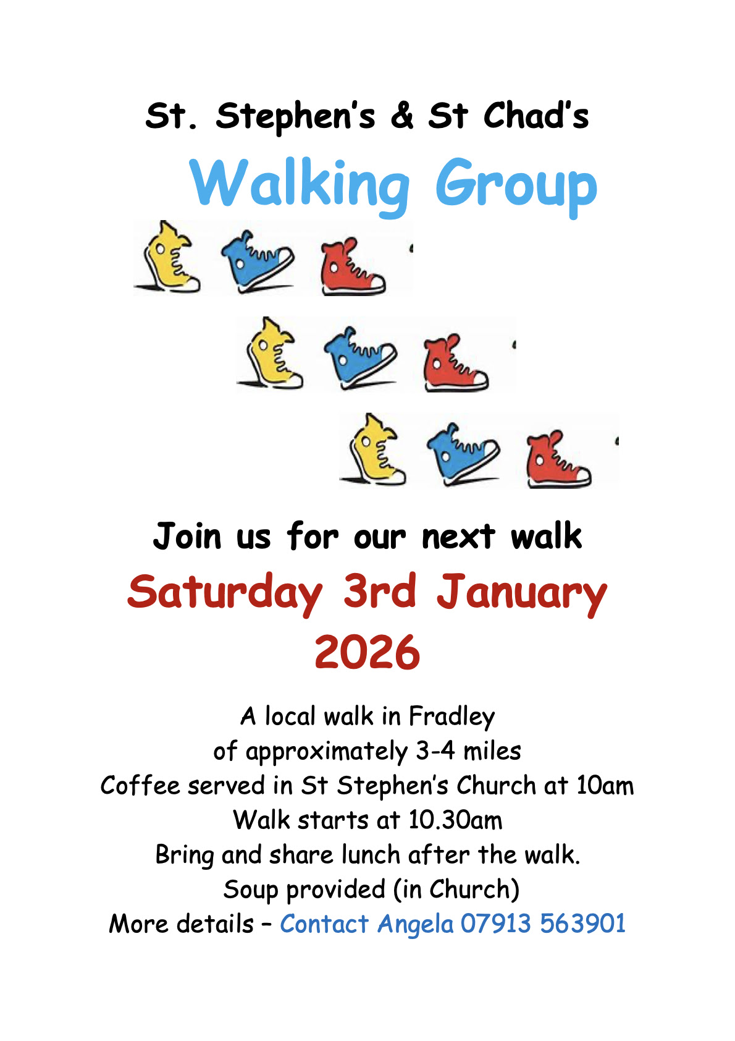

Christmas & New Year

Wednesday 24th December
4pm Birthday Service
Children are invited to come dressed as a character from the Nativity Scene as we retell the age old story
of The Birth of Christ.
11.30pm Midnight Service by Candlelight
The first Communion of Christmas with Traditional carols and music led by our Music Group
Thursday 25th December
No Service at St. Stephen’s.
Do join All Saints for 9am Holy Communion at the
All Saints Church, Alrewas
Sunday 28th December
No Service at St Stephen’s
Do join All Saints for 10am Holy Communion at
All Saints Alrewas

Sunday 4th January
10.30am Family Communion for Epiphany
with the
Music Group
Sunday 11th January
10.30am Family Service
Sunday 18th January
10.30am BENEFICE SERVICE
St Stephen’s Fradley and All Saints Alrewas
join with Alrewas Methodist Church for their Covenant Service
At Alrewas Methodist Church
Sunday 25th January
10.30am Family Communion

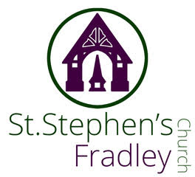



Christmas Tree Festival
20th-29th December
Free Entry
Refreshments available on
Saturday 20th December
10am-12 noon
Grand Hamper Raffle Draw at 12noon
Coffee, Cakes, Mince Pies
and Chocolate treats
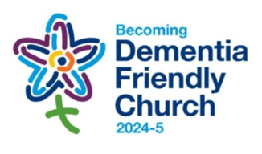
Can you help to support St Stephens Church?
St Stephen’s Church is heavily dependent on voluntary donations and income from events in order to fulfil its ministry to the local and wider communities.
If you would like to support us at this time,
donations can be made via our Just Giving page.
We are grateful for any donation, large or small.

https://www.justgiving.com/fundraising/ststephensfradley

Contact us
Revd. Elizabeth Wall
01543 254891
Email: ayton265@gmail.com

Churchwarden
Marian Derry
01283 791573

St Stephen’s Administrator: Di Cooper
07930162991
officeststephenfradley@gmail.com

Find us on
ACNY https://www.achurchnearyou.com/church/4123/
Face bookwww.facebook.comststephensfradley

DC 10/12/25

