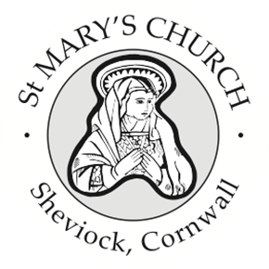
St Mary’s Church, Sheviock
Notices for Sunday 16 November 2025

- We held our Armistice Day Service on Tuesday and collected £ for the Royal British Legion. A reminder to anyone who still has a Gift Day envelope that Fiona will be accepting donations through to the end of November.
- Despite the recent torrential rain and a significant set-back with the drainage from the Church, we are hoping that our project will be largely completed by the end of this week.
- Next Saturday 22 November we will be holding our Winter Warmer Lunch and Food Market. We hope to follow the success of our May Market but with the added bonus of warming casseroles and puddings which will be served from 12 noon.
- The Book Club will be meeting on Wednesday 26 November at 3pm – returning to the Dawney Aisle when we will be looking at Chapter 5 of “Coming back to God when you feel empty” Whispers of Restoration from the Book of Ruth. If there is time, we will also start our Advent book “Do Nothing Christmas is Coming” or the re-published version “Let it Slow” by Stephen Cottrell. If you cannot find a copy of the first publication, please could you let Jenny Spear know so she can work out how many of the new publication to order. Everyone is welcome, even if it’s just to sit and listen to the conversation.
- Our next Church Care morning has been brought forward to Saturday 29th November between 0900 and 1200 and help is always much appreciated.
- This year we are holding our first Crib Festival on Saturday 6th December. All crib creations are welcome – in whatever medium you fancy! There will also be a concert with Reflections Choir at 2pm on the Saturday. We will be setting up on Friday 5th December from 2pm.
Weekly Services
A full list of weekly services and events for Rame & Rivers churches is published in the weekly Benefice Newsletter –please let Paul Gribble know if you are not receiving it (or receiving it twice!)

Next Sunday 23rd November - No service at St Mary’s
10 am Holy Communion at St Germans and Morning Worship at Maker
Sunday 30th November at 10 am
Joint Benefice Service for Advent Sunday at Sheviock

