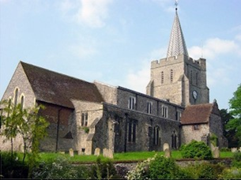
Please visit our website for information about our churches, services & events www.elhamvalleygroupofchurches.co.uk

Every Tuesday at St. Mary’s…

Traditional Morning Prayer at 8.30am in the Jesus Chapel. Download the free Church of England app or use the red book. A good way to begin the day. https://play.google.
com/store/apps/details?id=com.aimermedia.dailyprayer&pli=1


Every Monday at the Methodist Hall …
Coffee and cake, a warm welcome and friendship, 10.30am –
12pm

Churches Together in Elham Valley December
4th December Prayer meeting at 7.30pm Methodist church
6th December Prayer Breakfast at 8am Methodist Church.
Contact : David Whitethread (07961 053335)

7th December – 2nd Sunday of Advent
08:00 Said Eucharist 09.30 Sung Eucharist

Lectionary readings:
Isaiah 11.1-10; Psalm 72.1-7,18,19*; Romans 15.4-13; Matthew 3.1-12

14th December – 3rd Sunday of Advent
08:00 Said Eucharist . No service at 09:30 due to Christmas Market

Lectionary readings:
Isaiah 35.1-10; Psalm 146.4-10 or Canticle: Magnificat; James 5.7-10; Matthew 11.2-11

21st December – 4th Sunday of Advent
17:00 Joint Carol Service at the Methodist Church

Lectionary readings :
Isaiah 7.10-16; Psalm 80.1-8,18-20*; Romans 1.1-7; Matthew 1.18-25

Christmas Eve – 17:00 Crib Service 23:00 Midnight Mass

Lectionary readings:
Isaiah 52: 7-10; Psalm 98; Hebrews 1:1-4 (5-12); John 1:1-14

Christmas Day – 10:00 Benefice Eucharist of Christmas Morning

28th December – 1st Sunday of Christmas
09:30 All Age Eucharist

Lectionary readings:
Jeremiah 31:15-17; Psalm 124; 1 Cor 1:26-29; Matthew 2:13-18

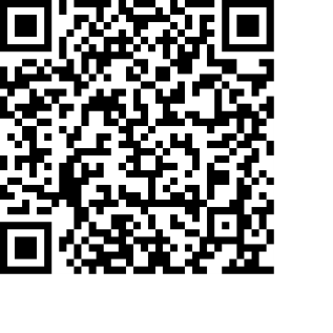
Donations
We would greatly appreciate your help to continue our work for God in the village of Elham and surrounding areas. If you can, please consider making a donation. This is our QR code for St Mary’s Elham. To donate using this code, open up the camera on a mobile phone - point the camera at the QR code – follow the instructions.
The offertory plate will go round in the service, during one of the hymns. There is also the opportunity to donate by card using the PAYAZ machine by the North door.

Safeguarding / ‘A Safe Church’:
If you ever have any concerns, contact our Parish Safeguarding Officer:
Susannah Pallot : susannahpallot@gmail.com

Paper Copies of Notices
Some copies are available on back table in church. Please take a copy to give to those unable to access the internet.

Elham Methodist Church
(all at 9.30am unless otherwise stated)
Services for DECEMBER
7th Dwight Harris
14th Revd Gill Songer HC Valley United Service at 10.15am
21st Revd Gill Songer Carol Service at 5pm
28th No service

