
SPIRE & LIGHT United Churches
United Benefice of St Keverne, St Ruan with St Grade & St.Wynwallow (The Lizard)

*If you do not wish to receive these notices, please let your Churchwarden know*

23rd November 2025

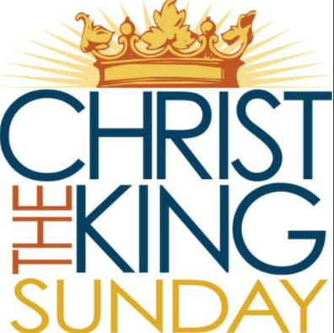
Readings
Jeremiah 23:1-6
Psalm 46
Colossians 1:11-20
Luke 23:33-43

9.30am – Morning Prayer– St.Peter’s, Coverack
9.30am – Holy Communion – St.Ruan, Ruan Minor
11am – Holy Communion - St.Keverne Church
11.15am – Café Church – St.Wynwallow, The Lizard

30th November – Advent Sunday
11am – Joint Benefice service of Holy Communion
with Bishop Hugh
St.Wynwallow Church, The Lizard

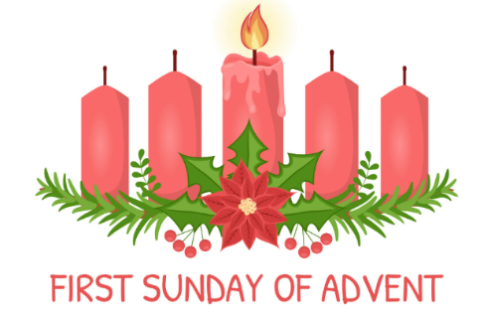



With special guests John Dowling on banjo
+ Ben Sutcliffe on fiddle


The Prayer Spot
Lord Jesus Christ, as we pray today, please be with us and guide us in all we do and say in your wonderful name.
Help us to remember that you are a God who cares, who understands and who meets all our needs. We pray for the benefice and Deanery we belong to and we thank you for the faithful people you have brought together.
Remind us that we have been brought to faith by our saviour Jesus Christ to enjoy our time together. We thank you Lord Jesus for your presence in our lives and the love you have given us to share with others. Keep us strong in our faith and close to you. Help us to be always there for others in their time of need.
You have given us gifts to use, to reach out to give comfort to those around us who are in need.
Heavenly Father we live in a world that is slowly destroying itself, through greed, hatred and with no care or concern for others. Remind us that we can bring love, care and understanding into the world by reaching out into our communities and showing our love to all. We pray for those in our communities who need Gods help as they care for others, for those in need of hospital care but also those who look after them.
Loving God, be with us always. Remind us daily we are brothers and sisters in Christ, that God is ever present in our lives, through his wonderful Holy Spirit that he gives us freely. God Bless you all
O Lord our rock and Redeemer, guide our thoughts and our words in our discussions today. Let our hearts be filled with your praise. Let us never forget the good things you do for us. You have forgiven our sins. You have rescued us from death. You have crowned us with love and tender mercies. Renew our strength and refresh our souls. Through Jesus Christ our Lord, Amen Sam Buchanan

On the Way Prayers

Back next week

The Diocese of Truro’s Prayer Diary for this week

