Psalm 122
Distribution of Communion –currently the Priest will dip the communion wafer in the wine while we discern a safe way to bring the common cup back into worship, as we want everyone to feel included and safe. We also have gluten free wafers available.
Please stand, if able, and join in the verses in bold

I was glad when they said to me,
‘Let us go to the house of the Lord!’
Our feet are standing
within your gates, O Jerusalem.

Jerusalem—built as a city
that is bound firmly together.
To it the tribes go up, the tribes of the Lord, as was decreed for Israel,
to give thanks to the name of the Lord.
For there the thrones for judgement were set up,
the thrones of the house of David.

Pray for the peace of Jerusalem:
‘May they prosper who love you.
Peace be within your walls,
and security within your towers.’
For the sake of my relatives and friends
I will say, ‘Peace be within you.’
For the sake of the house of the Lord our God,
I will seek your good.

Glory be to the Father and to the Son and to the Holy Spirit,
as it was in the beginning, is now and ever shall be,
world without end. Amen
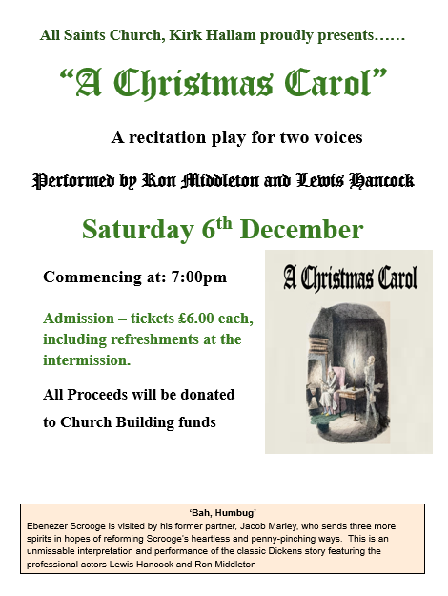
It’s Good to Talk! If you spot that someone is missing, please pop a news sheet through their door, & if you’ve time, call for a chat - just to check they’re OK & to let them know that they are not forgotten!
Our 4pm services are now in Friendship House (except on 21st December for the Carol Service) until Sunday 15th February.
In our weekly prayers for our parish
This week we pray for God’s blessing on Welbeck Avenue, Westfield Close & Windermere Avenue.

Gospel Readings from the Lectionary

Monday 1st St Andrew’s Day Matthew 4: 18 to 22
Tuesday 2nd Luke 10: 21 to 24
Wednesday 3rd Matthew 15: 29 to 37
Thursday 4th Matthew 7: 21, 24 to 27
Friday 5th Matthew 9: 27 to 31
Saturday 6th Matthew 9: 35 - 10: 1, 6 - 8

Readings from the Church of England’s Lectionary
All Saints Church
Church contact information
Contact: Rev’d Christine - revchristine@outlook.com
The Rectory, The Village, West Hallam, DE7 6GR
Landline 0115 646 1497
Rev’d Ailsa -revailsahunt@gmail.com
Tel - 07356064856

Churchwardens – Mrs Janet Wheeldon, -Tel: 0115 8771593
Mrs Linda Gregory – linda.gregory3@icloud.com
https://www.achurchnearyou.com/church/13402/
https://www.facebook.com/allsaintskirkhallam
Refreshments After the Morning Service
Please stay seated after the service and a hot drink will be brought to you in the pews.
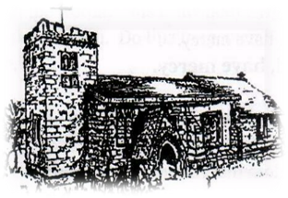
Kirk Hallam
Disabled Toilet in Friendship House.
Disabled Toilet in Friendship House.

Working with God to transform lives & communities.
Please can you ensure your mobile is on silence, or off during the service, it is affecting people with hearing aids and the loop system.

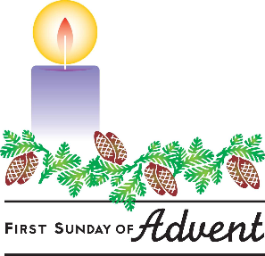
30th November – Advent Sunday
10.00am Iona Holy Communion Service with Rev’d Ailsa,
And Rev’d Christine
4.00pm Iona Evening Prayer in Friendship House
with Rev’d Jan and Julie

Forthcoming Events
Tues 2nd 6.00pm Home Group in Friendship House
Weds 3rd 9.30am Morning Prayer at UCAS, Stanley Common
Weds 3rd 12noon MU & Friends meal at Newdigate
Thurs 4th 9.30am Funeral for Jean Brown in church
Fri 5th 11.00am Interring ashes of Sonia Bamford
Fri 5th 6.00pm Choir Practice in Friendship House
Sat 6th 10.00am Prayer Meeting in Friendship House
Sat 6th 7.00pm ‘A Christmas Carol’ play in church
Weds 10th 10.30am Singing Carols in Oliver House

Weds 10th 7.00pm Tree of Light Service
Fri 12th 11.00am Funeral for June Rayment in church

7th December – Second Sunday of Advent
10.00am CW Holy Communion Service with Rev’d Alan Fitch
4.00pm BCP Evening Prayer in Friendship House with Eileen
‘Peace I leave with you, my peace I give to you, I do not give to you as the world gives. Do not let your hearts be troubled and do not be afraid.

