St James the Great  Wrightington with Heskin  www.stjamesthegreat.net | 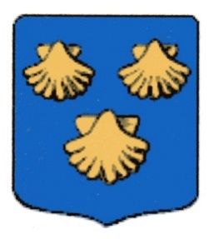 | 92 Church Lane  Wrightington  WN6 9SP  Phone: 07769 462502  vicar@stjamesthegreat.net

16th November – Second Sunday Before Advent
9.00am Holy Communion – Alex Baker
10.30am Holy Communion – Alex Baker
12.00 noon 36 Club Draw
5.00pm 30@5

*+*+*+*+*+*+*+*+

We are still collecting raffle prizes/tombola items/bottles/handbags & jewellery/toiletries etc for the Christmas Fair on Saturday – check with the list at the back of church if you would like to donate, Christmas Raffle Tickets also on sale at the back of Church – Thank you for your support.

Cathy has produced a Christmas Quiz (cost £1.00) for Church Funds – please look out for it in Church over the next few weeks. Answers will be in the next Church Magazine.

*+*+*+*+*+*+*+*+*
Tues 18th Nov 7.00pm PCC
Wed 19th Nov 10.30am Play & Praise Toddler Group
Fri 21st Nov 10.00am Setting up hall for Christmas Fair – help welcomed

Sat 22nd Nov 12.00noon CHRISTMAS FAIR

*+*+*+*+*+*+*+*+*
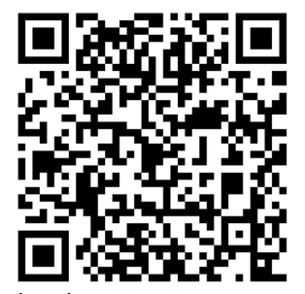
23rd November – Sunday Next before Advent Stir Up Sunday
09.00am No Holy Communion
10.30am Family Service with Communion – David Gaskell
5.00pm 30@5

24th Non Mon 7.00pm Vineyard at 398 |Mossy Lea Road

