
WELCOME!
ST STEPHEN’S CHURCH IS OPEN
10am-3pm daily
for Private Prayer and Reflection

The Third Sunday before Advent
REMEMBRANCE SUNDAY
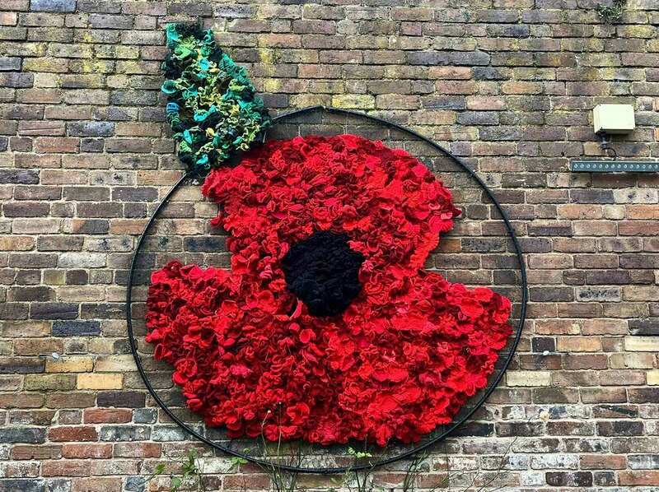
10.30am Family Communion
with Act of Remembrance
6pm Remembrance Service
with the Uniformed Organisations

Notices for inclusion in the bulletin please email to me by Tuesday of each week

officeststephenfradley@gmail.com
Please take Bulletin away with you

PARISH NEWS
An e- magazine for the Benefice



https://church.us11.list-manage.com/subscribe?u=51840f72959d6ab36a4f447dc&id=27f8de6679

A message from our Rural Dean Lynn McKeon
Bishop Tim has requested we hold this event within each of the 10 Deaneries within the Wolverhampton Episcopal Area this year.
Thursday 20th November at 7.00pm at Christ Church Burntwood. The evening will start with a time of worship together, during which Bishop Tim will preach, we will then split up into smaller groups around missional themed prayer tables, where we can share with each other the missional challenges we face, and what we can learn from each other with regards to missional opportunities that work within our parishes and perhaps what we have tried but have failed. We will be praying for ourselves and each other throughout the night.
Please share the details of this event with all of our congregations; our event is the last on the 2025 calendar, lets make ours a great event to end the year with.

Welcome to our Worship today
If you are visiting for the first time, please introduce yourself so that we may welcome you personally.
Refreshments

9th November 2025

Collect
God, our refuge and strength,
bring near the day when wars shall cease
and poverty and pain shall end,
that earth may know the peace of heaven
through Jesus Christ our Lord.

Readings
Job 19. 23-27a 2 Thessalonians.2.1-5, 13-end
Luke 20. 27-38

Post Communion
God of peace,
whose Son Jesus Christ proclaimed the kingdom
and restored the broken to wholeness of life:
look with compassion on the anguish of the world,
and by your healing power
make whole both people and nations;
through our Lord and Saviour Jesus Christ.

IF YOU CAN PLEASE MAKE A DONATION

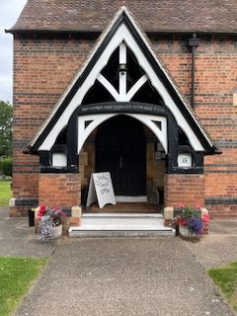

It costs £3,500 each month
to meet the running expenses of our beautiful church,
which we have to raise.
At this time we are not managing to meet these costs.
If you feel that you could make a donation to help it would be hugely appreciated.
THANK YOU

In our thoughts and prayers

We pray for those who paid the ultimate sacrifice………
In cemeteries aboard and graveyards at home, stones memorialise them, lasting markers of past history.
But they also remain as living stones in the fabric of our lives, calling us to look forward to what they did not see but for which we pray.
We come each to dedicate his or her life to the service of the great ideals of love and justice, wisdom and duty for which others, at home or abroad, in the east or in the west, offered their lives.

O God of truth and justice, we hold before you those whose memory we cherish, and those whose names we will never know.
Help us to lift our eyes above the torment of this broken world,
and grant us the grace to pray for those who wish us harm.
As we honour the past, may we put our faith in your future;
for you are the source of life and hope, now and for ever.

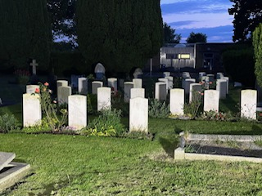



Diary Dates
November 2025
Sunday 9th 10.30am Family Communion with Act of Remembrance
6pm Remembrance Service with the Uniformed Organisations

Monday 10th 10am-12 noon Craft Group
Tuesday 11th 3.30pm Bowbrook Remembrance
7pm Community Choir rehearsal
Wednesday 12th 2-4pm Wednesday Welcome
Sunday 16th 10.30am Family Communion

Refreshments are served after every service


Forthcoming Events

November and December 2025



Sunday 23rd 1pm Christmas Meal at The Swan Fradley Junction -
only a few places left

*****
Thursday 4th December
7.30pm Heritage Concert with U3A Recorders
Free Event with Refreshments

Please see separate flier for Advent and Christmas events



Can you help to support St Stephens Church?
St Stephen’s Church is heavily dependent on voluntary donations and income from events in order to fulfil its ministry to the local and wider communities.
If you would like to support us at this time,
donations can be made via our Just Giving page.
We are grateful for any donation, large or small.

https://www.justgiving.com/
fundraising/ststephensfradley

Contact us
Revd. Elizabeth Wall
01543 254891
Email: ayton265@gmail.com

Churchwarden
Marian Derry
01283 791573

St Stephen’s Administrator: Di Cooper
07930162991
officeststephenfradley@gmail.com

Find us on
ACNY https://www.achurchnearyou.com/church/4123/
Face bookwww.facebook.comststephensfradley

DC 5/11/25

