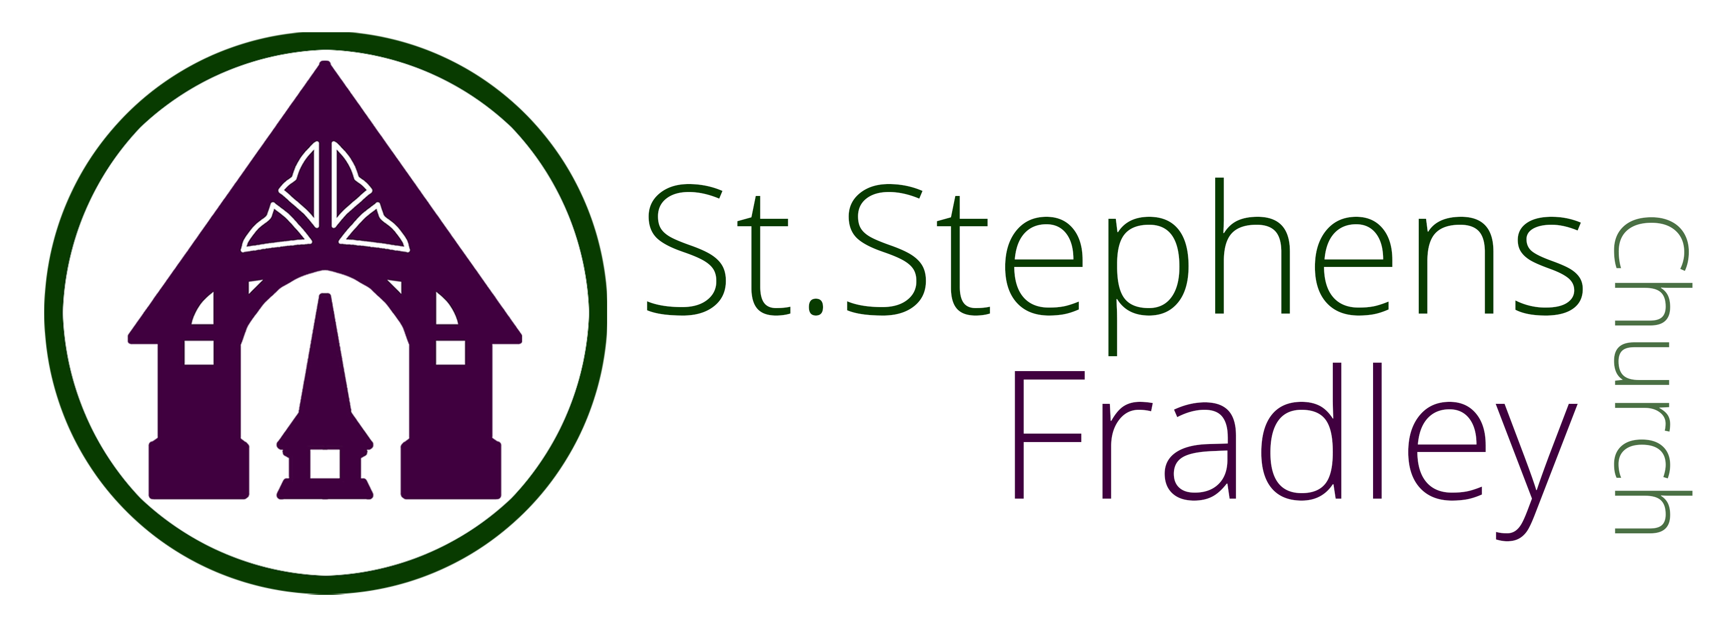
WELCOME!
ST STEPHEN’S CHURCH IS OPEN
10am-3pm daily
for Private Prayer and Reflection

BULLETIN
16th November 2025
The Second Sunday before Advent
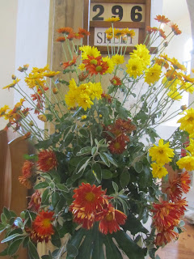

10.30am Family Communion

Notices for inclusion in the bulletin please email to me by Tuesday of each week

officeststephenfradley@gmail.com
Please take Bulletin away with you

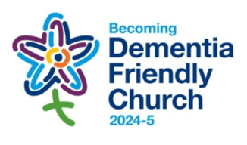
Diary Dates

November 2025
Sunday 16th 10.30am Family Communion
We welcome Revd Val Hicks who will preside and preach at today’s Service
Refreshments are served after every service

Monday 17th 10am-12noon Craft Group
7-8.30pm PCC Meeting

Tuesday 18th 7-9pm Community Choir rehearsal

Wednesday 19th 2-4pm Wednesday Welcome

Saturday 22nd 2-3pm Holy Baptism

Sunday 23rd 10.30am Family Communion
Christ the King
1pm Christmas Lunch at The Swan, Fradley Junction

Tuesday 25th Deanery Synod

Welcome to our Worship today
If you are visiting for the first time, please introduce yourself so that we may welcome you personally.

16^{h} November 2025

Collect
Heavenly Lord,
you long for the world’s salvation:
stir us from apathy,
restrain us from excess
and revive in us new hope
that all creation will one day be healed
in Jesus Christ our Lord.

Readings
Malachi 4.1-2a 2 Thessalonians.3.6-13
Luke 21.5-19

Post Communion
Gracious Lord,
in this holy sacrament
you give substance to our hope:
bring us at the last
to that fullness of life for which we long;
through Jesus Christ our Saviour.

PARISH NEWS
An e- magazine for the Benefice



https://church.us11.list-manage.com/subscribe?u=51840f72959d6ab36a4f447dc&id=27f8de6679

Prayer Event

A message from our Rural Dean Lynn McKeon

Bishop Tim has requested we hold this event within each of the 10 Deaneries within the Wolverhampton Episcopal Area this year.
Thursday 20th November at 7.00pm at Christ Church Burntwood. The evening will start with a time of worship together, during which Bishop Tim will preach, we will then split up into smaller groups around missional themed prayer tables, where we can share with each other the missional challenges we face, and what we can learn from each other with regards to missional opportunities that work within our parishes and perhaps what we have tried but have failed. We will be praying for ourselves and each other throughout the night.
Please share the details of this event with all of our congregations; our event is the last on the 2025 calendar, lets make ours a great event to end the year with.

St Stephen’s Church Fradley Advent & Christmas Events 2025
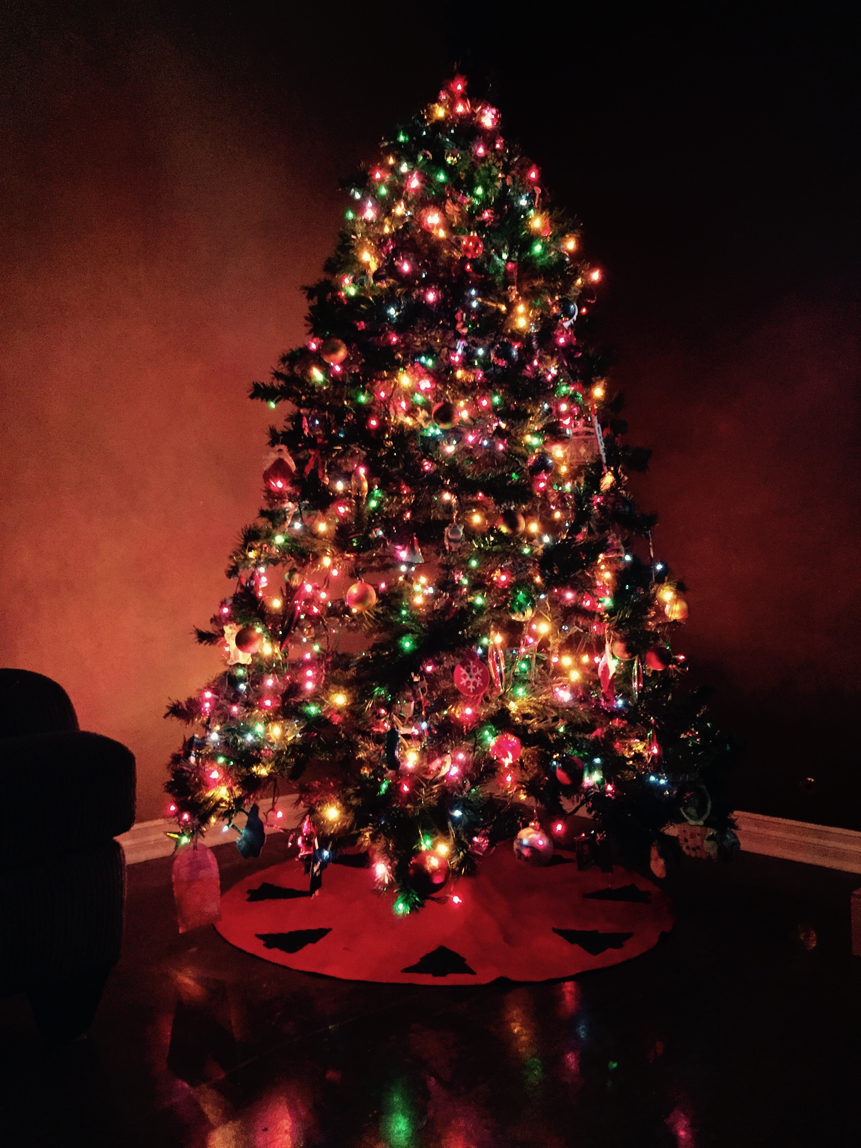
Wednesday 17th December 2pm Places of Welcome Carol Service followed by the usual places of welcome hospitality

Saturday 20th December 10am -12noon
CHRISTMAS TREE FESTIVAL begins
Come and admire the wonderful Christmas Trees. Coffee and Cake served.
12noon Hamper Raffle Draw
The Festival continues until 29th December

Sunday 21st December 4pm LESSONS & CAROLS by CANDLELIGHT
Mulled Cider and Mince Pies will be served

Wednesday 24th December 4pm Birthday Service
Children are invited to come dressed as a character from the Nativity Scene as we retell the age old story of The Birth of Christ.
11.30pm Midnight Service by Candlelight
The first Communion of Christmas with Traditional carols and music led by our Music Group

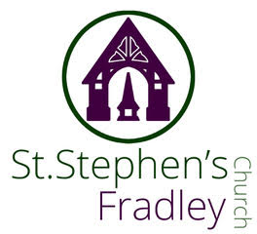
Heritage Concert by U3A Recorder Group

Music for the Season
Thursday 4th December
7.30pm
Light refreshments will be served after the concert
Free Event
Donations welcomed

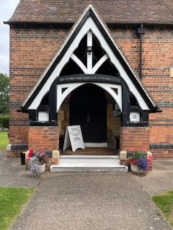
It costs £3,500 each month
to meet the running expenses of our beautiful church,
which we have to raise.
At this time we are not managing to meet these costs.
If you feel that you could make a donation to help it would be hugely appreciated.
THANK YOU

CHURCHES TOGETHER IN LICHFIELD

PRESS RELEASE 04 NOVEMBER 2025
PEACE AND COMMUNITY

The Churches Together in Lichfield respect and welcome those of all faiths or none and all countries of origin who are making Lichfield their temporary or permanent home, with whom we share a common humanity.
The Clergy Chair of Churches Together, the Revd. Ken Howcroft, said “A time of economic and social pressure and tension can lead to hostility towards those labelled as ‘different’ or ‘other’ and sometimes result in unrest. Whatever political policies and actions we individually think should be pursued, we believe that everyone should be treated with dignity and compassion. We do so because in his parable of the Good Samaritan, Jesus gave us an example of someone having the compassion and imagination to respond creatively to someone in need and treating them as a neighbour despite being from a different community.”
Background
Churches Together in Lichfield represents the local churches and related organisations in Lichfield and the surrounding area. It is a body of people from different traditions and backgrounds, exploring new ways to work and worship together

https://www.churchestogetherinlichfield.co.uk/
kenneth.howcroft@methodist.org.uk
077 8881 7315

Can you help to support St Stephens Church?
St Stephen’s Church is heavily dependent on voluntary donations and income from events in order to fulfil its ministry to the local and wider communities.
If you would like to support us at this time,
donations can be made via our Just Giving page.
We are grateful for any donation, large or small.

https://www.justgiving.com/fundraising/ststephensfradley

Contact us
Revd. Elizabeth Wall
01543 254891
Email: ayton265@gmail.com

Churchwarden
Marian Derry
01283 791573

St Stephen’s Administrator: Di Cooper
07930162991
officeststephenfradley@gmail.com

Find us on
ACNY https://www.achurchnearyou.com/church/4123/
Face bookwww.facebook.comststephensfradley

DC 12/11/25

