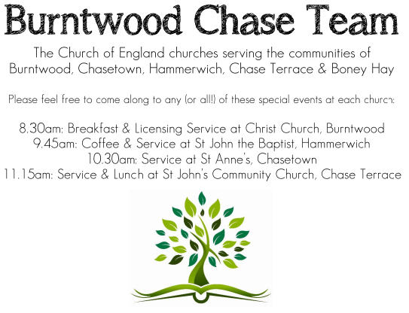 CHRIST CHURCH
SUNDAY 9th November 2025 at 10am

SERVICES:
Sunday 9th November 2025
Morning Worship
Remembrance Service

Readings:
Micah 4: 1-5
In days to come
the mountain of the Lord’s house
shall be established as the highest of the mountains,
and shall be raised up above the hills.
Peoples shall stream to it,
² and many nations shall come and say:
‘Come, let us go up to the mountain of the Lord,
to the house of the God of Jacob;
that he may teach us his ways
and that we may walk in his paths.’
For out of Zion shall go forth instruction,
and the word of the Lord from Jerusalem.
³ He shall judge between many peoples,
and shall arbitrate between strong nations far away;
they shall beat their swords into ploughshares,
and their spears into pruning-hooks;
nation shall not lift up sword against nation,
neither shall they learn war any more;
⁴ but they shall all sit under their own vines and under their own fig trees,
and no one shall make them afraid;
for the mouth of the Lord of hosts has spoken.

⁵ For all the peoples walk,
each in the name of its god,
but we will walk in the name of the Lord our God
for ever and ever.

1 Thessalonians 5 : 1-11
5 Now concerning the times and the seasons, brothers and sisters,you do not need to have anything written to you. ² For you yourselves know very well that the day of the Lord will come like a thief in the night. ³ When they say, ‘There is peace and security’, then sudden destruction will come upon them, as labour pains come upon a pregnant woman, and there will be no escape! ⁴ But you, beloved, are not in darkness, for that day to surprise you like a thief; ⁵ for you are all children of light and children of the day; we are not of the night or of darkness. ⁶ So then, let us not fall asleep as others do, but let us keep awake and be sober; ⁷ for those who sleep sleep at night, and those who are drunk get drunk at night. ⁸ But since we belong to the day, let us be sober, and put on the breastplate of faith and love, and for a helmet the hope of salvation. ⁹ For God has destined us not for wrath but for obtaining salvation through our Lord Jesus Christ, ¹⁰ who died for us, so that whether we are awake or asleep we may live with him. ¹¹ Therefore encourage one another and build up each other, as indeed you are doing.

COLLECT FOR TODAY
Almighty Father,
whose will is to restore all things
in your beloved Son, the King of all;
govern the hearts and minds of those in authority,
and bring the families of the nations,
divided and torn apart by the ravages of sin,
to be subject to his just and gentle rule;
who is alive and reigns with you,
in the unity of the Holy Spirit,
one God, now and for ever.

WHAT’S GOING ON
Upcoming Services

Wednesday 12th November Morning Prayer 9.30am
Saturday 15th November Christmas Fayre 2-4pm
Sunday 16th November Holy Communion 10am
Wednesday 19th November Morning Prayer 9.30am
Sunday 23rd November Holy Communion 10am

Christmas Fayre
Our Christmas Fayre will be on Saturday 15th November, 2-4pm.
Any help to set up would be very much appreciated.

DEANERY PRAYER AND PRAISE EVENING WITH BISHOP TIMOTHY,
in Church at 7pm on Thursday 20th November 2025.
ALL ARE WELCOME TO ATTEND.

An Evening of Christmas Music and Readings – Thursday, 11th December, 7.00pm
Time to dig out those Christmas jumpers! Come along to an informal evening of Christmas readings, carols and Christmas songs including the ever popular “White Christmas”. Bring your own drinks, if you wish, and a small amount of Christmas food to share.

Funeral

The funeral for Barbara Marshall will be held at Christ Church, Burntwood on Thursday 13th November at 11am.

FLOODLIGHTING
If you think about commemorating a special occasion by floodlighting our Church. Please contact Chris Brown on 01543 683862 for details.

PRAYER CHAIN
Christ Church is blessed with a very active prayer chain. If you, or anyone you know, feel that they would like others to pray for them, please speak to Chris Brown on 01543 683862.

HOME COMMUNION
For anyone who is unable to attend church and would like Home Communion,
Steve Morgan is able to carry this out.

VICAR CONTACT DETAILS
Stephen Morgan Tele: 07305 852152
CHURCH WARDENS CONTACT DETAILS
Judith Rogers Tele: 01543 324718
Mike Holmes Tele: 01543 672970
Church Office Tele: 01543 642187 [leave a message and we will respond]
Church Web Site:www.christchurchburntwood.org.uk
Church Email: christchurchburntwood15@gmail.com
Facebook: www.facebook.com/group/christchurchburntwood/

Other Contacts
Matt Wallace St. John’s, Chase Terrace— Tele: 01543 670078
Richard Westwood St. Anne’s, Chasetown—Tele: 01543 686111

NEXT SUNDAY SERVICE
Sunday 16th November at 10am
Holy Communion
Malachi 4: 1-2a
Luke 21: 5-19
2nd Sunday before Advent

